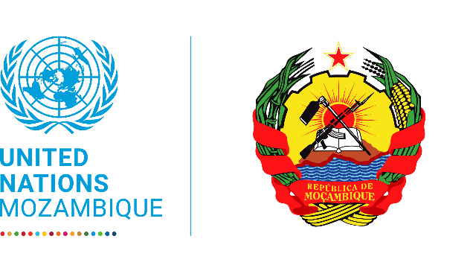

United nations mozambuqye

***2020 UN Mozambique Country Results Report***

Contents

**Acronyms** 2

**Foreword** 4

**UN Country Team** 5

Resident Agencies 5

Non-resident Agencies 5

**Key Development Partners of the UN development system in the country** 6

**1.** **CHAPTER 1** 7

1.1. Key developments in the country and regional context 7

**2.** **CHAPTER 2: UN development system support to national development priorities throughout the Cooperation Framework** 9

*2.1* *Overview of Cooperation Framework Results* 9

**I.** **FOOD SECURITY AND NUTRITION** 10

**II.** **ECONOMIC TRANSFORMATION** 11

**III.** **EDUCATION** 12

**IV.** **GENDER** 13

**V.** **SOCIAL PROTECTION** 14

**VI.** **HEALTH** 15

**VII.** **YOUTH** 16

**VIII.** **GOVERNANCE** 17

**IX.** **NATURAL RESOURCES MANAGEMENT** 18

**X.** **RESILIENCE** 19

*2.3 Support to Partnerships and Financing the 2030 Agenda* 20

*2.3* *Results of the UN Working more and better together: UN Coherence, Effectiveness and Efficiency (2 pages)* 22

*2.4* *Evaluations and Lessons Learnt* 22

*2.5* *Financial Overview and Resource Mobilization* 25

**3** **CHAPTER 3: UNCT Key focus for next year** 26

**4** **Annexes** 28

i. Indicators Performance 28

ii. Joint Programs 0

# **Acronyms**

|  |  |
| --- | --- |
| APCOC | Anti-Poaching Coordination Center |
| AQUA | Environmental Quality Agency |
| ART | Anti-Retroviral Treatment |
| ASR | Accelerate School Readiness Programme |
| BBB | Building Back Better |
| BDS | Business Development Services |
| CBO | Community Based Organizations |
| CCA | Common Country Analysis / Climate Change Adaptation |
| CCT | Tripartite Labor Advisory Committee |
| CEGRD | Disaster Risk Management School Committees |
| CENOE | National Operative Emergency Center |
| CNSC | National AIDS Council |
| CSE | Comprehensive Sexuality Education |
| CSO | Civil Society Organizations |
| DCP | Development Partners’ Group |
| DNOMT | National Directorate of Labor Market Observatory |
| EESE | Enabling Environment for Sustainable Enterprises |
| ENAP | Every Newborn Action |
| FAW | Fall Armyworm |
| FEDEMOMA Mozambican Federation of Timber Operators | |
| FMUS | Forest Management Units |
| FSN | Food Security and Nutrition |
| FUNAE | National Fund for Energy |
| GBV | Gender Based Violence |
| GFATM | Global Fund to Fight AIDS, Tuberculosis and Malaria |
| GREPOC | Government Reconstruction Cabinet |
| HWC | Human Wildlife Conflict |
| IDPs | Internally Displaced People |
| IFPRI | International Food Policy Research Institute |
| INAM | National Instituted for Meteorology |
| INE | National Institute for Statistics |
| INNOQ | National Institute for Standardization and Quality |
| IPAJ | Legal Assistance and Representation |
| IPC | Integrated Food Security Phase Classification |
| ISRI | Higher Institute for International Relations |
| KAP | Knowledge, Attitudes and Practices |
| LGBTI | Lesbians, Gays, Bisexuals, Transsexuals, and Intersex |
| LMIS | Labor Market Information System |
| LNOB | Leave No One Behind |
| MADER | Ministry of Agriculture and Rural Development |
| MAEFP | Ministry of State Administration and Civil Service |
| MAM | Moderate Acute Malnutrition |
| MEF | Ministry of Economy and Finance |
| MINEDH | Ministry of Education and Human Development |
| MITSS | Ministry of Labor and Social Security |
| MJCR | Ministry of Justice and Constitutional and Religious Affairs |
| MTA | Ministry of Land and Environment |
| MUAC | Mid Upper Arm Circumference |
| NCD | Non-Communicable Diseases |
| NDVP | National Development Vaccination Plan |
| NEP | National Employment Policy |
| NRMC | Natural Resource Management Committees |
| ODA | Official Development Assistance |
| PALOP | African Portuguese Language Speaking Countries |
| PALPOC | Housing Reconstruction and Rehabilitation Guideline |
| PAMRDC | Action Plan for the Reduction of Chronic Malnutrition |
| PASD | Direct Social Assistance Scheme |
| PASP | Productive Social Protection Scheme |
| PDNA | Post Disaster Needs Assessment |
| PEB | Pro-Employment Budgeting |
| PESOD | District Economic and Social Plan |
| PGR | General Attonery’s Office |
| PLWHIV | People Living With HIV |
| PRONAE | National School Feeding Program |
| PSSB | Bacic Social Security Plan |
| SADC | Southern Africa Development Community |
| SAM | Severe Acute Malnutrition |
| SBCC | Social Behavior Change Communication |
| SDAE | District Services for Economic Activities |
| SEJE | State Secretary for Youth and Employment |
| SERNIC | National Services for Criminal Investigations |
| SETSAN | Technical Secretariat for Food Security and Nutrition |
| SISTAFE | State Financial Administration System |
| SMEs | Small and Medium Enterprises |
| VAC | Violence Against Children |
| WASH | Water and Sanitation |
| WCU | Wildlife Crime Response Unit |

# **Foreword**

On behalf of the United Nations in Mozambique, I am pleased to present the 2020 progress report of the United Nations Development Framework (UNDAF 2017-2021). As you all know, this Cooperation Framework was formulated jointly by the Government of Mozambique and the UN System in 2015-16. The document identifies strategic and collective contributions of the United Nations Funds, Programmes and Specialized Agencies in support of the country’s development priorities as stated in the Government’s Five Year-Plan (*Plano Quinquenal do Governo – PQG*) and the 2030 Agenda.

This report follows the 2019 United Nations Sustainable Development Cooperation Framework and the results are organized around the 10 Outcomes (i) Food Security, (ii) Economic Transformation, (iii) Education, (iv) Gender, (v) Social Protection, (vi) Health, (vii) Youth, (viii) Governance, (ix) Natural Resources Management and (x) Resilience. For each Outcome, the report presents the context, achievements (including the updated results matrix), challenges and lessons learnt.

The year 2020 was marked by the spread of the COVID-19 pandemic and intensification of the insecurity and violence in the northern part of the country. In fact, Mozambique notified the first COVID-10 case on 22nd of March 2020. From that period up to December 2020 Mozambique had reported a cumulative of 18.642, among them 166 deaths, 16.663 recovered. All the 11 Provinces reported cases and about 87% of the District reported the cases. The peak of the cases of the first wave occurred in the month of July. At the same time, aggravation of the violent attacks by non-state armed groups in Cabo Delgado caused an estimated loss of over 2,000 lives, the displacement of 550,000 people (750,000 people by March 2021).

The UN system in Mozambique remains committed to supporting the Government and the persons living in Mozambique to achieve the 2030 Agenda and to accelerate the implementation of the Sustainable Development Goals (SDGs). Internally, the UN system is committed to further implement the Delivering as One, investing more and more to jointly interact with Government and development partners.

The preparation of this report was possible due to the dedicated efforts of the Programme Management Team (PMT) and the Monitoring and Evaluation Resource Group (M&ERG), with the support of the Resident Coordinator’s Office (RCO). Despite the challenges cause by the Emergency Law following the COVID-19 pandemic, I am happy to see the that we have managed to put together our collective achievements in one document. My appreciation goes also to the Heads of Agency who have created the conditions to make this work possible.

I take this opportunity to thank all our partners in Government, CSOs, academic circles, the media and Mozambique’s Development Partners for the joint work and collaboration in the implementation of the UNDAF.

We look forward to fruitful discussions on the contents of the report.

Estamos juntos!

____________________________

 Myrta Kaulard

UN Resident Coordinator

# **UN Country Team**

## Resident Agencies

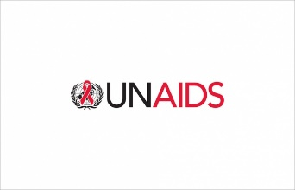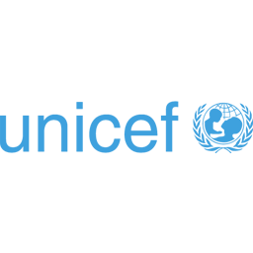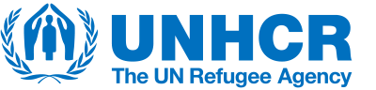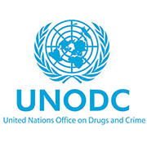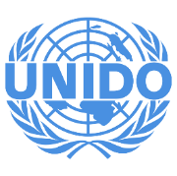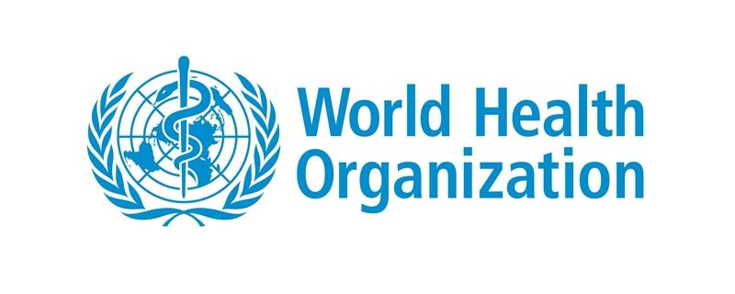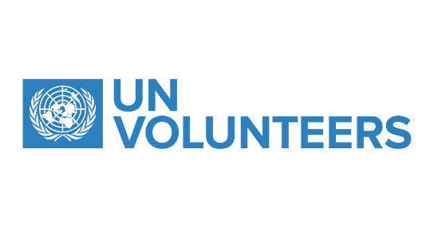

## Non-resident Agencies

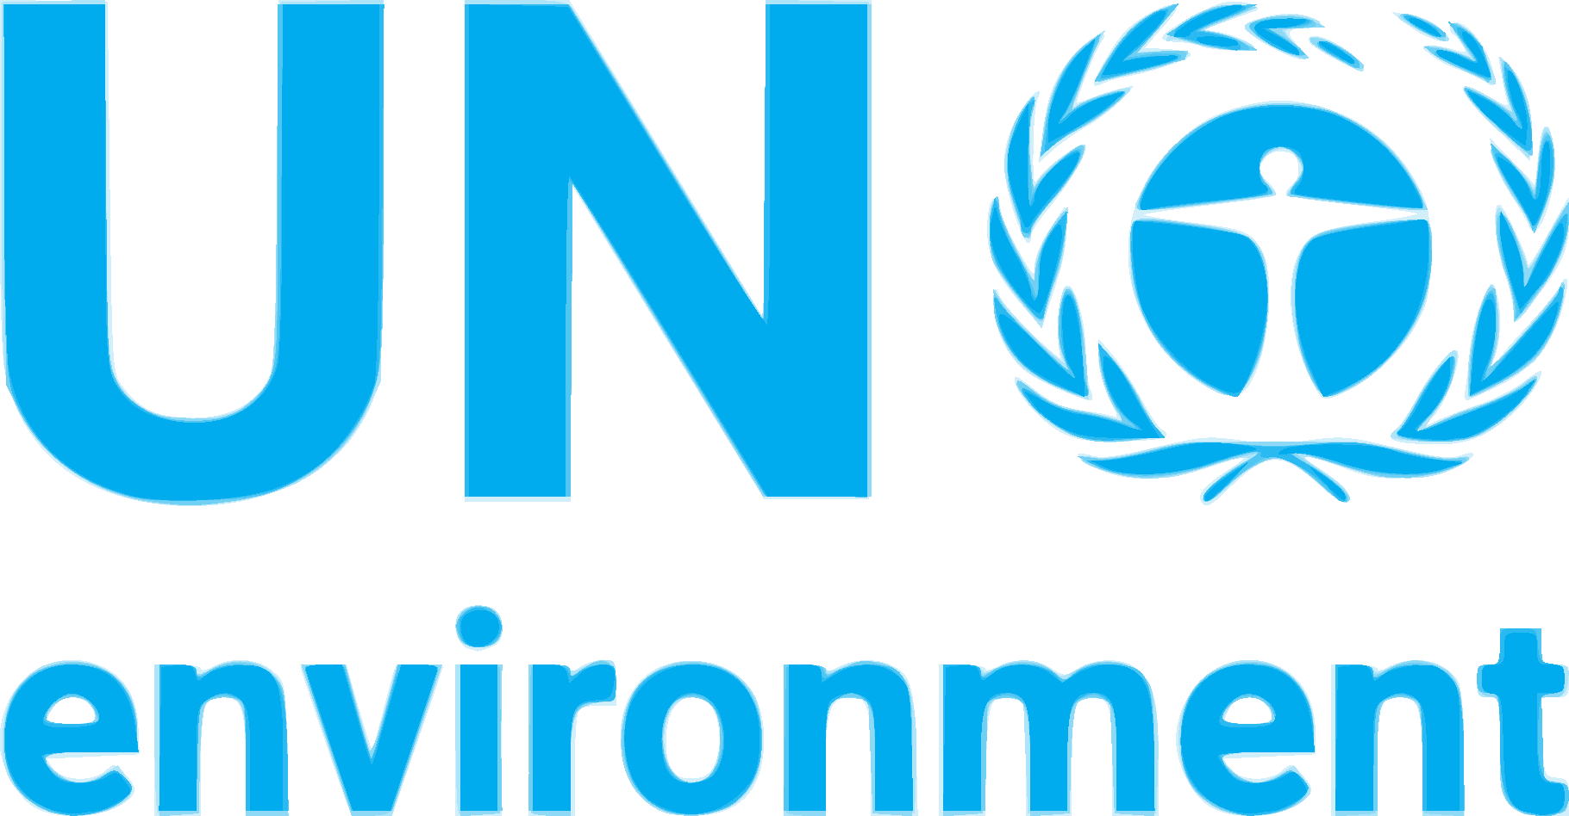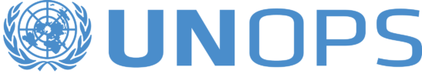

# **Key Development Partners of the UN development system in the country**

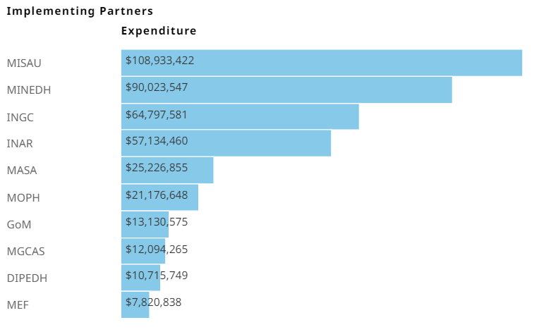

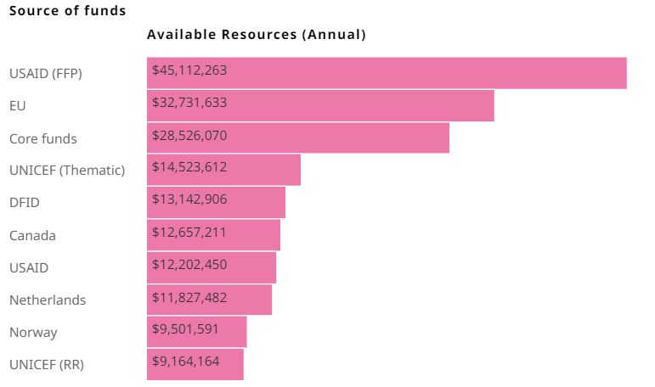

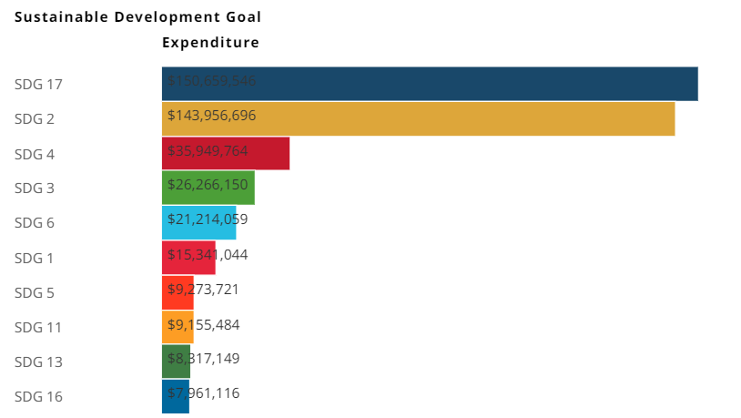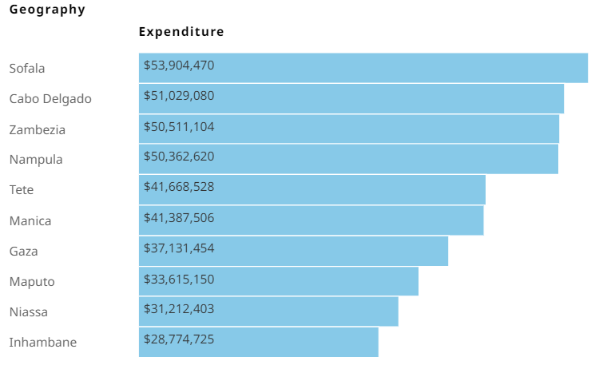

**Use of the Mozambique One Fund**

In 2020 the UN System has benefited from the support of the Mozambique One Fund for with a total amount of USD 51,359 to support the Common Country Analysis, as the first step for the formulation of the new United Nations Sustainable Cooperation Framework (UNSDCF -2022-2026). In addition, expenditures of the fund supported Outcomes 2,4,5, the cross-cutting project, HIV response to Cyclone Kenneth, and direct costs for the Mozambique One Fund.

# **CHAPTER 1**

## 

## Key developments in the country and regional context

**Key development trends and emerging issues in the year 2020 and their implications for Mozambique’s SDGs priorities**

*Key development trends and emerging issues*

In Mozambique, as in the whole world, 2020 was marked by the irruption of the COVID-19 pandemic. The country was less hit than neighboring countries such as South Africa and Eswatini as large sections of the Mozambique population live in rural areas detached from social exchanges with the rest of the country and with regional and global economies. From a public health perspective, the Government set up generally effective prevention measures, except in the Christmas period of 2020 when the relaxation of measures resulted in a spike in contagion. Nevertheless, the slump in global demand and commodity prices impacted the economy which recorded its first contraction in two decades (-1.3%) uncovering the extreme vulnerability of the current economic model to exogenous shocks. This was aggravated by the servicing of USD2.2 billion in undisclosed sovereign debt, discovered in 2017 which currently absorbs one-third of the country’s fiscal space. At the same time small scale agriculture and fishing, growing at 2.7% partially cushioned the impact, highlighting that it is key source of resilience for the country despite low productivity, as it occupies around 70% of the labor force. Agriculture was aided by the absence of major natural disasters in 2020.

The COVID-19 prevention measures hit the economy of the greater Maputo area hard which represents around 40% of the entire economy, especially the services sector, with large loses in formal employment and informal income generation opportunities in urban areas. The World Bank has estimated this will result in an increase in 1 million people falling below the poverty line. In addition, schools have remained close for about a year which creates the risk of worsening the already very low attendance rates (2.5 years on average for girls and 4.5 years on average for boys). Most public schools lacked WASH facilities that could have enabled them to resume presential lessons as their private school counterparts in Maputo.

Another key development was the aggravation of the attacks by non-state armed groups in Cabo Delgado which caused an estimated loss of over 2,000 lives, the displacement of 550,000 people (750,000 people by March 2021) and the disruption of livelihoods. In addition, Total paused the development of the gas liquification facilities in the District of Palma, causing an estimated loss of USD 2bn in supply chain contracts for Mozambican firms. Furthermore, Exxon suspended *sine die* its final investment decision, estimated at USD 30bn.

The concurrence of the COVID-19 pandemic and conflict in Cabo Delgado led the Government and the international community to focus on a short-term emergency response which included the following:

* The promotion of the national private sector, for example the lack of approval of a local content law and the decline of credit to agriculture.
* The lack of promotion of income generation opportunities, especially for the youth (for example, weak implementation of the employment policy and lack of operationalization of the youth work programme defined in the Post-Disaster National Assessment, PDNA);
* The lack of follow-up on long-standing recommendations from the Extractive Industries Transparency Initiatives to generate greater socioeconomic impact from the extractive industries;
* The partial implementation of the productive social protection scheme (PASP) (which budget was not executed in full, despite dire needs);
* Not leveraging opportunities for climate investment funds (including the carbon offset market) or to climate-proof investment (schools, health units, civil infrastructure);
* The lack of approval of the health financing strategy, the slow reform of the judicial system and the weak enforcement of the law on premature unions banning child marriage, and many other examples of sustainable development policies that have taken the back seat in the fact of the pandemic and the Cabo Delgado conflict.

The country has continued to record decreased scores of international governance indicators (African Governance Indicator, Democracy Index, etc.) reflecting the weakening of Rule of Law and the emergence of area of lawlessness and impunity (major corruption cases like the debt scandal where the national law was simply not applied as concluded by the Constitutional Council, no punition from violations of the environmental legislation, the Cabo Delgado conflict, widespread gender based violence (GBV) cases which remain unpunished, etc.). The process of disarmament and reconciliation of the opposition armed members of Renamo made positive progress and the attacks from the dissident group (Renamo Military Junta) in Sofala and Manica provinces reduced considerably.

*Implications for Mozambique’s SDGs priorities*

The main implication of the trends and issues recorded in 2020 is the undeferrable need to build people’s resilience to the multiple shocks they are subject to, some of which, like natural disasters are suspected to aggravate the situation with the intensification of climate change. This applies not only as a “sustainable development policy” but also as a “humanitarian response”, as the 700,000 internally displaced persons (IDPs) in Cabo Delgado need to develop resilient livelihoods alongside the host communities and cannot remain dependent on humanitarian aid continuously.

Too much of the overall ODA effort is concentrated in the South of the country (especially Maputo City and Province) in spite of the fact that the Centre and North are more vulnerable to natural disasters and conflict, contain a high proportion of the population and hold greater agricultural potential yet receive lower shares of investment and public spending.

The international community should apply contextual knowledge from both the local population and experts with long experience in the country, rather than simply following decontextualized topical priorities, to assist the Government go beyond a perpetual crisis-mode and recover its former long-term policy focus on sustainability, avoiding donor fragmentation, duplication and short-termism which undermines the capacity of the Government and the public administration to implement reforms and to design coherent, effective and sustainable policies.

**Major implications of contextual developments for UN development support in the year, including UNCT configuration**

More focus should go to the family and livelihood level, beyond the individual as a target beneficiary of public services, adopting community-based development approaches. Three out of four Mozambicans live off the rural economy and they work for themselves or for their family (unremunerated), carrying a burden of household dependency. Investing in families and livelihoods require tailored approaches that understand the dynamics of the informal sector (in both rural and urban areas). When families increase their production and manage to save or buy assets like livestock or insurance, they develop coping mechanisms to deal with shocks without becoming dependent on aid. However, a decreasing percentage of ODA is targeted to productive functions of the household and the resilience of livelihoods.

Development interventions should adopt a longitudinal approach where household capabilities are tracked over time rather than resorting to static counts of anonymous individuals who are continuously counted and double counted as they become affected by various disasters without tracking progress in building their resilience. Areas of UNCT focus should include occupational, entrepreneurial and employment promotion, capacity development programmes like technical and vocational training, support to small and medium enterprises (SME) development, including both the formal and informal sectors, developing access to credit leveraging mobile technologies (currently mobile technologies are only used for payments thus benefit mostly consumers rather than producers) and support to leverage climate financing opportunities to develop the green and blue economies, UN projects to provide weather and price information to local producers constitute a best practice on this.

Moreover, it is paramount to go beyond a 1-year horizon in humanitarian and action to support integrated long-term sustainable development policy led by the Government, as it vested with the legitimacy from the recent elections held and it is accountable to the people. The operating models of the various entities in the UN development system should be become more agile, for example by developing the corporate capability to outsource and deploy local capacity timeously, leveraging local skills.

In addition, the UNCT should promote capacity development of the institutional system at the local level (district councils, district administrators) as local participation and representation is more inclusive and provides a “social stability” dividend.

In areas affected by humanitarian crises like Cabo Delgado under the current conflict and provinces affected by natural disasters there should be an explicit focus on linking humanitarian response to regular services provided within the national institutional framework, as this creates sustainability, and links the humanitarian response to national planning and budgeting with a long-term orientation (a holistic, integrated and systematic sustainable development approach).

# **CHAPTER 2: UN development system support to national development priorities throughout the Cooperation Framework**

### 

### *Overview of Cooperation Framework Results*

During 2020, the UN supported the analysis of Integrated Food Security Phase Classification (IPC) in Mozambique, providing decision-makers with a rigorous, evidence- and consensus-based analysis of food insecurity and acute malnutrition situations, to inform emergency responses, as well as medium- and long-term policy and programming. Results from the most recent IPC conducted, suggests that 2.7 million people faced high levels of acute food insecurity (IPC Phase 3 or above) in rural (approx. 1.9 million) and urban (0.8 million) areas across the country between October and December 2020. The number of people facing high acute food insecurity (IPC Phase 3 or above) was estimated to increase to 2.9 million people in rural (approx. 2.1 million) and urban (0.8 million) areas across the country between January and March 2021.

Despite the challenges posed by COVID-19, UN agencies continued its support to the Ministry of Education and Human Development (MINEDH), the Ministry of Gender and Social Action (MGCAS) and other partners, including the National Early Childhood Development Network (R-DPI), to provide early childhood education services.

The UN contributed to strengthening the democratic process, service delivery for all segments of society, protection and enjoyment of human rights, inclusion and participation in democratic process and ensuring that no one is left behind.

The response to COVID-19 has been integrated in current ongoing development programs under the UNDAF. To this end, 13% of development programs have redirected their funds to support the COVID-19 Response. Mozambique has slightly improved its reporting rate, compared to previous quarters. In the first quarter, Mozambique was categorized among countries with the lowest reporting rate (less than 33%), however, improvements have been made such that Mozambique currently scores as medium (defined as a report rate between 34%-66%.) It is also important to note that the Macroeconomic Response Pillar (Pillar 4) is not currently being reported on.

Under the first pillar, *Health First: Protecting health services and systems during the crisis*, there have been some 34,646 beneficiaries. Through nutrition programs, 16,668 beneficiaries have been reached. Furthermore, 31 health workers have been supported. Under the second pillar, *Protecting People: Social protection and basic services,* there have been some 1,960,601 beneficiaries. 1,015,330 children have been supposed with distance and home-based learning, 131,170 children have received a take-home ration as an alternative to meals, 23,365 beneficiaries have received WASH supplies (including hygiene items), 778,559 beneficiaries are engaged in cash transfer programs and 12,177 individuals received psychosocial support.

Under the third pillar, *Economic Response and Recovery: Protecting jobs, small and medium-sized enterprises and vulnerable workers in the informal economy*, there have been 707,516 beneficiaries, 7,302 formal sector workers and 707,516 beneficiaries through food supply protection regimes. Finally, under the fifth pillar, *Social Cohesion and community resilience*, three community-based organizations were supported.

* 1. *OUTCOMES*

### **FOOD SECURITY AND NUTRITION**

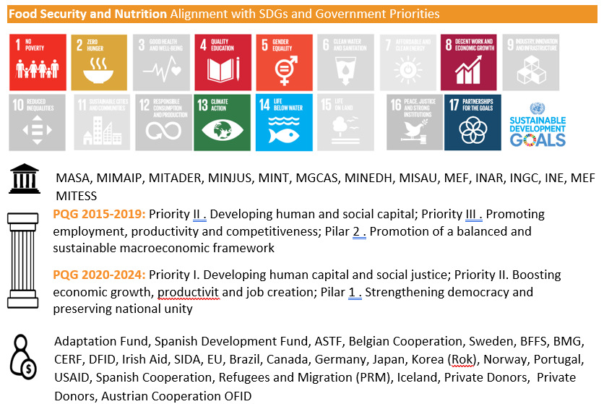

**Key achievements**

The UN contributed to strengthening the capacity of the Ministry of Agriculture and Rural Development (MADER), the Technical Secretariat for Food Security and Nutrition (SETSAN) and other stakeholders to design and implement evidence-based and gender-responsive agriculture and food and nutrition security policies, programs and investments[1]. Additionally, the UN provided technical and financial support provided to MADER to strengthen quality agricultural extension services[2].

The UN continued to provide Emergency Food and Agricultural Assistance through in-kind and cash-based transfer assistance as well as agricultural inputs and tools. Lifesaving and recovery assistance were provided in nine provinces reaching 1.2 million people following extensive crop loss and damage of agricultural livelihoods in 2019.

The UN also supported improved interventions to promote nutrition including the operationalization of nutrition communication strategies, programs related to vitamin A supplementation for children, immunization initiative and malnutrition campaigns.

**One UN tackling the needs of displaced people in Northern Mozambique**

In Cabo Delgado, one in five people has had their livelihoods disrupted by the current crisis. In Metuge, 33,000 displaced people are safe from violence in temporary shelters, but food is the main need of displaced people; and children are the most at risk of malnutrition.

Ancha lives in a shelter with four daughters. Her youngest is suffering from moderate acute malnutrition. Since fleeing home, the girl has barely eaten because of trauma and scarcity of food. Their family is counting on the assistance of WFP and UNICEF. “We cannot work on our farm anymore; if the help stops, we will die.”

In 2020, WFP provided food to over 400,000 people in Cabo Delgado. But to treat acute malnutrition more calories and nutrients are required. UNICEF distributes energy and nutrient-dense specialized therapeutic food to health centres for children with severe acute malnutrition, and WFP provides for children with moderate acute malnutrition.

WFP and UNICEF partnered with the Government in a nutrition survey to document the levels of malnutrition. They found that 6% of displaced children under-5 had acute malnutrition, which is life-threatening, but treatable. Chronic malnutrition (or ‘stunting’) reaches 50% of displaced children (41% among host communities). Stunting, however, cannot be reversed; it occurs cumulatively due to inadequate food intake, causing lifelong consequences, like poor cognitive development.

Figure 1 Ancha and her daughters in front of their temporary shelter in 25 de Junho. Photo: WFP/Nuno Rebocho

Such high levels of malnutrition are a ticking time bomb for Cabo Delgado’s children that is why multi-sectoral approaches are needed to ensure them a better future.

In Katapua village, also in Cabo Delgado, a mother of two Cristina Mariano was trained as a Care Mother by the FAO Nutrition programme to fight malnutrition among children under 5 years-old. She now leads a group of 10 other mothers, pregnant and lactating women and teach them good practices on nutrition, hygiene, health, cooking demonstrations, and vegetable growing.

FAO programme empowers women to teach each other within their communities. “We suffered a lot with our kid’s nutritional. With this programme we are saving children”, says Cristina. “We have learnt to prepare the enriched porridges with moringa flour, peanut butter, eggs and sugar”. Enriched porridge had become a powerful tool for mothers to fight malnutrition.

Cristina and the other women also learned how to grow nutritious foods, a lesson that will improve the food security of their families forever. “We will keep what we learned in our houses”.

### **ECONOMIC TRANSFORMATION**

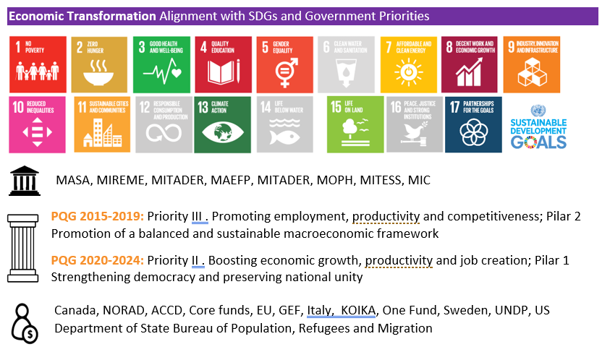

**Key achievements**

The UN continued to support national and sub-national systems and institutions to enhance economic policy coherence and implemented providing financial and technical support on a variety of interventions[3]. Furthermore, the UN continues to promote the enhancement of the business environment, competitiveness and employment creation in the country[4].

The UN also conducted a variety of assessments and research in the areas of COVID-19 recovery, identification value chains for commodities with the strongest potential for regional and global trade[5]. Furthermore, the UN strengthened the capacity of institutions across sectors in data analysis[6].

### **EDUCATION**

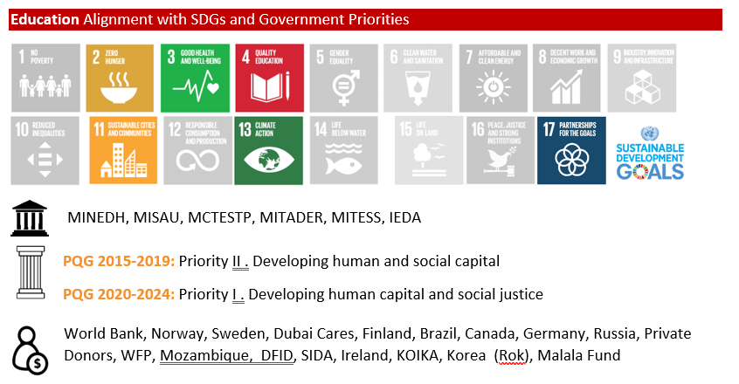

**Key achievements**

to benefit from UN’s support to develop, implement, and monitor the 10-year Mozambique Education Sector Plan (ESP) (2020-2029) and its Operational Plan (2020-2022).

The UN supported MINEDH to respond to school closure due to COVID-19, ensuring learning continuity for children, youth and adults, through the provision of remote learning including radio and TV broadcasts, from early childhood education to adult education programs and the provision of an Accelerated School Readiness (ASR) Program. Furthermore, the UN continued its supported to MINEDH in implementing school feeding interventions, reaching 2.6% of total students.

The UN continued to support the development of MINEDH capacity in various areas. The Government’s capacity to deal with Violence Against Children in schools was strengthened, including the approval by MINEDH of the policy[7] for reporting and referral mechanism for cases of violence occurring in schools and training of focal points for gender and health. Furthermore, MINEDH strengthened the existing platforms for adolescents and young people to engage on issues related to Comprehensive Sexuality Education (CSE) and contributed to build capacity of teachers, health workers and social workers on referral mechanisms at school to support survivors of School Related Gender Base Violence.

**Television is helping the learning continuity of children during COVID-19**

**MAPUTO, Mozambique** – “We miss our teachers, they were really nice and helped us solve our exercises, but with the coronavirus we need to adapt and learn to solve our exercises alone at home,” said 17-year-old Alzira Ngomane and her 14-year-old brother Amilcar Ngomane, in the neighborhood of Albazine, in Maputo City. Since their school was closed in March 2020, as a preventive measure due to the COVID-19 pandemic, they are now studying at home using the Telescola television programme from the national TV station TVM.

Every afternoon, for 30 minutes, Alzira and Amilcar place their notebooks on the small wooden table in their living room and turn on their television to accompany the lessons transmitted by the national TV station TVM, every day from 3 pm. They both recognize that it is not the same as being in a classroom with their classmates, and despite the short time they manage to remember some subjects and do their exercises.

Alzira studies at Escola Secundária Eduardo Mondlane at 12th grade, and dreams of becoming a Civil Engineer. Her school closed 6 months ago when the Government of Mozambique declared the State of Emergency due to the coronavirus. "I try to maintain a routine while at home, I wake up and do my house chores, then I study with the Telescola. Without the Telescola, it would be difficult to understand the subjects and solve the exercises, the teachers who participate in the Telescola clarify many of my questions, and I manage to make the home work they give at school and understand the subject better," said Alzira.



*17-year-old Alzira Ngomane, and her 14-year-old brother Amilcar Ngomane, study at home using the Telescola television programme since their schools closed due to the COVID-19 pandemic. © UNICEF Mozambique/2020/Claudio Fauvrelle*

"At school it was easier to get answers to my questions because we had the teacher there, at home it’s more difficult to study and concentrate. My dream is to be an architect, because I like to draw. And I know that I need to go to school in order to achieve my dream in the future, and, with the schools closed, the Telescola is helping me to continue studying at home, so that I can continue working towards achieving my dream," said Amilcar.

To support learning continuity of children during the school closure, United Nations Children's Fund (UNICEF), with funding from the Education Cannot Wait (ECW) programme, is supporting Telescola (TV education programme) and radio education programmes, including translating into local languages and broadcasting on community radios. For instance, TVM broadcasts about 1.5 to 2.5 hours of Telescola per day to support the continuity of learning for primary and secondary school children. During COVID-19, school closures and restrictions in movements ensued in Mozambique, hindering the learning of millions of children. Up until September 2020, the Government has yet to decide on the opening of primary and secondary schools.

### **GENDER**

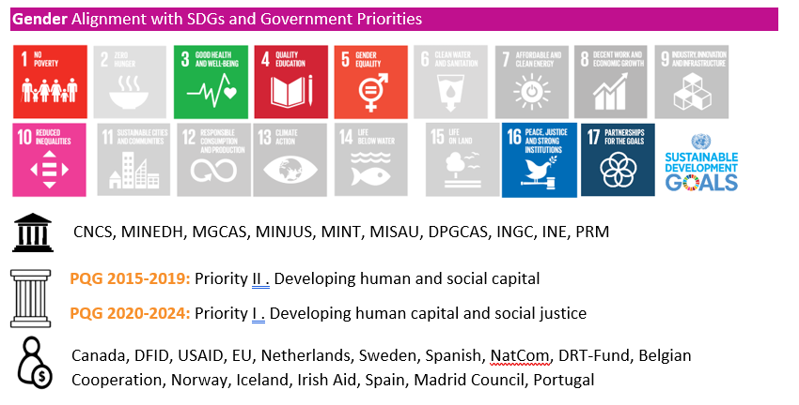

**Key achievements**

The UN strengthened the Government’s capacity to advance gender equality, oversee and monitor the implementation of commitments on gender equality, assisting on planning and budgeting sub-system to enable public allocation and tracking of resources for gender equality, and training of government officials at all levels in its use; , gender response monitoring and oversight, discussing the Guideline on Gender Sensitive Planning and Budgeting as well as the Proposal of Specific and Standard Activities to promote gender equality. At the community level, engagement activities for individual on gender took place[8], as well as trainings for community leaders and prominent members of the community[9].

The UN support the provision of integrated assistance to women and girls affected by GBV including capacity strengthening of officials from the health, police, social action, and justice sectors. The capacity of professionals of the justice system administration to implement the GBV legislation was also strengthened by the revamped Gender Unit of the Ministry of Justice and Gender created at Forensics National Investigation Police resulting in the referral of GBV in the context of humanitarian assistance to cases to Multi-Sectoral Integrated Teams.

The UN contribute to the improved availability of data to inform policy making, supporting the development of Infoviolencia, a digital platform to register and manage reported GBV cases. The UN supported the improvement of gender data by producing statistics and information on the impact of COVID-19 on women and girls in Maputo municipality, the impact of cyclones Idai and Kenneth and the impact of displacement and conflict in a gender perspective in central and northern Mozambique. The capacity of technical staff from government institutions also improved to report on GBV.

### **SOCIAL PROTECTION**

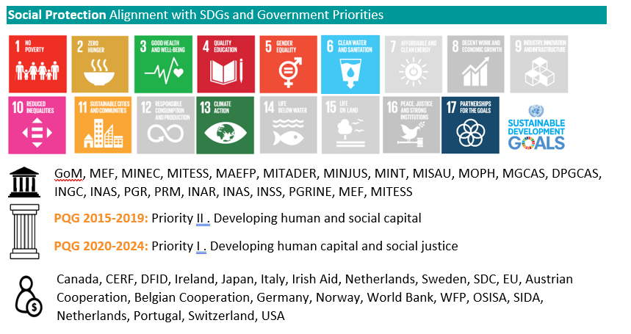

**Key achievements**

The UN continues to support a variety of social protection programs at the national level, including the implementation, program redesign, improvement and expansion of the National Strategy of Basic Social Protection 2016-2024 in conjunction with INAS; and improved transparency and efficient of basic social protection systems through the design and roll-out to a new Management Information System for social protection programs (e-INAS).

In response to COVID-19, the UN supported the design and implementation of the innovative, shock-responsive Social Protection Response Plan to COVID-19, including additional payments for regular beneficiaries and coverage extension to new beneficiaries, in the poorest neighborhoods in urban and peri-urban areas. The same programs is being used for households in Sofala affected by Cyclone, Idai, using electronic transfers and helping establish new payment methods for social protection programs, especially the shock responsive system. The UN is also providing technical assistance to the distribution of the Child Grant.

### 

### **HEALTH**

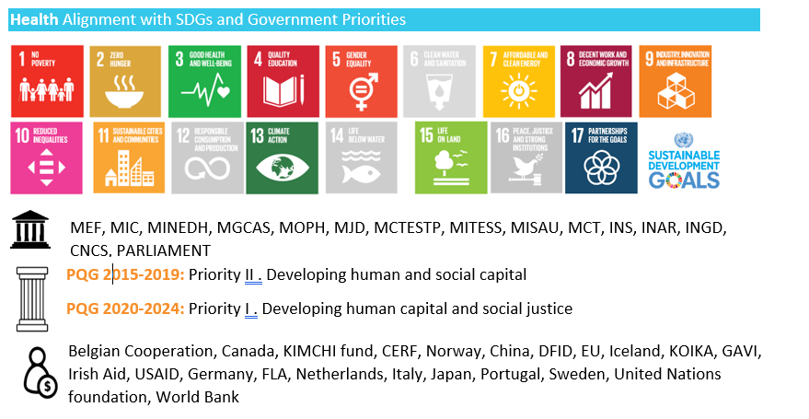

**Key achievements**

The UN supported the strengthening of institutional capacity of the health sectors including technical support to develop key strategic documents including the National Health Policy 2020-2030, the Health Strategic Plan 2020-2024, the COVID-19 National Response Plan, the National Development Vaccination Plan (NDVP) and technical guidance. The UN has also supported implementation in different programmatic areas including the Every Newborn Action 2019-2023 (ENAP, 2019-2023) for the prevention of newborn deaths, the National Plan for the Triple Elimination of Mother-to-Child Transmission of HIV, Syphilis and Hepatitis-B 2020-2024 and the National Multisectoral Strategy for NCD prevention and control 2020 – 2030.

In response to COVID-19, the UN has committed 19.6 million to health WASH and basic nutrition to support COVID-19 response plans. Despite limitations posed by COVID-19 and the challenges created by the institutional changes at provincial level, annual targets for safe water supply were achieved and overall CPD targets for water supply were surpassed, including reducing the number of communities with ODF, improving sanitation conditions in schools and improving WASH infrastructure in health centers. Technical support includes training of the health workers on rapid response actions and surveillance teams in contact tracing and strengthening diagnostic capacities for laboratories. The UN has also supported the Risk Communication and Community Engagement. Under the COVAX mechanism, the UN is supporting MISAU to assess the national capacities to receive and rollout the COVID-19 vaccine.

The UN continues to provide technical and financial support to MISAU in the priority health areas including sexual and reproductive health[10], malnutrition[11], and PLHIV[12]. Building on its partnership with the Global Fund and with PEPFAR, the UN supported the mobilization of resources for the HIV response through the PEPFAR COP 20 planning process and development of Global Fund 2021 – 2023 proposal. Furthermore, in the area of sexual and reproductive health. the UN advocated for the My Choice program, funded by the Netherlands, was a major factor in meeting the need for family planning in 2020 by providing $6.7 million for the procurement of contraceptive methods.

### **YOUTH**

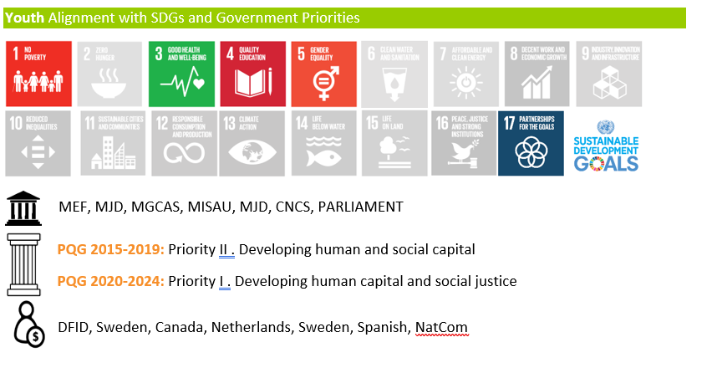

**Key achievements**

The UN supported the establishment of the national Youth Partners Group for strategic advisory and multi-sector coordination to maximize investments in youth and harness the demographic dividend; improved MEF capacities at central and provincial levels to integrate demographic variables into main planning instruments and inform the annual Economic and Social Plan and State Budget; improved awareness of the impact of humanitarian crises on youth and other vulnerable populations; new 5-year program designed to strengthen data systems for youth empowerment and the demographic dividend.

Through UN support and engagement girls, boys and women across the country had access to various programs on CSE, SRHR, GBV and HIV strengthening their capacity to actively participate in economic, social, cultural and political development. Furthermore, women have increased access to health care services including adaptation of maternal and child health service delivery models, and access to voluntary family planning through enhancing the access, services and supply of quality contraceptives. Furthermore, the UN responded to increased demand for quality access to ASRH and HIV prevention services[13]

### 

### **GOVERNANCE**

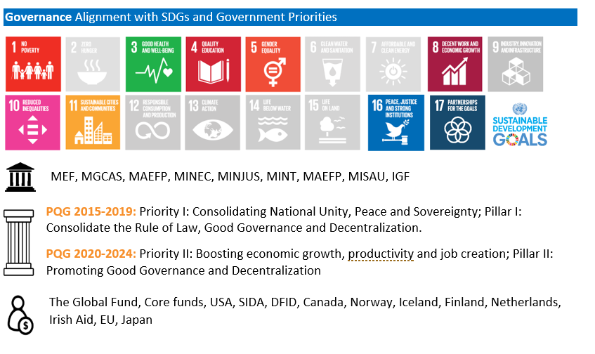

**Key achievements**

The UN produced of series of analyses and assessments pertaining to the elections in 2019 [14]; supported the drafting and launch of the Shadow Report on the Implementation of the Recommendations of the 2nd Cycle UPR and subsequent submission and Human Rights Citizen Perception Report[15]; supported the development and approval of

the Strategic and Development Plans of the 2 main National Human Rights Institutions; conducted mapping reports covering municipal Markets and awareness raising on COVID-19; and supported the development of the Strategy of Community Policing (*Estratégia de Policiamento Comunitario*) with the objective of improving dialogue between the Police and community on crime prevention[16].

The UN supported key government institutions with relevant technological equipment and knowledge to pilot digital governance services. Improved capacity of the Parliament, MEF, Administrative Court and the Budget Monitoring Forum / CSO platform to carry out actions to respond to the socio-economic impact of the COVID-19. Furthermore, officials at central to provincial levels acquired technical capacities to respond to the current demands of ongoing reforms in the public administration, improve technical assistance at different levels in the Planning, Budgeting components, Monitoring and Evaluation, taking into account the challenges of decentralization, as well as the revised SISTAFE Law.

### 

### **NATURAL RESOURCES MANAGEMENT**

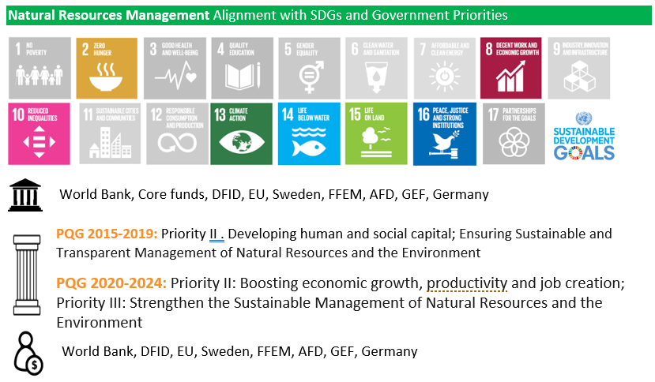

**Key achievements**

The UN continued to promote good governance of natural resources and environment. The UN supported the Ministry of Land and Environment (MTA) to finalize a status report on implementation of the National Strategy for Climate Change from 2013–2019. The IWT developed its strategy and drafted its Action Plan. Anti-crime operations to combat IWT were successfully conducted by national authorities, training on Conversation Law took place at the community level in Gorongosa National Park and community rangers’ groups gained more surveillance capacity through new equipment. National and local policy makers, executives and non-governmental actors including from the private sector improved their capacity to combat wildlife crime. Improvements in coordination for natural resource management were achieved with the approval of the co-management agreement in the Niassa Reserve by different government institutions at national and subnational levels.

The new Forest Policy and its implementation Strategy was formulated under strategic and technical support to the National Forestry Directorate and approved by the Council of Ministers. In addition, a National-wide Forest Information System for the administrative monitoring and control of the timber and NWFP value chain was developed. Data management was strengthened with the customized human-wildlife conflict Field App for real-time data collection and sharing in the Gorongosa National Park. The UN also supported capacity building activities[17].

The UN were also engaged in several key areas including: Trainings on awareness about natural resource exploitation, gender and social inclusion, awareness raising on climate change and trainings on climate change reporting were conducted[18]; Biodiversity conservation management tools for strategic biodiversity investments and policy development[19]; and the provision and use of digital infrastructure[20].

**Human-wildlife coexistence strategies in Gorongosa and Niassa Parks**

**In Niassa Special Reserve**, a Human-Wildlife Conflict Team was created and deployed in February 2020 in Mecula town to improve the Human Wildlife Conflict (HWC) response capacity to respond to problem animals, when requested by the affected community. This team works together with the local Administration to respond to HWC incidents. Human wildlife conflict mitigation activities also included setting up a hotline for the local communities to report conflict incidences as they occur, establishing an incident report and registry system, updating the maps of HWC hotspots and installation of electric fencing and green fences in productive agriculture areas. The competition over water resources often leads to HWC and is also a major cause for water-borne disease, thus, mitigating conflict is an important activity for the communities.

**In Gorongosa National Park,** the team is hiring six community-based coexistence collaborators who are all women. An initial group of 12 women candidates was selected. They are currently undergoing training and evaluations. The Conservation team built and launched a new customized Human Wildlife Conflict Field App on Blackview smartphones that the team utilizes in the field for real-time data collection data on conflict incidents, activities implemented, and regular monitoring of existing mitigation activities. These data will later be used in Earth Ranger alongside real-time elephant movement data for monitoring and operational purposes.

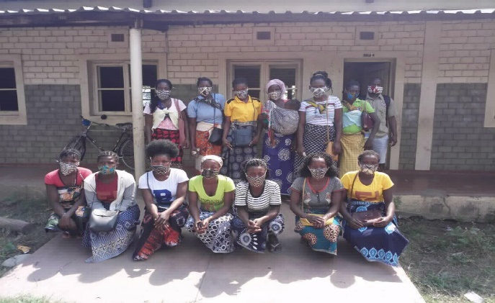

*Gorongosa Restauration Park: Fifteen women collaborators will take ownership of and operate elephant proof fences while producing income-generating profits from honey, produced through 400 beehives*

### **RESILIENCE**

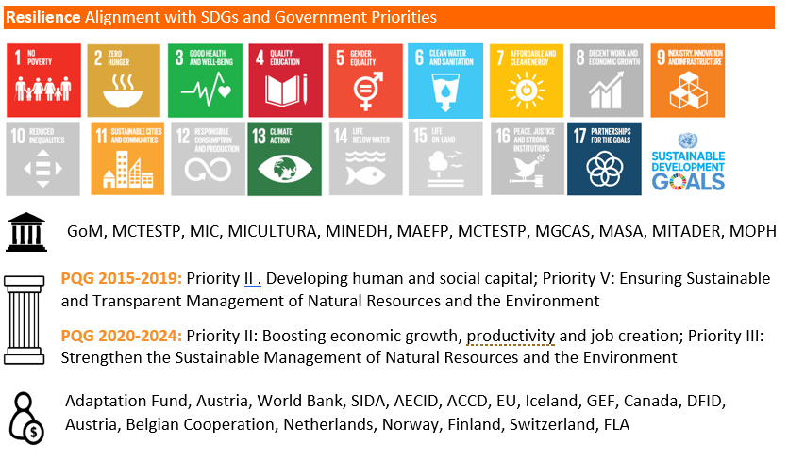

**Key achievements**

The UN supported the National Institute of Meteorology (INAM) to increase its capacity to collect and report climate information[21]; strengthened the Government’s Capacity for Early Warning[22] and enhanced local capacities for climate change adaption and disaster risk reduction[23]. Technical support was provided to CENOE to operationalize the information management system for disaster preparedness and response[24]. Additionally, the UN strengthened the capacity of the Government Reconstruction Cabinet (GREPOC) to manage, monitor and coordinate disaster recovery and capacity of Ministry of Public Works through WASH cluster coordination engagement. The UN was involved in the drafting of guidelines and standards for safe and resilient construction of public buildings in line with BBB principles and contributed to the development of development of the Housing Reconstruction and Rehabilitation Guideline (PALPOC) developed by GREPOC.

Finally, the at the community level, the UN supported farmers to increase adoption of CCA practices[25].

**Building Resilient Communities in Mozambique “Where there is life, there is hope” Resilient House**

*After Cyclone Idai, Cecília Chata Valentim, a young mother, and the seven children under her care were resettled to Mandruzi site to start a life. The UN supports Cecília through new housing and women economic empowerment activities.*

A mud house in a flood plain, describes the home of Cecília, 24, her four children and three orphan nephews lived before Cyclone Idai, which affected 1.8 million people in Mozambique in 2019. “Due to the cyclone, I lost my house and documents. I worked with agriculture and managed to sell my produce, but after Cyclone Idai, I had no money and nowhere to live. I thought about how I could go on with my life to get back to normal”, she recalls.

To start over, Cecília and the seven children moved to the Mandruzi resettlement site, an area designated by the local government as grant land for vulnerable displaced families and set with a neighborhood development plan. “At that time, the important thing for me was that the place was safer and we would have our own space, without having to leave afterwards”, said Cecília, remembering the schools and temporary shelters where they had flee before.

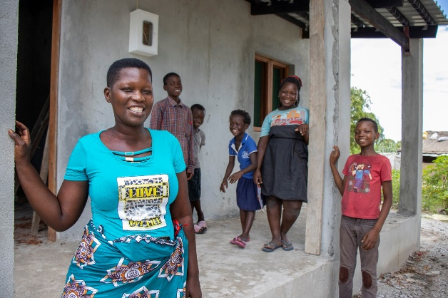

*Cecília Chata Valentim with five of the seven children, in front of the new house under construction. Photo by UN/Brenda Hada*

Today, two years later, the family seeks to build a new life, with the support of organizations. The United Nations is building a house for the family and has promoted several income-generating activities for the head of the family, through the post-cyclone program Mozambique Recovery Facility (MRF), in coordination with Government’s Reconstruction Cabinet (GREPOC), with funds from the European Union, Canada, China, Finland, India, the Netherlands and Norway.

For the first time Cecília and her children will live in cement house, sturdy to withstand climate challenges, and safe in the rainy season. From the backyard of the old house, she has been following the construction work of the new residence since its foundation. “I see the materials they use and there is a lot of difference. It will also be simpler to maintain hygiene, while in the mud house which has no windows the dust never ends.”

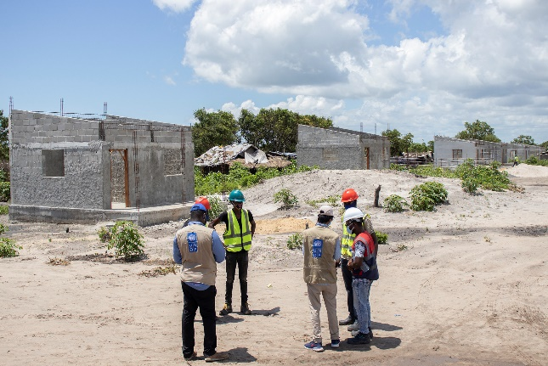

*Single-family resilient houses under construction with a roof-covered area of 34 m2 each. This is a 'evolutionary housing' model in which households can expand the structure or develop new functions for the rooms according to their needs. Photo by UN/Brenda Hada*

The construction of Cecília's house follows resilience standards to endure natural disasters, which are so recurrent in Mozambique. In total, 160 houses are under construction following the same rationale and project in Mandruzi neighborhood by the Mozambique Recovery Facility and are designated to vulnerable families, most headed by the elderly, single mothers, and people with disabilities or chronic diseases.

Through the reinforced roof and window connections made by local bricklayers and artisans under the supervision of engineers and technicians, the construction gains the necessary durability while serving as a learning experience for the community to build better adapted houses. The participation of other community members in the construction includes unskilled temporary work arrangement, such as water collection and meal preparation, to ensure an additional source of income for the community and cohesion among neighbors.

**Resilience in the face of climate shocks**

*“These storms came to bother us, and you never know what might happen, but the community knows how to prepare and is building stronger houses. What happened in Idai cannot happen two, three times… It was very sad”,* she warns.

Cecília's testimony aligns with the facts. From 2019 to 2021, four cyclones hit Mozambique, which further challenged communities' resilience to climate crisis. In each natural disaster, Mozambique loses lives, more infrastructure is destroyed and essential services are disrupted. Disproportionately, it is estimated that, by 2100 the poorest countries in the world could experience up to 100 more days of extreme weather due to climate change each year–Mozambique is one of the ten countries in the world with the lowest human development ([HDI 2020](https://www.undp.org/content/undp/en/home/news-centre/news/2020/Human_Development_Report_2020.html)).

To help build resilience for vulnerable communities in Sofala province, more than 1,100 homes and 18 infrastructures, including schools and markets, are being built and/or rehabilitated by the Recovery Facility, following resilient construction standards (Building Back Better) for the reestablishment of services and the assurance of durable infrastructure, which may serve as shelter for communities in possible future disasters. At least 15,000 people will directly benefit from this initiative.

In addition, to help reduce disaster risk and encourage action within the affected communities, several access roads (960 km) and drainage ditches (8.5 km3) have been cleared through temporary work with cash-transfer (cash-for-work).

**Livelihoods to create resilience in future disasters**

Despite the trauma she experienced with the cyclones, Cecília remains moved by the responsibility of taking care of her children and, designed a work routine in which she manages to “save money so that the children live more comfortable”. “I am both the mother and father to them. I have to work so they don't feel bad because they are missing something,” Cecília explains.

The resumption of her income accelerated from July 2020, when the young mother started to participate in the Mozambique Recovery Facility’s cycle of activities with focus on women economic empowerment and livelihood recovery. She received an agricultural kit of seeds and tools and a duck rearing kit, participated in village savings and loan associations and engaged in cleaning drainage ditches in the neighborhood and in building the community’s waste management and treatment center.

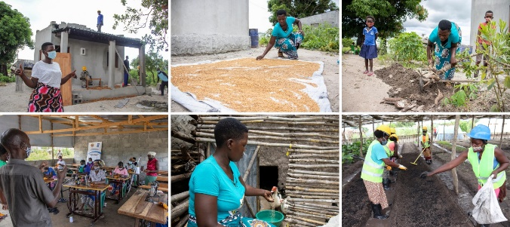

*Cecília during her routine of working in the community and taking care of her children. Photo by UN / Brenda Hada*

The young woman also received training on the production of organic fertilizers (biological charcoal and composting), on entrepreneurship and tailoring. Such activities promoted by the MRF program, in addition to reduce poverty, help reduce disaster risk and encourage sustainable actions adapted to the reality of women, so that they become multiplier leaders of these initiatives in the community in view of climate change.

Cecília's participation in economic empowerment activities has energized her life; she takes advantage of the tools and knowledge acquired to sustain her family and help her community. She planted rice, corn and sweet potato in her garden, flowers and other vegetables in the community crops using the fertilizer produced, and her ducks hatched two nests. Amid this routine, she was able to finish her studies in basic education, in the same school that sheltered her during Cyclone Idai, another milestone from her tireless effort.

Aware of the importance of her community, Cecília concluded by saying: “I would like to mobilize and sensitize other people, neighbors, so that they do not lose hope. Everything is a process. Where there is life, there is hope”.

**Key Constraints**

During 2020, the most significant constraint to the implementation of planned activities is COVID-19, identified as a key constraint in all Outcomes. It resulted in changes (and in many instances a slow-down) in the implementation of programmes, reallocation of regular budgets, increased implementation costs, adaption of implementation mechanisms to reduce in-person events, expansion of the timeframes required to implement activities and pressure on the human and financial resources required. With regards to education, COVID-19 resulted constraints such as learning losses among students from vulnerable families and a lack of access to media channels for remote learning for most students (Outcome 3).

In relation to health, the impact of COVID-19 on the health services is significant, resulting in already-limited resources and compromising the availability and quality of services and the workforce (Outcome 6). COVID-19 restrictions negatively impacted on a timely and wider capacity building initiatives (Outcome 7). Furthermore, COVID-19 restrictions caused significant challenges to women entrepreneurs to carry out their business and school closure represented and extra burden and increase in household demands (Outcome 10).

The crisis in Cabo Delgado has also been a significant challenge to the implementation of activities across many Outcomes. Key constraints include decreased physical access in some areas, a lack of access to education for displaced children, concomitant outbreaks of COVID-19, measles, cholera, limited access to sexual and reproductive health services, increased poverty, inequality and resulted in deficient access to basic services and increased risk of sexual and gender based violence affecting youth, girls and women, particularly in the context of military conflicts.

Furthermore, across five Outcomes issues related to working with institutional partners are noted as key constraints, including changes to government structures after the 2019 elections (Outcome 1), changes in government mandates and consequent reengineering of institutional set-up (Outcome 2), the decentralisation process and new Government structures (Outcome 4, 8), coordination mechanisms at local level (Outcome 10).

Across Outcomes, constraints surrounding policy, data and research are evident. These include issues of reliable data for evidenced-based policymaking and planning (Outcome 2), misalignment of policy making with fast-paced urbanisation and socioeconomic changes (Outcome 2), the necessity of robust monitoring and evaluation systems, in particular to monitor UPR recommendations (Outcome 7), limited political leadership and coordination buy-in due to limited understanding of the social and development impact of demographic trends (Outcome 7) the postponement of studies planned for 2020 (Outcome 9 & 10). Resource mobilisation is also a key constraint in two Outcome groups (Outcome 6 & 8).

There were also some key constraints specific to outcome groups including poor infrastructure and equipped rooms to attend to GBV victims, insufficient mental health professionals and a lack of appropriate GBV monitoring registers (Outcome 4). Similarly, issues around infrastructure are also evidenced in relation to resilient housing and public infrastructure resilient recovery need to be scale up (Outcome 10). Issues in the operationalisation of social protection in the Multi-sector response plan to COVID-19 including the expansion of the programmes to include more beneficiaries, correct implementation of the programme in parallel with the emergency programme, compliance of identification and verification of PASD-PE beneficiaries with eligibility criteria and issues surrounding payment mechanisms are also identified (Outcome 6)

### *2.3 Support to Partnerships and Financing the 2030 Agenda*

**Example of innovative partnerships in advancing efforts to achieve 2030 Agenda/SDGs**

Partnerships with the International Community in Mozambique: In 2019, the UN was requested by the Development Partner’s Group (DCP) to chair its Secretariat, a reflection of the UN’s positive perception in the country further to the reform. Under the RC’s leadership, the secretariat led a process of consultation with DCP at the HOC and the HOM level to ascertain what would be the focus for the DCP as it headed toward the end of 2020 and into a new year.

Through the secretariat, the UN has supported the DCP’s response to COVID-19 pandemic by ensuring that the DCP is provided with regular situation reports and by supporting the coordination between the OCG (Task Force on COVID-19) and the DCP. It has also coordinated the development of a COVID-19 Resource Tracker to capture the financial response of the international community to COVID-19. The result was the endorsement of the DCP mandated with focus on action and deliverable results and an agreement on the priority themes.

In her role as the Head of the Secretariat for the DCP, the RC has been instrumental in proposing a renewed focus on the theme of "Macroeconomics, fiscal management and Financing for Development". A new ‘coalition' of specialist agencies, institutions and cooperation partners (and members of the DCP) have formed to look at supporting this theme, in part through renewed and developed relationships with IFI's (the IMF, WB, AfDB, for example, are all members).

The RC also participated in the high-profile political dialogue platform on COVID-19, representing the UN and contribute UN convening power and policy dialogue with authorities on health, social protection, macro-fiscal space, the private sector and education. The members of the ICCT include ambassadors from member states with the largest development portfolio in Mozambique, IFIs and the UN.

The UN extended its partnerships forged particularly during the pandemic, bringing innovation such as with: JHU to produce BCC manuals, Helpcode that in partnership with VODACOM is setting-up e-Voucher platforms, with FSDMOZ to set-up a GBV Reporting Platform - USSD & Voice and support to Linha Verde, free inter-agency humanitarian assistance/feedback hotline, in the context of COVID-19 to address the lack of a GBV hotline in the country, through training of operators, and working to make a closer link (Outcome 4).

Importance of enhanced coordination amongst development partners and the UN in providing technical and financial support to the GoM: the design of the COVID-19 Social Protection Response Plan was led by the Ministry of Gender, Children and Social Action, and had the support of development partners and UN agencies in a coordinated and harmonized manner, through the Technical Advisory Group (TAG) for the COVID-19 response, constituted by three UN agencies and three Development Partners, making possible to raise additional financial support to implement Social Protection Response Plan to COVID-19 (Outcome 5).

Civil society involvement: the COVID-19 Social Protection Response Plan involves significant participation from Civil Society Organizations (OSC) and community-based organizations for the implementation of the COVID-19 PASD-PE. The active engagement of OSC is seen as fundamental for the identification and verification of potential beneficiaries, as well as for plan monitoring, channeling any beneficiary complaints and claims, to ensure effective and agile implementation of the Response Plan. The UN Agencies supported effective and active engagement of NGOs to monitor Social Protection Response Plan to COVID-19 in Mozambique (Outcome 5).

The partnerships with CSOs and CBOs particularly Community Based including Organizations of Women and Youth, Mainstream and Community Media particularly the National Institute of Social Communication, Faith-based organizations, Traditional and Religious Leaders, Community influencers, Ministries of Gender, Interior, Health and Justice and the Private sector and celebrities remained crucial to the advancement of gender equality especially in relation to awareness and mobilizing communities and key actors to prevent Gender Based Violence. The partnership with the private sector (BCI) and Mobile Phone Operators enabled an expanded outreach of messages on prevention of GBV using ATM during the 16 days of activism, which contributed to increase awareness of millions of clients all over the country from rural to urban targeting diverse population groups.

The UN has signed a comprehensive Memorandum of Understanding (MOU) with the Commercial and Investment Bank (BCI) in 2020. The MOU envisages, among other areas of cooperation, to promote the access of women and young women to financial services (including preferential credit and insurance for agriculture, livestock, agro-processing and non-farm commercial initiatives). It is expected that the gender gap in the access to climate resilience related financial services is narrowed (Outcome 10).

MoU between UN, GREPOC and UEM has been signed with the purpose of establishes a formal collaboration between the Parties in the development of technical assistance activities for GREPOC and the national, sub-local and local institutions of the housing and human settlements sector, as well as cooperation partners wishing to operate in the area of housing recovery, providing expert advice and orientations related to physical planning and spatial planning as well as the resilient reconstruction of infrastructure and buildings affected by cyclones Kenneth and Idai. GREPOC has requested UN-Habitat technical assistance for the Resilient Housing reconstruction in areas affected by Cyclones Idai and Kenneth (Outcome 10).

The MRF also is involved a partnership with the academic institution UniPiaget to train 50 undergraduate engineers and architects and 12 lecturers to supervise the construction quality and ensure resilient construction techniques, BBB principles and also to provide knowledge sharing and learning opportunity to the interns in a practical ground with local ground reality (Outcome 10).

**Realignment of Government expenditure towards SDS (being climate sensitive/gender sensitive)**

In addition, the UN also supported MITSS on the development of Pro-Employment Budgeting (PEB) analysis including the adoption of employment indicators designed by the project MozTrabalha (outcome 2).

The Ministry of Economy and Finance (MEF) has advanced in improving its capacity to track expenditure on environment and climate change in the public financial management system. A study provided findings to improve the budget coding in the State Financial Administration System (SISTAFE). This new coding will help policymakers and managers to track and allocate budget to address climate change and environment protection more effectively. The environment and climate budget tracking must be integrated in the new sub-programme for planning and budgeting (SPO). SOP and its manual (MPO) were elaborated in 2019. In 2020, testing of the SPO in e-SISTAFE was undertaken along with capacity building at the central level and in Gaza and Maputo provinces. (Outcome 2)

**Strengthening procurement**

**Domestic, international, private, and public financial floors of other stakeholders realigned with the above**

### *Results of the UN Working more and better together: UN Coherence, Effectiveness and Efficiency (2 pages)*

* **How the tailored UNCT configuration resulted in a more relevant and effective delivery? N/A**
* **Use of joint work plans, results groups, and other innovations to reduce transaction costs**
* **More and better policy advice by the UN to the Government**
* **Communicating and advocating together**
* **Implementation of the BOS**

### *Evaluations and Lessons Learnt*

In 2020-21 the UN has conducted the UNDAF evaluation aiming at **assessing progress made towards the results formulated** and provide lessons and recommendations for the future programme and activities of the UN in the country. The evaluation undertaken serves two main purposes: i) to support greater accountability of the UNCT to UNDAF stakeholders for the achievements and non-achievements of agreed results in support of the PQG; ii) to support greater learning and improve planning and decision-making. The evaluation used the standard set of evaluation criteria across all UNDAF evaluations, namely Relevance, Effectiveness, Efficiency, Impact, Sustainability, as well as aspects of Coordination and Coherence, and the Lessons learned. The main conclusions, lessons learned and recommendations, drawn from these findings, are as follow:

Relevance

* The UNDAF is aligned to the Mozambican context of the time it was drafted and has developed a theory of change accordingly. It is not, however, aligned to all government priorities.
* A human rights-based approach and gender equity as well as the other programming principles were used to design the programme and make it more relevant.
* The UNDAF structure is relatively broad and wide while at the same time the SDGs are not evident.
* The UNDAF did not anticipate the extensive humanitarian crises that the country has been facing in recent years – cyclones, violence, and displacement – as well as the cuts of international donor support as a reaction to the hidden-debt scandal. In both cases, the UN could respond effectively.

Effectiveness

* Budget execution is low, around 57%, with some Outcomes performing much better than others and only Outcome 3 (Gender) has fully executed and almost doubled (194%) the projected budget. In terms of budget execution performance, Outcome 3 performance is followed by Outcome 9, on Natural Resources management (89%), Outcome 7 on Youth (74%), and Outcome 5, on Social Protection (60%). Outcome 2 (Economic Transformation) and Outcome 10 (Resilience) were the outcomes that performed worse in terms of budget execution with 39% and 33% respectively.
* The UNDAF was able to adapt to quick changes and still perform and manage additional resources provided for the emergencies (but not budgeted in the UNDAF).

Efficiency

* Efficiency was affected by changes, crises and namely by the absence of an appointed RCO for around nine months. But while the activities ‘on the ground’ were generally affected by the multiple crises, the normative work continued.
* UN programming principles were considered and mainstreamed in the chain of results and the harmonisation measures at the operational level contributed to improved efficiency and results.
* Bureaucracy and administrative procedures still have negative effects in the implementation of the UNDAF.
* The resources allocated were generally adequate and extra funding was even received (although the latter was used specifically for emergency work).

Impact

* Direct impact in emergency work is highly recognised by the partners.
* For the period 2017-2021, impact directly resulting from the activities planned in the UNDAF is foreseen to be reduced given the important disturbances and constraints brought by the several crises.

Sustainability

* Sustainability of the results was not sufficiently clear in the design of the UNDAF, although recurrently mentioned as an objective.
* The weight of the efforts in emergency work compromised sustainability.
* The continuous decrease in government budget allocations to social areas can put the sustainability of large investments done by the UN at risk.

Coordination

* The Delivering as One (DaO) approach to Mozambican development was consolidated throughout the programme, particularly through the joint activities targeted at emergencies that brought closer the joint work.
* Mechanisms and systems have helped improving coordination, such as the UNINFO system but also the process of preparation of the UNDAF.

Coherence

* The participation of agencies in thematic Working Groups with multiple national and international partners provides the opportunity for improved coherence and alignment to development work in the country.
* UNDAF alignment to all government priorities is not always visible.

The analysis and recommendations of the evaluation are expected to inform the formulation of the new UNSDCF (UN Sustainable Development Country Framework), the ‘new generation’ of UNDAF programming.

Relevance

* Review reassessed government priorities through consultation of ongoing review mechanisms and address new needs, namely, to allow flexibility in contexts of emergencies. Clearly recognise problems like corruption, which is not in the current UNDAF, or the debt, which is real, and assure that emergencies are clearly considered in the design, most particularly the conflict in Cabo Delgado, which will require UN’s political involvement at higher level and peacebuilding and counterterrorism instances too; and the expected prolonged COVID-19 crisis.
* Build from programmes with good results and where the UN brings added value. These include not only the gender equity and human rights-based approaches but also those targeting the youth and expand them to more comprehensive work in the area of employment, new technologies and capacity building.
* The UNSDCF needs to make the SDGs more evident and at the same time concentrate the Outcomes in fewer areas. A more focused scope of intervention areas, demanding less efforts of coordination, is likely to foster more involvement on the part of the agencies in Mozambique and signal reduced dispersion of efforts.

Effectiveness

* Until the end of the current UNDAF, the UNCT will have to monitor and closely follow-up the results still to be achieved. The extension of the cooperation framework may help achieving higher performance levels given that incomplete activities will spread for another 12 months and therefore this opportunity should be seized through monitoring of the activities still to be completed.
* To allow increased and improved flexibility, the UNSDCF will have to anticipate the main risks and trends at the economic and political levels. Concentrating the Outcomes and aligning to the SDGs should be done simultaneously with a clear allocation of resources to emergency and crises.

Efficiency

* The next UNSDCF will have to be more flexible to absorb (foreseen) new changes in the context of Mozambique. On the one hand, this calls for more decentralised work to attend the humanitarian issues more efficiently, in the provinces where natural disasters are more frequent or in those affected by violence and insecurity.

The joint work of the UNCT requires improvements in systems and procedures, as well as in terms of the human resources available. There is a need to continuously improve the systematic use and updating of the UNINFO system for improved planning, implementation, and monitoring. The UNCT needs to improve efficiency in general to deliver the UNDAF, namely in what concerns disbursements or supporting implementing partners for more efficient reporting.

Impact

* The combination of emergency work with a continued focus on UN’s strategic areas is desired. Both short and long-term impact activities need to be prepared for the next UNSDCF, as the framework needs to anticipate the prevalence of issues such as consequences of the COVID19 pandemic and of the armed conflict in Cabo Delgado.

Sustainability

* The UN needs to strategize sustainability more clearly in the next UNSDCF. The next framework should build from good experiences that already proved to be sustainable, such as the continued work in the areas of youth and reproductive health and take in consideration recurrent and long-term needs of the government and beneficiaries.

Coordination

* The preparation of the new UNSDCF should take momentum from the good practices developed for emergency work. These can be mobilised for planning, implementation and monitoring and evaluation.

Coherence

* Agency and joint participation in multi-stakeholders thematic and task groups should continue, as well as more collaboration with government. The programme can absorb lessons from joint work/project implementation and use it to plan and revise the work with other development partners in the country. The work with the GoM should be constantly aware of the need to improve the visibility of the UNSDCF alignment to government priorities, assuring that all or almost all government priorities are integrated in the framework.

### 

### *Financial Overview and Resource Mobilization*

1. Financial Overview

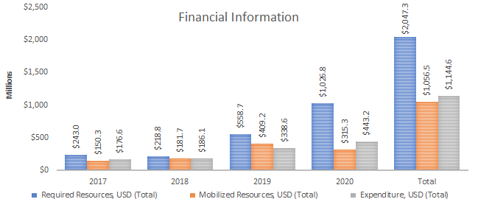

Together with more than 50 financial partners, over USD $1.05 billion has been mobilized for the UNDAF out of a required USD $2.04 billion, representing 48% shortfall in required resources. Outcome 1, Food security and nutrition, Outcome 6, Health and Outcome 3, Education have mobilized the largest amount of resources.

1. Resource Mobilization

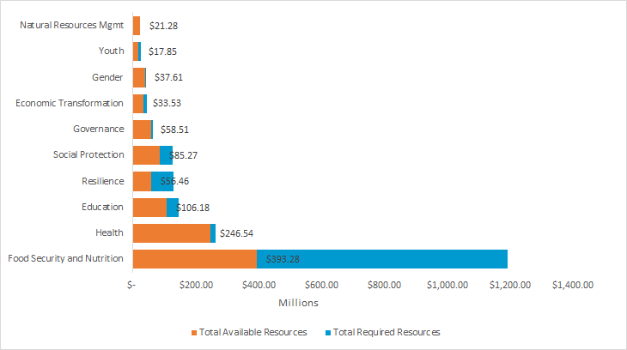

In partnership with more than 40 government institutions and over 80 non-government partners, 423 programmes have been implemented under the UNDAF. Without the leadership of the government institutions and the partners for their collaboration and advice, the UN would not have successfully been able to make the progress it made, nor advance the sustainable development of the country as it has. The UN stands jointly to deliver as one and to help accelerate the sustainable development of Mozambique.

# **CHAPTER 3: UNCT Key focus for next year**

* Staring new cycle or consolidated winding up the current cycle
* Direction of key results as well as risks for next year, based on the development in country context in current year and expected in next year, e.g. Covid-19 pandemic, conflict in Cabo Delgado and IDPs, economic crisis, etc.

This year started with Mozambique’s first new generation CCA process and the formulation of the CCA document. The process started on the basis of 4 issues papers that were prepared by 4 inter-agency group (Planet, Prosperity, People and Peace).

The process will naturally include training sessions and consultations with the inter-agency Joint Support Group, with the Civil Society (including academia, CSOs, labour unions and business associations) and with Government, while maintaining CCA’s nature as UN’s independent and impartial analysis of Mozambique’s critical issues and opportunities for 2022-26.

A key risk will be to manage the UN entities’ varying levels of knowledge and attitudes towards UN reform and the new generation CCAs and UNSDCFs (henceforth CF). Three UN entities (Unicef, UNFPA and UNDP) are developing CPDs this year, coincident with the formulation of the CCA and the CF. Many senior staff from UN entities are new to the country.

Another key risk comes from the fact that the previous framework (the last UNDAF) was extended by one year. As a result, in 2020 the first Volunteer National Review (VNR) took place, yet in the absence of a CF. The Government defined a SDG National Indicator Framework, that excluded SDG 12 and key indicators of other SDGs, in the absence of a strategic design exercise, namely the CF, therefore prior to jointly defining a Results Framework as part of the CF. This will require fine-tuning the SDG National Indicator Framework and the CF so that the nationalization of Agenda 2030 truly reflects strategic priorities.

Relevant UN-internal groups like the M&E group and the Programme Management Group will provide inputs and reviews. The CCA draft will be submitted to UNCT and Regional Peer Support Group for review and endorsement. Thereafter the process for the formulation of the Cooperation Framework (CF) will start.

The Government has been generally successful in preventing the expansion of the COVID-19 pandemic in Mozambique, with support from international partners, especially in the socioeconomic response. Nevertheless, the risk of the pandemic expanding more widely, as it has in neighboring South Africa, remains possible. The roll-out of the vaccine will be key to mitigating the risk of expansion. The country will require support from Covax and other mechanisms (for example ECA) to acquire sufficient vaccines for a relatively large population compared to other countries in the region (30 million in 2020).

Another crucial challenge will be the status of the conflict in Cabo Delgado Province. This has caused a humanitarian crisis and has perpetuated the “crisis mode” the Government and many development partners adopted since the 2019 cyclones, thus forgoing a longer-term sustainable development focus. The Government has signaled interest in support from the EU and the US. However, the role of the Southern African Development Community and of the United Nations will be key to unlock effective and holistic responses to the conflict that consider both security and socioeconomic dimensions.

Despite a relatively contained impact of the COVID-19 pandemic on the population, Mozambique’s vulnerability to global commodity prices and the slump in global demand resulted in a fall of exports (extractives, manufacturing and agricultural) and confinement measures hit the services sector hard. The economy performed well below forecasts by the IMF and WB, shrinking by 1.3% in 2020 and poverty has been estimated to increase, especially urban poverty, as well as unemployment in urban and peri-urban areas, especially the informal sector. In 2021, recovery of the external sector will hinge on the speed of vaccination rollouts worldwide to steer global demand. Likewise, the domestic services sector is likely to depend on vaccination roll-out, yet the country has not reported to have adequate vaccines stocks.

The combination of multiple shocks (COVID-19, aggravating conflict, economic recession and one of the highest debt-to-GDP ratios in Africa triggered by the illicit issuance of debt by the previous Government) has uncovered the extent of the vulnerability of the country. Moreover, the country is one of the most vulnerable to extreme weather events triggered by climate change. A chronic short-term focus has not allowed the country to develop the longer-term resilience and prevention capabilities it requires to cope with natural disasters. In 2020 the country was spared of large-scale natural disasters. However, should a natural disaster occur in 2021 it would add to the pressure from multiple concurrent shocks. There is a considerable risk of economic breakdown and ensuing social instability.

# **Annexes**

## Indicators Performance

|  |  |  |  |  |  |  |
| --- | --- | --- | --- | --- | --- | --- |
| **Result Group** | **Number of Indicators** | **Report Rate** | **Low (Below 50%)** | **Average (50%-90%)** | **Good (90%-100%)** | **Excelent (above 100%)** |
| Food Security and Nutrition | 20 | 75% | 27% | 7% | 7% | 60% |
| Economic transformation | 16 | 44% | 29% | 14% | 0% | 57% |
| Education | 13 | 46% | 33% | 0% | 17% | 50% |
| Gender | 14 | 64% | 33% | 22% | 0% | 44% |
| Social Protection | 12 | 75% | 22% | 44% | 0% | 33% |
| Health | 28 | 96% | 7% | 19% | 11% | 63% |
| Youth | 11 | 55% | 0% | 50% | 0% | 50% |
| Governance | 19 | 68% | 23% | 23% | 0% | 54% |
| Natural resources management | 16 | 50% | 25% | 25% | 0% | 50% |
| Resilience | 12 | 58% | 43% | 14% | 0% | 43% |
| **Total** | **161** | **68%** | **21%** | **21%** | **5%** | **54%** |

## Joint Programs

|  |  |  |  |  |  |
| --- | --- | --- | --- | --- | --- |
| **Joint Programs** | | | | |  |
| **Division/Unit/ Sector/office** | **Description of Programme/Fund including thematic focus** | **Lead Agency** | **Participating Agencies** | **Other partners (non-UN) - including private sector, South South, Foundations** | **Total agreement Amount** |
| Child Protection, Social Policy, Evaluation & Research | Joint Programme on Social Protection | UNICEF | ILO | Ministry of Gender, Children and Social Action, National Institute of Social Action, Ministry of Finance, World Bank, Irish Aid. | $22,771,270 |
| Health & Nutrition | Improving sexual RMNCAH | UNFPA | UNICEF, UNFPA, WHO | Ministry of Health, Ministry of Public Works, Housing and Water Resources, National Directorate of Water Supply and Sanitation | $13,479,479 |
| Health & Nutrition | Lean season nutrition response and resilience building | UNICEF, WFP | UNICEF, WFP | Ministry of Health | $3,171,611 |
| Communication, Advocacy & Partnerships | Action for girls and young women's sexual and reproductive health and rights in Mozambique | UNFPA | UNICEF, UNFPA, UN Women, UNESCO, UNRCO | Ministry of Youth & Sports | $3,114,014 |
| Child Protection | Strengthening civil registration and vital statistics | UNICEF | UNICEF, WHO | Ministry of Justice Constitutional and Religious Affairs, Ministry of Health, National Institute of Statistics, University of Toronto, Centre for Global Health Research Save the Children | $11,740,984 |
| Child Protection | Global Programme to accelerate action to end child marriage | UNICEF | UNFPA, UNDP, UN Women, IOM | Ministry of Education, Ministry of Gender, Children and Social Action, Save the Children, FDC, World Vision, WEI, FHI360 | $2,561,209 |
| Child Protection | Support to Social Protection | UNICEF | UNICEF, ILO | Ministry of Gender, Children and Social Action, Mozambican Civil Society Platform for Social Protection, District Office of Health, Women and Social Action | $568,182 |
| Education | Building Resilience through Education and Youth engagement in cyclone affected schools in Mozambique | UNICEF, UN-Habitat | UNICEF, UN-Habitat | Ministry of Education, Education Cluster | $4,694,217 |
| Education | Education cannot wait in communities affected by cyclones and floods in Mozambique | UNICEF | UN Habitat | Ministry of Education, Education Cluster | $3,990,395 |
| Communication, Advocacy & Partnerships | Spotlight Initiative to end violence against children and women | UNRCO | UNICEF, UNFPA, UNDP, UN Women | Ministry of Gender, Children and Social Action | $3,812,322 |
| Programme/Fund Profile and Partners | The Accelerate Progress Towards Millennium Development Goal 1C (MDG1.C Programme) | FAO, IFAD, WFP | FAO, IFAD, WFP | Technical Secretariat for Food and Nutrition Security |  |
| Programme/Fund Profile and Partners | The Livelihoods for Durable Solutions Project | WFP | WFP, UNHCR, FAO, UN-Habitat | Mozambique’s National Refugee Support Institute | $4,459,441 |
| Programme/Fund Profile and Partners | COVID-19 Response | WFP, UNICEF | WFP, UNICEF | Ministry of Gender, Children and Social Action, National Institute of Social Action, Ministry of Finance, World Bank. | $22,000,000 |
| Programme/Fund Profile and Partners | Mitigating and preventing violence in and around hard-to-reach areas through participatory analysis, trust-building and social cohesion in the border region of Cabo Delgado (Mozambique) and Mtwara (Tanzania) | UNDP | WFP, IOM, UNDP | Ministry of Foreign Affairs and CooperationMinistry of Land and EnvironmentMinistry of InteriorMinistry of State Administration and Public FunctionAgency for Northern Integrated Development | 4,306,124 (3,020,000 funded by PEB) |
| Health & Nutrition | HIV-TB Emergency Response to Tropical Cyclone Idai | UNAIDS | WFP, IOM, UNICEF, WHO | H2N |  |
| Health & Nutrition | Enhancing the HIV Response within the Response to Tropical Cyclone Kenneth, Including the Provision of Nutritional Support, Dignified Return and Shelter to HIV/Vulnerable Populations, Cabo Delgado | UNAIDS | WFP | Pathfinder, ICS | $648,637 |
| Health & Nutrition | IOM, UNICEF, WFP & WHO roadside HIV/TB services for key populations, vulnerable groups, and communities in transport corridors | UNAIDS | WFP, IOM, UNICEF, WHO | AMEND and North Star Alliance | $100,000 |
| Food Security | Enhancing Self-Reliance in a Protracted Refugee Situation (Maratane Refugee Community, Mozambique) | WFP | FAO, WFP, UNHCR, UN Habitat | MADER (at Provincial and distrital level), MINT/INAR, Highgest | $4,100,000 |
| Resilience | Resilience building for food and income security in shock-affected areas (PROACT) | WFP | FAO, WFP | MADER/ Direcção Provincial de Agricultura e Pescas | $3,000,000 |
| Health & Nutrition | WFP&UNICEF's joint nutrition relief recovery operation respon Cyclone | UNICEF, WFP | UNICEF, WFP | Ministry of Health | $4,042,251 |
| Education | Growing Safer: Supporting school disaster prevention, building back better reconstruction | UNICEF, UN-Habitat | UNICEF, UN-Habitat | Ministry of Education, Education Cluster | $182,728 |
| Programme Coordination Unit | Provision of tollfree inter-agency reporting for enhanced AAP | UNICEF | WFP |  | $17,512 |
| Social Policy Evaluation & Reseach | Unconditional cash transfers to vulnerable households under the national social protection response to COVID-19 | UNICEF | WFP |  | $500,000 |
| Education | School Feeding under the Education in Emergency Programme financed by the Global Partnership for Education (GPE) | UNICEF | WFP |  | $5,040,299 |
| Child Protection | Support technical assistance to Coalition to End Child Marriage (CECAP) to coordinate CSO activities with government | UNICEF | UNFPA |  | $73,830 |
| Child Protection | Assessing the protection and child protection risks and needs in Cabo Delgado | UNICEF | IOM |  | $105,000 |
| CHN | Enhancing HIV and TB response for displaced and vulnerable populations in Cabo Delgado | UNICEF | IOM |  | $150,000 |
| Child Protection | Pilot intervention in supporting GoM in strengthening reference groups for child protection and combating trafficking in persons | UNICEF | IOM |  | $320,000 |
| Education | Ensuring learning continuity in the context of COVID-19 pandemic: transition from primary to secondary education in Zambeze Province | UNICEF | UNESCO |  | $150,000 |
| Education | Capacity Building on School Infrastructures Reconstruction with BBB Approach in areas affected by cyclones Idai & Kenneth | UNICEF | UN Habitat |  | $300,000 |

1. Specific examples include the establishment of commercial agreements between farmer association and large buyers; nutrition behavior change interventions; food security and vulnerability assessments and IPC analysis of data; analysis of food commodities price incentives; studies on post-harvest losses; and development plans to establish a Food Security and nutrition information system.
2. Specific examples include improved knowledge, attitudes and practices on crop production, seed multiplication, post-harvest handling, marketing nutrition, health and hygiene; increased capacity to reduce post-harvest losses and strengthen market linages, establishment of community seed banks; and rehabilitation of public infrastructure. Furthermore, there were improvements in capacity to adequately monitor and control agricultural and livestock pests and diseases across all levels, as well as strengthen links between farmers and markets.
3. Specific examples include the National Employment Policy (NEP); strengthen the government’s capacity pertinent to improving inter-ministerial and tripartite coordination, information sharing, and effective discussions on pro-employment sectoral policies and supported MITSS on the development of Pro-Employment Budgeting analysis.
4. These include the signing of partnerships with financial and business development service providers, to train and provide financial services to COVID-19 affected SMEs and to promote market linkages; and strengthen the competitiveness of the export sector, to the SADC and EU markets.
5. These include a policy note compiled, on Pro-Employment Policy for post COVID-19 recovery and two technical notes on potential post COVID-19 employment policy reforms. he UN updated the assessment of INNOQ capacity in key Quality Infrastructure areas that are critical for supporting trade, and a baseline study focused on the challenges and opportunities for SMEs and Business Development Services (BDS).
6. Support to develop and coordinate the implementation of an employment projection model through the course “Stata for Labor Market Analysis” to technical officers from various ministries. DNOMT benefited from assistance to develop new applications and modules for the Labor Market Information Systems (LMIS) to process and analyze labor market data. The UN also provided support to upgrade INEP’s Employment Portal.
7. This new policy is a multi-sectorial tool, which builds upon existing mechanism in schools and communities, and takes advantage of the work being done by government and non-government actors to address issues of violence in schools.
8. Activities include: mobilization interventions directed at boys and girls to increase knowledge on discriminatory socio-cultural practices against women; provincial community leaders forums to discuss their role on preventing discriminatory practices; community radios disseminating messages to prevent and fight gender-based violence, using gender transformative approaches.
9. Community leaders increased their knowledge and reinforced their commitment to prevent and combat GBV which resulted in the rescue of 15 girls from early union and the establishment of platforms of these key allies against GBV in 3 provinces. Additionally, community members including traditional and religious leaders, matrons (*Mães da Comunidade*), fathers and local musicians identified ways to work collectively to contribute to the implementation of the existing mechanisms to prevent and respond to cases of GBV.
10. Activities include financial support to purchase and deliver contraceptives; provision of counselling to women and girls to increase their awareness of family planning and provision of mobile brigades delivered sexual and reproductive health care in Tete provinces; support to maternal and child health nurses to complete their training and training of health professionals in obstetric fistula repair. The UN provided equipped mobile health units for woman and girls to receive sexual and reproductive health and gender-based violence services and pre-packaged reproductive health kits and supported MISAU to conduct 2 rounds of Oral Cholera Vaccination following cholera outbreaks.
11. Support was provided to new approaches to treat severe acute malnutrition including community case management and mid-upper arm circumference (MUAC)-only admissions
12. implement a rapid assessment of the impact of COVID-19 on PLHIV, provision of technical and catalytic funding to PLHIV organizations to train activists to ensure continuity of HIV services for ART for patients and distribution of hygiene kits and cloth face masks distributed to ensure continuum of care and distribution of food baskets in Maputo and Matola cities to support PLHIV with unique vulnerabilities.
13. The UN Supported the country policy to fight stigma and discrimination in the workplace and the Legal Environment Assessment for legislation of HIV/AIDS, as well as the Resolution n.28/2020 of 29th April “HIV and AIDS Strategy in the Public Administration II 2020-2024”, the new Penal Code to reinforce the legal framework to improve the prosecution of cases and perpetrators in cases of sexual violence with HIV and AIDS contamination, and with National AIDS Council (CNCS) for national and local level consultations to develop the “HIV and AIDS Strategic Plan 2020-2025”.
14. Including electoral claims and complaints 2003-2019 with the objective of contributing to the strengthening of the electoral dispute resolution mechanism and judicial response to the electoral reform; analysis of women’s participation in the elections to further enhance their participation through gender mainstreaming and development of a strategy for political and electoral processes; and assessment study of the people with disabilities vis a vis the political and electoral processes, aimed at developing a strategy for their inclusion to the future electoral process.
15. As a result CSOs have created a UPR database platform providing a live monitoring tool to effectively monitor and report on a daily basis on the situation of the UPR in the country.
16. Capacity building of Policewomen of Network of Policewoman, aimed at strengthening their capacity to prevent all forms of GBV including a specific type produced within the framework of conflict, post conflict and early recovery. Further achievements on Peace building include the implementation by the CFJJ of a wide dialogue and advocacy among justice institutions including a seminar among justice institutions, academia, FBOs, CSOs on women and youth building peace and community resilience.
17. The MTA carried out a workshop for small scale entrepreneurs on the green economy and financing and commercial viability. The National Resources Management authorities gained coordination capacity with the establishment of an Anti-Poaching Coordination Center with new patrolling vehicles.
18. Community members in conservation areas of Niassa and Gorongosa received training to increase awareness about natural resources exploitation and A two-day course for 23 journalists on climate change was carried out. The Gorongosa Park commissioned a Gender and Social Inclusion Assessment in 7 communities in the Gorongosa District resulting in a training session on gender and social inclusion to facilitate the implementation of specific activities based on findings. The MTA prioritized the area of awareness and education through television programs on different aspects of climate change.
19. New regulation tools were adopted to implement biodiversity offsets. A dedicated Biodiversity Finance and Resource Mobilization Unit was established in the MTA to improve economic planning and budgetary planning and revenue generation for biodiversity conservation. Planning, monitoring, and reporting in biodiversity conservation and sustainable use was also informed by independent peer-review through an Environment Impact Assessment.
20. ANAC reinforced its digital infrastructure and gained capacity for data management to optimize its operations, including the biodiversity conservation database and revenue collection and management systems. Staff from protected areas were equipped with new knowledge and normative tools in technical administrative areas. Finally, the first metrics to measure results of biodiversity offset mechanisms for mangrove ecosystem were defined at national level.
21. Through the rehabilitation of two weather station and installation of 9 new weather stations. The data generated is being used by the Gaza provincial branch of INAM and by the District Services for Economic Activities (SDAE) to produce the Meteorological Bulletin for Agriculture and agrometeorological bulletins.
22. Through the installation of community sensors along rivers
23. Through the establishment and equipment of 4 Disaster Risk Management School Committees (CEGRD) to support preparedness, prevention, mitigation, response and recovery activities at school levels.
24. Including data uploads, rapid field diagnostics on data collection process and information flow and training of provincial information officers to familiarize with the platform
25. This included training on CCA practices, community Seed Banks were established, and support to implement climate resilient micro-projects. Exchange of technical information, demonstrations, exchange of experience among actors, field days were also organized under the umbrella of the Conservation Agriculture platform.