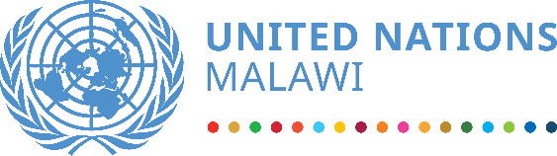

Malawi SDG Acceleration Fund
2022 ANNUAL REPORT

Table of Contents

Acronyms and Abbreviations…………………………………………………………………………………………………………….3
- Introduction……………………………………………………………………………………………………………………………………5
1.1 Strategic Framework…………………………………………………………………………………………………………………5
1.2 The Malawi SDG Acceleration Fund.………………………………………………………………………………………….6
  - Operation of the Fund....………………………………………………………………………………………………………….7
1.4 Cross Cutting Approaches…………………………………………………………………………………………………………9
2.Results of the Fund in 2022.…………………………………………………………………………………………………………….9
2.1 Overview of Country Context in 2022……………………………………………………………………………………….8
2.2 Overall results………………………………………………………………………………………………………………………….10
2.3 The Fund’s Programmes in 2022………………………………………………………………………………………………14
2.2 Programmes Description.…………………………………………………………………………………………………….17
Malawi Partnership for Resilience (MP4R/PROSPER).………………………………………………………………….17
UN Joint Programme on Health Systems Strengthening for Equitable Health Outcomes…………….21
UN Joint Programme on Girls’ Education III: Learning for All in Malawi……………………………………….24
Joint Action addressing GBV, Child Marriage, and Teenage Pregnancy………………………………………..28
Border District and Community-Based Conflict Prevention and Peace Building in Malawi……………31
UN Joint Programme- Learning Never Stops….…………………….………………………………………………………33
Malawi National COVID-19 Vaccine Programme….………………………………………………………………………36
UN Joint Programme- Cash Assistance and Livelihoods Support to Refugees.………………………………38
3. Conclusions…………………………………………………………………………………………………………………………………..40
4. Recommendations…………………………………………………………………………………………………………………………...40

CONTRIBUTORS
Belgium Canada Iceland Ireland
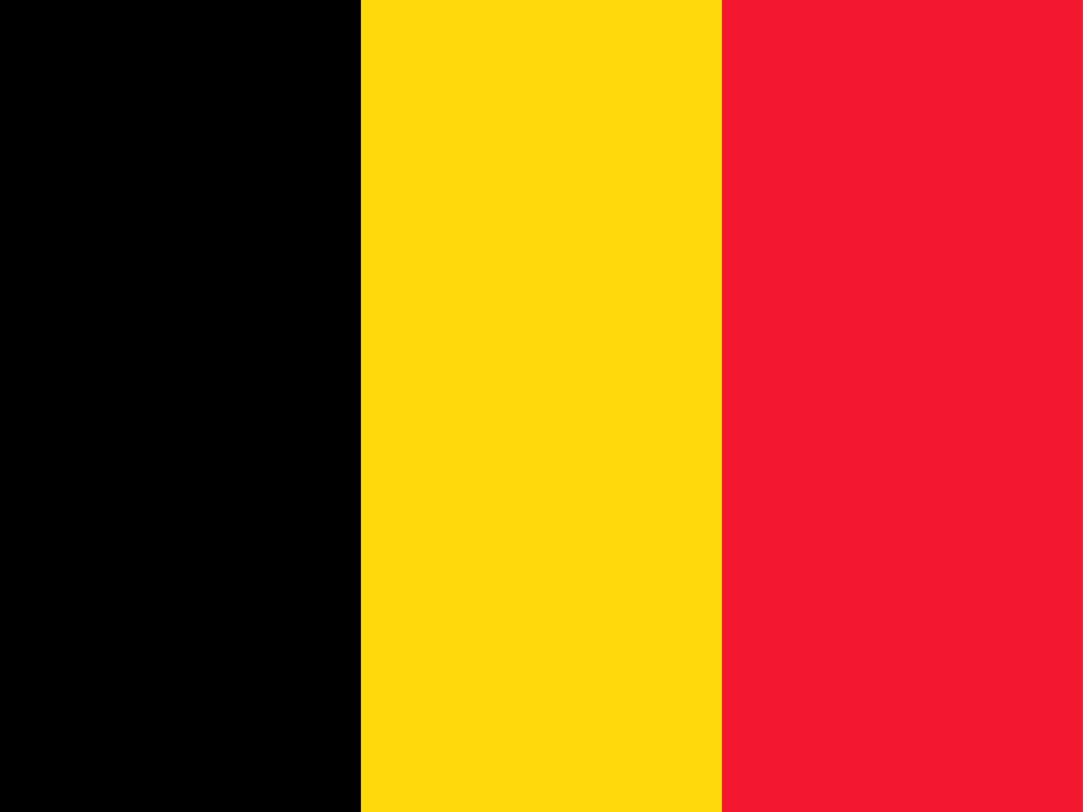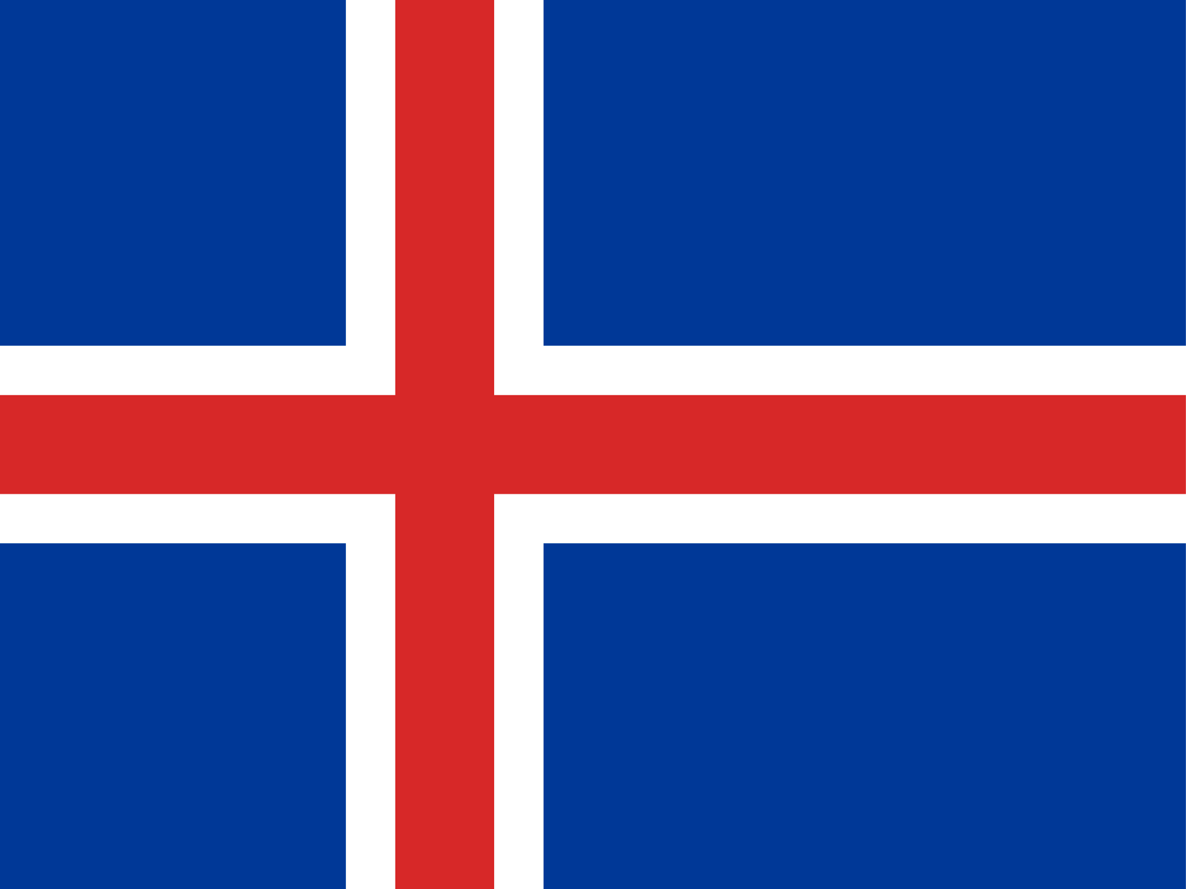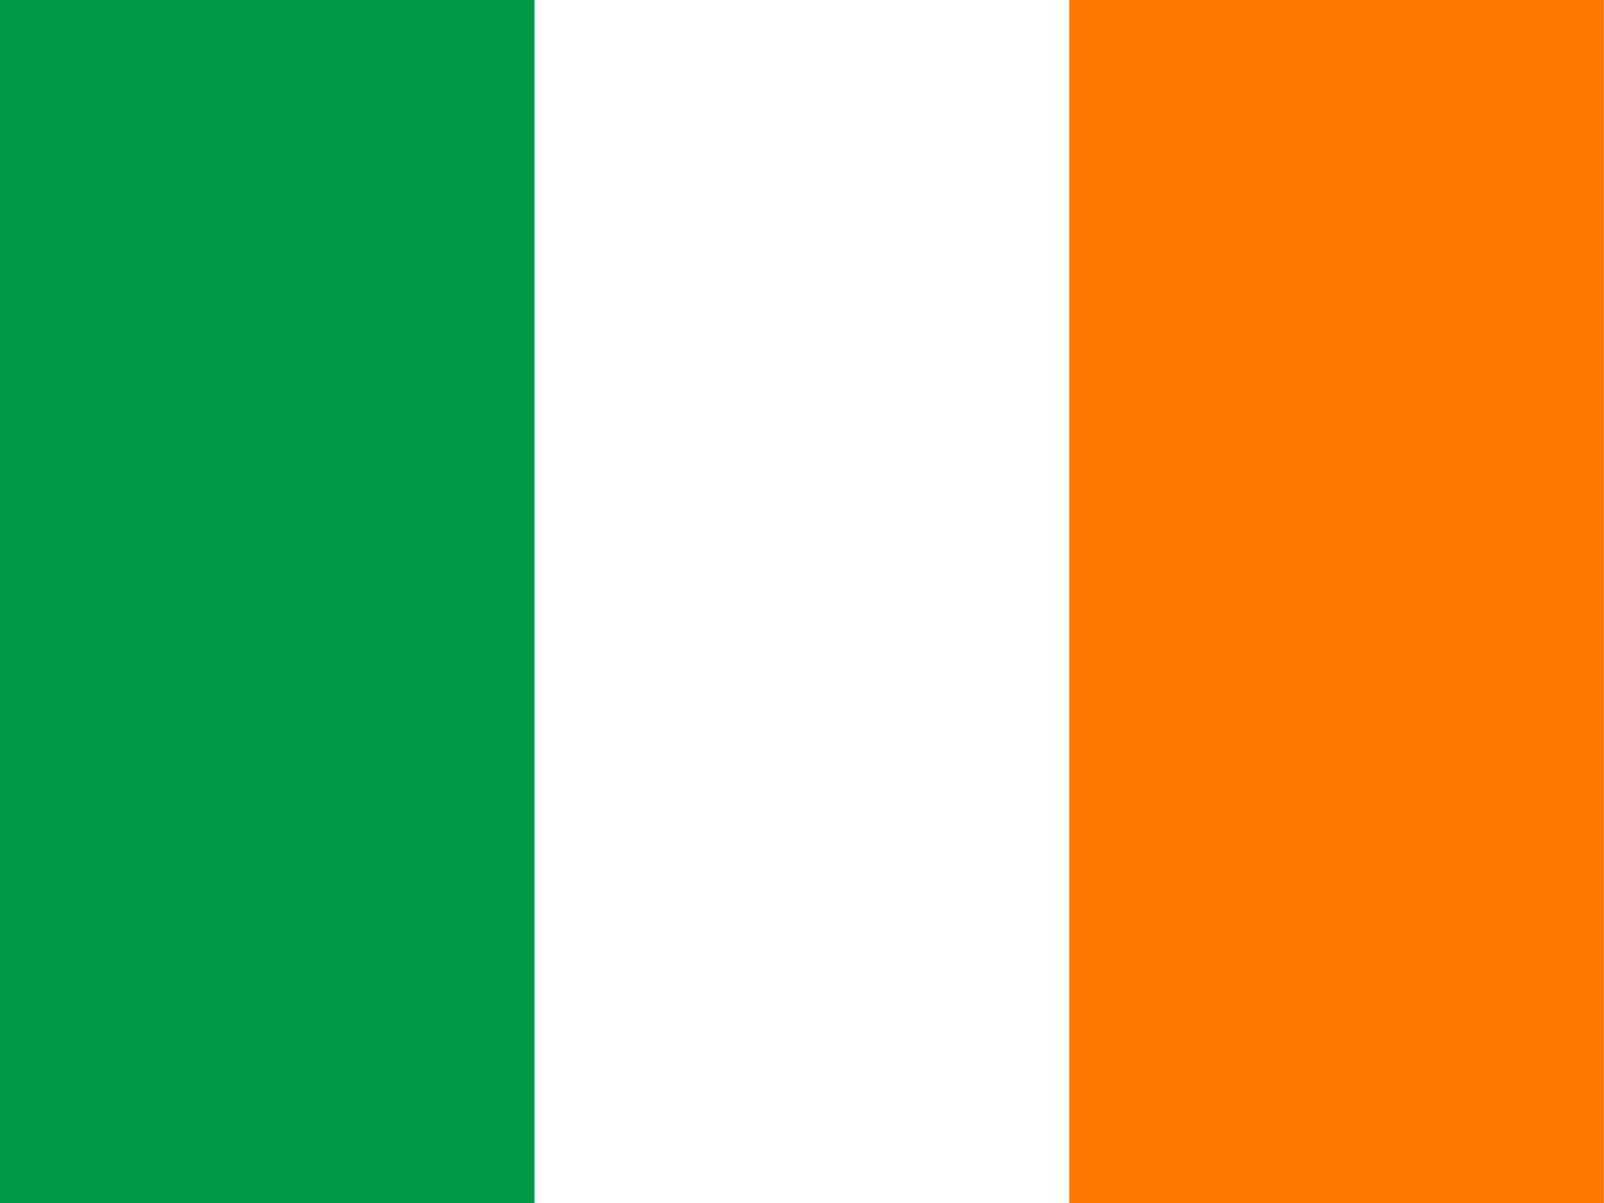
Norway Romania United Kingdom
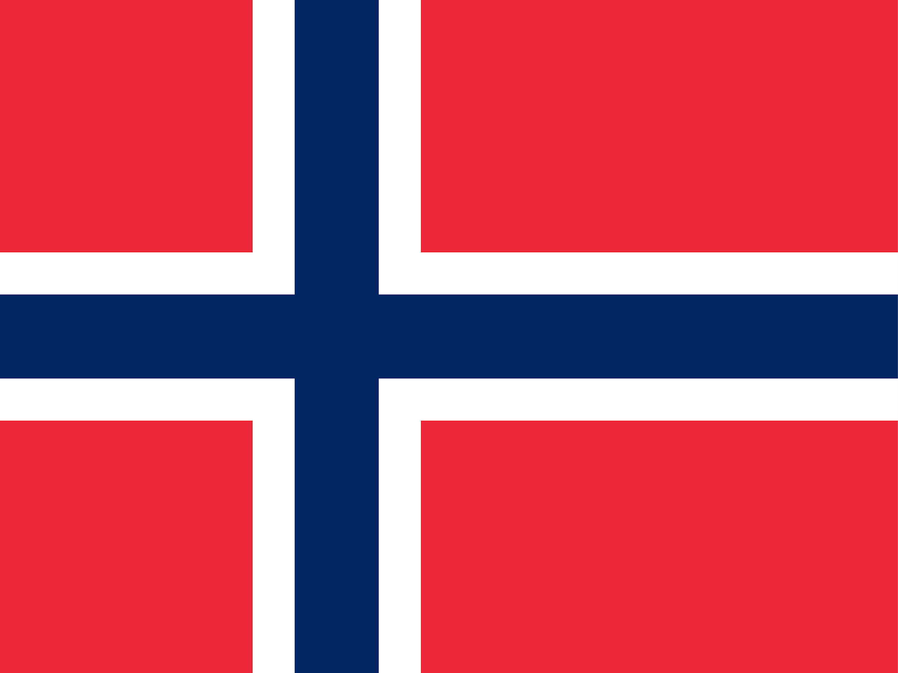

UN PARTICIPATING AGENCIES
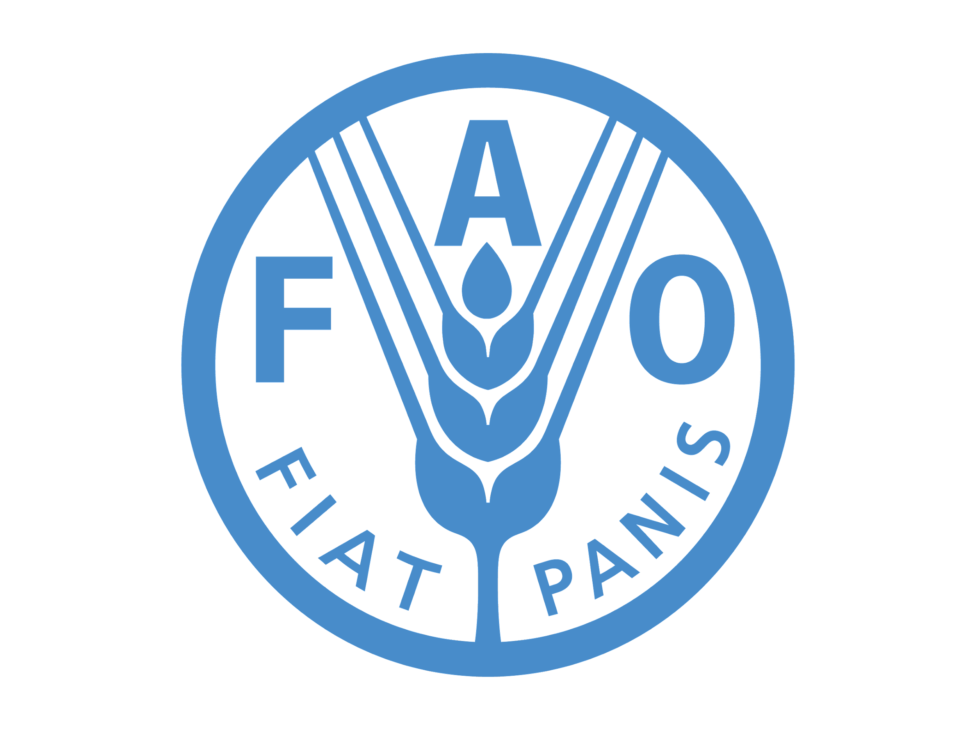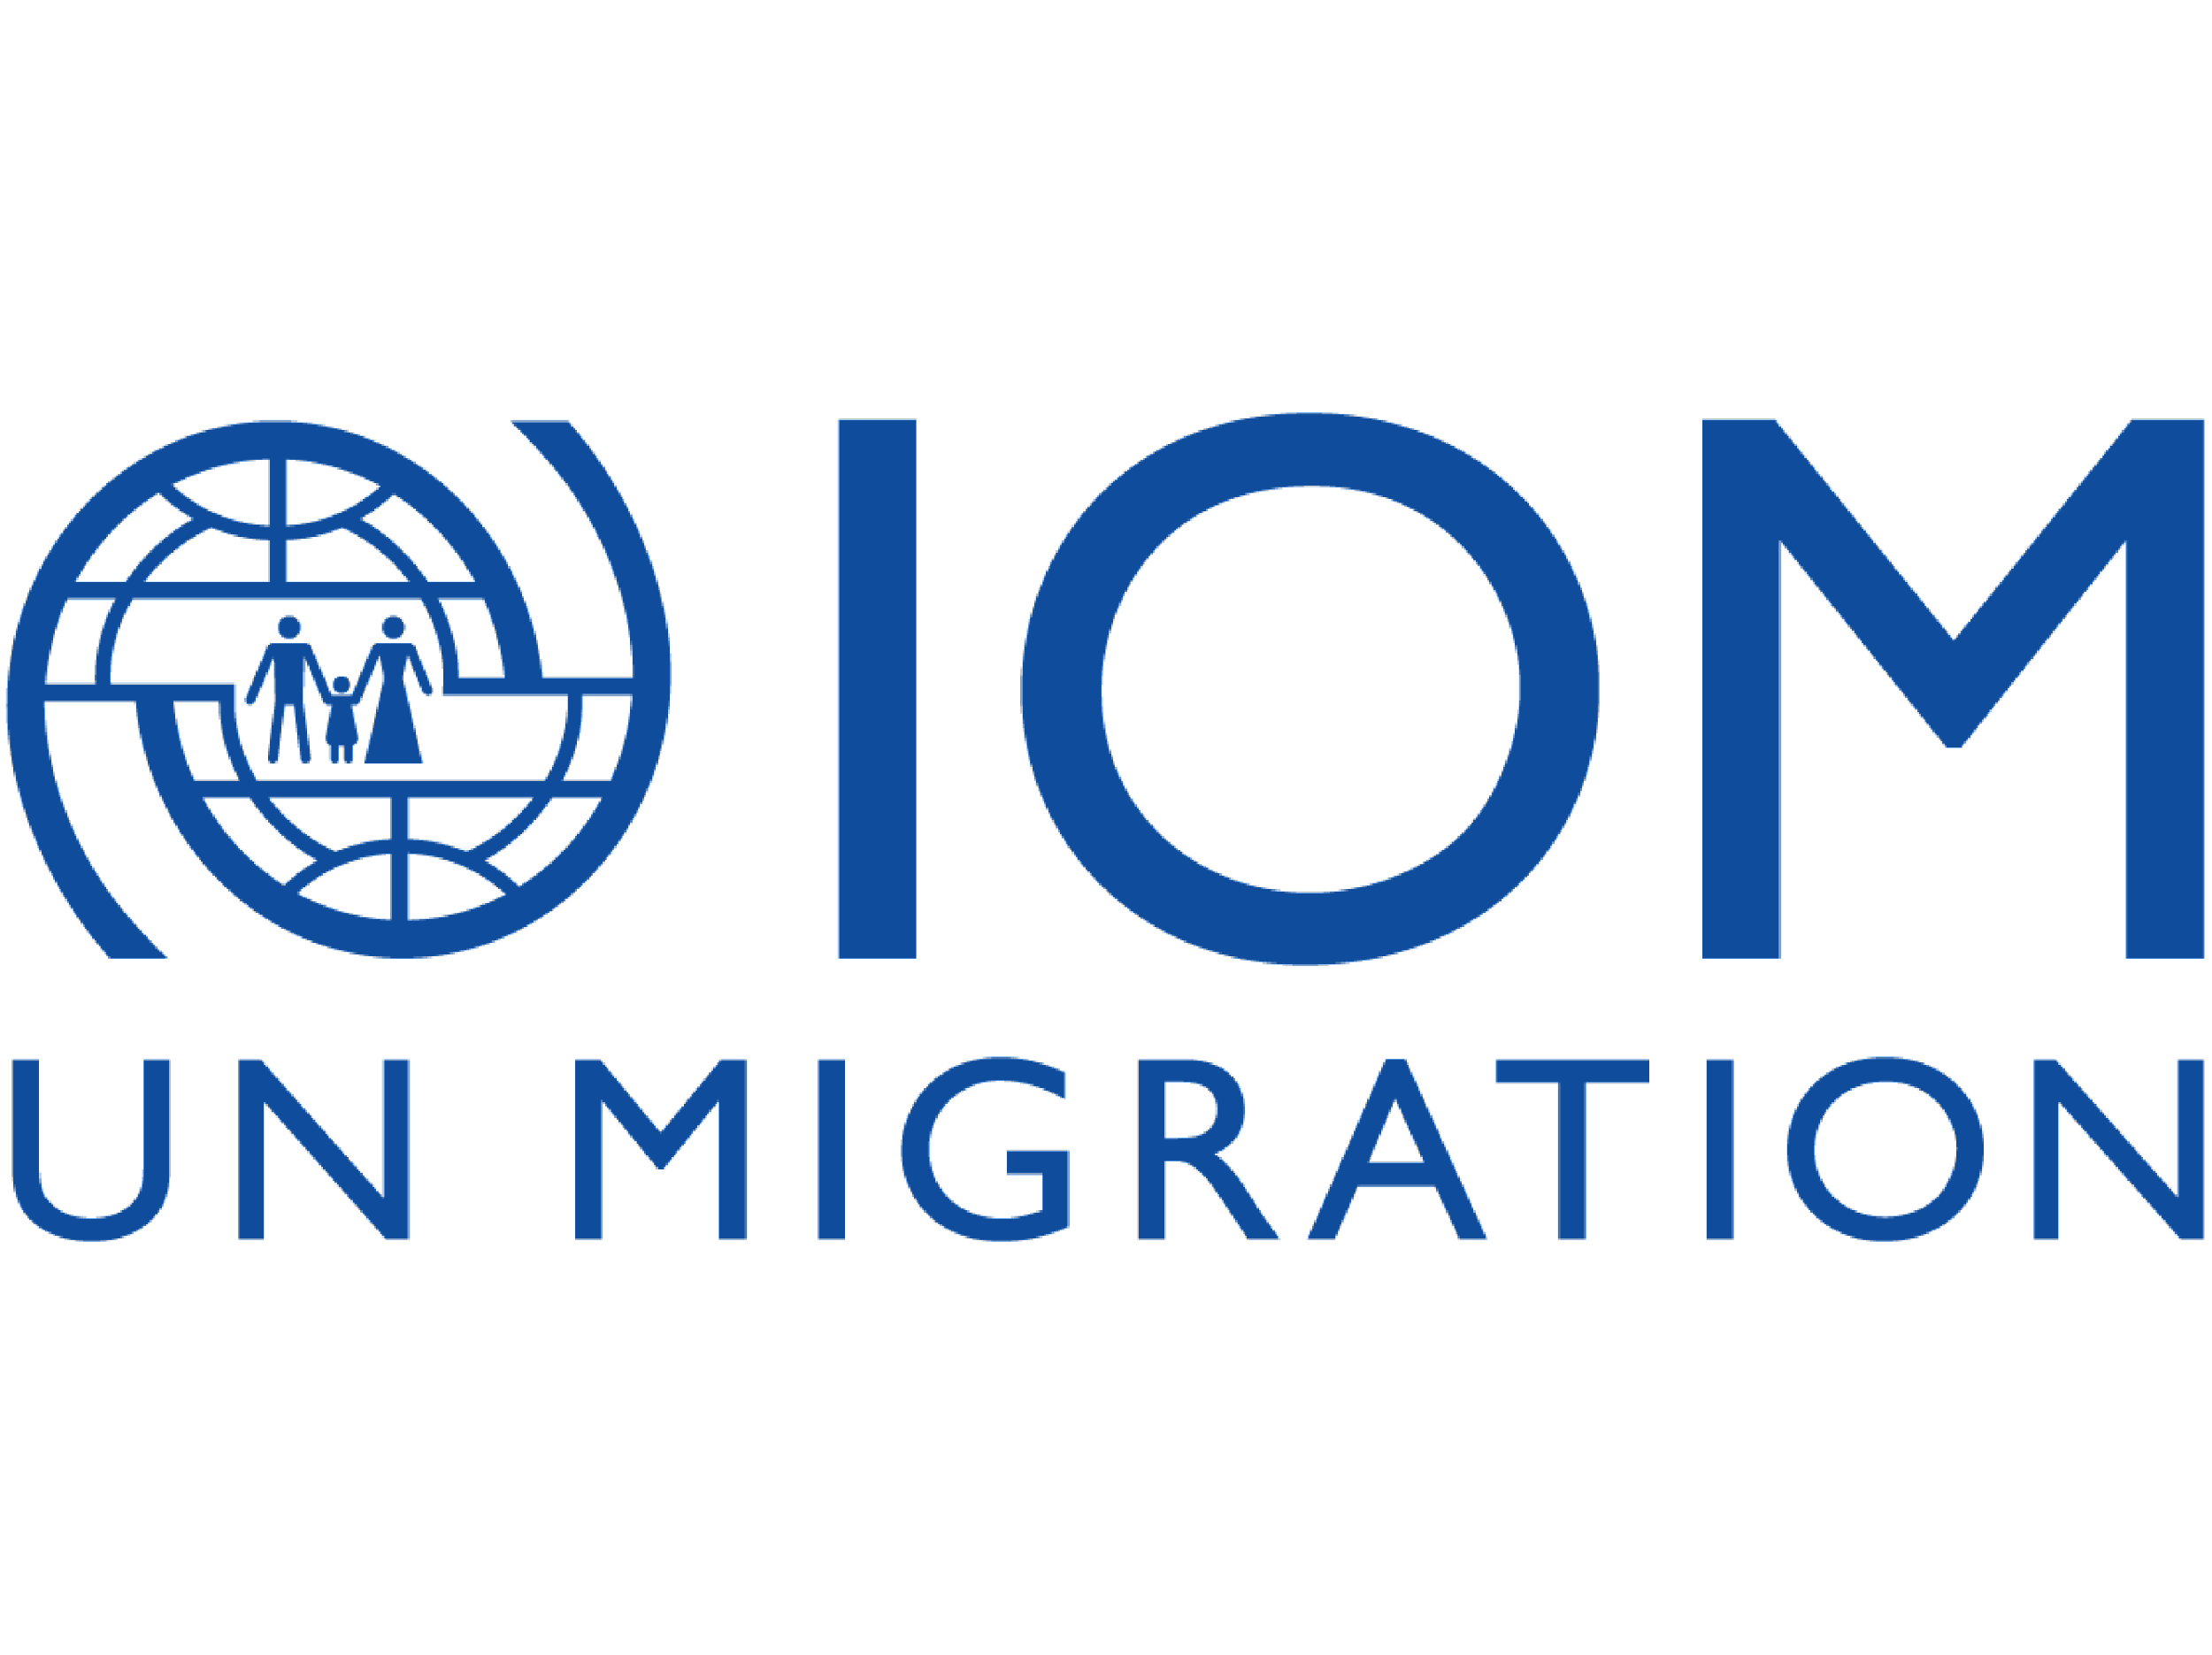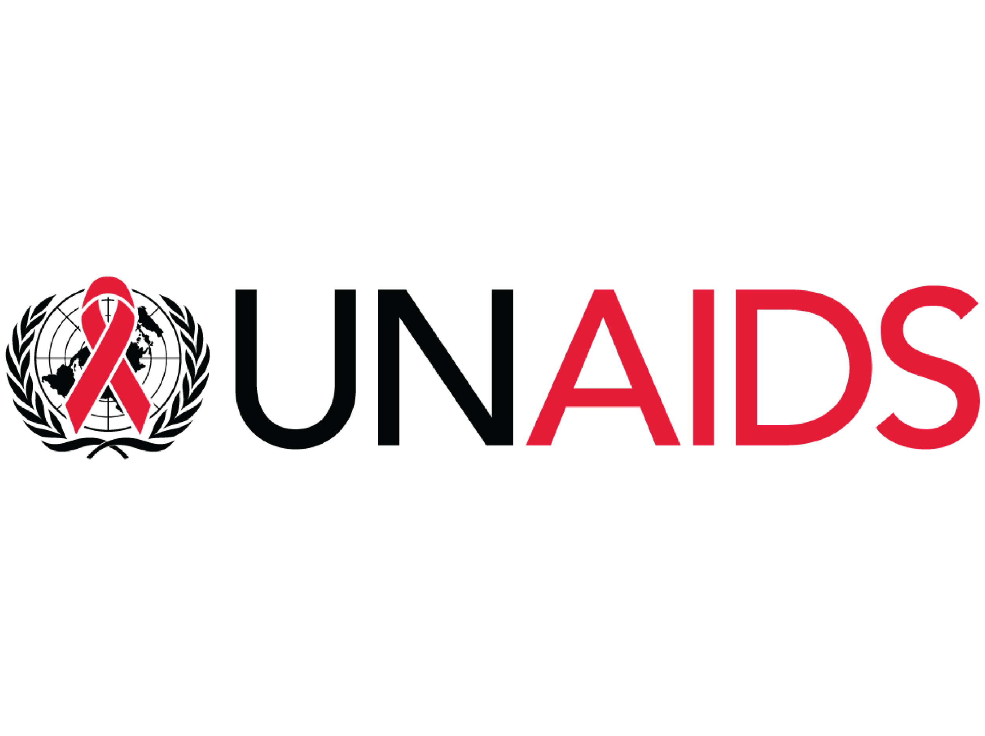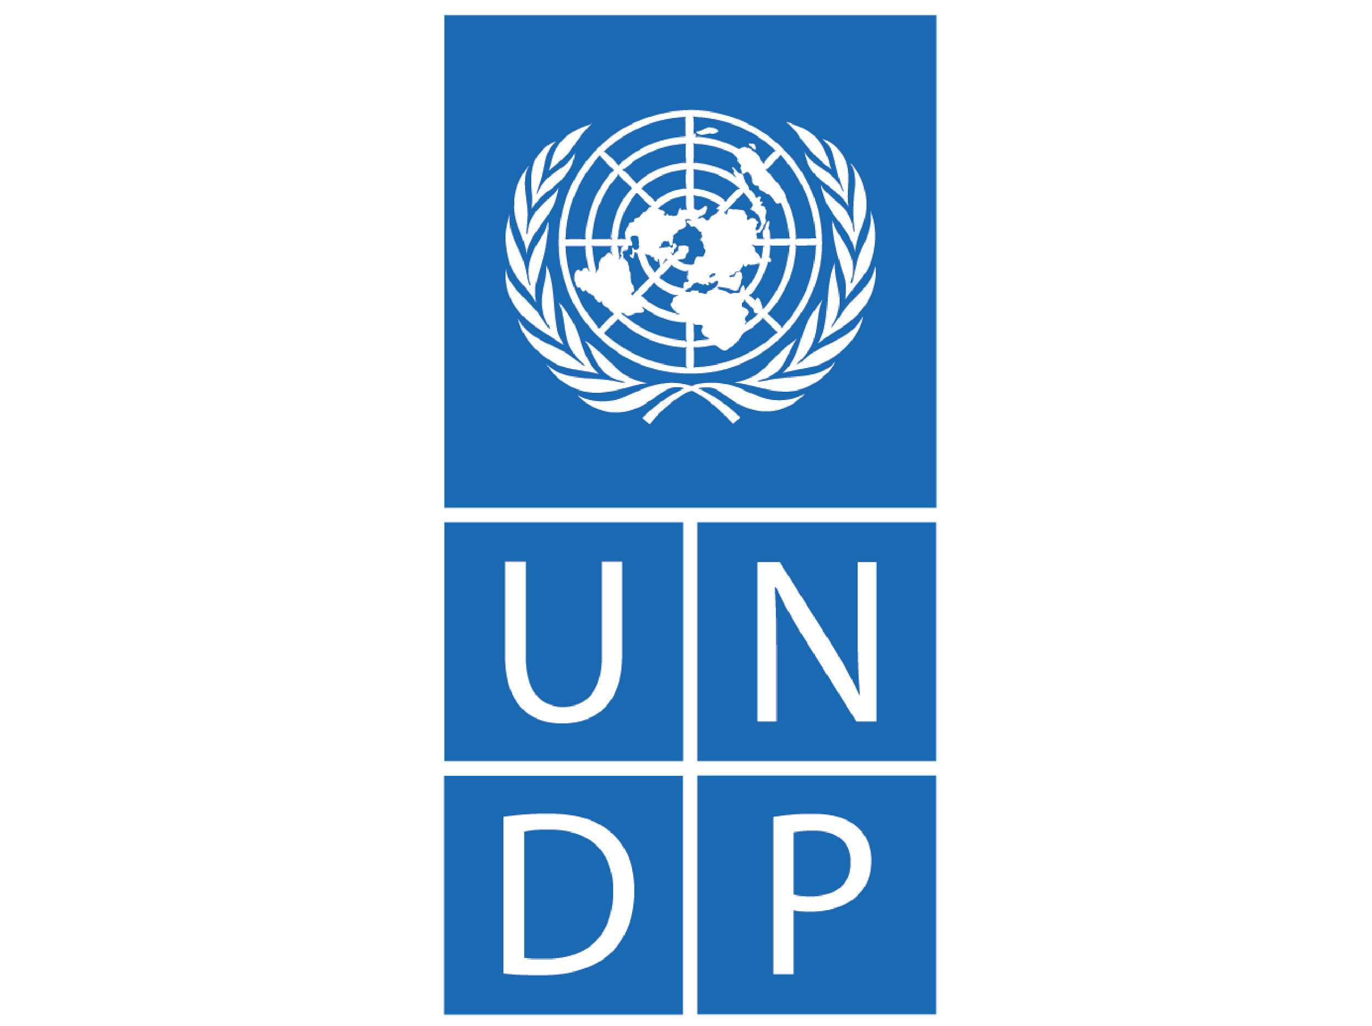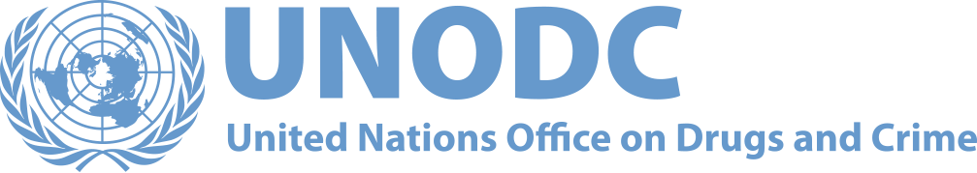
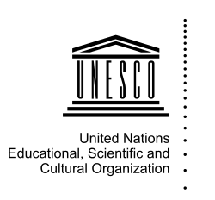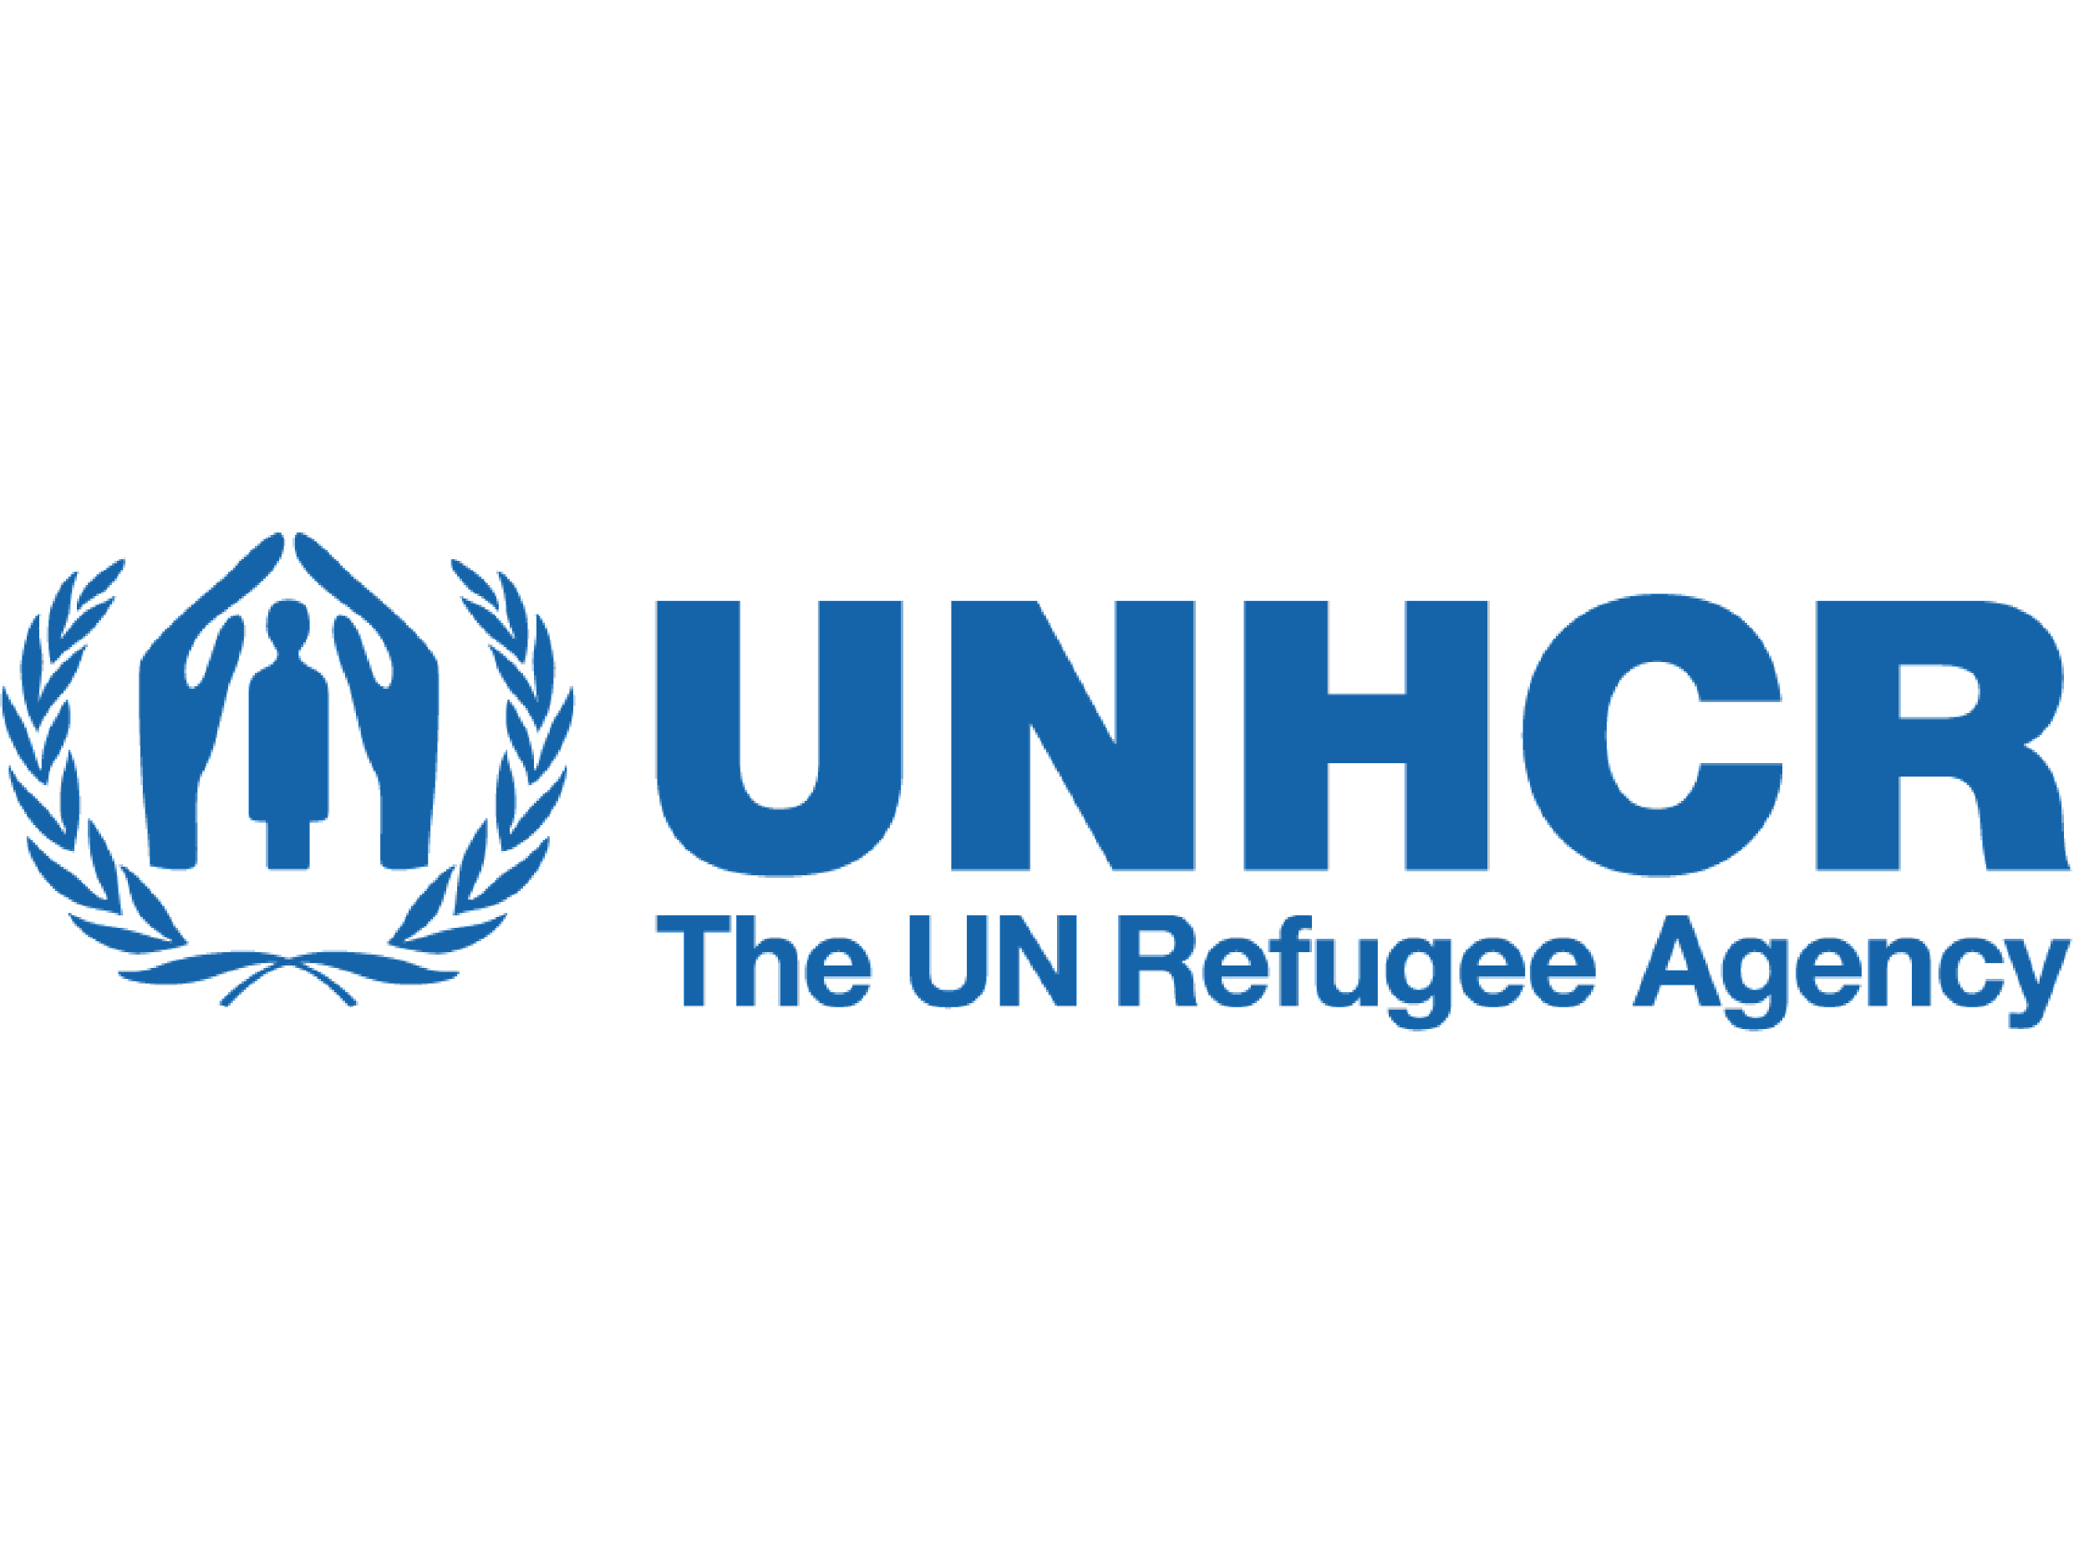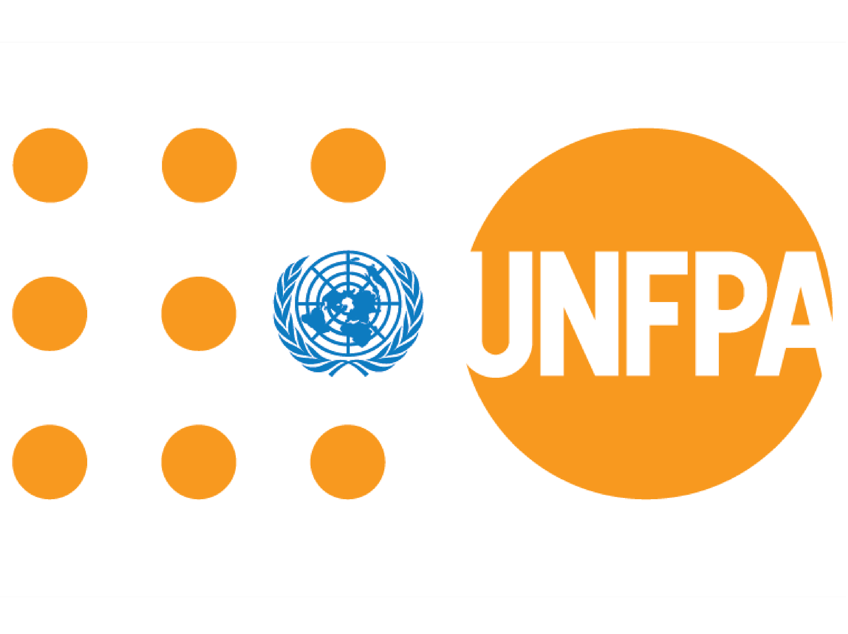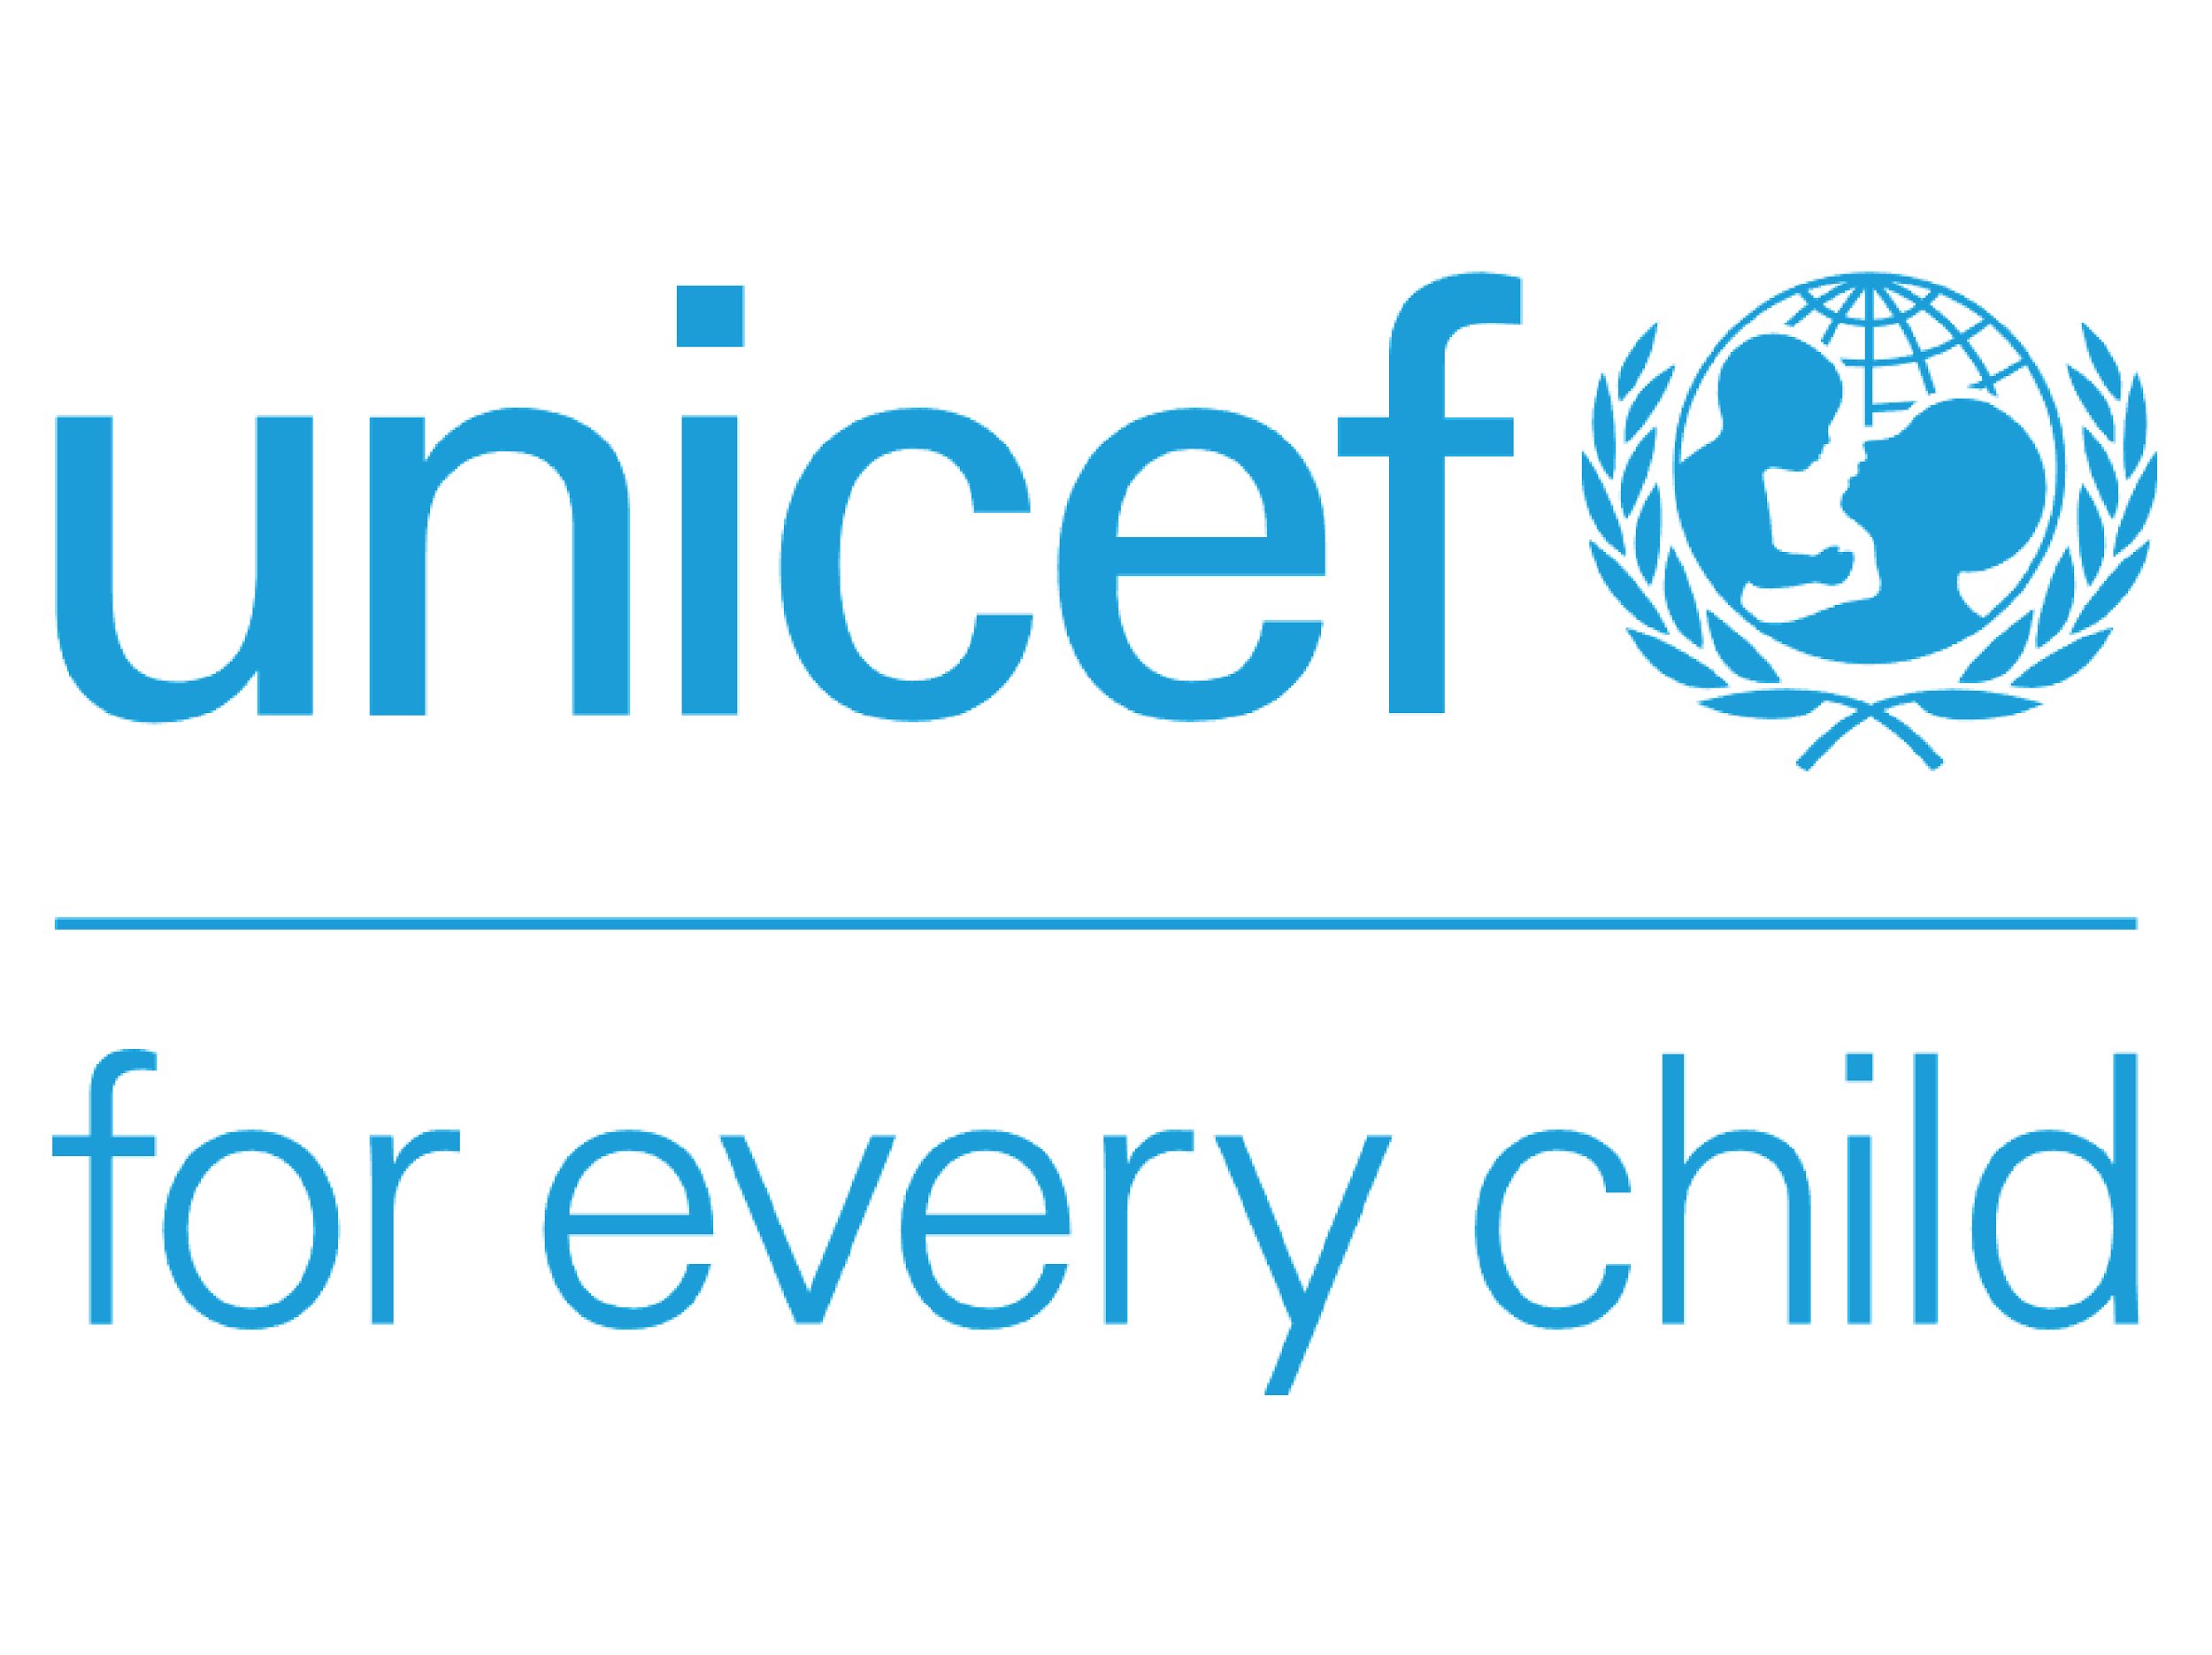
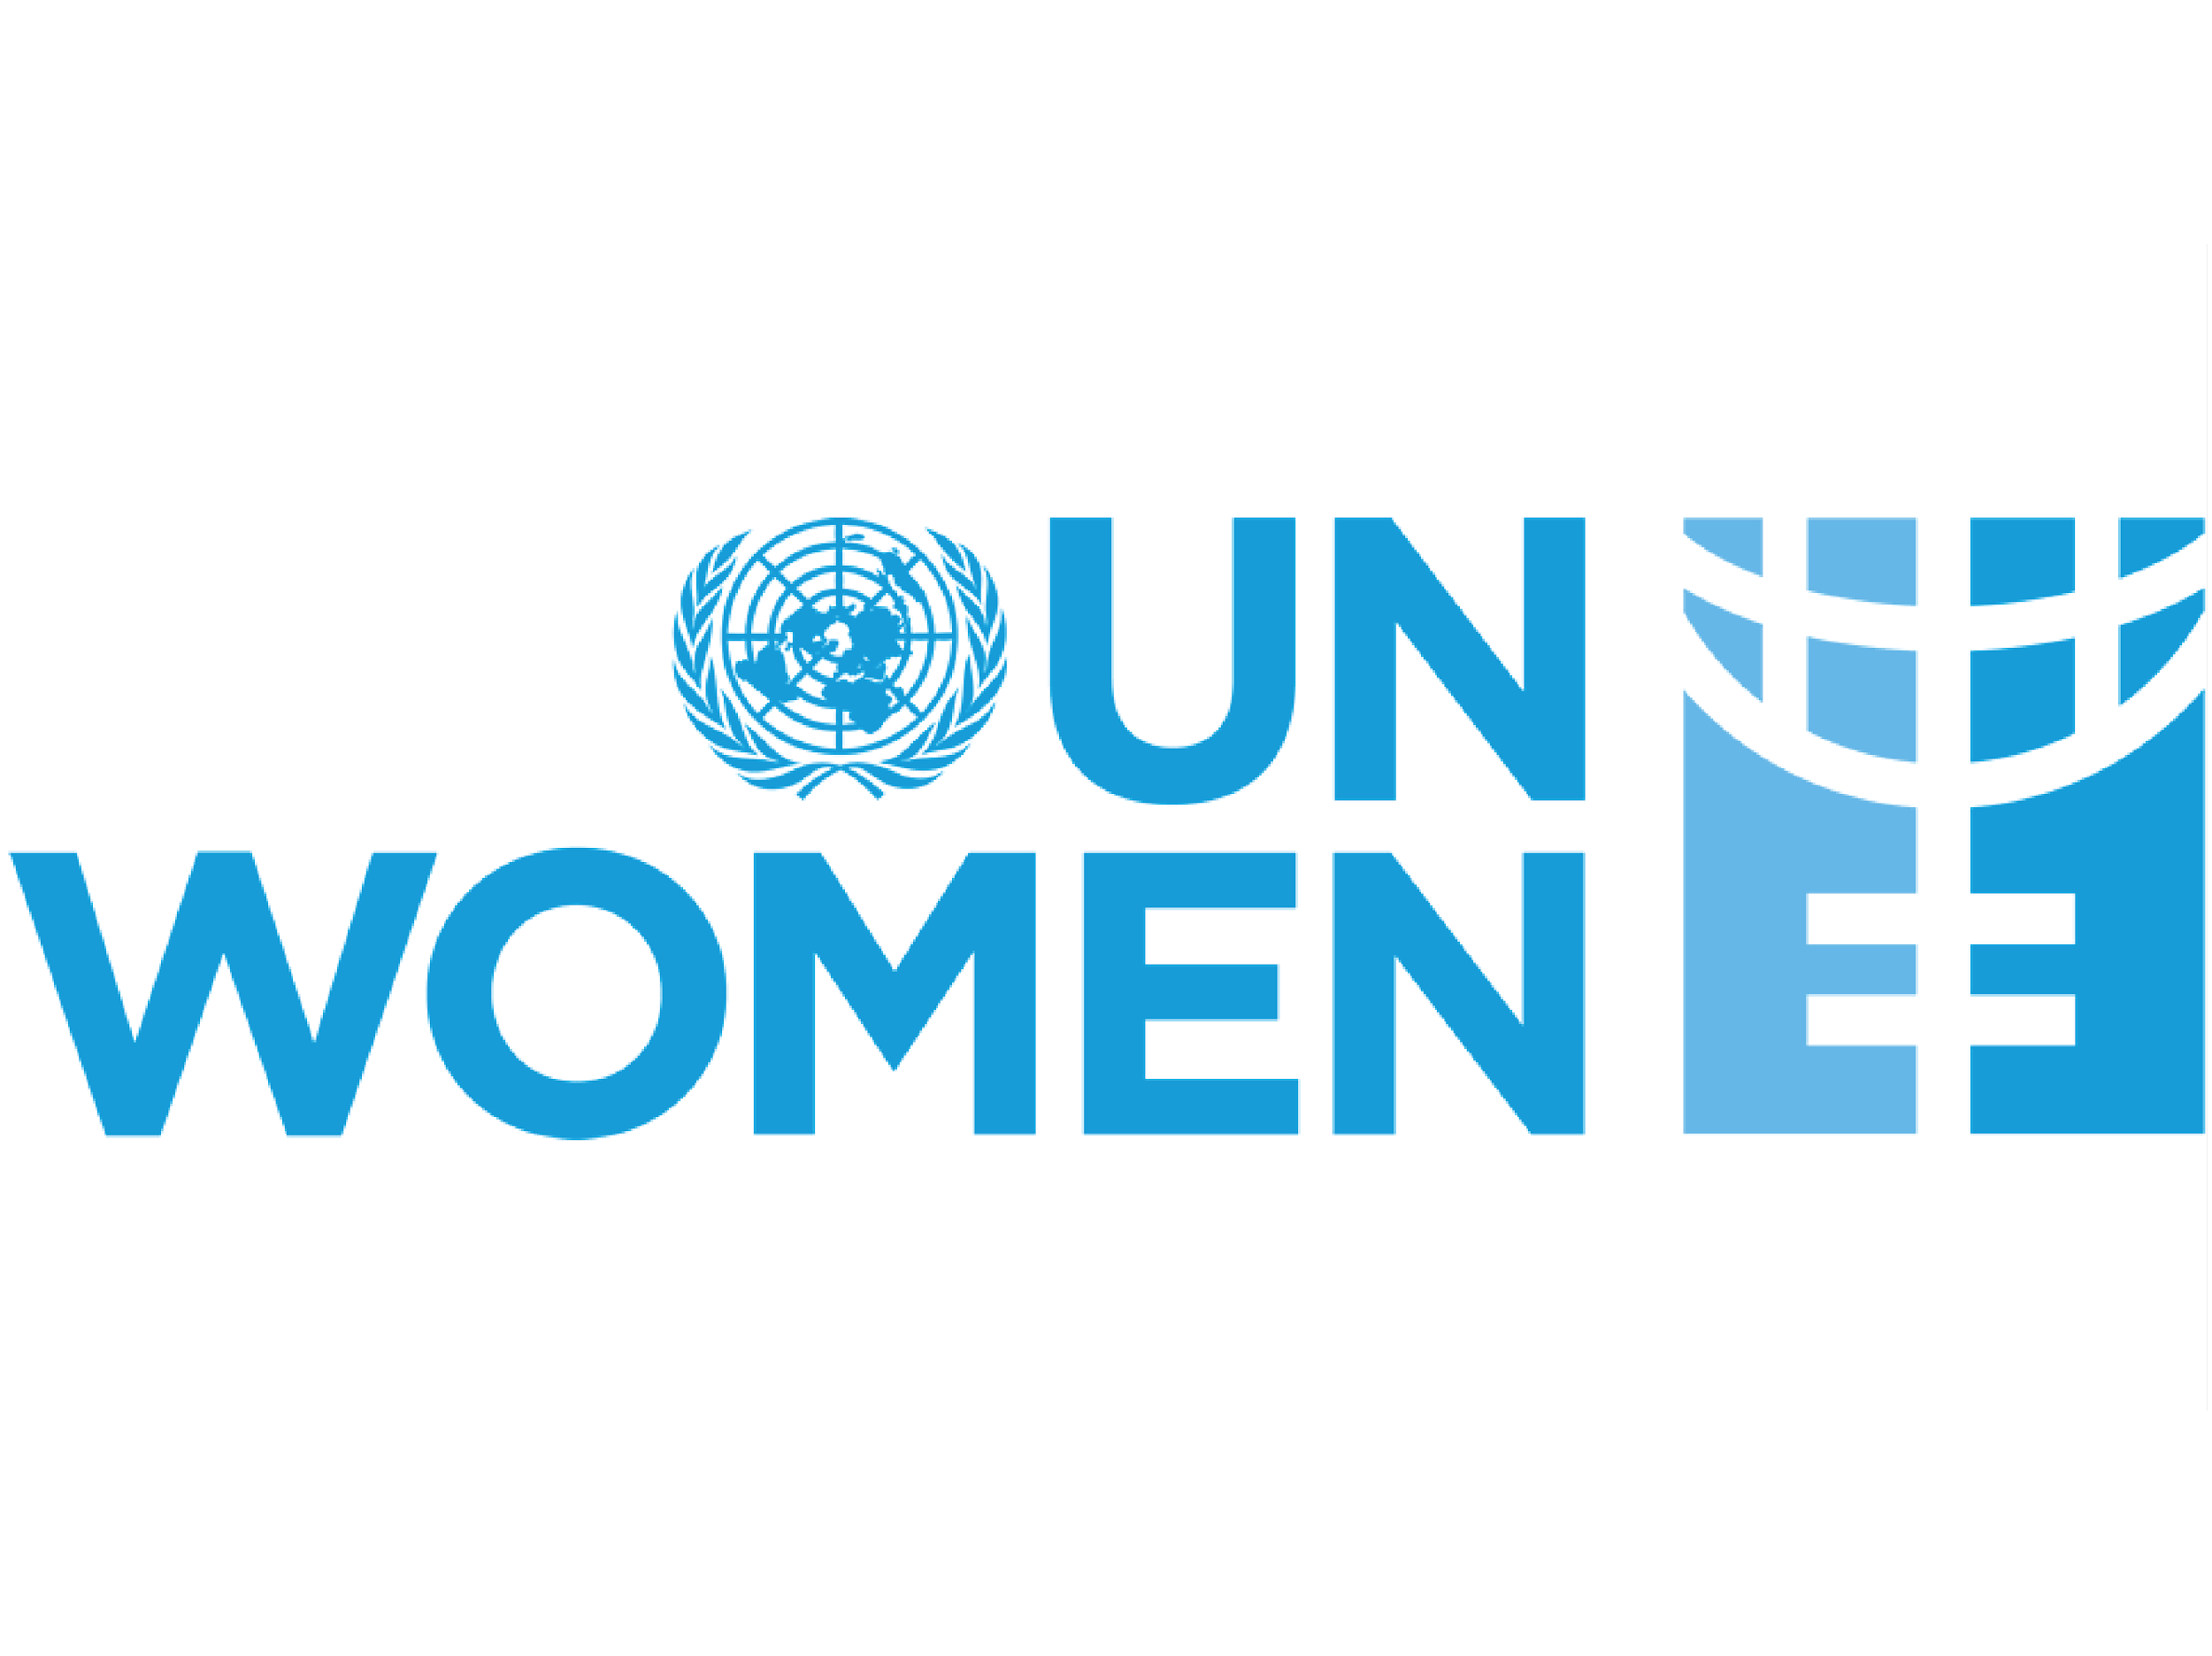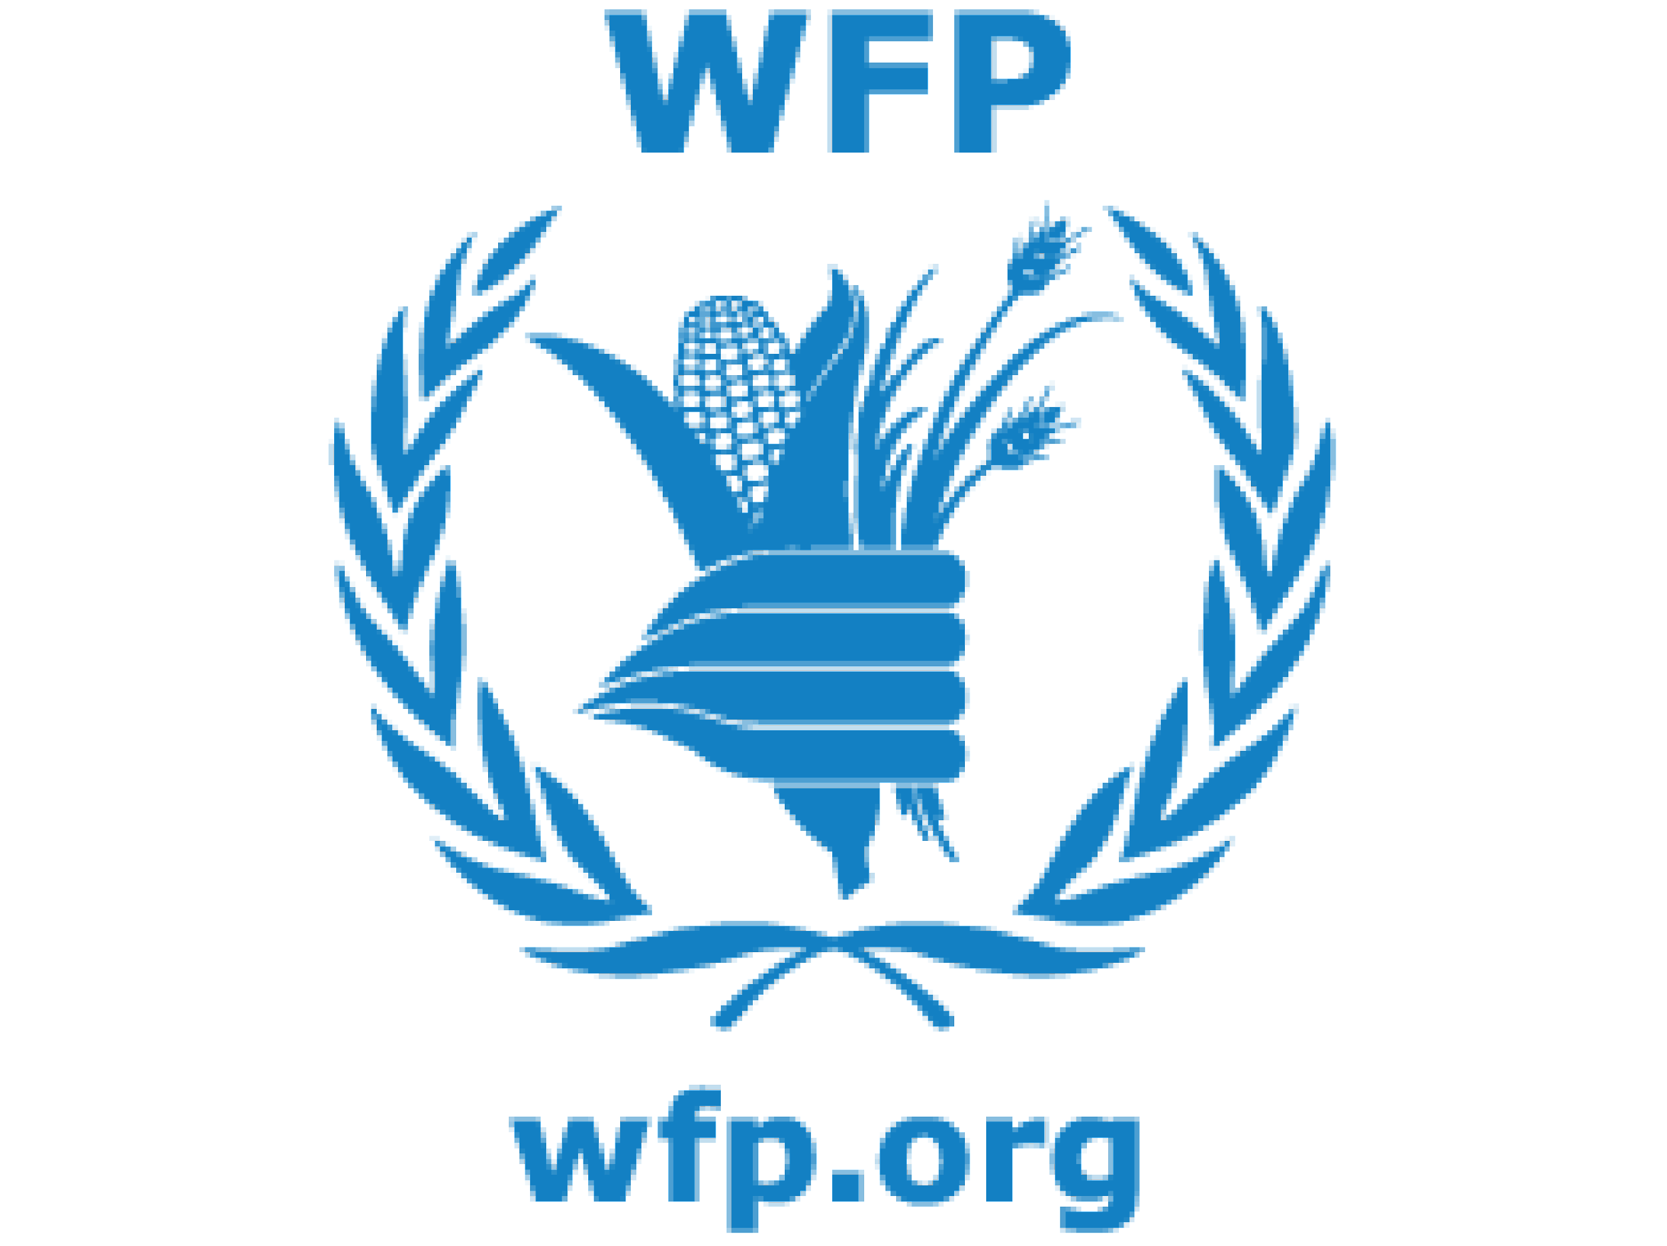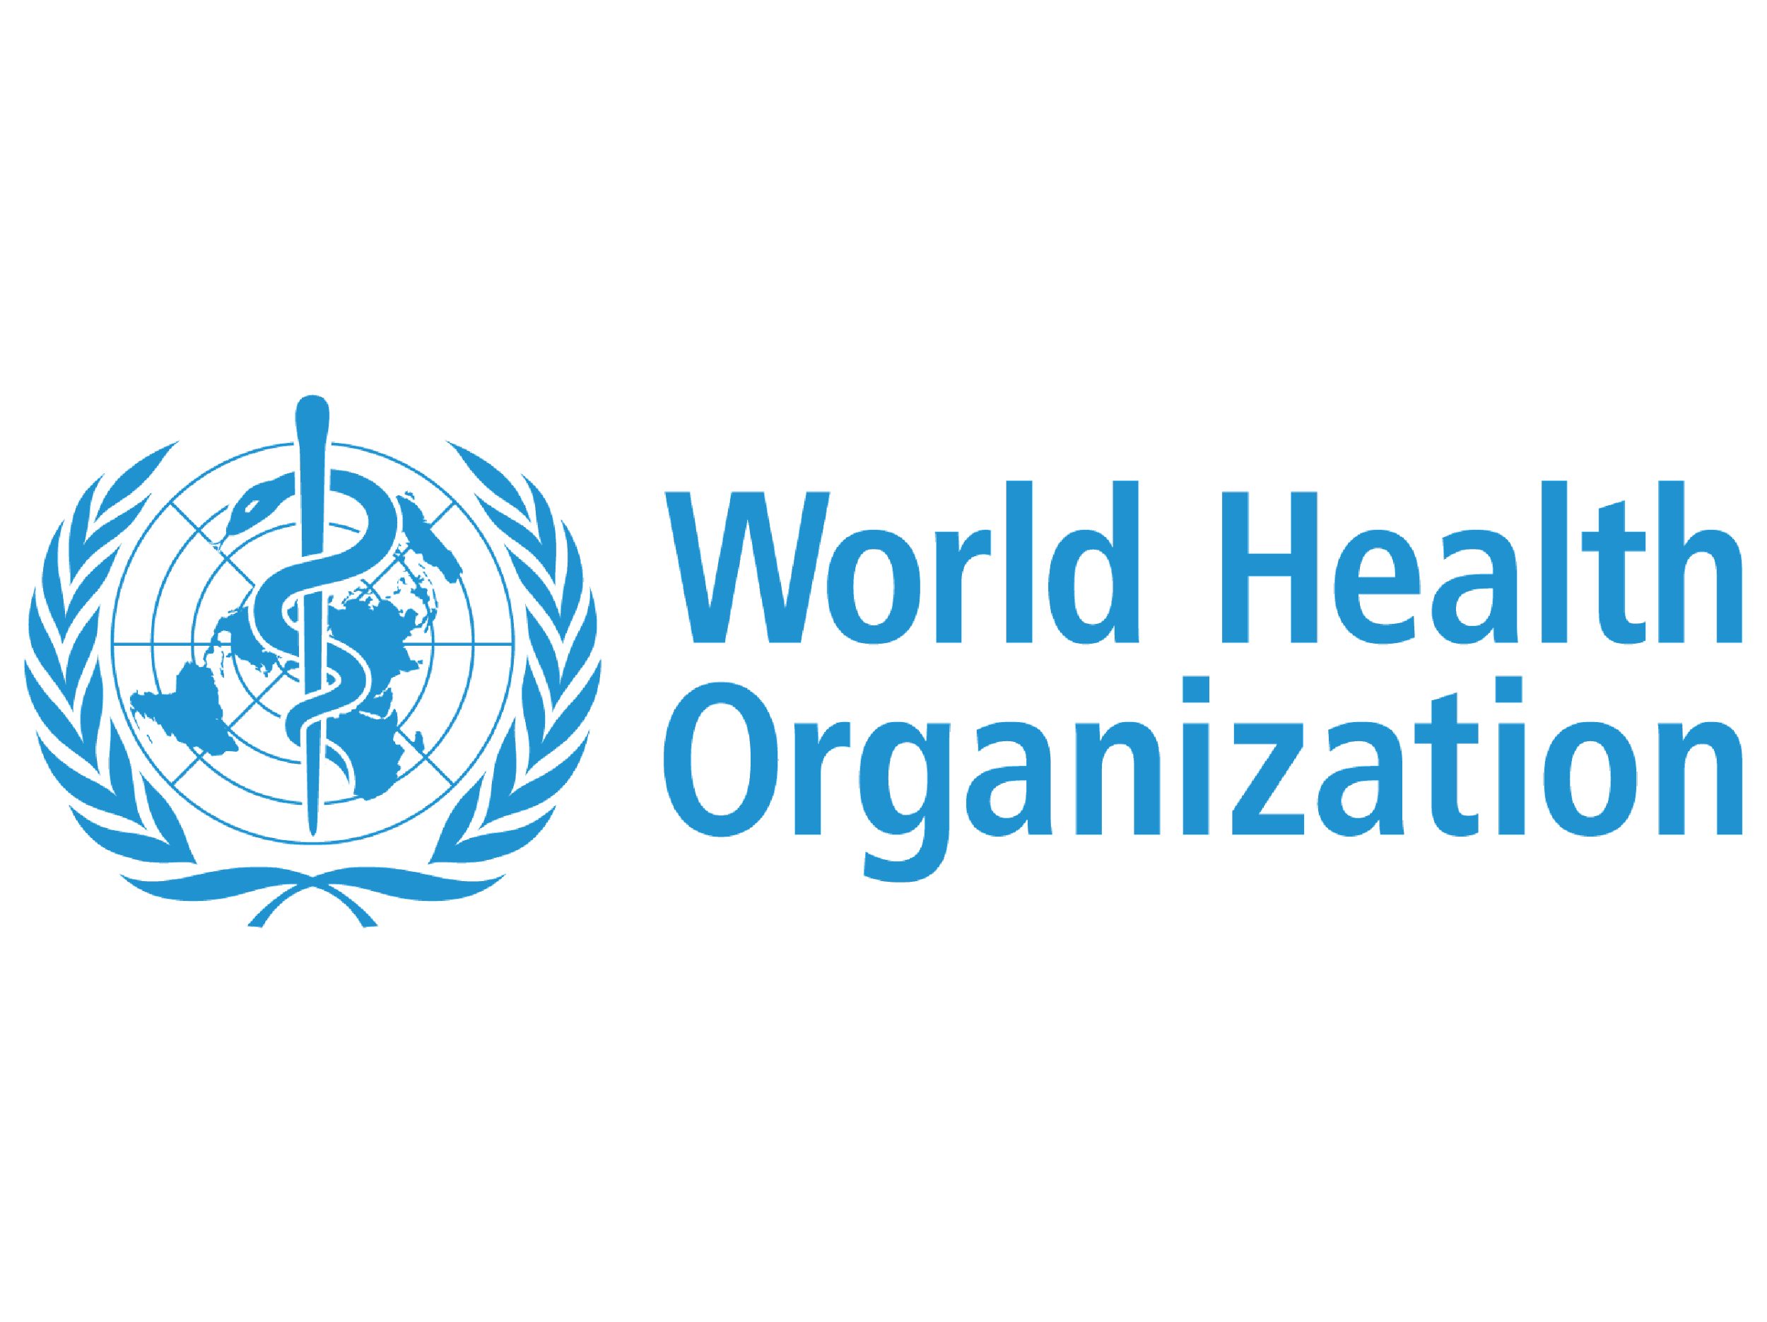

Acronyms and Abbreviations
AGYWs | Adolescents Girls and Young Women
ANC | Antenatal Care
ASRHR | Adolescent Sexual and Reproductive Health and Rights
BTS | Breaking the Silence
CBFs | Community-Based Facilitators
COVAX | COVID-19 Vaccines Global Access
COVID-19 MPTF Fund | COVID-19 Multi Partner Trust Fund
CSE | Comprehensive sexuality education
CSOs | Civil Society Organizations
CUCI | COVID-19 Urban Cash Intervention
DPs | Development Partners
DSWOs | District Social Welfare Officers
eHIN | Electronic Health Information Network
EmONC | Emergency Obstetric and Newborn Care
ETP | Ending Teenage Pregnancy
FAO | Food and Agriculture Organization
FFA | Food Assistance for Assets
FFS | Farmer Field Schools
GBV | Gender Based Violence
GoM | Government of Malawi
GRM | Grievance and Redress Mechanisms
HPV | Human Papilloma Virus
HSAs | Health Surveillance Assistants
iCHIS | Community Health Information System
IDSR | Integrated Disease Surveillance and Response
IDSR | Integrated Diseases Surveillance and Response
IE | Inclusive Education
IEC | Information, Education and Communication
IOM | International Organization for Migration
IPC | Infection Prevention and Control
IRI | Interactive Radio Instruction
JP | Joint Programme
JPGE | UN Joint Programme on Girls’ Education
KUHES | Kamuzu University of Health Sciences
M&E | Monitoring and Evaluation
MAITAG | Malawi Immunization Technical Advisory Group
MIP-1 | Malawi 2063 First 10-year Implementation Plan (2021-2030)
MIS | Management Information System
MoE | Ministry of Education
MoGCDSW | Ministry of Gender, Community Development and Social Welfare
MoH | Ministry of Health
MP4R | Malawi Partnership for Resilience Joint Programme
MPDSR | Maternal Death Surveillance and Response
MTs | Master Trainers
MW2063 | Malawi 2063
NEEF | National Economic Empowerment Fund
NGO | Non- Governmental Organization
OC | Operational Committee
OHSP | One Health Surveillance Platform
OHSP | One Health Surveillance Platform
PCC | Parent-Child Communication
PICSA | Participatory Integrated Climate Services for Agriculture
PLHIV | People Living with HIV
PROSPER | Promoting Sustainable Partnerships for Empowered Resilience
PSEA | Prevention of Sexual Exploitation and Abuse
RCCE | Risk Communication and Community Engagement
RCO | Resident Coordinator Office
SC | Steering Committee
SCTP | Social Cash-Transfer Programme
SDG-AF | SDG Acceleration Fund
SDGs  SHIMMER | Sustainable Development Goals  Strengthening Humanitarian Information in Malawi for Enhanced Response
SOPs | Standard Operating Procedures
SRHR | Sexual Reproductive Health Rights
SSSP | Shock-Sensitive Social Protection
UN | United Nations
UN Women | United Nations Entity for Gender Equality and the Empowerment of Women
UNAIDS | Joint United Nations Programme on HIV/AIDS
UNDP | United Nations Development Programme
UNDS | UN development system
UNESCO | United Nations Educational, Scientific and Cultural Organization
UNFPA | United Nations Population Fund
UNHCR | UN Refugee Agency
UNICEF | United Nations Children’s Fund
UNODC | United Nations Office on Drugs and Crimes
UNSDCF | United Nations Sustainable Development Cooperation Frameworks
UNSDG | UN Sustainable Development Group
UW-HSS | Umoyo Wathu Health Systems Strengthening Joint Programme
WASH | Water and Sanitation
WFP | World Food Programme
WHO | World Health Organization
YFHS | Youth Friendly Health Services

Introduction

1.1 Strategic Framework
In December 2016, the UN General Assembly passed a resolution calling for a more strategic, accountable, and results-oriented UN development system (UNDS) capable of achieving the goals outlined in the 2030 Agenda for Sustainable Development. To this effect, on 31 May 2018 the General Assembly unanimously adopted Resolution 72/279 and agreed to a package of reforms to reposition the UNDS. The resolution, informally known as the ‘UN Reform’, welcomed the call by UN Secretary-General António Guterres for a ‘Funding Compact’ between the UN system and Member States to address UNDS funding patterns (including a growing imbalance between core and non-core resources), and ensure a more predictable funding base to accelerate implementation of the 2030 Agenda.
The Funding Compact is a non-binding instrument based on voluntary commitments by Member States and UN Sustainable Development Group (UNSDG) entities in their pursuit of the achievement of the Sustainable Development Goals (SDGs). It outlines two sets of parallel commitments – one for Member States, and another for UNSDG entities – each with relevant indicators to measure progress. Through the Compact, Member States commit to aligning their funding with requirements set by UNSDG entities via an increase in core resources to a level of at least 30 per cent by 2023; multi-year and flexible contributions; and the doubling of resources channeled through development-related inter-agency pooled funds. UNSDG entities, in turn, commit to accelerating results for countries on the ground by working jointly towards common objectives; improved transparency through reporting on needs, resources, results and impact; and increased efficiency and coherence. In July 2019, the Funding Compact was adopted, and its implementation is guided by ten distinct parameters which together enable the required behavior shift in funding development activities at the country level by UN Member States, and UN Country Teams together with Resident Coordinator Offices (RCOs), and other multilateral contributors.
With the adoption of the Funding Compact, Member States have asked the UN development system to do more and better in inter-agency pooled funding. And there is good reason for it: pooled funds bring the UN together, strengthen coherence, reduce fragmentation, broaden the donor base, allow sharing risks with partners, and tackle multi-dimensional challenges with comprehensive, innovative solutions. While the UN has worked through pooled funds for over a decade in diverse settings and applications, including through standalone joint programmes, a new generation of United Nations Sustainable Development Cooperation Frameworks (UNSDCF) offers an excellent opportunity to further scale and improve their efficiency and effectiveness.
To operationalize the recommendations of the QCPR, the UN in Malawi created the Malawi SDG Acceleration Fund. The Fund improves the quality of non-core resources to help the UNDS support the Government of Malawi in achieving the SDGs by supporting priorities that have an impact on national engagement and can accelerate the SDGs through joint implementation. The Fund complements other resources by providing targeted resources for multi-agency initiatives that strengthen national capacities for integrated policy; developing the national SDG financing ecosystem; implementing catalytic SDG programming and investments and ensuring effective and sustainable development results at national and sub-national levels.

1.2 The Malawi SDG Acceleration Fund
The Fund, established in December 2018, is a financing coordination mechanism whereby the Government of Malawi (GoM), Development Partners (DPs), and the United Nations (UN) agree on joint priorities and mobilize resources for key interventions in support of the SDGs and related national priorities. It represents the commitment of its stakeholders to uphold the pledge of leaving no one behind, a principle laying at the heart of the 2030 Agenda for Sustainable Development. The objective of the Fund is to support coherent resource mobilization to under-funded cross-sectoral areas where the UN has a comparative advantage in implementing together. The focus of the Fund is the mobilization, financing coordination and co-financing of catalytic interventions in support of the SDGs.
The SDG-AF places emphasis on collective partnerships, predictable funding, innovative and transformative results; moving from fragmentation to strategic planning, improved coordination; responding rapidly to national priorities, and leveraging on the added value of UN entities in Malawi, enabling greater synergies and coherence in cross-sectorial SDG priorities.
The Fund’s first year of implementation, 2019, represented the year of transition from a previous coordinating financing mechanism to the SDG Acceleration Fund. In the second year of implementation, 2020, the Fund underwent a thorough review of its governance and operational structure that led to enhanced coordination and broader participation of stakeholders, with the result of an exponential growth both in terms of partners, programmes, and of resource mobilization. In 2021 and 2022, these years were more of consolidation and enhancing portfolio. The Fund focused more on implementation of approved joint programmes and also mobilizing resources for improved joint programmes to sustain UN’s approach towards supporting Malawi’s progress towards achievement of the SDGs.

1.3 Operation of the Fund
1.3.1 Structure of the Fund
The structure of the Fund is aligned to the key outcome areas of the 2019-2023 UNSDCF and has three thematic windows (that are married against the pillar of the UNSDCF and related Outcomes), and one ad-hoc window as demonstrated in the diagram below:
Population Management and Inclusive Human Development
PILLAR 1
PILLAR 2
PILLAR 3
HUMANITARIAN WINDOW
UNSDCF OUTCOMES
1,2 & 3
UNSDCF OUTCOMES
4 & 5

UNSDCF OUTCOMES
6,7,8 & 9

For Humanitarian rapid response actions
Peace, Inclusion and Effective Institutions
Inclusive and Resilient Growth
Humanitarian/Nexus Window
Supporting the Government’s agenda in addressing issues related to respect for human rights, corruption, equal access to justice for all, gender inequality and discrimination of women, children and marginalized groups
Supporting the Government’s agenda in strengthening key areas of public sector such as health and education with special focus on women and children
Supporting the Government’s agenda in advancing more inclusive and resilient development by addressing economic and environmental to achieve sustainable transformation
Supporting the Government in prioritized and rapid response actions to save lives, alleviate suffering and maintain human dignity ahead, during and in the aftermath of crises and natural disasters, as well as prevention and preparedness strategies

1.3.2 Governance of the Fund
The governance of the Fund has three levels: decision-making, oversight, and coordination (Steering Committee, Operational Committee and Secretariat of the Fund), design and administration (MPTF Office), and implementation (Recipient Organizations). Diagram below demonstrates the levels of governance.
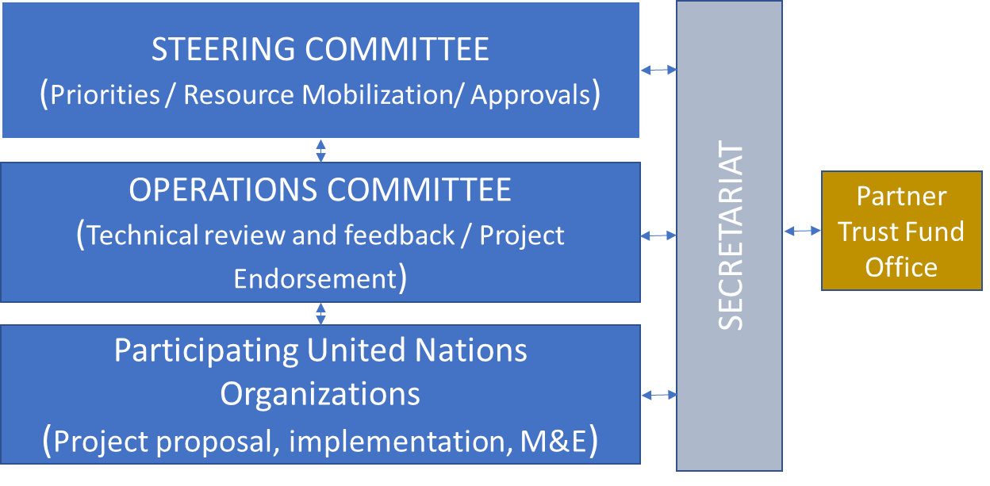

Steering Committee: The Steering Committee provides strategic guidance and performs oversight of the Fund. The SC is the highest decision-making body of the Fund and it makes decisions by consensus.
- Operational Committee: The Operational Committee (OC) is the authority in charge of performing technical review and initial endorsement of projects and programs submitted to the Fund. The OC also is in charge of reviewing and approving requests for changes (scope, budget) to programmes/projects in implementation that are submitted to the Fund for consideration. To help ensure the programmes’ technical quality of the proposals submitted for endorsement, the UN Agencies will designate thematic experts for peer review of proposals.

- Fund Secretariat: The Fund Secretariat is set up to support the Fund’s operational functioning. It’s hosted in the UN Resident Coordinator’s Office. The Secretariat provides technical, management, and administrative support to the Steering and Operational Committees and is responsible for organizing the Fund’s processes related to programme review, approval, monitoring, evaluation and reporting.

The diagram below highlights the overall composition of the governance structures under the Fund
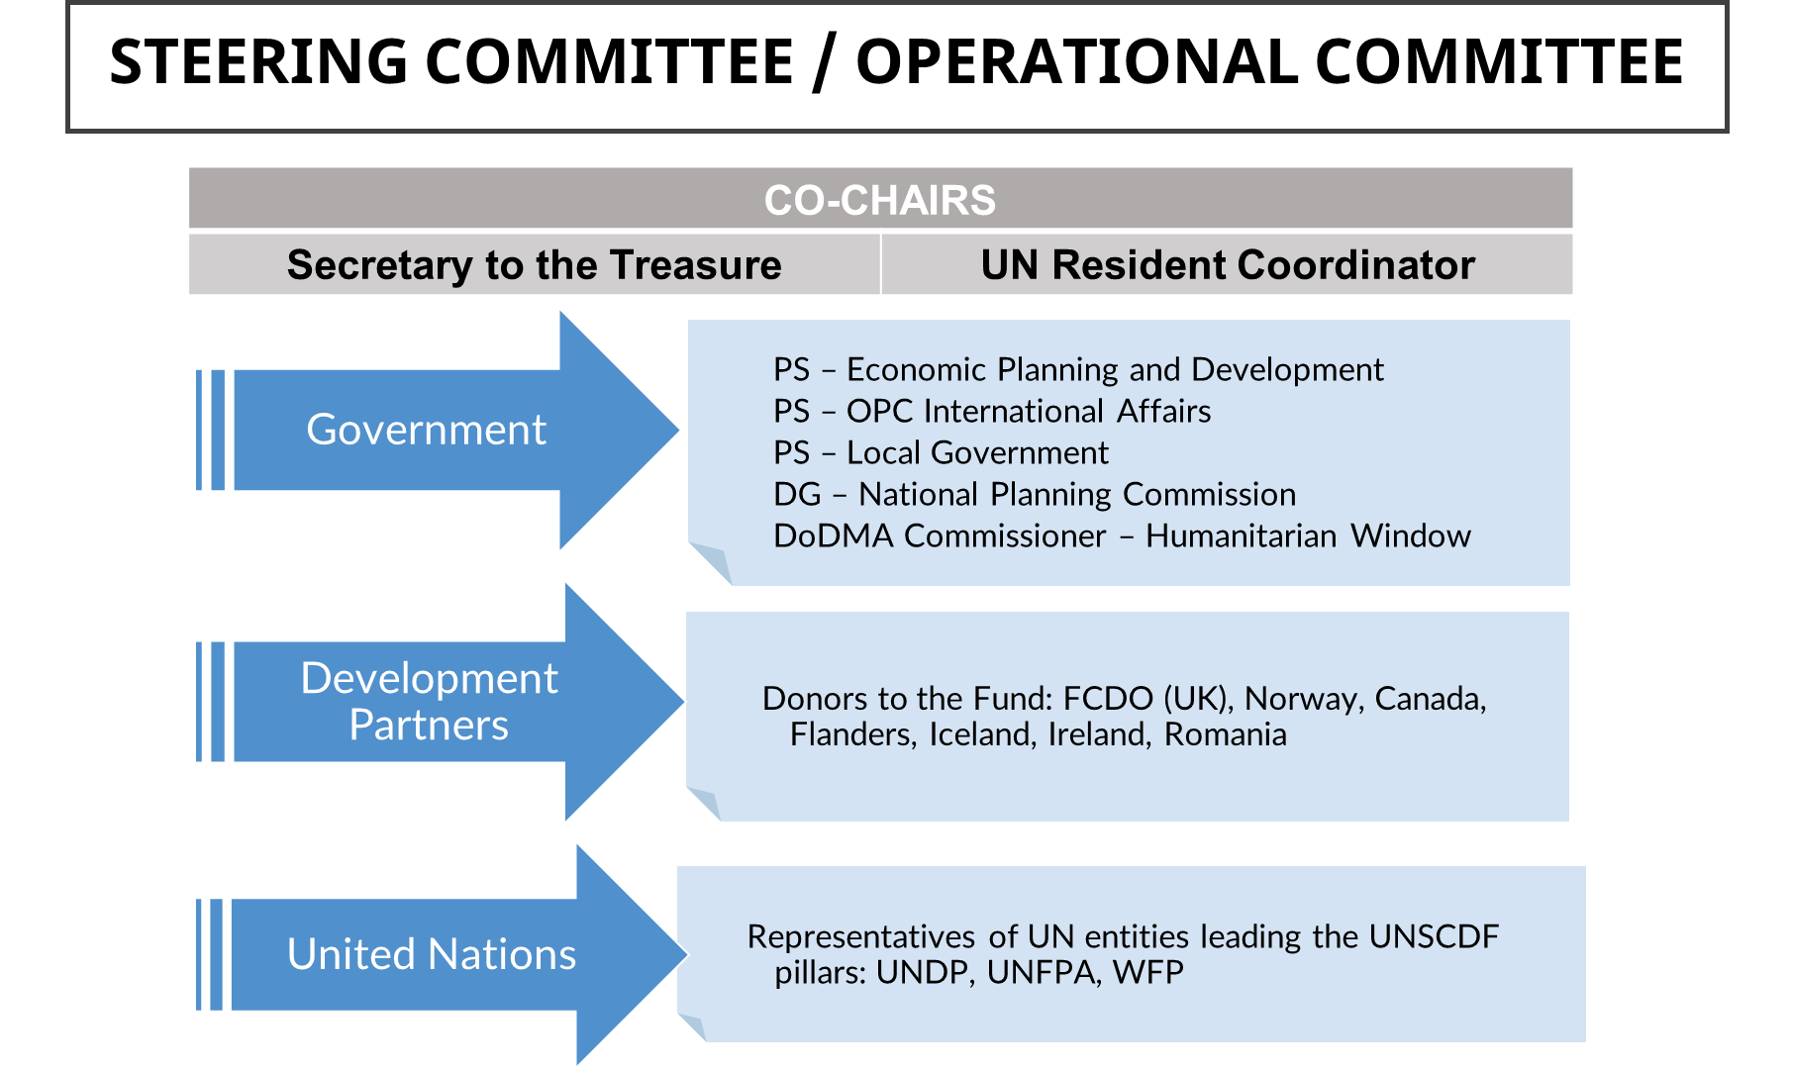

1.4 Cross Cutting Approaches
Building on the Fund’s goal to enable transformative change, and to ensure that tailored and specific actions to achieve SDGs are programmed, the Fund now prioritizes interventions that include cross-cutting approaches that empower women and youth, and include a Human Rights Based Approach. The Fund has a cross-cutting priority to ensure no environmental damage in any of its interventions. These approaches are incorporated and evaluated in each Programme according to the characteristics of each intervention.
For the Fund it is essential to ensure the promotion of gender equality and the empowerment of women through their participation in decision-making and to guarantee the protection of women and girls from all forms of violence. The Fund seeks to allocate a minimum of 30 percent of its resources to activities that promote the participation and empowerment of women, as well as gender equality. The Fund also supports the incorporation of a gender-sensitive approach throughout all project cycles, starting from formulation, through to implementation and evaluation.

Results of the Fund in 2022

2.1 Overview of Country Context in 2022
The year 2022 has been particularly difficult and challenging. The country endured two tropical cyclones – Ana and Gombe – early in the year and a cholera outbreak, on the back of adverse global economic conditions that negatively impacted the economy. A difficult macro-economic environment worsened already elevated poverty levels threatening to reverse gains towards achievement of the SDGs. Economic growth is estimated to decline to 1.2 percent in 2022 from 4.6 percent in 2021 driven by the impact of a global commodity price shock and the passthrough to domestic inflation, persistent forex shortages that affected importation of raw materials and other strategic commodities as well as erratic electricity supply. Tropical Cyclone Ana alone is estimated to have caused damages equivalent to 1.5–2.7 percent of Malawi’s GDP— and most notably, the severe damage of the Kapichira hydroelectricity generation plant that accounted for loss of one-third of the country’s electricity generation capacity. Despite these challenges, Malawi has recorded recent improvement on the Human Development Index, amidst an overall global regression of human development. The country moved up five steps on the 2021-22 UNDP Human Development Index (HDI) from position 174 out of 189 countries to position 169 out of 191 countries.

The adverse weather events in 2022 also impacted agriculture productivity, with a significant portion of subsidized fertilizer being rendered ineffective, particularly in areas where flooding destroyed crops. As a result, despite increased investment, maize yields did not see proportional improvement, and 3.8 million people were assessed as food insecure according to the Malawi Vulnerability Assessment Committee (MVAC). The severe flooding from these two tropical cyclones also increased the risk of communicable disease outbreaks, and on 3 March 2022, the Ministry of Health declared a cholera outbreak, which has been the deadliest cholera outbreak in the country within the last decade. While the outbreak originally began in March 2022 in southern Malawi, namely in the Nsanje and Machinga districts, it spread to northern regions, which remained the most affected by the outbreak as of October 2022. As of January 2023, all Malawian districts were affected by the cholera outbreak, with 28 of the 29 districts reporting recent cases. Since the onset of the outbreak, the total confirmed cases and deaths were 26,888 and 881, respectively. The socio-economic impacts are heightened as the outbreak is also impacting communities that are facing food insecurity and malnutrition.

2.2 Overall Results
In 2022, Malawi experienced multiple health related emergencies, including tropical storms, cholera and polio outbreaks, and also the effects of COVID 19. Despite these setbacks that Malawi suffered in 2022, the SDG Acceleration Funds remain the best tool to achieve transformational results needed.
The Fund programmes’ areas of intervention focus on six SDGs: SDG 1- SDG 1- No poverty, SDG 2-No hunger, SDG 3-Good Health and Well-being, SDG 4-Quality education, SDG 5- Gender equality and SDG 13-Climate Change

2.2.1 The overall key results of the 2022 implementation of the SDG-Acceleration Fund

In the third and fourth years of the Fund, 2021 and 2022 was more of consolidation and enhancing the portfolio focusing on implementation of approved initiatives while mobilizing resources for new and improved initiatives. The key results achieved through joint programmes implemented by the Fund are:

- Strengthened coherence – In 2022, the UN implemented 13 joint programmes managed by the SDG-AF, placing significant emphasis on coherence and complementarity among development, humanitarian, and peacebuilding efforts despite multiple emergencies. Efforts were made to strengthen coherence between the planned activities of UN entities and non-UN partners.

- Enhanced efficiency of the UN and partners at country level: The SDG-AF continued to strengthen joint programming for UN agencies. Joint Programmes generate greater synergies and coherence, while allowing UN entities to engage in cross-sectorial SDG priorities. Joint programmes are a very powerful tool to leverage the added value of UN entities at country level.

- Boosted joint planning, joint programming, and better collective results for SDGs: The close collaboration and coordination among UN partners has resulted in improved collective results and also provided grounds for more joint planning amongst UN partners. For instance, the joint programme on Health Systems Strengthening (UNICEF, UNFPA, and WHO) which brought together technical expertise that ably provided the leadership and technical assistance required for the programme of this nature. Synergies have been created across the UN agencies and additional resources and expertise outside the programme leveraged on. Collaboration with other health partners in the districts has also proven to be useful in making use of local knowledge. Also, the programme chose interventions from the DIPs of the district to ensure alignment with district priorities and hence ownership and sustainability.

PROSPER strengthened social protection systems to respond to shocks and supported a digital disaster response system. Implemented in a coordinated manner, the interventions have improved livelihoods by creating healthier natural environments and reducing the risks and potential impacts of climate shocks. In 2022, the programme directly strengthened the resilience of 305,8336 people to withstand current and future weather-related shocks and stresses.
- Improved Humanitarian/Nexus support: Just like the year 2021, the year 2022, has been one of consolidation and enhancing portfolio, whereby more focus has been given to implementation of approved initiatives while advancing in new/improved Joint Programmes. The Strengthening Humanitarian Information Management in Malawi for Enhanced Response (SHIMMER) project was approved through the Humanitarian Window to improve humanitarian response in Malawi, based on reflections from the Cyclone Ana and Gombe After Action Review (AAR) which took place in mid-August 2022, and also due to the catalytic potential of enhanced information management across all sectors and agencies. This programme will leverage existing resources, knowledge, and opportunities to meet emergency needs, while embodying a process aimed at sustainable capacity development.

- Boosted Implementation of the UN reform and Funding Compact: The SDG Acceleration Fund continues to mobilize resources for financing coordinated SDG interventions in the country. Despite challenges in 2022, the Fund managed to initiate two projects namely, Border Security and Conflict Prevention; and UN Joint Programme- Cash Assistance and Livelihoods Support to Refugees.

- Strengthened multi-sectoral and gender-responsive approach: Most of the programmes use a multi sectoral approach to accelerate gender equality from different angles, ranging from promoting economic growth, reducing poverty, enhancing human capital through health, education, and protection, attaining food security, strengthening resilience to disasters, and laying the basis for behavioral change in rooted cultural beliefs that enable gender inequalities.

- The Joint Programme on Girls’ Education (JPGE) has contributed to decreasing gender inequality through its multi-faceted approach. Lower dropout rates and better pass rates are foreseen to strengthen the position of girls in their adult life, and together with gender sensitive environment in schools, (e.g., supporting girls who dropped out of school, helping girls to achieve leadership positions and strengthening access to YFHS) has helped in bridging gaps between girls and boys, contributed to transforming discriminatory gender norms and practices and provided an equal chance in life to both boys and girls. JPGE contributes to the awareness raising and empowerment of girls and encourages them to take on leadership positions in the community and in school clubs.

- The Joint Action addressing GBV, Child Marriage, and Teenage Pregnancy Programme has strengthened the capacity of national district and community levels, humanitarian structures and stakeholders on gender mainstreaming in COVID-19 response and recovery. Area Child Protection Committees (ACPCS) and VCPCs in the targeted districts have the capacity to collect sex, age disability disaggregated data, conduct rapid gender analysis, promote women participation and influence in COVID-19 response, integrate GBV and protect beneficiaries from sexual exploitation and abuse so that men, women, boys, and girls including people living with disabilities equally benefit from assistance. Furthermore, the project has addressed specific practical needs of women, rather than strategic needs, through their inclusion in the community structures and leadership positions.

- The Cash assistance and livelihoods support to refugees in Malawi project aimed to meet urgent food gaps of refugees living in Dzaleka refugee camp while also enhancing their livelihoods. Overall, the objective was to prevent households from sliding further into severe vulnerabilities and to contribute to Sustainable Development Goal (SDG) 2, Zero Hunger. The project focused on trainings, rigorous coaching and mentorship on cross-cutting issues such as gender equality to ensure that the skills imparted are internalized and manifested into the delivery of products, social behavior change communication was also used to sensitize on gender and protection issues during distributions.

- Increased investments on health and well-being, as essential features for sustainable development: despite the challenging implementation environment and all the challenges that have been highlighted the programme recorded early successes and obtained significant results. This is mainly due to the UNJP team's longstanding relationships with the government which bolstered the government’s trust in the UNJP-HSS program. This partnership paved way for the programme to establish mutually beneficial relationships with the district teams and leadership from the DHMTs. Of importance is the close collaboration and coordination amongst the UN partners (UNICEF, UNFPA, and WHO) which brought together technical expertise that ably provided the leadership and technical assistance required for the programme of this nature. Synergies have been created across the UN agencies and additional resources and expertise outside the programme leveraged on. Collaboration with other health partners in the districts has also proven to be useful in making use of local knowledge. Also, the programme chose interventions from the DIPs of the district to ensure alignment with district priorities and hence ownership and sustainability.

- Focus on inclusive education as SDG accelerator: The Fund continues to support efforts aimed at eliminating barriers impeding the right to education for all students of the relevant age range with conducive learning environment, including quality inclusive, gender sensitive and SRH education materials. In 2022 learners under the JPGE received eyeglasses, magnifiers, telescopes or hearing aids, among others. Braille life skills textbooks were also supplied to schools. The inclusion of the Inclusive Education (IE) component in the new phase of the programme continued to be a key success also in the second year, continuing to support identification and addressing conditions for mild disabilities, which if not addressed, could result in visual or hearing impairments in future. In 2022, the effects of the COVID-19 pandemic started to slow down, with emerging positive effects on the education sector. Nationally there has been a small increase in primary school enrolment, while a slight increase in dropouts. However, in the JPGE-supported schools, dropout rates decreased from the previous year, attendance continued to increase and there was improvement on repetition rates.

SUPPORTING YOUNG WOMEN AND FAMILIES TO MAKE RIGHT CHOICES
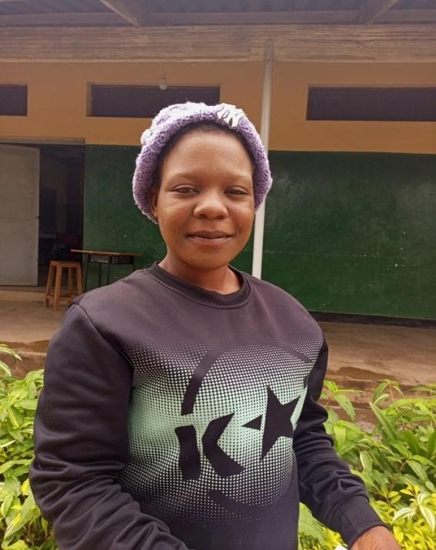
“One of my mentees, who is 21 years old and married, reported that her husband used to restrain her from accessing family planning methods due to myths and misconceptions. They were both not conversant with family planning and contraceptives to the point that they have 3 children that were born within a space of three years because they did not practice family planning. Although my mentee was not comfortable with bearing children every other year, she was not empowered enough to talk to her husband”, explains Selina.
She continues to explain that when her mentee started attending the Safe Space sessions, she noticed that she had keen interest in the topic about family planning and initiated a one -on-one conversation with her and later referred her to the nearest clinic. When she got all the necessary information about family planning, her mentee was confident enough to approach her husband with the information she had gotten. She expressed her worry over their unplanned pregnancies and discussed with him the negative health and economical challenges brought about by unplanned pregnancies. Her husband was convinced and finally let his wife start accessing family planning methods at her nearest health centre in the district, which she does freely.
Selina Malola a Mentor from Mangochi
Selina explained the positive impact she had brought to this family, all thanks to the Joint Programme on Girls’ Education (JPGE) for the mentorship programme, “it is doing wonders for the young women girls in the safe spaces”.

2.3 The Fund’s programmes in 2022
In 2022, the SDG Acceleration Fund supported implementation of 8 Joint Programmes, the Fund has been instrumental for implementing the UN Reform and advancing more and better joint programming to boost UN relevance. The coordination efforts among participating UN agencies have accelerated the progress towards the achievement of the SDG, particularly SDG 1 (No poverty), SDG 2 (Zero hunger), SDG 3 (Good Health and Well-Being), SDG4 (Quality Education), SDG5 (Gender Equality).
The Fund’s 2022 portfolio also includes three new Joint Programmes approved in late 2022; SHIMMER, Empowering Women and Youth in Agriculture in Malawi and Strengthening Malawi’s Peace Infrastructure for conflict prevention and sustaining peace in borderland districts, these were planned to kick off implementation in 2022, due to circumstances beyond the JPs control, the programmes will start full implementation in 2023 hence there are no further results to showcase in this report. Priority areas for these new programmes include:
- Strengthening Humanitarian Information Management in Malawi for Enhanced Response (SHIMMER: This is a 9-month project under the SDG Acceleration Fund’s Humanitarian Window funded by Flanders (USD $187,000) to be implemented by WFP. SHIMMER concept was selected as a priority area and need to improve humanitarian response in Malawi, based on reflections from the Cyclone Ana and Gombe After Action Review (AAR) which took place in mid-August 2022. The project aims at improving the immediate humanitarian response through strengthened coordination and information management systems at country level, full implementation planned within 2023.

- Empowering Women and Youth in Agriculture in Malawi: This is a two-year programme under the SDG-Acceleration Fund’s Inclusive and Resilience Growth Window implemented by FAO and UNDP. The programme aims at enhancing agricultural production and promote access to markets through the following broad objectives: Agricultural productivity of key-value chains by promoting utilization of advanced and low-cost technologies, access to and leveraging capital finance and advancing high-quality extension and advisory services; and Facilitate an enabling environment for market access and linkages through processing and value addition, aggregation, de-risking instruments for private sector engagement and formation of primary and secondary cooperatives.

- Strengthening Malawi’s Peace Infrastructure for conflict prevention and sustaining peace in borderland districts: This is two-year programme seeks to strengthen and build the capacity of national and subnational infrastructures for peace and conflict prevention, with a special focus on borderland communities. The project will take a three-pronged approach to achieve this goal and focus on supporting the establishment of the Malawi Peace and Unity Commission and District Peace and Unity Committees focusing on the three target districts, while also empowering community-level structures to identify and reduce root causes of conflict and potential triggers of violence; and strengthening the capacities of law enforcement actors in border security in targeted borderland districts to identify trends that could contribute to potential conflict, respond effectively to these early warning and enhance the protection of human rights for border communities.

Malawi SDG Acceleration Fund Programmes in 2022
NAME OF PROGRAMME | Participating  UN Agencies | STATUS
Joint Programme on Girls’ Education III: Learning for All in Malawi | - UNFPA  - UNICEF  - WFP | On-going  End Date: 31/10/24
United Nations Joint Programme on Health Systems Strengthening for Equitable Health outcomes | - WHO  - UNFPA  - UNICEF | On-going  End Date: 31/12/2023
Border District and Community-Based Conflict Prevention and Peace Building in Malawi | - UNDP  - UNFPA  - UNODC  - IOM  - UN WOMEN | On-going  End Date: 31/08/2023
PROSPER | - UNDP  - WFP  - UNICEF  - FAO | On-going  End Date: 31/12/2023
Empowering Women and Youth in Agriculture in Malawi | - FAO  - UNDP | Starting 2023  End Date: 30/08/2024
Strengthening Humanitarian Information Management in Malawi for Enhanced Response (SHIMMER | - WFP | On-going  End Date: 31/12/2023
Strengthening Malawi’s Peace Infrastructure for conflict prevention and sustaining peace in borderland districts | - UNDP  - UNFPA,  - UNODC  - IOM  - UN Women | Starting 2023  End Date: 31/01/2025
Joint Action Addressing GBV, Child marriage, and Teenage Pregnancy | - UNFPA  - UNAIDS  - UNWOMEN | Closed: 31/12/2022
National COVID-19 Vaccine Programme | - UNDP  - WFP  - WHO  - UNICEF | Closed: 31/07/2022
Learning Never Stops Malawi | - UNICEF  - UNESCO | Closed: 31/08/2022
Support to Refugees | - WFP  - UNHCR | Closed: 31/06/2022
Improved Accountability for Malawi’s COVID-19 social protection response through Grievance and Redress Mechanisms and Monitoring | - UNICEF | Closed: 31/03/2021
Promoting Secure Land Rights for Women and other Vulnerable Groups | - FAO | Closed: 31/03/2021

MORE THAN INFECTION PREVENTION
The morning commotion at Lura Health Centre in the Rumphi district can be seen from afar. Busy mothers with their babies bundled in colourful wrappers move from one room to another, accessing the facility's various under-five services. The maternity ward is equally busy. It is filled with pregnant mothers passing the time as they wait for their babies to arrive.  Success Mkalira, the facility's senior health surveillance assistant (HAS), is eager to show us around. But first, he instructs us to wash our hands with soap before entering the hospital building. "Handwashing with soap is important in infection prevention; it helps to stop the spread of diseases by 50 percent," he says. | 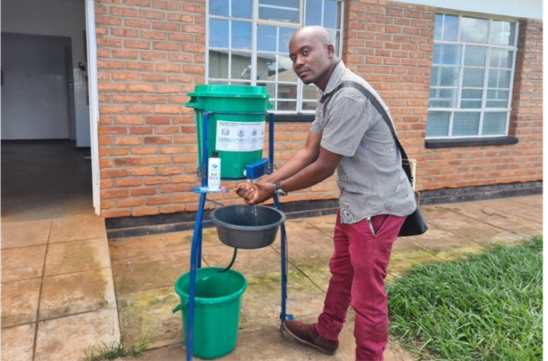  Success demonstrating how to wash hands correctly at Lula health centre. UNICEF Malawi/2022/Kalemba
Lula health centre is managed by seven permanent staff who treat approximately 120 patients per day, including pregnant women and children. "We used to have a lot of diarrhoea and scabies cases. The recurrence of these infectious diseases was a result of lack of hygiene and sanitation in the community and at the hospital," Success explains.
In a country where many health facilities lack plans and budgets for improving water and sanitation, infection prevention is a concern. The lack of proper infection prevention practices compromises health workers' ability to provide safe and quality care to their patients. It also prevents people from seeking care and undermines staff morale –according to the WHO and UNICEF's "A practical guide for improving quality of care through water, sanitation, and hygiene in health care facilities".
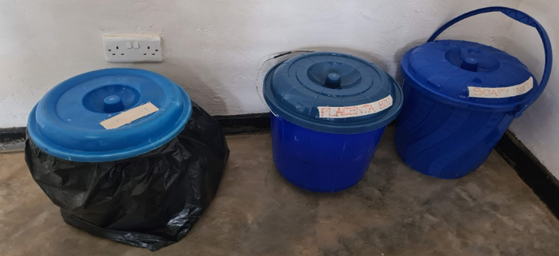  The three-pail system is used to separate wet and dry waste in the labour ward. UNICEF Malawi/2022/Kalemba  The facility has installed hand-washing buckets and soap at all entry points following the assessment. Hand sanitizers have been placed at all points where healthcare workers interact with patients. No one is allowed into any of the health facility buildings without washing their hands.  The maternity wing has also transformed. All plumbing issues have been resolved. Unclogging blocked pipes has resulted in cleaner bathrooms and better-smelling wards. Now more pregnant women prefer to spend their time in the ward rather than outside, as was the case in the past. This is important because pregnant women are encouraged to come to the facility to wait to give birth two weeks before their due date. The labour ward's waste management has also improved. The three-pail technique is being used to properly separate infectious and noninfectious waste for proper disposal. The equipment is clean and sterilized, and the floors and walls are spotless. | UNICEF, in collaboration with Rumphi district hospital, has trained Lura health facility staff in the WASH FIT (Water and Sanitation for Health Facility Improvement) tool. As part of the training, the health facility was assessed in water supply, sanitation, waste management, hand hygiene and environmental cleaning, environment and climate change, and management and workforce. Gaps were identified, and a plan to close them with available financial and human resources was developed and implemented and tracked to sustain the improvements made so far.  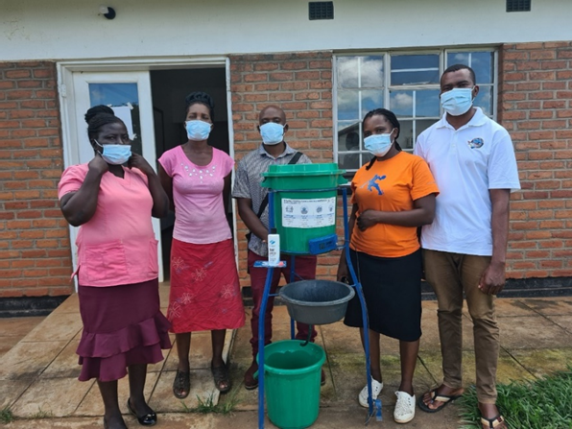  Annie Mwandalira in a purple skirt with other staff from Lula health centre. UNICEF Malawi/2022/Kalemba

2.4 Programmes’ description
In this section, the report presents the actions, relevant outputs and outcomes of each programme implemented in 2022 made possible with funding from different donors through the SDG-AF, highlighting key areas of intervention and the changes achieved or expected from the initiative. Beyond the coordination, the results generated by programmes under the SDG-AF has contributed to the achievement of Malawi’s key priority areas, including a dedicated outcome on gender equality and women’s empowerment.
The eight joint programmes that were implemented in 2022 with support from the SDG AF to ensure strengthened UN coherence, coordination and collaboration in Malawi, are highlighted below.
2.4.1 Malawi Partnership for Resilience (MP4R/PROSPER)
Participating UN Agencies: | FAO, UNDP, UNICEF, WFP | Geographic scope: | Balaka, Chikwawa, Mangochi and Phalombe
Government Partners: | Ministries of Health, Agriculture, Gender and Social Welfare, Finance and Economic Planning, Local Governance, Natural Resources Management, and Department of Disasters Management Affairs | Budget: | originally US $ 59,590,000 USD allocated, subsequently downscaled)
Other Partners: | • Consortium: Concern Worldwide, United Purpose, GOAL Malawi, Kadale Consultants, CUMO Microfinance  • Cooperating: Find Your Feet, PLAN International, World Vision, CARE Malawi. | SDGs targets: | SDG 1: No Poverty SDG 2: Zero hunger SDG 13: Climate action  SDG 17: Partnerships
Duration | 2019-2023

The MP4R is part of a greater consortium called PROSPER – Promoting Sustainable Partnerships for Empowered Resilience (PROSPER). PROSPER was a multi-stakeholder resilience programme scheduled to run from 2019-2023. PROSPER is currently implemented by a joint UN consortium consisting of the Food and Agriculture Organisation, the United Nations Resident Coordinator’s Office in Malawi, the United Nations Development Programme, the United Nations Children’s Fund, and the United Nations World Food Programme in the districts of Balaka, Chikwawa, Mangochi and Phalombe.

Key areas of intervention
Diversified agricultural production and nutrition | Access to productive resources | Reduce vulnerability and exposure of communities to risk | Increase resilience programming

2.4.1.1 Overall results
In year four, the Malawi Partnership for Resilience (MP4R) continued to show positive outcomes. In programme areas, agriculture production has increased, and food security and nutrition indicators have improved. Regreening efforts are bearing results and high-resolution satellite images show that there is an overall improvement in vegetation. Most participants reported increased yields and improved ability to resist natural disasters such as floods and prolonged dry spells. Together, PROSPER partners strengthened social protection systems to respond to shocks and supported a digital disaster response system. Implemented in a coordinated manner, the interventions have improved livelihoods by creating healthier natural environments and reducing the risks and potential impacts of climate shocks. This year, the programme directly strengthened the resilience of 305,833 people to withstand current and future weather-related shocks and stresses. The programme also indirectly supported 759,852 reaching a total of 1,065,685 people. 3,011 hectares of degraded micro catchment/watershed was rehabilitated or conserved. As the PROSPER programme enters its final year in 2023, exit plans for activities have been put in place by the different partners.
2.4.1.2 Specific Results
- Improved adoption of nutrition practices: the programme continued to provide technical assistance to district councils and national-level structures to enable the Government to take over the implementation of nutrition-sensitive activities. Community-level nutrition interventions such as care group door-to-door visits aimed at improving infant and young child feeding practices, maternal nutrition and wellbeing, and water, sanitation, and hygiene (WASH) and dietary diversification continued. PROSPER also supported other traditional social behaviour change communication (SBCC) approaches such as songs, theatre, mobile vans, public address systems, and cooking demonstrations to increase coverage of nutrition information reaching 82,000 people, including school children (56 percent girls).

- Increased agricultural production, adoption of Climate Smart Agriculture, and inclusive access to quality agricultural inputs: In 2022, the programme continued implementing farmer field schools (FFS) to support agricultural livelihoods. A total of 30 master trainers (MTs) and 30 community-based facilitators (CBFs) graduated from the 3rd cohort with improved knowledge on good agriculture and climate change resilient practices to implement during the rainy season. The programme trained 2,404 community-based facilitators (CBFs) through farmers field schools. And are providing extension support to approximately 70,000 farmers. About 17,600 households directly participating in the community outreach groups started adopting some of the technologies showcased at the FFS groups. To boost incomes sustainably, PROSPER supported groups to do commercial farming and business activities, 120 CBFs were involved in VSL schemes and established commercial plots for winter and rain fed cropping activities. Proceeds from commercial plots were supporting other FFS group activities to the extent that 22 groups have used part of the savings to buy land upon which their business will be established. Support was also provided to livestock pass on beneficiaries with a total of 24,309 goats passed on to 10,546 beneficiaries from the start of the program including provision of animal health services to the beneficiaries.

- Improved natural resource management through asset creation and protection linked to food security: the programme continued supporting 16,716 households in Balaka and Phalombe Districts with land resource management, forestation, flood control measures and small-scale irrigation, among other activities, to implement integrated watershed management activities. Of the 16,716 participating households, cash-based transfers covered immediate food needs for 2,750 households. The remaining households received technical assistance to build or maintain assets, to participate in village savings and loans (VSLs) for financial inclusion and/or to adopt post-harvest handling technologies and market support for sales. Farmers have also reported improved water availability for irrigation and domestic usage owing to the land resources structures (i.e. deep trenches), which have helped to increase water infiltration and enhanced groundwater recharge.

- Improved natural resource management through asset creation and protection linked to sustainable natural resources-based livelihoods: the Programme we constructed flood mitigation works in Chikwawa to protect vulnerable communities at Milole River and Mankhwadzi River. The works were designed to protect 382 households, 1,910 people. When Tropical Cyclone Ana hit Malawi in January 2022, the programme supported evacuation centers in Chikwawa and Phalombe which provided refuge to 1,995 people during Tropical Storm Ana and Cyclone Gombe (748 Chikwawa, 582 for Phalombe and 665 for Mangochi. The centers and the flood mitigation work directly reduced the risk and impact of this major shock.

- Increased access to insurance products for smallholder farmers and private sector entities engaging with smallholder farmers: The programme offered a community-based micro-credit scheme (locally called VSLs) aimed at increasing smallholder farmers’ ability to purchase food and agricultural inputs; invest in income-generating activities; cover the cost of education and health-related expenses; and diversify their livelihoods. WFP is currently exploring a partnership with a telecommunications company to roll out a digital group wallet for VSLs, by building on a pilot led by the Ministry of Gender, Community Development and Social Welfare with the company. During the 2021-2022 farming season, 13,584 farmers insured crops such as maize, sorghum, rice, groundnuts, pigeon peas and cotton to protect their incomes from harvest losses. Farmers accessed these policies by either paying a portion of their premium in cash or participating in building community assets such as shallow wells, vegetable gardens and tree nurseries to enable them to withstand future weather shocks. For the 2021/2022 crop season, they have received a pay out of USD 320,232. This represents an average payout of USD 24 per individual.

- Improved community access to effective climate information services and community-based risk mitigation: The project scaled up the Participatory Integrated Climate Services for Agriculture (PICSA) to reach 5,840 households in PROSPER TAs through extension officers and lead farmers, who received weather and climate information. PICSA uses historical climate information to assist farmers to choose crop, livestock, and livelihood options best suited to them. This is further expanded by district-specific seasonal rainfall forecasts for informed decision-making through radio messages. WFP’s monitoring shows that most farmers continue to obtain weather and climate information through radios (61 percent).

- Provision of Lean Season Top Ups to vulnerable households: In the 2021/2022 lean season response, WFP provided monthly cash-based transfers to 75,000 affected people in Chikwawa District. Due to limited resources, beneficiaries received a monthly transfer (USD 23 or MWK 18,000) which was equivalent to 75 percent of the monthly household in-kind food basket. The programme also piloted "cash-plus" interventions in parallel to its cash support to food-insecure populations. To facilitate the targeting of food-insecure households, the programme developed a web-based application for the national social registry. The programme also provided technical support that enabled the provision of lean season response payments through both a vertical expansion through the national social protection system in Balaka district and a horizontal expansion in the urban areas. Over 158,681 households will receive their lean season support via the existing national social protection system receiving support via mobile money payments.

- Increased capacity of national, sub-national and non-state actors to plan, coordinate and monitor resilience programming, including shock-responsive social protection: In 2022, the programme continued to support district councils with Shock Sensitive Social Protection cash plus interventions: bulk messages (SMS) on cholera awareness and prevention in Chichewa were sent to over 721,744 people in Malawi’s 4 urban areas (Zomba, Blantyre, Lilongwe and Mzuzu). Face-to-face social behaviour change messages on cholera reached an additional 29,228 people. The programme provided technical assistance in usage of the Management Information System (MIS) to ensure smooth implementation of the lean season. The support also extended to development of the Urban Lean Season Targeting Tool and Data collection training sessions on the e-MIS, an Operations Manual for the E-MIS was developed to guide and form a basis for all future interventions in the urban areas. This enhanced sustainability and accountability mechanisms and also increased the efficiency and effectiveness of the programme. Under the urban lean season response 2022/23, over 145,000 households received their transfers via e-payment modality of the national social protection system.

- Improved Disaster Risk Management Information System (DRMIS): The system is designed to digitally record disaster-related information, make better sense of the data available, and provide more accurate data-informed insights on what action to take. Whenever a disaster strikes, data is paramount for informing effective response strategies. Having all the data in a singular, accessible and shared system makes it more efficient for analysis, planning and coordinated response. This digital system collates information from various sectors to better understand the affected communities and their needs immediately after a disaster.

2.4.1.3 Challenges and lessons learned
The usage of call center through TNM Bulk messaging software to send cholera preventive messages to all households benefiting from the urban Lean season response was a very innovative, easy and faster way of disseminating information and it further confirmed how social protection systems can be leveraged upon during humanitarian response. Monitoring data showed that the adoption of the better practices learnt at the FFS study plots led to a significant increase of yields and quality of produce when compared with previous harvest periods in which farmers relied on traditional practices. Disaster Risk Management Information Systems was successfully implemented in the four districts and having realized the capability of the humanitarian information system that reached people, address the full scale of needs caused by increasingly intense and overlapping crises the government of Malawi has incorporated the Information System in the draft Disaster Management Bill.

2.4.2 UN Joint Programme on Health Systems Strengthening for Equitable Health Outcomes
Participating UN Agencies: | WHO, UNFPA, UNICEF | Geographic scope: | Rumphi, Mzimba, Ntchisi, Kasungu, Chikwawa, and Nsanje
Government Partners: | Ministry of Health | Budget: | US $ 10,575,249
Other Partners: | Malawi Red Cross Society (MRCS),  Kamuzu University of Health Sciences (KUHeS), Chancellor College, Christian Health Alliance of Malawi, Banja La Mtsogolo (BLM), Family Planning Association of Malawi (FPAM), Staff Development Institute (SDI), Clinton Health Access Initiative (CHAI) | SDGs targets: | SDG 3: Good health and wellbeing  SDG 5: Gender equality  SDG 6: Clean water and sanitation
Duration | 2020-2023
The Umoyo Wathu Health Systems Strengthening Joint Programme (UW-HSS) aims to build a responsive and resilient health system, improve the quality of health services, attain Universal Health Coverage (UHC) and integrate service delivery at the sub-national level through decentralized governance mechanisms and stakeholder engagement. It supports a package of system strengthening initiatives at the district level across maternal, neonatal and child health (MNCH) services as well as a component to strengthen preparedness and response to health shocks, such as COVID-19.
The primary objective of the programme is to develop a responsive and resilient health system that facilitates the simultaneous availability of the “4 Ps”: skilled People, accessible necessary Products, well-maintained Places of care, and supportive Policies and governance that will provide quality, people-centric, integrated health services through a prioritized Essential Health Package (EHP), in line with the Universal Health Coverage aspirations.
Key areas of intervention
Quality of Care | Integration | Resilience | Governance

2.4.2.1 Overall results
To improve the quality of care obtained by people in Malawi the programme supported the development of an online quality of care continuous development platform and built the capacity of the 129 members of the Quality improvements support teams. The programme supported Malawi Emergency Obstetric Care Assessment to identify capacity and gaps in services and helped with the design and development of a Network of Care model and Centres of excellence to improve emergency services. The programme supported the adoption of the One Health Surveillance Platform (OHSP), a digital health platform to improve Integrated Disease Surveillance and Response (IDSR).
2.4.2.2 Specific Results
- Improved Quality of Care: The Continues Professional Development (CPD) online platform is bridging the knowledge and skill gaps in healthcare quality among healthcare workers for better maternal and newborn care outcomes. The programme supported MNCH mentorship program for 228 which is an 87.7 per cent increase compared to 25 in 2021. To ensure quality, comprehensive, and dignified care for women during antenatal care (ANC), labour, and delivery, and postnatal care (PNC), 209 midwives and health cares have been mentored. To increase the use of data at the district and sub-district levels, and the district capacity vis-a-vis the MatSurv platform-DHIS2 interoperability, a three-day capacity-building workshop for district safe motherhood coordinators and HMIS focal persons was conducted. In 2022 close attention has been paid to perinatal surveillance and Response. Improved data quality for decision making. To ensure that high-quality data was available and utilized in decision-making at all health system levels, hands-on onsite coaching was conducted.

- Enhanced Integration: the programme increased the capacity among health workers (facility and community workers) to provide Integrated Management of Childhood Illnesses (IMCI) and Integrated Community Case Management (iCCM) services respectively. Approximately, 316,000 people in Nsanje and Chikwawa have been reached with messages on safe motherhood services: Family planning, Antenatal care, Obstetric care, postnatal care, prevention of mother-to-child transmission of HIV (STI and HIV control), as well as male involvement in reproductive health issues. As part of an integrated package, the programme strengthened the community-to -health facility nexus and improved the availability and access to health services in forty hard-to-reach areas. A total of 1,688 people (353 males, 1,335 females) accessed ANC, cervical cancer screening, HIV testing services, and STI consultations. 3,186 children (1,375 males; 1,811 females) benefitted from vaccination services in the three districts.

- Strengthened Resilience: the programme continues to support the Ministry of Health in the use of the One Health Surveillance Platform (OHSP), a digital health platform which has improved IDSR weekly and monthly IDSR reporting target of 80% on the timeliness of weekly reporting. The programme also strengthened the capacity of healthcare workers and cleaners from 134 health facilities on the infection prevention protocols using the practical WASHFIT tool, this was very crucial in the period of the prolonged Cholera outbreak that plagued all the 29 districts in Malawi.

The programme has also been supporting Malawi's new health commodity logistics system which has reduced stockout rates, improved inventory management, including adherence to national standards. To improve health workers' availability, accessibility, and motivation, a human resource functional review was conducted in Chikwawa district in leadership and management. The UNJP has contributed to improving the use of health information to guide program planning and management.
- Governance: the programme continues to support the strengthening of the health sector planning, budgeting, coordination, and implementation at the sub-national level and improving accountability for improved health outcomes, at health facility level. Specifically, the programme supported DIP and HMIS reviews which contributed to improved health information to guide planning and management, improved capacity in evidence-based planning and management of resources, conducted on-site coaching, increased the capacity among governance structures to execute leadership and governance roles, contributed to improving the use of health information guide program planning and management.

2.4.2.3 Challenges and lessons learned
The programme experienced a delayed start mainly due to the multiple revisions and delay in funding disbursement. This delayed disbursement of funds affected the program’s scope of work and the alignment of available funds to the scope of work. The thematic scope of the programme has been revised multiple times to meet the reduced finances available. The programmatic implication for this is that the programme becomes an activity focus instead of a strategic focus which is challenging for a system-strengthening program. Monitoring and evaluating the program outcomes and impact became challenging as several activities implemented in the first year were discontinued due to funding issues. Also, the fragmented nature of the programme makes results-based reporting challenging, as tangible results cannot be attributed to the program, given the approach of implementing activities in a disjointed manner. Operationally, the irregular flow of funds results in sub-standard programme effectiveness and, unfortunately also has implications on the value-for-money component of the programme
Furthermore, the unpredictable funding levels and disbursement timeframes, especially for subsequent years, continue to affect the advocacy and continuity of the programme at national and district levels. Continued engagement with funding partners to ascertain the level of funding and the focus area is ongoing.
Quality Drugs compliments Quality Care!!!
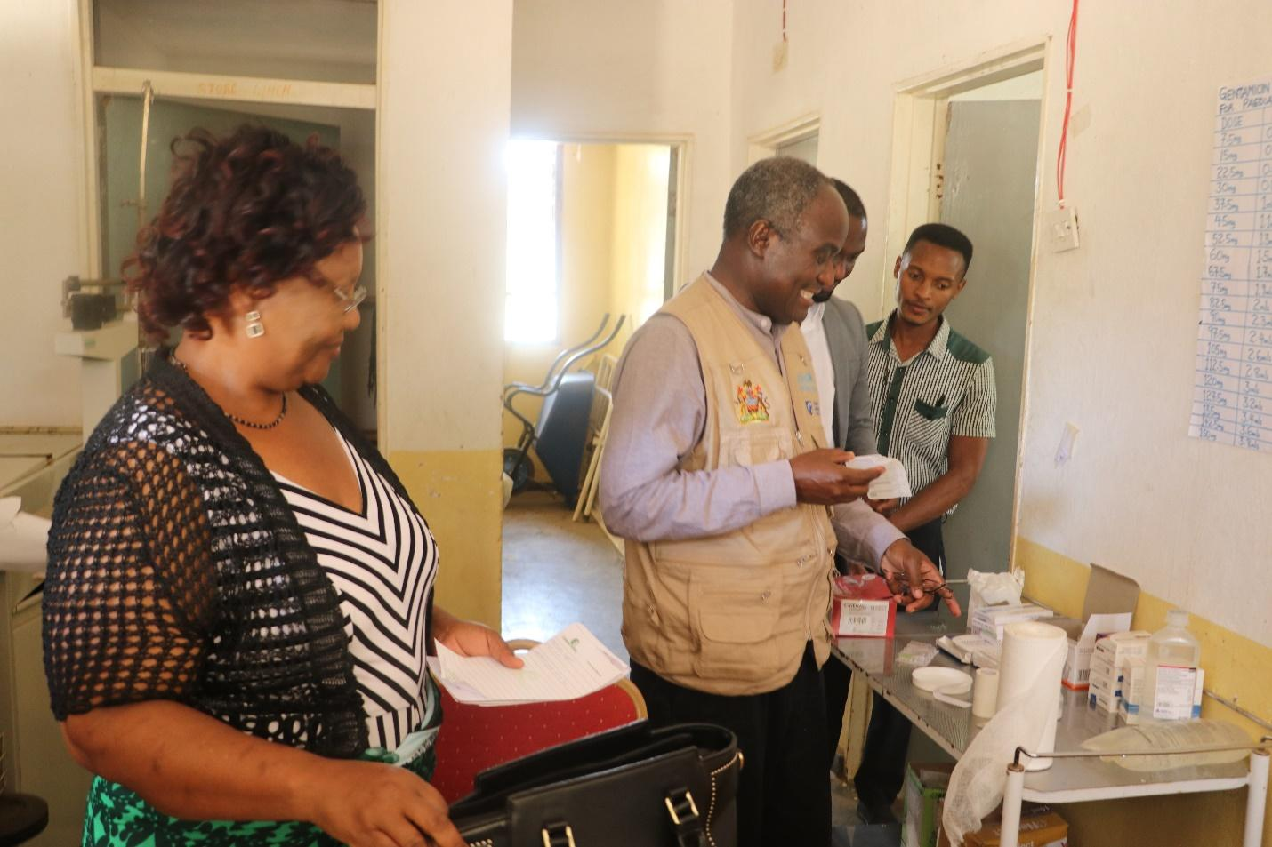
Secretary for Health, Dr Charles Mwansambo inspecting drugs as Chisimuka Health Center during a UNJP and FCDO Joint Field Trip to Rumphi District
2.4.3 UN Joint Programme on Girls’ Education III: Learning for All in Malawi
Participating UN Agencies: | UNFPA, UNICEF, WFP | Geographic scope: | Dedza, Kasungu, Mangochi, Salima
Government Partners: | Ministry of Education; Ministry of Health; Ministry of Youth and Sports; Ministry of Gender, Community Development and Social Welfare; Ministry of Agriculture; Ministry of Information and Communication; Malawi Police Services; District councils | Budget: | US $ 28,781,729
Other Partners: | Malawi Girl Guides Association (MAGGA); Family Planning Association of Malawi (FPAM); Ujamaa – Pamodzi. | SDGs targets: | SDG4 - Quality Education  SDG3 - Good Health and Well-being  SDG5- Gender Equality  SDG2 Zero Hunger  SDG17 Partnerships
Duration | March 2021-October 2024

The programme started in 2014 and is currently in its third phase (2021-2024). The JPGE III “Learning for All in Malawi – Ensuring the realization of girls’ and boys’ rights to quality, inclusive and equitable education and life skills” was included under the umbrella of the Malawi SDGs Acceleration Fund, acknowledging girls’ education as one of the most important SDGs accelerators for the country.
The programme promotes a multi-sectoral approach addressing socio-economic, cultural, health, nutrition, and gender barriers. It also adopts a gender transformative approach, maintaining a focus on girls but ensuring the needs of boys are addressed and that they are actively engaged so they can be champions in promoting gender equality. During 2022, the programme completed its expansion from 169 to 199 primary schools as the roll out to the new district of Kasungu was completed.
Key areas of intervention
Education results | Equity and Inclusiveness | Community involvement | Sustainability

2.4.3.1 Overall results
In 2022, JPGE expanded from 169 school in 2021 to 199 (41 schools in Dedza; 54 schools in Salima; 74 schools in Mangochi and 30 in Kasungu) primary schools as the expansion to Kasungu has been completed over the year. The programme reaches 60 health facilities, that are within the targeted schools’ catchment areas (29 in Mangochi, 14 in Dedza, 10 in Salima and 6 in Kasungu). In terms of coverage in the four districts, JPGE reaches 18.2 percent of schools (199 out of 1092 public primary schools) and 46 percent of the health facilities (60 out of 130).
In 2022, JPGE III directly reached 242,849 learners in schools (52 percent girls, and 48 percent boys) through improved delivery and quality of education, school meals, Sexual Reproductive Health Rights (SRHR) and information including comprehensive sexuality education, safety and protection services. 260,173 young people (aged 10-24 years), (54 percent girls and 46 percent boys) benefitted from Youth Friendly Health Services (YFHS), and 56,342 out of school adolescents (64 percent girls, 36 percent boys) were engaged with trainings on life skills, alternative learning, adolescent nutrition support.

To increase knowledge, awareness and support towards education, safety and protection, health and nutrition, the programme reached 165,000 parents/guardians, teachers, community leaders, education stakeholders and youths with different integrated messages through the Social Behaviour Change and Communication (SBCC) strategy.

2.4.3.2 Specific results
- Strengthened capacities of teachers to provide quality inclusive education: In 2022, a total of 3,496 teachers (1,183 females) were trained in Inclusive Education, Sexual Reproductive Health Rights (SRHR), Comprehensive Sexuality Education (CSE); the teachers were also oriented on e-CPD platform, use of braille for teaching comprehensive sexuality education. Head Teachers and PEAs were oriented in child protection in schools. 40,563 learners (20,798 girls) were reached with CSE digitized application. To equip schools with quality inclusive, gender sensitive and SRH education materials, learners received eyeglasses, magnifiers, telescopes or hearing aids, among others. Screening of learners for possible disabilities was conducted and 723 learners were identified with learning difficulties.

- Provision of integrated services in and through schools: 242,849 learners (52% girls) received diversified nutritious school meals prepared from a combination of cereals, legumes, vegetables, tubers, and fruits and procured from small-holder farmers. 122 schools have also established orchards and school gardens contributing to increasing the relevance and quality of education through active learning and through introduction of agriculture and nutrition knowledge and skills. 3,530 adolescents were trained on nutrition and cooking demonstrations to impart skills on preparation of nutrient dense diversified diets. 31,441 in-school girls received weekly Iron and Folic Acid (IFA) supplements. 216,865 learners (111,467 girls) have accessed functional violence reporting and response mechanisms through the school. The school health programme was supported to promote the health of school children to reduce school dropout and to help learners to achieve the highest possible level of education. A total of 29,612 learners (16,896 are girls) were reached with WASH activities using the SHASHA toolkit.

- Increased enrollment and participation of out of school children and adolescents in quality complementary alternative learning and life skills programmes: 5,862 young people (14 -19 years) enrolled in a Functional Literacy programme, a 9 month non formal programme for those that have never been to school or dropped out early. 248 adolescents completed the Complementary Basic Education (CBE) programme, which is a two-year programme that allows out of school adolescents (9-17 years old) to acquire basic literacy and numeracy skills through an accelerated curriculum and enroll back to formal schools after completion of the programme. 44,452 adolescents (aged 10-24 years, 55 % girls) supported with life skills and ASRHR mentorship programmes, which provides a safe space opportunity for girls and boys to discuss SRH, human rights and GBV issues so they can make healthy and informed decisions and seek services when needed. 480 mentors were recruited and trained to have knowledge, skills, and a positive attitude in providing CSE, GBV, livelihood and other topics of relevance.

- Increased availability of integrated SRHR, safety, health and nutrition services for out of school adolescent girls and boys: 390 health care workers supported with on-job sessions on minimum package for integrated YFHS including HIV and SRHR services - providers were assessed and supported to achieve individual clinical competencies across all components of YFHS by certified District Quality Teams. 260,173 (173,275 girls) reached with outreach and mobile clinics services for SRHR and YFHS –In 2022, services scaled up through use of mobile vans, Youth Community Distribution Agents (YCBDAs) providing door-to-door services, and by utilizing youth clubs, teen clubs, and youth community-based organizations as a result 57,360 young people accessed YFHS (36,399 girls). In addition, personal protective equipment was procured and distributed which led to uninterrupted and continuity of Youth Friendly Health Services. In Mangochi and Salima, 4,715 out of schoolgirls received weekly Iron and Folic Acid supplements.

- Stronger engagement of parents and communities: 390 families (918 parents [62.5 %] and 1,660 children [56 % girls] engaged through the Parent-Child Communication (PCC) sessions – this is a two-way communication strategy to improve communication gap between parents and adolescents including issues of sexuality and reproductive health rights. To increase knowledge, awareness and support towards education, safety and protection, health and nutrition, 165,000 (62,500 females) parents, teachers, community leaders and youths reached with different messages through the Social Behaviour Change and Communication. 80 radio programmes were produced and aired on community radio stations to increase knowledge and awareness on SRH issues. 45 percent (44 % female) of targeted farmers sold a variety of food commodities to schools, they were also trained in business management, group leadership and dynamics, record keeping, post-harvest handling, crop protection and collective marketing. This enabled the farmers to provide quality products and bid competitively for their commodities.

2.4.3.3 Challenges and lessons learned
In 2022, the programme implementation was to some extent affected by emergencies. Tropical storms that hit the country in the first quarter of the year resulted in damage to infrastructure in some schools and disrupted learning. The cholera outbreak, that worsened in the last quarter of the year, affected implementation of some activities in a few schools; for example, school feeding was put on hold for a few weeks and in some districts, cholera led to a temporary closure of schools, especially in lakeshore areas in Mangochi and Salima districts. The outbreak also resulted in morbidity and mortality of some learners. Lastly, a protracted national fuel scarcity, combined with depreciation of the national currency, led to commodity price increases and fluctuations on the market that also affected implementation of some activities. However, the programme managed to deliver on planned activities for the year due to its capacity to address and mitigate these kinds of shocks, climatic and economic.
Based on the lessons learnt from the previous phases, to strengthen ownership, coordination at the implementation level has been led by District Councils. Effective coordination, including monitoring, data sharing and actual use of existing tools need to be continuously promoted and strengthened among government authorities at and among all levels, also in terms of sustainability.
The programme aims to produce results that meet the needs of beneficiaries while making the best use of resources available. These principles are being promoted in the implementation of each activity, but also by strengthening synergies and integration among the different interventions. The main approach adopted by JPGE III is to facilitate combining resources and specific knowledge and expertise across several sectors, thus benefiting from multiplier effects.
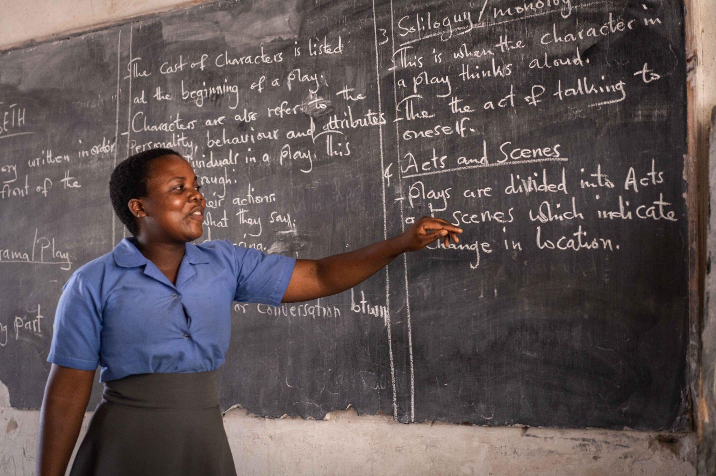
Pemphero, a teen mother, is now back in school in Form 4 at Ngodzi School in Salima under the JPGE

2.4.4 Joint Action addressing GBV, Child Marriage, and Teenage Pregnancy
Participating UN Agencies: | UNFPA, UNAIDS, UNWOMEN | Geographic scope: | Lilongwe, Nsanje, Nkhatabay, Mulanje
Other Partners: | Ministry of Gender, Ministry of Health, National AIDS Commission, Department of Disaster Management Affairs, District Councils | Budget: | US $ 1,075,000
Implementing Partners: | Catholic Commission for Justice and Peace (CCJP) Malawi Interfaith Association (MIAA) GENET, FPAM; PAM, Market Link and Support; African Institute for Corperate Citizenship (IACC); Mzimba Community Radio, Plan international, Female Sex Workers Association, CADECOM | SDGs targets: | SDG3 - Good Health and Well-being  SDG5- Gender Equality
Duration | April 2021 - December 2022

The Joint Action addressing GBV, Child Marriage, and Teenage Pregnancy aimed to advance gender equality and empowerment of women and girls through the provision of protection and prevention services in response to the systemic socio-political discrimination and violence during COVID-19, by building an environment whereby women and girls in Malawi are protected and empowered to live without violence and with availability of care. This project aimed at improving the health conditions of adolescent girls and women through provision of health services, and prevention of Gender Based Violence (GBV), teenage pregnancies through broad scale Sexual Reproductive Health Rights (SRHR), GBV information and services.
Key areas of intervention
Prevention | Protection | Access to services

2.4.4.1 Overall Results
During the project implementation period, there was a demonstration of how Gender Based Violence (GBV) support and scaling up of safe spaces for girls enhanced their capacity to acquire life planning skills. The GBV support services also managed to expand services to include sexual and reproductive health services and information component. Further, the project managed to strengthen GBV and Prevention of Sexual Exploitation and Abuse (PSEA) monitoring, reporting, referral and coordination mechanisms. The expanded space for adolescent girls promoted prevention of violence against women and gender equitable social norms. Attitudes and behavior change were also promoted to prevent violence against women. Within the same space, there was notable improved awareness, knowledge and access to HIV prevention and care among adolescent girls, women and PLHIV during COVID-19. Thus, this intervention managed to integrate a complete package of the SRHR services to adolescents, within a catchment population in a most difficult period to provide services when movement was restricted.
2.4.4.2 Specific Results
- Continuity of maternal and child health services during COVID-19 through the provision of outreach community services and last-mile care: In 2022, there was continuity of SRHR services through FPAM which resulted in a total of 600-hospital scrubs and 200-gowns procured in order to support service providers with prevention measures against Covid-19 pandemic. Community based distribution agents continued to provide door-door of family planning services and referrals. The programe also supported the procurement of Theater equipment for Mulanje and Nsanje districts and the refurbishment of a Fistula ward which is also used as a gynecology ward. The refurbishment works at Milonde and Kang’oma have strengthened infection prevention in the facilities.

- Expanded safe spaces for girls to strengthen life skills, with scaled up provision of SRHR services: A total 66 adolescent girls and young women were equipped with key life skills and demonstrated an average of 80% improvement in knowledge on Sexual Reproductive Health and Rights, gender-based violence, COVID and other related topics. The participating girls have shown empowerment, making key decisions about their lives, including decisions to access family planning services to prevent teenage pregnancies and early marriages, and decisions to go back to school. At community level, 65 mentors and focal persons have been linked to service providers through interface and engagement meetings with different stakeholders. These meetings enabled different structures to better understand their role in supporting mentors and Adolescent Girls and Young Women (AGYWs) in their communities, opened opportunities for AGYW to themselves engage and hold accountable their duty bearers. The programme initiated the creation and orientation of 6 VSL groups and offered a start-up capital of MWK200,000 to each group to boost their capital. The economic empowerment has positively impacted GBV survivors and has led to a decrease in the risk for further abuse of survivors due to poverty.

- Strengthened GBV and SEA monitoring, reporting, referral and coordination mechanisms: To ensure that violence is mitigated in communities that surround the AGYW, awareness meetings with community structures on mentorship activities, and GBV prevention and response were conducted. This has created a safe space that allows women and girls to feel protected from all forms of violence through GBV prevention, mitigation, and response intervention. A total of 102 girls have been referred to SRH services including 35 girls accessing family planning services. 115 girls in need of psychosocial counseling have been counseled and linked to social welfare for further services.

- Strengthened focus on gender equitable social norms, attitudes and behavior change: On addressing the Gender equitable social norms, attitudes and behaviour change promoted to prevent violence against women; a total of 135 male champions engaged as agents of change in promoting positive masculinities for male engagement on EVAWG and SRHR were identified and oriented on the male engagement HeForShe barbershop toolbox approach. Trained male champions have scaled up the initiative and reached out to other groups of men in their communities through community dialogues and awareness campaigns as designed by the toolbox. A total of 270 men and boys have been reached directly while over 1000 men and boys have been reached indirectly. In addition, 150 parental and adult committees engaging in dialogues on ending child marriages, teenage pregnancies, SRHR and positive social norms, alcohol and drug abuse were formulated. This has helped in changing mind set of some parents towards their girl child and they are advocating for girl child education.

- Strengthened capacities of national, district and community levels on gender mainstreaming in COVID-19 response programming: In 2022, the programme continued to build capacities of national, district and community levels humanitarian stakeholders on gender mainstreaming in COVID 19 response programming. Skills and knowledge equipped included collecting sex, age and disability disaggregated data, conducting rapid gender analysis, women participation and influence in COVID-19 response and recovery, PSEA and GBV in emergencies. A total 70 (27 females and 43 males) MHPSS service providers were mapped and linked with frontline workers on protection and GBV prevention in response to COVID-19 to raise awareness on GBV, SRHR and COVID-19 through community radio programmes and public outreach campaigns reaching out to approximately 10,000, this resulted in a decrease of GBV cases.

2.4.4.3 Challenges and lessons learned
The year 2022 in Malawi started off with a period of heavy rains and a tropical storm ANA (Malawi 24th and 27th January 2022) which led to severe flooding across some districts in the southern region of Malawi. This resulted in loss of lives, injuries and missing persons and massive displacement of the affected population including health care workers working in the affected areas. Displaced populations are mostly being hosted in poorly equipped camps in which men, women and children including adolescent girls are sleeping under one shelter putting at risk health lifestyles of the Internally Displaced People (IDPs).
The situation was an emergency, and a state of disaster was declared with 3-main districts affected, mainly Nsanje, Chikwawa and Mulanje districts. The 2-districts of Nsanje and Mulanje that were targeted for the SDG acceleration fund extension for theatre refurbishments were severely affected with roads cut off limiting movement to these 2-districts and a major focus by the district teams towards the emergency response as opposed to usual programme implementation. This therefore has resulted in a hold on the progress to be made towards the programme implementation especially refurbishment of the 2-operating theatres.

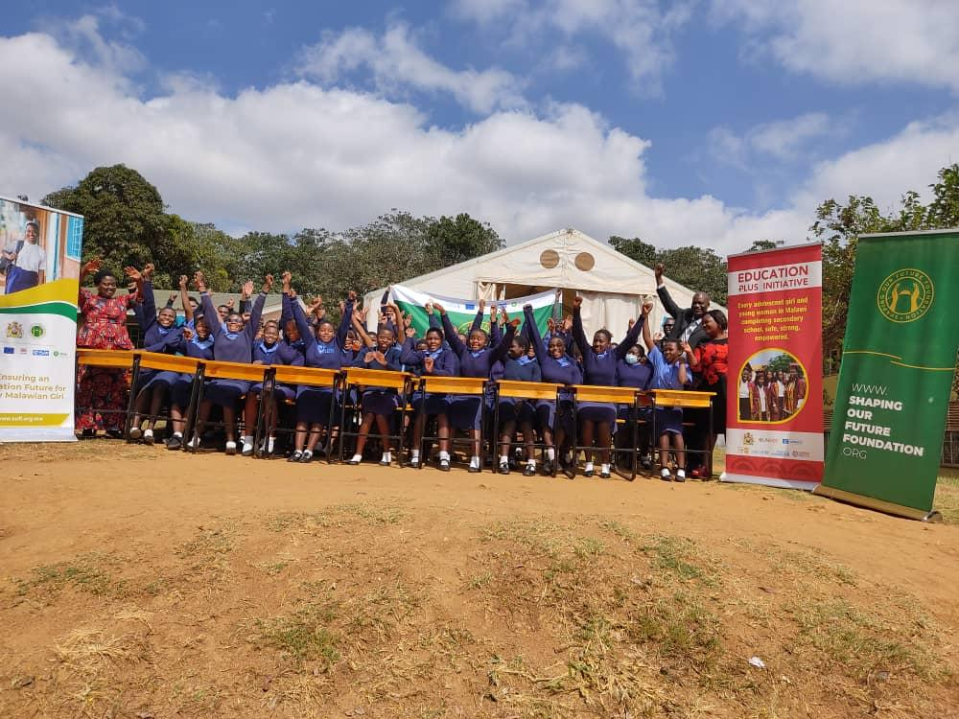 Donation of Desks by The Joint Action addressing GBV, Child Marriage and Teenage Pregnancy- Lilongwe Girls Secondary School

2.4.5. Border Districts and Community-Based Conflict prevention and Peace Building in Malawi

Participating UN Agencies: | UNDP, UNFPA, UNODC, IOM. UNWOMEN | Geographic scope: | Mangochi and Mulanje
Government Partners: | Ministry of Local Government, Unity and Culture, Ministry of Homeland Security Ministry of Justice Ministry of Local Government and Rural Development Ministry of Gender, Community Development and Social Welfare Ministry of Youth and Sports | Budget: | US$ 837,312
Other Partners: | Public Affairs Committee non-state actors, including civil society organizations | SDGs targets: | SDG 5 -Gender equality  SDG 16 -Peace, justice & strong institutions
Duration | September 2022- August 2023

The project aims to provide support in two border districts in areas of institutional, professional, and community resources to identify, mitigate, and respond to violent conflict or risk of conflict including radicalization and terrorism and the potential for Islamic radicalization directly from Mozambique, which is playing on existing latent religious tensions at the community level. This includes supporting community networks, increasing their engagement in conflict identification, mitigation, and prevention, strengthening border security management, and increasing the capacity of the national peace architecture.

 |  |  | Key areas of intervention
Mitigation | Prevention | Strengthening border security management |  | Community Involvement

2.4.5.1 Overall Results
In the period between 2 September – 31 December 2023, the project reached a total of 703 people in Mulanje and Mangochi (71%male, 29% Female). The activities that were carried out included trainings on peacebuilding, conflict prevention, and mediation. The trainings targeted key officers working at the district level as well as community representatives who play a key role in conflict prevention and mediation in their localities. The approach recognizes that border communities are unique in livelihoods, socio-economic relationships, and cultures, and that successful peacebuilding initiatives are owned and led by people in their local context. It includes support for established formal institutional structures, including the legal framework and district peace and unity committees, as well as community-led initiatives and platforms. Further to this, 21 informal crossing points/Points of Entry (PoE) identified 12 congregation areas, and delineated 18 potential route corridors used by travelers across 4 T/As (Makanjira, Katuli, Jalasi, and Bwananyambi).
2.4.5.2 Specific Results
- Strengthened National Peace Architecture: The programme strengthened the peace architecture at the district level and enhanced coordination between national and district peace institutions. Further to this, the capacity of District Peace and Unity Committees (DPUC) was strengthened, a total of 54 participants were trained on conflict prevention, gender analysis, mediation, border security, conflict monitoring and reporting, both at community and district level. The trainings also provided an opportunity for the DPUC members to strengthen their relationships and explore potential areas of synergies with stakeholders in their locations as well as exchange information and coordinated response to potential threats in a timely manner.

- Enhanced community capacity to mitigate and respond to conflict: To improve the capacity of community-level leaders and mediators to prevent escalation of small-scale conflicts, the programme trained borderland communities in conflict monitoring, analysis, reporting, and mediation. They were also equipped with knowledge on counterterrorism and transnational crimes, border security and management, community policing and peacebuilding, legislative and policy framework on peace and unity and related elements including UNSCR 1325 on Women, Peace, and Security and UNSCR 2250 on Youth Peace and Security. Furthermore, participants gained knowledge and skills on how they can mainstream gender through gender-responsive mediation, conflict analysis, community policing and peacebuilding.

- Provided training to security actors on information gathering, monitoring and enforcement of border control measures: IOM and partners including UNDSS conducted Flow Monitoring Local-Level High-Mobility Assessment (HMLA) a Population Mobility Mapping/Participatory Mapping Exercise (PMM/PME) to identify potential informal crossing points, congregation areas and route corridors used by travelers crossing the border. The HMLA exercise was attended by a total of 20 participants (3 female, 17 Male) Seven Flow Monitoring Points (FMPs) from a total of 21 identified informal entry points were established. Seven (7) Displacement Tracking Matrix (DTM) enumerators were successfully trained, oriented, introduced to local community leaders and deployed to collect Flow Monitoring (FM) data. DTM has been producing monthly dashboard reports since December 2022, providing monthly updates on human mobility including flows, reasons of movement, vulnerabilities, and monthly flow trends among others.

- UNFPA is providing technical and operational support to gender equality and mainstreaming and youth empowerment on service delivery and community empowerment: so that the communities are able to tackle the causes of conflict and harm, including violence against women and side-lining of the youth, to enhance social stability. Increasing the capacity of these groups will lead to more resilient communities capable of resolving disputes through peaceful formal and informal mechanisms that support an inclusive and tolerant society. The use of safe spaces for adolescent girls and young women is one way of conflict prevention, mitigation and conflict management.

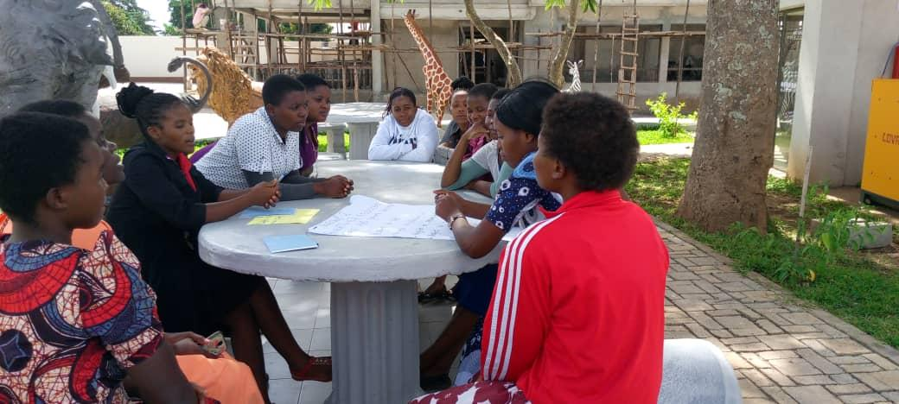
Group Discussion during Safe Space Mentors Training for Mulanje

2.4.6. UN Joint Programme- Learning Never Stops Malawi

Participating UN Agencies: | UNICEF, UNESCO | Geographic scope: | National level and reach all six education divisions
Government Partners: | Ministry of Education, Ministry of Gender, Community Development and Social Welfare | Budget: | US $ 700, 000.00
Other Partners: | Centre for Therapeutic Services and Social Change | SDGs targets: | SDG4- Quality Education  SDG5- Gender Equality
Duration | April 2021-August 2022

The Learning never stops Joint programme improved the access to education for children and adolescent girls in Malawi in crisis-like situations, especially for the most vulnerable children with special education needs, within a school environment able to ensure the well-being of learners. The project responded to the immediate need of the Ministry of Education to ensure continuity of learning in the context of the COVID-19 pandemic. The project sought also to partially fill the gaps in ongoing interventions in distance learning, offering solutions that would enhance the provision of flexible, inclusive education in future crises and mitigate the impacts of the current one, with a special focus on the right to education of marginalized and vulnerable girls and learners with special needs.
Key areas of intervention
Access to quality inclusive education | Social behavior change

2.4.6.1 Overall Results
The Learning Never Stops project enabled 1.9 million learners (57 per cent females), especially girls and those with special needs to access quality learning opportunities through distance learning programmes and materials to enhance the continuity of learning using the community platforms since schools were closed during the COVID-19 emergency. Through the SDG LNS funding, the Ministry of Education (MoE) developed Interactive Radio Instruction (IRI) materials which improved its readiness to ensure continuity of learning in response to COVID-19 school-related closure and for future use in the likelihood of any other emergency. Over 600,000 learners (66 per cent girls) were empowered to challenge social-cultural norms leading to sexual and gender-based violence through social behaviour change and communication messages which were developed focusing on COVID-19 prevention and management. The messages also focused on Sexual Reproductive Health (SRH), Ending Teenage Pregnancy (ETP), and Gender-Based Violence (GBV) through role modeling activities with students, television documentaries, radio drama, and jingles to facilitate community engagement and awareness.
2.4.6.2 Specific Results
- Improved coverage and quality of distance learning programmes for all, including those with special needs: Four hundred Interactive Radio Instruction (IRI) programmes for term two for primary schools in English, Chichewa, Maths, and Science were developed. The programme has enabled MoE to have radio programs that cover the whole primary school year and would enable continuity of learning through radio should schools close at any time. A Life Skills Education radio lessons for Forms 1 and 2 was also developed and the development of additional lessons for Life Skills Education will ensure continuity of learning during school closures. The programme has also been supporting the development of a package of COVID-19 prevention and control, Sexual Reproductive Health, Ending Teenage Pregnancy, and Gender Based Violence messages.

- Strengthened education system’s capacities to provide psychosocial support to teachers and learners: To enhance the psychosocial and mental health of learners, capacity building activities addressed to 1,711 (866 females, 845 males) between headteachers, PEAs and teachers were conducted from 80 selected primary schools in five targeted districts namely, Lilongwe, Mzimba, Mwanza, Nkhatabay, and Blantyre Districts. Capacity building activities for 38 teachers (16 females, 22 males) of learners with disabilities on inclusive methods of also conducted, through the Breaking the Silence (BTS) approach, an evidence-based curriculum- delivering lessons were implementation approach targeting the delivery of Comprehensive sexuality education (CSE), parenting support, and community engagement for learners with disabilities in and out of schools. Additionally, a draft Referral Pathways for Mental Health Support at the school level was developed.

- Strengthened support to vulnerable and at-risk girls for their safe return to schools: High-level role modeling activities have been conducted in primary and secondary schools in the target districts with the aim of empowering and motivating girls to remain in school. Approximately 2,000 adolescent girls have been empowered and over 105,000 people have been reached on readmission policy, continuity of education, gender equality, sexual gender-based violence, and COVID-19 prevention. This component will be reinforced by the current development of Information, Education and Communication (IEC) materials, such as posters, flyers, radio jingles, short videos, radio drama translated in vernacular languages and will support the scaling up of awareness activities around continuity of learning. Multimedia messages are expected to reach over 1,000,000 people across the five districts and even spill over across the country.

2.4.6.3 Challenges and lessons learned
COVID-19 had a devastating impact on education worldwide. In Malawi, between March – September 2020 and January -February 2021 schools were closed for prolonged time causing enormous disruption and loss of learning among children. The immediate and continuing need therefore was to provide additional support to children and teachers to recover from the learning losses through different means. This included training to teachers to provide remedial support and remedial learning including targeted instruction and small group tutoring, including guided learning to learners. The third wave of COVID-19 between June and August 2021 proved to be a challenge, slowing down implementation of activities.
The lesson learnt is that the COVID-19 school related school closure and the response in terms of continuity of learning requires new ways of delivering learning, particularly through digital learning and internet enabled learning platforms. This calls for urgent action for the education system to ensure the digital transformation and application of technologies in teaching and learning is strengthened as part of policy and practice including budgetary allocation to realize a new vision for education, one in which learning happens for everyone, everywhere for all children.
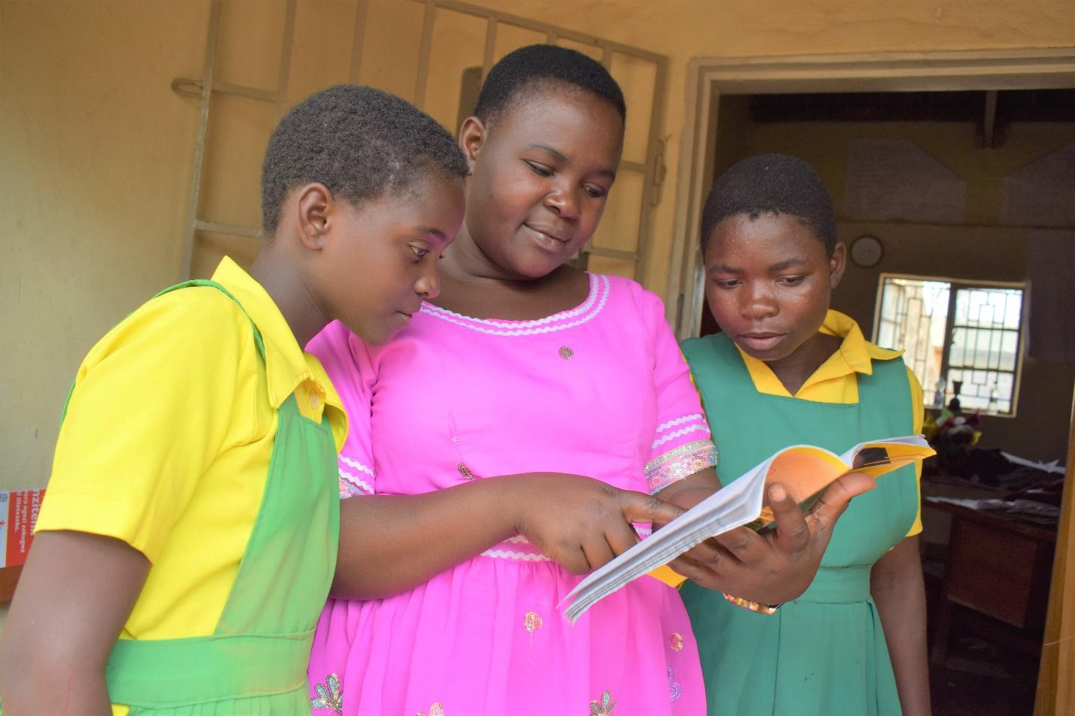
Alefa with her teacher Enless and her classmate © UNICEF Malawi/2022/Chavula
2.4.7 Malawi National COVID-19 Vaccine Programme Support
Participating UN Agencies: | WHO, UNDP, UNICEF, WFP | Geographic scope: | Nationwide
Government Partners: | Government of Malawi, Ministry of Health | Budget: | US $:2,099,949
Other Partners: | College of Medicine, University of Malawi | SDGs targets: | SDG3 - Good Health and Well-being  SDG17 Partnerships
Duration | April 2021- July 2022

The Malawi National COVID-19 Vaccine Programme supported the national deployment of the COVID-19 vaccine in Malawi to directly lead to the vaccination of 3.8 million people from specific priority groups over the course of one year under the implementation of the COVID-19 National Preparedness and Response plan. The progress achieved so far was due to the support provided to the Government of Malawi and its partners to improve demand and uptake of the vaccine. The programme also strengthened human resources capacity required for the deployment of vaccines, and augmented the cold-chain, general supply chain capacity of the health system, implementation, monitoring, evaluation, and shared learning of the vaccination roll out process.

Key areas of intervention
Planning and coordination | Effective vaccine deployment | Supply chain and logistic

2.4.7.1 Overall Results
Over 8,000 health workers of which 3,760 were female have been trained for COVID-19 vaccine roll out and in the conduct of effective monitoring and supervision. At the end of the project, over 3 million COVID-19 vaccine doses had been administered, and 1,716,923 Malawians had been fully vaccinated representing 9.1% vaccine coverage compared to 0% before the implementation of the activities under this grant. 52,418 (94.4%) health workers had received at least a dose of COVID-19 vaccine and 66% (33,300) were fully vaccinated. By 25th June 2022, 1,328,049 and 797,601 persons in the general population had received AstraZenecca dose 1 and dose 2 respectively. 684,024 people were vaccinated with dose 1 and 24,895 received dose 2 of the Johnson and Johnson vaccine by 25 June 2022
2.4.7.2 Specific Results
- Improved capacity: Three port health laboratories were also constructed in Chiponde, Mbirima and Songwe (Chitipa) border crossings and were installed with ultra-cold chain storage equipment for vaccine storage. 5 mobile vaccine storage units were also constructed.700m³ of storage space was availed to the Ministry of Health for the storage of PPEs and related medical equipment. Five 320m² mobile storage units were also installed for vaccine campaigns.

- Strengthened supply chain of COVID-19 Vaccines: Over 8,000 health workers of which 3,760 were female have been trained for COVID-19 vaccine roll out and in the conduct of effective monitoring and supervision. At the end of the programme over 3 million COVID-19 vaccine doses had been administered by trained health workers, with 1,722,793 Malawians fully vaccinated against COVID-19 by 25th June 2022.The use of mobile branded vehicles to support district deployment efforts increased the daily vaccine utilization in districts and consumption increased from a 3, 000 per day to 15,000 per a day (3 times more consumption and utilization).

- Increased vaccine roll-out and demand creation: At the end of the project, over 3 million COVID-19 vaccine doses have been administered, and 1,716,923 Malawians had been fully vaccinated representing 9.1% vaccine coverage compared to 0% before the implementation of the activities under this grant. 52,418 (94.4%) health workers had received at least a dose of COVID-19 vaccine and 66% (33,300) were fully vaccinated. By 25th June 2022, 1,328,049 and 797,601 persons in the general population had received AstraZenecca dose 1 and dose 2 respectively. 684,024 people were vaccinated with dose 1 and 24,895 received dose 2 of the Johnson and Johnson vaccine by 25 June 2022.

2.4.7.3 Challenges and lessons learned
During the period of implementation, Malawi experienced multiple health related emergencies. These included floods with subsequent displacement of close to one million people, wild polio outbreak and Cholera outbreaks. These emergencies required prompt actions to control the situation with a subsequent increase in workload for all health staff. These emergencies also disrupted routine service delivery including COVID-19 service delivery and led to postponement of many planned activities.

2.4.8 UN Joint Programme- Cash Assistance and Livelihoods Support to Refugees
Participating UN Agencies: | WFP | Geographic scope: | Dowa, Dzaleka Refugee Camp
Government Partners: | Ministry of Homeland Security | Budget: | US $ 180,000
Other Partners: | UN High Commission for Refugees (UNHCR)  MyBucks Banking Corporation | SDGs targets: | SDG2- Zero Hunger
Duration | January 2022-June 2022

The project’s aim was to meet urgent food gaps of refugees living in Dzaleka refugee camp while also enhancing their livelihoods. The objective of this support has been to prevent households from sliding further into severe vulnerabilities and to contribute to Sustainable Development Goal (SDG) 2, Zero Hunger. Under this programme, WFP provided targeted cash food assistance to registered refugees and asylum seekers to support food and nutrition security and protect the safety, dignity, and integrity of the most vulnerable. The project also included livelihoods-based activities to build their self-reliance and reduce dependence on external assistance to meet food needs. By involving the host community itself, the livelihood and income-generating activities became an avenue to focus on social cohesion and improve the environment within and surrounding the camp.
Key areas of intervention
Food Security | Livelihoods

2.4.8.1 Overall Results
The programme provided monthly food assistance at a 75 percent ration size to meet the urgent food and nutritional needs of refugees and asylum-seekers in Dzaleka refugee camp. As of January 2022, WFP’s food assistance reached 46,625 refugees (51% women) residing in the camp, exceeding the initial target figure of 46,000 refugees. The programme also rolled out top-up cash-based transfers for malnutrition prevention for households with children aged 6-23 months to replace the remaining in-kind (super cereal) component of the ration and an average of 2,100 households with children aged under 2 years received the top-up cash-based transfers for malnutrition. The programme also incorporated capacity building of the targeted beneficiaries enhancing their capacity to produce both quantity and quality products that meet market demand.

2.4.8.2 Specific Results
- Improved food security: in February 2022, WFP began implementing its targeted food assistance strategy within the camp. From the results of the door-to-door vulnerability profiling assessment (March 2020), a total of 687 refugee households within the camp had gained access to alternate livelihoods and economic opportunities, making them less vulnerable to food insecurity. As of June 2022, 44,891 refugees (51% female) received assistance.

- Livelihoods and income generating activities: a total of 200 households were scaled up with an additional 100 households to reach a total of 300 participants. Jointly with UNHCR, the livelihood activities targeted 900 households (40% households were from the host community), this approach also contributed to maintaining peaceful co-existence between refugees and host community. Additionally, the project supported the 300 beneficiaries (45% women) with start-up materials/inputs -soy seed, inoculant and pesticide for the soy production farmers; mushroom seed and shed for the mushroom farmers; sewing machines, cloths and related materials for the mask production group and; molds, caustic soda, palm oil and related materials in soap making for households.

- Gender Equality: Cash transfers Boosted female-headed food security as cash entitlement holder is in the name of the female household head to the extent possible. Livelihoods the programme encouraged the participation of women, youth and other vulnerable groups in activities, while being mindful of the cultural norms of the division of labour.
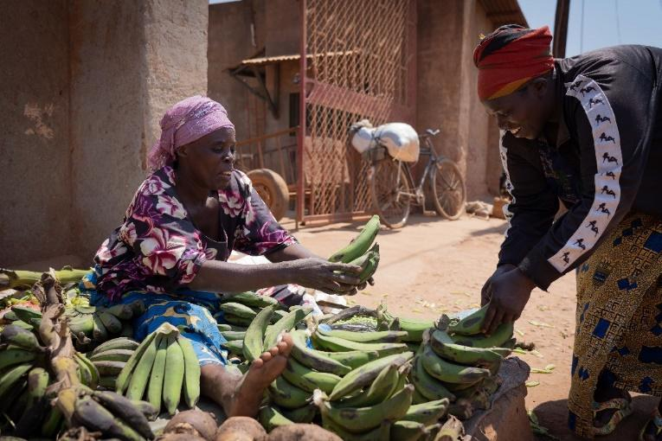
Josephine Hakizimana participated in WFP's Livelihood Interventions for Refugees
2.4.8.3 Challenges and Lessons Learned
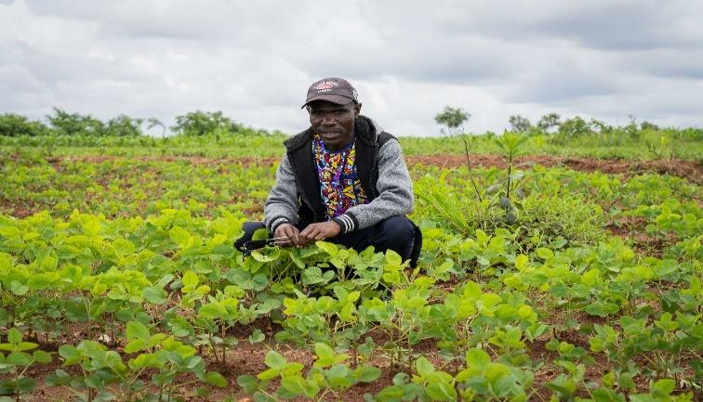
In the context of increasing numbers of refugees (nearly 5,000 new refugees registered in 2021, and nearly 1,700 new refugees registered in 2022 as of May 2022) and increasing food needs coupled with deteriorating food security and unpredictable funding trends, there was a need for additional resources.
Despite poor food security indicators in 2021, households targeted with livelihood interventions showed improved results in food security indicators when compared to households not targeted with the interventions. This further highlights the key role the interventions can play in alleviating food insecurity and lessening the need for food assistance in the camp.

Conclusions

The SDG Acceleration Fund is a financing mechanism which strengthens financing, planning and coordination, and is a suitable tool to channel adequate, predictable, and sustainable funds towards the highest priority areas. It aims to accelerate progress towards attainment of SDG’s. The Fund continues to implement quality programmes that are in line with the government's priorities, it supports the United Nations Sustainable Development Cooperation Framework (UNSDCF), supports the achievement of the Sustainable Development Goals (SDGs), Malawi 2063 and the Malawi Implementation Plan (MIP-1).
The Fund has proved to be an enabler to streamline cooperation between donors with multiple UN Agencies in an integrated way to leverage development impacts. In 2022, the Fund has successfully strengthened joint efforts that were particularly vested to respond to the emerging needs that arose from the aftermaths of Covid-19 crisis as well as other health related emergencies (polio and cholera outbreaks). Joint efforts were key in supporting the most vulnerable communities in solidarity and leadership for coordinated, multilateral action with government and other partners. The Fund’s 13 Joint Programmes further complimented the execution of the 2019-2023 UNSDCF.

For the Fund to continue being instrumental in implementing the UN Reform and advancing more and better Joint Programming, there is need for repurposing as one way of guaranteeing its relevance so that the SDG-AF results can be mirrored in the UNSDCF and be in-line with the MIP.
Significant and continued pressures on donor funding due to a range of global events necessitated repurposing of funds and thematic adjustments which had some risk against programme delivery. For instance, budget cuts during implementation meant determining the direction of the programmes and engaging in long-term planning and strategy. However, emergency programmes were prioritized with reducing funding.

Recommendations

For the next year, it is recommended to:
- Mobilize more Resources: Although the SDG-AF has been somewhat consistent in mobilizing resources, a more ‘joint’ effort, including agencies could support improving mobilization, with particular focus in Joint Programming to enhance ownership. This will also support joint mobilization strategy that counts with the SDG-AF as a suitable tool for Joint programming.

- Repurposing of the SDG-AF: While the Fund has been instrumental for implementing the UN Reform and advancing more and better Joint Programming (boosting relevance of UN), among others, it requires a repurposing exercise that can facilitate resource mobilization and a principle of ‘no competition’ among UN agencies.

- Reconfiguring the Malawi SDG Acceleration Fund in line with new Cooperation Framework: Normally the Fund Steering Committee sets up the Fund priorities in the first quarter of the year. However, these priorities tend to be broad. There is need to strategically repurpose the Fund, to guarantee the Fund’s relevance and alignment with the UNSDCF.

- Enhance ownership: Although the Fund is well known by all stakeholders, there is still a need to improve the level of ownership by the Government and the United Nations Team. The government has been key in helping to support the priorities, however it is not so involved in the implementation of the Fund itself- sometimes participant UN agencies tend to advance Joint Programming discussions outside the SDG-AF which has been designed to facilitate these discussions.

- To continue efforts to advance gender equality: in building on recommendations from 2021, the Fund continues to advance gender equality by ensuring that all the approved programmes allocated at least 30 percent of resources to activities that support gender equality. This practice has registered successes although the results and progress were not effectively measured. Going forward, the Fund should intensify its M&E measures so that the successes are highlighted in the most effective way.

General Assembly resolution 72/279 elevates the United Nations Development Assistance Framework (now renamed the United Nations Sustainable Development Cooperation Framework) as “the most important instrument for planning and implementation of the UN development activities at country level in support of the implementation of the 2030 Agenda for Sustainable Development (2030 Agenda).” The Cooperation Framework now guides the entire programme cycle, driving planning, implementation, monitoring, reporting and evaluation of collective UN support for achieving the 2030 Agenda. It also determines and reflects the UN development system’s contributions in the country and shapes the configuration of UN assets required inside and outside the country.
Guidance Note For Un Country Teams- UN Country-level Pooled Funds, A financing instrument to invest in the UN Sustainable Development Cooperation Frameworks 2020, UN Sustainable Development Group
The One Fund, established in 2009. Under the leadership of the Government of Malawi, the One Fund supported coherent resource mobilization allocation and disbursement of donor resources. The One Fund closed on December 2018.
World Bank, 2002. Malawi Country Climate and Development Report
United Nations Office for the Coordination of Humanitarian Affairs. (2022). Malawi Humanitarian Response Dashboard.
World Health Organization. (2022). Disease Outbreak News: Cholera – Malawi. https://www.who.int/emergencies/disease-outbreak-news/item/2022-DON419
Ministry of Health. (2023). COVID-19 SITUATION UPDATE AS OF 18TH JANUARY 2023. This [Image attached] [Status update]. Facebook. https://www.facebook.com/photo/?fbid=488058203506458&set=pcb.488058273506451
Malawi cholera flash appeal https://reliefweb.int/report/malawi/malawi-cholera-flash-appeal-2023-february-june-2023
People reached through VSL: 25,867 (16,520F, 9347F) People reached through PICSA: 8,100 (4860F,3240M) People reached through Evacuation Centres: 1,995 (1188F,807M) People reached through Crisis Modifier HE: 168, 246 (82,439M, 85,807F) People reached through FFS: 69,997(48090F, 21907M) People reached through FFA: 18,044(12159F, 5885M) People reached through Insurance: 13,584(10202F, 3382M)
A complete sexual and reproductive health and rights package component includes: maternal and newborn health; family planning; prevention of unsafe abortion; management of reproductive tract infections (RTIs) and sexually transmitted infections (STIs), including HIV/AIDS; and promotion of sexual health, prevention of gender based violence, fistula management, reproductive cancers and fistula management. Guttmacher Lancet; 2018.

