WOMEN IN LEADERSHIP
IN SAMOA (WILS)

Progress Report (January – December 2021)

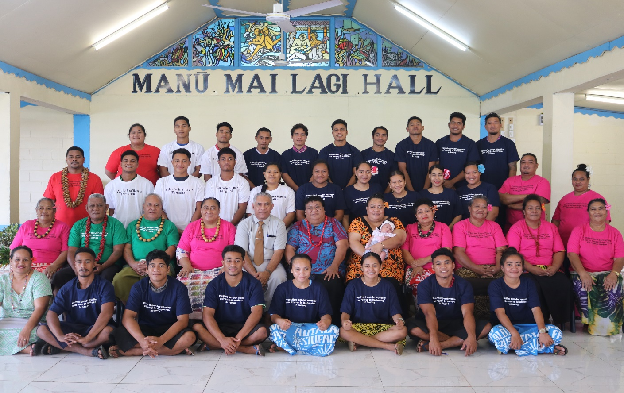

Photo credit: UN Women-WILS
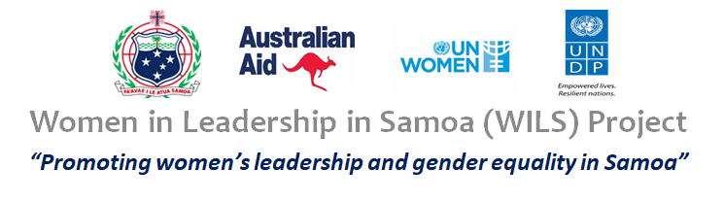
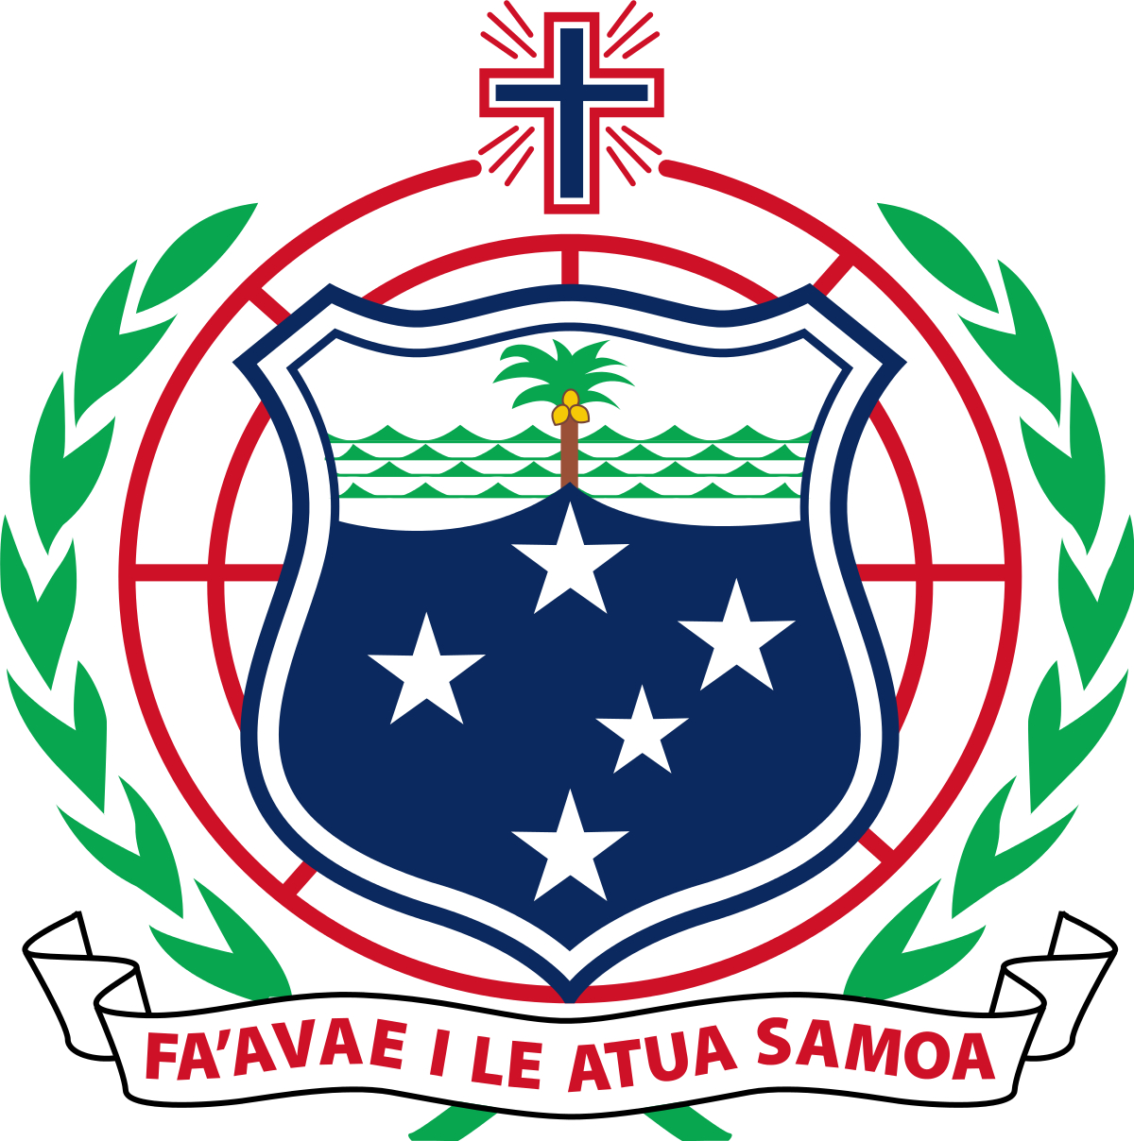
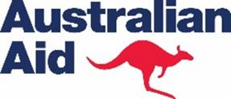
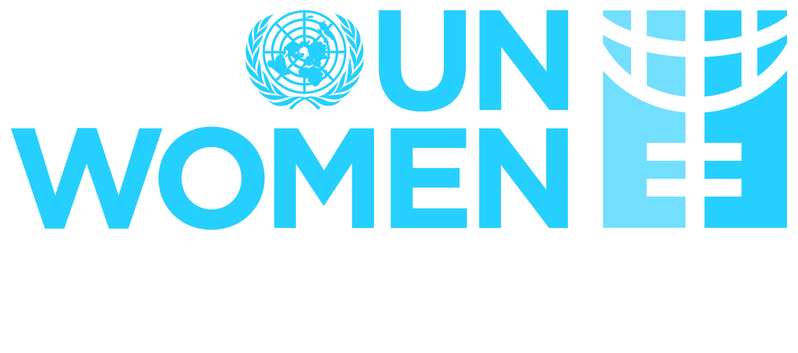
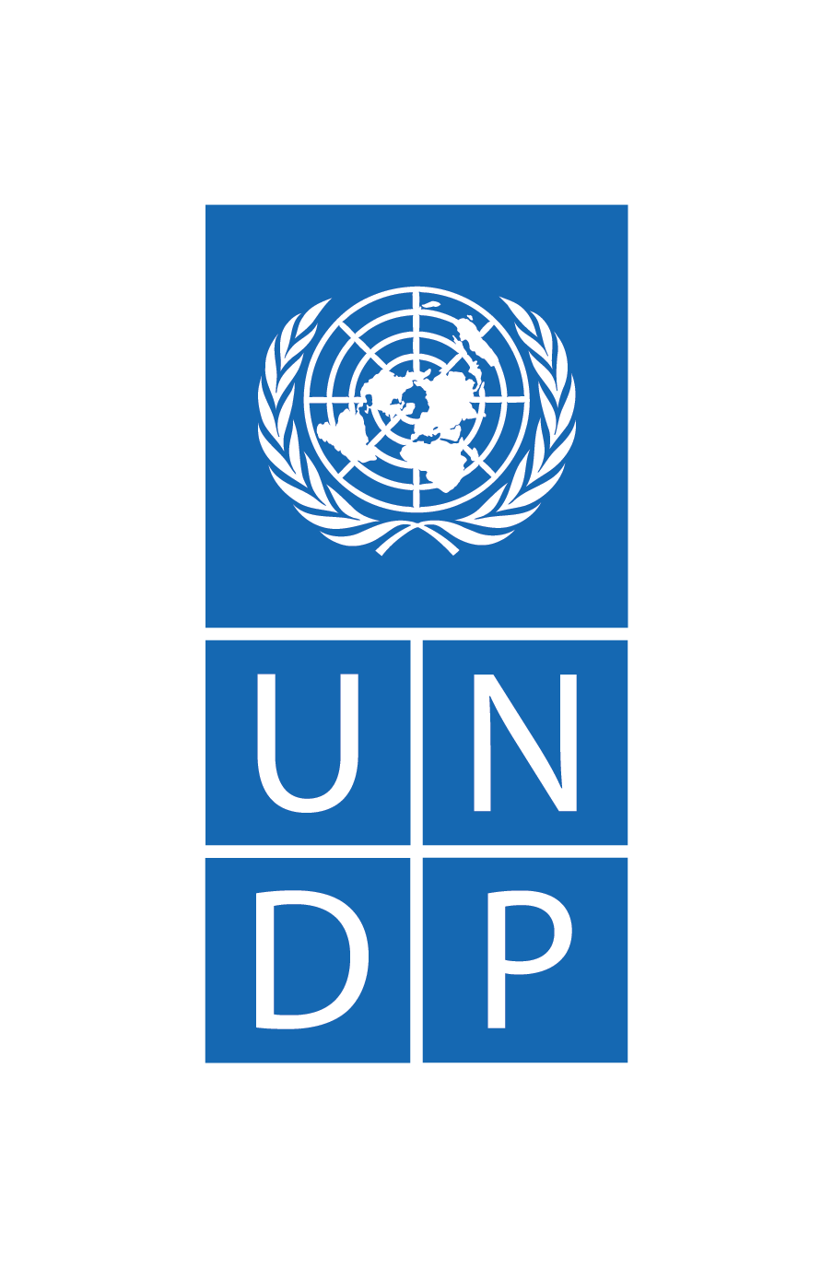

TABLE OF CONTENTS

Table of contents……………………………………………………………………………………………………….. 2
Acronyms…………………………………………………………………………………………………………………… 3
Background……………………………………………………………………………………………………………….. 4
Overall brief of activities……………………………………………………………………………………………. 5
Output 1: Strengthened opportunities for women’s participation in leadership
pathways………………………………………………………………………………………………………………….. 6
Output 2: Promoting political inclusivity and supporting women’s political participation
through a focus on development……………………………………………………………………………... 8
Output 3: Increased public awareness of and engagement in inclusive and effective
political participation………………………………………………………………………………………………. 10
Output 4: Sharing knowledge of Samoa’s experience in promoting women’s
leadership……………………………………………………………………………………………………………… 13
Communications, media, advocacy............................................................................ 13
Evidenced-based information around progress towards programme objectives…… 15
Lessons learned…………………………………………………………………………………………………….. 17
Annex A: Financial report & 2021 ................................……………………………………………19
Annex B: Summary of Media on WILS during the reporting period………………………...20
Photos from programme............................................................................................23

ACRONYMS

BTI – Break Through Initiative
DDC – District Development Committee
DDPs – District Development Plans
DFAT – Department of Foreign Affairs and Trade
GLOW – Girls Leading Our World
IPPWS – Increasing the Political Participation of Women in Samoa
NGOs – Non-Governmental Organisations
NUS – National University of Samoa
MFAT – Ministry of Foreign Affairs and Trade
MOF – Ministry of Finance
MPs – Members of Parliament
MWCSD – Ministry of Women, Community and Social Development
OCLA – Office of the Clerk of the Legislative Assembly
OEC – Office of the Electoral Commissioner
SAMPOD – Samoa Alliance of Media Practitioners for Development
SDGs – Sustainable Development Goals
SIOD – Samoa Institute of Directors
SUNGO – Samoa Umbrella of Non-Governmental Organizations
ToC – Theory of Change
ToT – Training of Trainers
TLDP – Transformational Leadership Development Programme
UNDP – United Nations Development Programme
UN Women – United Nations Entity for Gender Equality and the Empowerment of Women
VDLI – Village Leadership Development Initiative
WINLA - Women in Leadership Advocacy

WOMEN IN LEADERSHIP IN SAMOA (WILS) PROGRESS REPORT, JANUARY – DECEMBER 2021

Background

Name of the programme, duration and funding:
The Women in Leadership in Samoa (WILS) Project is a three and a half (3.5) year initiative covering the period from April 2018 to October 2022. The project is funded by the Department of Foreign Affairs and Trade (DFAT), Australia as part of the Pacific Women Shaping Pacific Development initiative and implemented by the United Nations Development Programme (UNDP) and UN Women.

Description of the overall programme rationale:
The overarching goal of the WILS project is to strengthen gender equality and women’s leadership in Samoa building on lessons learnt from the Increasing the Political Participation of Women in Samoa (IPPWS) project and reinforcing progress already made on gender equality and women’s leadership at the national level.

The project is based on a Theory of Change (ToC), which states that the project will adopt a Samoanisation concept, an idea that contextualizes international best practices, and where the involvement and partnerships of local people will facilitate an inclusive and participatory process to increase project ownership. These locally-driven strategies aim to contribute to the sustainability of initiatives beyond the project’s timeframe.

The project works very closely with the Government of Samoa and relevant ministries including the Ministry of Finance (MOF), Ministry of Foreign Affairs and Trade (MFAT), Ministry of Women, Community and Social Development (MWCSD), Office of the Electoral Commissioner (OEC), Office of the Clerk of the Legislative Assembly (OCLA) and Ministry of Public Enterprises. It also engages with the Samoa Institute of Directors, Non-Governmental Organisations (NGOs) including the Women in Leadership Advocacy Group (WiNLA), Samoa Rugby Union, Samoa Netball Association, Samoa National Teachers Association, Society of Private Sector Nurses and Midwives (SPNM), Samoa National Council of Women (SNCW) and Samoa Umbrella for Non-Governmental Organisations (SUNGO), District Development Committees (DDC), civil society, private sector and individuals to deliver the activities outlined in its Work Plan.

Reporting period:
January – December 2021

Date of report submission to DFAT: 28 February 2022

Name and contact of the person submitting the report:
Name: Alanna Mapu
Designation: Programme Manager, WILS
Contact: alanna.mapu@undp.org

Brief information about project activities implemented during the reporting period:

Overall
2021 was the third year for the WILS project. Despite the challenging circumstances of 2021, the WILS project continued to deliver on its goal to strengthen gender equality and women’s leadership in Samoa.

During the reporting period, the main activities focused on the implementation of a contextualized leadership development programme for women, emerging leaders (both male and female youth leaders) and current and potential female candidates in the lead-up to the April general elections. The WILS partners OEC and MWCSD continued work on increased community and civic understanding of the electoral process and women’s leadership respectively.

The main highlights from the project for 2021 include the following:

- Participation of 571 people (389 females, 180 males, 2 transgender) from 15 villages in 12 districts as well as the public and private sectors in Upolu and Savaii in the Village Leadership Development Initiative (VLDI) trainings. This resulted in the demonstration of leadership in action via the Break Through Initiatives (BTIs) organized and led by the participants within their communities. Based on the expressed interest and need, WILS also initiated a leadership training for aspiring women directors.
- Support provided under the WILS project to all the 23 women candidates for the 2021 elections included an instrumental course on Language of Communication for the women leaders to master the Samoan oratory language in public speeches.
- Through the partnership with OEC, the implementation of civic awareness multi-media programmes contributed to increased public awareness on election related matters. 99% of Samoa was covered through radio and television programmes. Some key improvements noted as a result of the capacity building programmes for the OEC staff and polling officials included completion of the polling process before the 3pm closing time compared to long ques of voters and lengthy process in the past where some of them could not vote by the closing time. In addition, the results for 2021 general elections were relayed to the Election Operation Centre upon the completion of the preliminary count, hence reduced the number of complaints from the candidates and scrutineers.
- Overall, the WILS team, with support from the UN Women’s and UNDP’s communications units, has produced a total of twenty-five plus media releases for publication to local newspapers, television, radio stations and social media. In 2021, this included 7 Knowledge Products (Briefs and Postcards), 4 internal information reports, 1 Media Survey (By Samoa Alliance of Media Practitioners for Development) and 7 articles (for newspapers, social media, television, and radio). SUSTINEO Limited was contracted to carry out research on women in leadership for the project and this will be released in 2022.

The Mid Term Review (MTR) for the Project was carried out from October to December 2020 by a local consultant and finalized in March 2021. The MTR report recommendations resulted in changes in the 2021 project implementation approach for some activities, a revised Performance Management Framework and more importantly paved the way for the design of a Phase 2 Concept Note. The MTR reported the extent of relevance, significance, and usefulness of the WILS Project for the people of Samoa.

In 2021, the WILS Project hosted 3 WILS Steering Committee meetings for approval of the MTR and workplan as well as to provide updates on the progress of the project.
During the reporting period, the project had a total budget of USD755,510.00 whereby by the end of December 2021, a total of 90.4% delivery was recorded.

Output 1.1 Strengthened opportunities for women’s participation in leadership pathways.
A.R.1.1: Enhanced leadership capacity of women in their communities.
Output 1.1 Activities: Work with the Samoa Institute of Directors to implement capacity building programmes on directorship, deliver trainings on the Village Leadership Development Initiative (VLDI) for community women, supporting coalitions and collaborative efforts amongst women, supporting Break Through Initiatives.

The activities planned under Output 1 included the delivery of the VLDI and BTIs, capacity building programmes on directorship, and supporting coalitions and collaborative efforts amongst women.

The VLDI was developed from the Transformational Leadership Development Programme (TLDP). It is the first contextualized leadership development curriculum, translated and delivered in the Samoan language and aimed to enhance leadership capacity and pathways of women and girls, community leaders (men and women), and emerging leaders (men and women) including people with disabilities. The VLDI brought women and men together to discuss challenges faced by their communities and ways to overcome them, contributed to building women’s confidence to exercise leadership and made a meaningful contribution to community development for the common good.
In collaboration with the Ministry of Women, Community and Social Development (MWCSD), a total of seven VLDI trainings were conducted in 2021. The project placed a strong emphasis on the inclusion of marginalized groups such as women, girls and PWD in VLDI trainings to build their capacity in transformational leadership and making informed contributions to decision making. The VLDI trainings were undertaken by 216 people - 120 females (including 4 female matais) and 96 males (including 50 male matais). Of the 216 participants, 57 were People with Disabilities (PWD) - 54 with vision problems and 3 with physical disabilities. Forty-six participants were aged 18 – 35 years, ninety-eight aged 36 – 55 years and seventy-two aged 56 years and over. Women’s participation in the VLDI trainings was at 56% compared to 44% males.
Participants learned about inner values (equality, justice, dignity, courage, kindness, peace, love, empathy, patience, etc) and how to take actions according to those values. They identified patterns and systems that exist in society that perpetuates social, economic, environmental and governance issues and discussed alternatives to address these issues including the underlying causes. Participants also learned about transformational tools to enable personal and social transformation. Additionally, they learned the value of initiating sustainable change through their faamaite (BTIs), to deliver the intended results as an individual and as a group, and to scale up and lead change.
A total of eight BTIs resulted from the trainings in 2021. Some examples of Break Through Initiatives being carried out in the communities as a result of VLDI trainings include:
- Addressing issues such as Domestic Violence, Alcohol and Drug Abuse, Management of Village Assets, Education and Village Penalties, teenage violence, children not going to school, youth unemployment etc.
- Economic projects such as the building of a traditional communal pigsty, developing historical sites within the village as tourist sites, markets for Siapo, vegetables, etc.
- Community-based events such as: village beautification with floral gardening, sports day, Bible classes, cultural practices, etc.

An important lesson learned from previous years is for the targeted villages to implement one collective BTI instead of individual BTIs as per previous practice. The collective faamaite ensures commitment by everyone involved including the village council. For instance, the VLDI training enabled the men and women of Siutu and Sili villages to work together to address issues affecting the village. These two villages are examples of where collaboration between village council, youth and women were instrumental in the successful implementation of their faamaite. This has proven more effective than would have been if they were to do it separately. During the follow-up, whilst some participants did their own fundraising for the faamaite, others did identify the need for funding and other resources to help carry out the BTIs in their communities.
The quote below reflects how the VLDI through the faamaite is supporting the inclusion of women in decision making within village governance systems:

“During the training when we were tasked with coming up with a BTI, our team decided that we would propose to our village that the traditional triangle of the village governance (tafatolu o faiganu’u) be changed to a ‘square’ and that the social aggregate of faletua, tausi ma ava a taulelea (inlaws) are given a recognized placing in our village seating so that they are part of our decision making process. When we presented our proposal to our village council, there was good support as they all knew and understood the value these women bring into our village. This is a very big change for us especially when we know that others may question why we are changing the foundation of village governance but I thank God for helping our matai to make this big decision. Today, when we have our village meetings, we have a representative from this group of women sitting in and contributing to our discussions” Male Trainee

The Break Through Initiatives collectively identified by VLDI participants not only reflect their strengthened capability in applying the leadership skills, tools and reflections but also enable them to set out a clear pathway for leading transformative change as leaders within their areas of influence.

Apart from the various faamaite (BTI), the VLDI also nurtured space for much needed conversation around discriminatory practices that women married into the village known as Nofotane which means ‘stay or live with husband’) often face. There is a common power struggle found in every village between the women of the village (known as the Daughters of the Village) and Nofotane. The Nofotane often face domestic abuse, and most of the time, have no say in decisions made within their own homes or communities and are also excluded from development activities for the women. Another group of women, known as the Faletua ma Tausi are women who have married into the village and are wives of the matais. They too often face exclusion. These groups of women would operate in silos and had very little communication with each other. In efforts to bridge the gap, the Project took an inclusive approach to create safe spaces for the women who are married into the villages to attend the trainings.
This inclusion of the Nofotane took place in the villages of Leulumoega and Vaiafai, where they were able to participate together in a programme with the Daughters of the Village groups and freely converse with one another for the first time. This approach has bridged the communication and interaction and had transformed the way women connect, appreciate, and respect the strengths and values of other women.
This training was the first ever opportunity for the Nofotane to get to know the Sa’otamaitai (leader of the Daughters of the Village group) on an equal level, and as a result of the rapport they have developed over the week, Nofotane are now more comfortable and closer to not only the Sa’otamaitai, but also other members of the Village Women’s Committee. Women of the Faletua ma Tausi have also testified on difficulties communicating amongst themselves as well as between themselves and the Sa’otamaitai, but the training gave them the opportunity to reflect and uncover the causes of their communication problems. The women changed the seating every day and encouraged each other to sit next to someone different every day of the training so they can develop rapport with them. Several women who attended the training with their sisters-in-law found a new opening to improve their relationships within their families and testified to these changes throughout the week.
The Daughters of the Village groups in the two villages have committed to participate and network with the Nofotane including those who are wives of men of title, and to work collectively on their BTI implementation.
After the VLDI trainings, the four villages undertaking the women’s programmes kept up the momentum by continuing with various initiatives such as implementing their advocacy programmes for women’s leadership and empowerment, health programmes through physical activities, the revival of traditional blinds, serving mats, mats for the village council house, initiating village policies for the prevention of all forms of violence affecting women and children, economic empowerment initiatives, governance, as well as safe water and sanitation.
Some reflections from the training are as follows;
“Ever since I came to this village 30 years ago, I used to see Teiosooaemalelagi (Sa’otamaitai) like godly idols. I was ever careful and used to keep my distance. I could not even talk to them unless I am asked a question then will give only the answer to that question. This week is the first time in 30 years that I have sat close to them and talked openly, sharing and even laughing and dancing with them. I feel that I am in heaven.” (Selau Togitele – a 56 year old female participant, married into Leulumoega for 30 years)
Moreover, the WILS Project is continuing its efforts to increase female participation in directorship and make decision-making processes and bodies more representative and inclusive.
In its efforts to increase the number of potential and eligible women applicants for public boards from which the ISC can select, the WILS Project worked with the SIOD to implement a professional programme which was attended by 25 aspiring directors (24 females, 1 male). The participants learned new knowledge and skills about the roles and responsibilities of a director, the legal requirements and obligations of boards and directors, financial operations, strategic planning, company analytics and board relations. Each received their ‘Certificate of Competence in Directorship’ which is recognized by the Samoa Qualifications Authority. As a result of the training in 2021, eight women submitted their applications for director positions immediately after the programme. The application submission is evidence of the 8 women fully understanding the roles and responsibilities of a director as well as understanding the application process and criteria.
The WILS Project investment expanded the reach for women to be trained in directorship which resulted in an increase of women directors in public body boards in 2021 to 33% from 29% in 2020. The WILS supported trainings resulted in an increased pool of potential applicants the Independent Select Committee can select from. Forty-six out of 76 (60%) women who applied were successful in becoming a board member. This is an increase of 10% from 42 in 2020. Currently, 2 out of 6 women Chairpersons of public organizations were trained through WILS. In developing the second phase of WILS, the Project plans to incorporate a session on gender mainstreaming whereby board directors can review and provide feedback on policies, budgets and financials from a gender lens. Women’s participation was of great emphasis in the first phase of the Project which is evidenced by 96% of director programme participants being females. This emphasis will continue in the second phase.

- Output 2. Promoting political inclusivity and supporting women’s political participation through a focus on development.
- A.R.2.1: Role of Parliamentarians in operationalizing the Sustainable Development Goals (SDGs) in Samoa promoted.
- Output 2.1 Activities: Work with the Office of the Clerk of the Legislative Assembly (OCLA) and SLIP in conducting the Briefing Programmes for the MPs, support the MPs knowledge exchange programmes.

The activities planned under Output 2 included a series of seminars for MPs, supporting knowledge exchange programmes for MPs, design and implementation of a support programme for potential candidates, and expanding the Language of Communication course to women leaders and potential women leaders in the public and private sectors.

The Briefing Programme (BP) was designed with the overarching aim of promoting the role of Samoa’s Members of Parliament (MPs) in operationalizing the Sustainable Development Goals (SDGs) in Samoa.
The Members of Parliament (MPs) seminar(s) on the SDGs was not implemented in 2021 due to conflicting priorities of the Government, the national election in April and the political impasse which delayed Parliament proceedings. The WILS project committed to contribute to the implementation of an Induction programme for all MPs planned for February - March 2022.
No engagements between local MPs and regional and/or international MPs supported by the Project occurred during the reporting period due to COVID-19 and State of Emergency orders by the Government specifically on border restrictions.

- Output 2. Promoting political inclusivity and supporting women’s political participation through a focus on development.
- A.R.2.2: Enhanced capacity of potential candidates for 2021 elections.
- Output 2.2 Activities: Work with the Women in Leadership Advocacy Group (WINLA) to identify potential candidates, design and implement support programmes for candidates, support south-south exchange.

Supporting potential women candidates was the main objective of the Training and Support Programme for Potential Female Candidates for the 2021 Election. Due to the hectic campaign schedules of women candidates and the fact that the majority have completed the 2 courses under this programme, only one Language of Communication course was delivered in March 2021 for candidates.
The Language of Communication course provided the opportunity for female candidates, women matais and women leaders to master the Samoan oratory language to be used in public speeches and public engagements. Being informed of how these proverbs derive and how to correctly apply them in speeches enabled women to speak up and make meaningful contributions during village council meetings. A key result of the course was the increased capacity of women participants to speak confidently and be more vocal about issues discussed during village council meetings and external meetings. A notable result was the improved confidence and enhanced capacity in public speaking of female candidates during the 2021 elections.
In the 2021 Elections, twenty-three women candidates were supported by the Project through various streams: (i) the MPs Seminars in 2018-2019, (ii) the Language of Communication and Campaign Strategy courses, (iii) the production and airing of television and newspaper advertisements with key messages for women, thus encouraging voters to vote for women candidates and support women in leadership positions. Furthermore, the candidates were supported through advertisements that profiled all women candidates, thus raising awareness with the public of who they were (their names, age and village), their constituencies, and campaign messages. The current Minister of Finance (female and first time a woman has held this role in Samoan history) and Minister for Justice and Courts Administration (female) were amongst the participants of the Language of Communication and Campaign Strategy courses.
In addition, due to high demand from other women leaders, two additional Language of Communication courses were implemented for 27 women in the public and private sectors. 100% of the participants passed their practical oratory speech which is concrete evidence of improved knowledge and enhanced understanding of the oratory skills and their usage during speeches. 90% of the participants testified that this is the first time they have drafted a speech and the first time to stand in front of an audience to make a speech of this nature. Another key feedback from the participants was how useful the course was for their area of work as they frequently deal with members of the public and Members of Parliament. This in turn could be their pathway to higher level leadership including politics.
- Output 3. Increased public awareness of and engagement in inclusive and effective political participation
- A.R.3.1: Enhanced advocacy and outreach to encourage inclusive and effective political participation.
- Output 3.1 Activities: Work with the Communications, Advocacy and Awareness Coordinator to develop and finalize the Communications and Advocacy Strategy, implement TV roundtables, radio dialogues, competitions, work with the SAMPOD to conduct the media survey and Sustineo to implement the research.

- Output 3.1 Enhanced advocacy and outreach to encourage inclusive and effective political participation

The activities planned under Output 3 included implementing a media survey, implementation of advocacy and awareness raising activities, developing a training programme for young women in communities and in the public and private sector, as well as supporting new matai title holders to participate in village councils.

A media content survey was conducted to accurately gauge the average Samoan response was in relation to women leaders. As a prelude to the media survey, a content analysis was done to provide a snapshot of prioritisation of women in leadership coverage in politics, economy, education, health, sports, culture and society in general by the Samoan printed and online media. The media survey reiterated the overall findings of the content analysis that there is over 20% coverage in Samoa on women’s leadership despite the need for more ‘inclusive and in-depth articles’ that highlight extensive leadership roles taken by women in the community. There were several factors that were found through the survey to have contributed to the inconsistencies in the trends of media participation and capacity of Samoan journalists when reporting leadership and participation of women in the community. This includes gaps in achieving quality journalism in providing a wide range of stories across the industry which is evident in 10% of respondents covering stories not specifically on women development.
Recommendations from the survey identified the need to develop a handbook (both hard copy and online versions) for media companies as well a short curriculum guide for journalism students containing guidance and tips on covering investigative stories on women’s issues made available in both the English and Samoan languages. The survey also recommended a refresher and capacity building for media personnel hence the Media Training which will be used to inform and develop a Training package for local journalists on gender responsive approaches to reporting on women’s issues. The Terms of Reference to procure a trainer to conduct the media training as recommended by the media content survey was developed and is in the pipeline for implementation in 2022. One of the deliverables would be the media guide which will be used as a knowledge product for the project.
Research on Leadership Pathways for Samoan Women will be completed in 2022. A combination of factors such as COVID 19 SOE Restrictions and delays in obtaining the Research Permit to allow Sustineo to implement the Data Collection and field work and the political situation in Samoa after the 2021 elections has resulted in a delay in the completion of the research. Some of the initial findings from the research include the need to make visible the stories of diverse pathways to leadership for women; the importance of a continued focus on women’s leadership within village governance systems; the structural discrimination which places emphasis on male leadership and devalues women’s contributions and services; the importance of incorporating the principles of feutagaiga (consultation) into leadership training including focus on oratory skills; the silos and divisions between male dominated and female dominated leadership spaces within villages; the hostile context for young women’s leadership; and the importance of sustaining networks which connect women together for collective action.
The WILS Project also partnered with the MWCSD to implement a series of awareness raising and advocacy activities in 2021. However, only one activity was implemented in May 2021 through Focus Group Discussions (FGDs) followed by advocacy and awareness via a parade on the importance of the role of women in community leadership. A total of 236 women participated in the FGDs to discuss the roles of women in leadership within their own communities and villages as well as the challenges and barriers for women to be in leadership roles. The emphasis of the FGDs was on how the women can work together to break barriers which contribute to discrimination against women in leadership roles and consequently strengthen women’s involvement in leadership roles. Most of the women in the FGDs saw their roles as advisors to the family matais, as leads for initiatives on economic empowerment and health and wellbeing, child rearing, domestic duties and village beautification. Barriers identified included having no matai title, no recognition of women’s voices by men and women leaders, low self-esteem and confidence, and lack of awareness and knowledge on what must be done to achieve leadership roles
This was followed by a parade attended by 432 people which included the participation of 7 women’s committees from Upolu and 7 from Savaii. As part of the women’s parade and competitions, women displayed key messages during the parade advocating for women’s leadership, good governance, ending violence against women and children, women as advisors, women as entrepreneurs and income earners for families.
- A.R.3.2: Strengthened leadership capacity of young women and new matai titleholders.
- Output 3.2 Activities: Work with the consultant to design and implement a leadership programme for young women, support title holders to participate in village council.

The VLDI curriculum which is used in Output 1 for women, and men was also utilized for leadership training for emerging leaders and matai title holders. Through the VLDI trainings, WILS has successfully brought together 257 people from 8 villages to strengthen and create inclusive civic participation pathways for women for greater public participation, leadership and decision making within their communities. Of this number, 6 were aged 0 – 17 years and 174 aged 18 to 35 years. The VLDI for Youths in the Community targeted the development of young women and men as emerging leaders as individuals and as a group – to try and work together to address women’s leadership and gender equality issues and to enhance their leadership for the common good of their villages, constituencies, and the country. Not only have the VLDI sessions provided leadership skills sessions to support new title holders, particularly young women, to engage more within the village council, it has also created an opportunity for the community to work towards dismantling gendered norms and discriminatory practices and reducing barriers to create pathways and entry points for women’s representation and participation in village decision making platforms.
Some of the key priority areas of focus identified by the emerging leaders include a collective approach to the village councils for their support on initiatives to reduce youth unemployment, increase decision making opportunities for youth, and support social problems affecting youth such as absence of social support to prevent violence, suicide etc. In addition, the VLDI youth participants have committed to take action to improve environmental cleanliness, improved personal hygiene amongst all villagers and equally important is the commitment by youth to work together so that their strengths can be fully utilised to address issues affecting them. The BTI collectively identified by young women not only reflects their strengthened capability in applying the leadership skills, tools and reflections, but also enables them to set out a clear pathway for leading transformative change as emerging young women leaders within their areas of influence.
The Project’s focus on emerging young women leaders in the private and public sectors is an innovative, and catalytic area of intervention within the broader scope of development initiatives on gender equality in Samoa. Using the VLDI model, the Project targeted young women in partnership with Women in Leadership Advocacy (WINLA). A total of four 5-day transformational leadership trainings were conducted for young leaders in the public and private sectors in Upolu and Savaii. Under this initiative, a network has been established for the young emerging women leaders with young women who are already in leadership positions in Parliament and in the public and private sectors. It is envisioned that this network will be a space to nurture transformative leadership growth; support mentorship to build confidence in leadership; and will contribute to a range of communities and workplaces. The post training evaluation showed that 100% of the participants rated the training programme as relevant and useful in building their leadership skills. As a result of the WILNA trainings, 98 emerging leaders, which includes 95 young women, 2 young men and 1 transgender leaders in the public and private sector, have demonstrated increased confidence and leadership skills to meaningfully engage within their workplaces as well as their Aiga (family settings) and Fa’amatai (indigenous political system) which are vital entry points for becoming involved in village development work, governance and decision-making as well as advancing the basic welfare of their families and communities.

- Output 3. Increased public awareness of and engagement in inclusive and effective political participation
- A.R.3.3: Strengthened civic awareness.
- Output 3.2 Activities: Work with the Office of the Electoral Commissioner (OEC) to implement civic education programmes and conduct community survey.

Through a partnership with the Office of the Electoral Commission (OEC), WILS is bringing greater clarity and understanding of the institutions of parliament, government, role of elections and roles and expectations of Members of Parliament to rural communities. These communities have a greater comprehension of their civic responsibilities as voters. Through the voter education programme, communities were informed of how Parliament functions, how development priorities are decided by the government, and how citizens can address village problems and issues with their respective Member(s) of Parliament. This is an important step in linking local level needs, priorities and agenda with national level dialogue, action, and response. Enhanced civic awareness and political engagement of Samoans, particularly rural and remote communities, was a pronounced outcome from the awareness raising initiatives delivered by the OEC.
As of December 2021, the implementation of civic awareness multi-media programmes contributed to increased awareness on election related matters. This included:
  - 25,000 viewers on OEC’s Facebook page for the Election Process outlining the polling process when voters arrive at the polling booth
  - 24,000 viewers on OEC’s Facebook page on the Palota ma le Poto (Smart voting) advertisements, promoting the importance of voting without influence from parents, candidates, candidates’ committees, friends etc
  - 26,000 viewers on OEC’s Facebook page on Inclusive participation on pre-polling for voters with disabilities and senior citizens
  - 29,000 viewers on OEC’s Facebook page on advertisements to inform communities to refrain from using transportation provided by the candidates and their committees.

The number of registered voters recorded for the 2021 general election is 123,575 which is a 2% increase from 2016.
The Project also supported the OEC staff and polling officials to undertake a capacity building on the election process and leadership. This led to improvements by the polling officials in carrying out their roles and responsibilities which included:
  - Polling process completed at most polling booths before 3pm.
  - People did not have to stand in long lines at polling booths as in previous elections.
  - Most of the results were quickly relayed to the Election Operation Center at the completing of the preliminary count.
  - Reduced number of complaints from scrutineers on capacity of polling officials compared to 2016.
  - Smooth handover process of resources before and after the polling day.

- Output 4. Sharing knowledge of Samoa’s experience in promoting women’s leadership.
- A.R.4.1: Increased understanding of Samoa’s experience in promoting women’s leadership and lessons in the region.
- Output 4.1 Activities: Work with the SUSTINEO Company to design and implement the research on women’s leadership at all levels, longitudinal study and a documentary analysis from the research and longitudinal study.

During this reporting period, the WILS research which seeks to create clear understanding of the barriers to women aspiring and pursuing leadership was carried out. The research will also review access to and types of capacity development required to display leadership qualities. It seeks to engage with research institutions, organizations, and individuals with research background and experiences, as well as understanding and awareness of the global, regional, and local context, to explore pathways for women’s leadership at all levels, and document evidence of where different manifestations of leadership for women take place, and where exercise of leadership by women is making an effective contribution to development. As of December 2021, the Sustineo has completed the research field work and a draft report will be submitted by the research company in January 2022.
Additionally, work is progressing on contracting a company for developing a documentary on the experiences, learnings, and leadership journeys supported through the WILS Project. Both the research and the documentary will be vital information for development partners, government, key stakeholders as well as women from other Pacific Island nations.
Communications, Media and Advocacy
During the reporting period, the WILS Project continued to leverage existing relationships with media outlets and specific media contacts to ensure maximum exposure for the project’s activities and impacts at the national level. The team has also worked to ensure communications materials were distributed to internal and external partners, stakeholders and the public (where appropriate) to improve the awareness and understanding of the Project and its activities.

Media outreach
The WILS team, with support from the UN Women’s and UNDP’s communications units, has produced a total of twenty-five media releases for publication to local newspapers, television, radio stations and social media.
Media coverage during this reporting period mainly focused on activities such as the VLDI trainings, the BTI implementation, the SIOD professional programmes, the mentoring programme for young people in the public and private sectors, the Candidates Programmes and the Government of Samoa General Elections.

Annex B provides a full listing of all media coverage regarding WILS project activities during this reporting period.

Communications

The WILS project has produced updated activity briefs based on the lessons learned through project implementation. The following knowledge products produced in 2020 and updated and reprinted in 2021 were published and disseminated, highlighting the impact of the Project activities. The same will be updated in 2022 to reflect the coverage and lessons throughout the WILS project Phase 1 from 2018 to 2021.
- WILS Updated Project Brief in English
- Samoa Institute of Directors Updated Brief in English
- Samoa Institute of Directors Updated Brief in Samoan
- Village Leadership Development Initiative Brief in Samoan
- Village Leadership Development Initiative Brief in English
- Two postcards on Samoa Institute of Directors
- Twp postcards for VLDI trainings

Seven articles for newspapers, social media, television and radio were written, these are:
- “Apia village attends leadership training”
- “Women exceed Parliamentary quota”
- “SIOD Professional Programme for Aspiring Board Members”
- “The Quest continues for aspiring Women Directors”
- “Women leading from the front in workplaces”
- “Empowering women locally in their leadership journey through targeted trainings to mirror international success”
The team also prepared draft speeches and talking points for high-level representatives for public engagements such as official opening and closing ceremonies for project activities.

Social Media:
The WILS Project is a regular contributor to the social network sites of UNDP, UN Women Pacific, Australian High Commission – Samoa and the Government of Samoa.

During the reporting period, there have been 19 posts highlighting WILS events on the Facebook pages of UNDP in Samoa, Cook Islands, Tokelau & Niue and UN Women Pacific. The WILS Project posts are also being shared by partners of WILS as well as its training participants adding to the number of those already being reached through the UNDP and UN Women Facebook page. To date, these posts, on the UNDP in Samoa, Cook Islands, Tokelau & Niue and UN Women Pacific Facebook pages have received 262 Shares, 3,414 Likes, with 36,678 people reached and engagements totalling 4,619.

Project Governance

During the reporting period, three Project Steering Committee (PSC) meetings were held on 2nd February, 17th February, and 16th September 2021. The PSC members include Samoa’s Ministry of Foreign Affairs and Trade (MFAT), Ministry of Finance (MOF), MWCSD, Samoa Umbrella of Non-Governmental Organizations (SUNGO), Government of Australia, UNDP, UN Women and the United Nations Resident Coordinator. The PSC provides the overall oversight and guidance to the project and meets quarterly.
During these meetings, the following were approved:
- 2021 Annual Work Plan and Budget
- Revised WILS Performance Management Framework
- Mid Term Review Report and recommendations
- Activity reports (VLDI, BTI, SIOD Director’s Programme, Candidates Programme, Media survey)
- Research plan and Inception Report

The meetings have also discussed the first draft of the WILS Project Phase 2 Concept Note.

Evidence-based information around progress towards program objectives:
- Evidence of strengthening support for WILS from local authorities

- In 2021 the project partnered with three cultural experts to deliver VLDI trainings targeting men, boys, women and girls in the communities as well as young leaders (male and female) in the public and private sectors. Having high profile, titled leaders who are well respected and regarded by the local people enabled the project to effectively deliver quality trainings at the village level. These programmes were highly supported by the village councils which is the decision-making body in villages as well as the Aualuma which is the women’s decision-making body known as Daughters of the Village.
- The ongoing support by the MWCSD to liaise with the community networks and villages saw the selection of villages that had conflicts between the village subgroups, existing conflicts amongst village councils and women’s committee where the training would most likely have an impact.
- The community representatives from the WILS supported programmes have been very active in mobilizing resources for community development projects. They were also very active in mobilizing the village participants and encouraging networking with them after the trainings. This has been confirmed from the BTI follow up reports received.

- Evidence of strengthening support for WILS and recognition of WILS from external stakeholders
The WILS Project has received support and recognition from our donor partner, the Australian Government. Other important stakeholders include the increasing recognition of WILS by government stakeholders. Some examples below not already mentioned include:

- Barry Patterson, Deputy High Commissioner delivered closing remarks at the Language of Communication course.
- Barry Patterson, Deputy High Commissioner delivered closing remarks at the Language of Communication course.
- Barry Patterson, Deputy High Commission delivered closing remarks at the Director’s programme.
- Julia Wheeler delivered opening remarks at VLDI training for youth, Siufaga Falelatai.
- The UNDP Resident Representative and Deputy Resident Representative delivered closing remarks at the Language of Communication course.
- The UNDP Resident Representative delivered closing remarks at the SIOD programme.
- The UNDP Deputy Resident Representative delivered opening remarks at the SIOD programme.
- The UN Women County Programme Coordinator delivered opening remarks to public and private sector trainings for women.
- The UN Women Country Programme Coordinator delivered closing remarks for VLDI training for youth, Poutasi.
- Improved engagement with partners such as the OEC, WINLA, MWCSD, MOF, MFAT, MPE.
- Improved engagement with church leaders, village councils, women’s groups, youth groups.
- Improved engagement with political candidates, potential women leaders.
- Ongoing collaboration with the Samoa Institute of Directors.

- Evidence of raised awareness and recognition of the value of the WILS Project
Overall: As highlighted in the communications section, there is growing recognition of the value of the WILS Project in supporting women’s leadership at all levels.
- Improved support from the members of the Steering Committee, key government ministries crucial to the successful implementation of the project activities such as the MWCSD, MOF, MFAT, OCLA, OEC, and active NGOs such as Samoa Teachers Association, SUNGO, WINLA, and media outlets. This is evident in the partners implementing the delivery for the project and stakeholders granting their approval during Steering Committee for project activities.
- Also, there is great potential in the collaboration between the BTI groups in the villages and the district councils responsible for the district development for their SAT2000,000.00 grants each year. Participants of WILS supported programmes are members of the District Council who will be responsible for the prioritization of initiatives for the government grant. This was validated from the interviews and focus group discussions for the Phase 2 Concept Note.
- The WILS Project Management Unit has received requests from members of the public especially on how they can register for WILS programmes such as the directorship programme, the VLDI programme, the Language of Communication programme to name a few. This resulted in the project implementing a language course for potential women leaders in the public and private sectors in October – November 2021.
- The women candidates who were supported by the WILS project acknowledged the project’s support towards them in the general elections in April 2021. Please refer to the link https://undpsamoa.medium.com/empowering-women-locally-in-their-leadership-journey-through-targeted-trainings-to-mirror-462748e768ea for article.
- The implementing partners, the Australian High Commission to Samoa and the PMU have established close working relationships and continue to hold regular updates on the project.
- The feedback from all the interviews for the WILS project Phase 2 states the usefulness and relevance of the project and recommends that the project be extended. For example, the participants recommended the inclusion of all groups of people in the village (village council, women’s committee, youth) in the VLDI programmes, inclusion of the District Councils in WILS training programmes, more programmes to encourage women’s participation in leadership and politics. They further agreed that the BTIs can be linked to the government’s annual grant of SAT2000,000.00 hence why they need to align their priorities to the district development plan.

Lessons learned: Based upon the original assumptions, together with evidence to date from program achievements and information, and information about each of the contexts where the program is implemented, answer the following questions:

- What is your organization learning about supporting change towards gender equality in the Pacific?

- While the project aims towards strengthening and building leadership pathways for women, this cannot be achieved by involving women only. The social norm is that leadership is seen as a man’s role which is why some women are not confident to exercise leadership especially in the village council. Hence, it is equally important to mobilize men and boys and engage them in advocacy for gender equality and to work with men who can then create spaces and opportunities for women to participate in decision making and leadership in an empowering manner.
- Also important is the need to enroll youth as advocates for gender equality and as future leaders into programmes so they can sustain the learning through action and advocacy. They are instrumental in using technology to promote their activities and engage more villagers to work with them. Consequently, the whole village will support their initiatives for the common good of the village. It is particularly important to engage youths to address gender issues such as domestic violence, unemployment and build allies for the promotion and advancement of women’s participation in decision-making.
- In order for an initiative to be successful and sustainable, it must be noted that while it is important to learn from international best practices, all materials and tools must be contextualized to be relevant and applicable to the Samoan context, including translation to Samoan language particularly when related to gender. These were continuously refined to fit each target audience. More importantly, experienced local trainers/experts must be used for relevance and appreciation of context.

- What other lessons are being learned (positive or negative) from implementing activities that might serve to improve the effectiveness of any future similar activities?

- While it is important to use the cultural experts to deliver the VLDI and language of communication courses, it will be beneficial and sustainable for the WILS Project if a course on the same is offered at the National University of Samoa. Hence, continuity beyond project life is guaranteed.

- It is of note that the approach and priorities may change according to the circumstances of the country which may impact the project delivery. Policies and priorities must be flexible to accommodate these environmental and unforeseen circumstances.

Follow-on activities: How will the next set of activities be different as a result of achievements and learning to date? Provide a summary of agreed changes following discussions with stakeholders.

The Concept Note for the WILS Project Phase 2 will foresee the inclusion of a gender session so that we encourage women to apply and be selected as board members but more importantly they have the capacity to mainstream gender into board meeting discussions, they are able to analyze budgets, policies from a gender lens. Also, Phase 2 will look into recommending institutionalizing approaches to yield better results and sustainability. For example, the Language of Communication course can be a course at the National University of Samoa. Also, the VLDI can be part of the government’s orientation programme for new recruits and all public servants with the directors’ training recommended as part of the Institutional Strengthening Programme for middle level and senior level management. This will remove the adhoc implementation and concerns on the unavailability of trainers. Furthermore, cast the net wider to include women in agriculture, women in science, sports and how to empower them and capitalize on the use of media to increase civic awareness.

Brief Information about program outputs and achievements from these activities:
NOTE:

The WILS Project Performance Management Framework was revised in May 2021 as per recommendation by the MTR and has been updated annually.

Other information/comments: Please provide here any other information or comments you consider relevant in assessing the benefits of the activities or the likely benefits of similar activities in the future.
NA.

Financial Report (please refer to Annex A) January – December 2021
Note: The expenditures included in this report are locally reported amounts, the official amounts will be on the MPTF Gateway.

Annex A: Financial Report

Budget Expenditure January - December 2021
UNDP Component Activities | 2021 Available Resource | Approved budget 2021 | Year End Expenditures | Budget % Utilisation | Resource % Utilisation
UNDP Output 1. Strengthening Women’s pathway | USD86,671.00 | USD86,671.00 | USD78,871.00 | 91%
UNDP Output 2. Political Inclusivity | USD87,300.00 | USD87,300.00 | USD61,717.00 | 70.6%
UNDP Output 5. Project Management & Project Assurance | USD85,086.00 | USD85,086.00 | USD71,009.00 | 84.6%
UNDP Budget Totals | USD259,057.00 | USD259,057.00 | USD212597.00 | 82.20% | %
C/F resource balance | USD
UNWOMEN Component Activities
UNW Activity: Community Outreach, Emerging Leaders Programme, Civic Education | USD 415,973.00 | USD415,973.00 | USD402,386.00 | 96.7%
UNW Activity 4. Research | USD25,480.00 | USD25,480.00 | USD15,093.00 | 59.2%
UNW Activity 5. Project Management & Project Assurance | USD55,000.00 | USD55,000.00 | USD53,515.00 | 97.3%
UNWomen Budget Totals | USD496,453.00 | USD496,453.00 | USD470,994.00 | 94.8% | %
C/F resource bal | USD
WILS Overall Totals (UNDP & UN Women) | USD755,510.00 | USD755,510.00 | USD683,591.00 | 90.4% | %
Total C/F resource bal | USD

Annex B – Summary of Media on WILS during this reporting period

# | Media | Date | Title | Link
1 | Samoa Observer | 09-Feb-21 | Apia Village attends leadership training | https://www.samoaobserver.ws/category/samoa/78816?utm_content=bufferedd6c&utm_medium=social&utm_source=facebook.com&utm_campaign=buffer&fbclid=IwAR1sYxbtglLNHtVr7CkgZNluCq7iuI0m368xIJhSi7OhA-UwmvH8xnsIXEs
2 | UN Women Facebook Page | 15-Mar-21 | IWD celebration | https://www.facebook.com/unwomenpacific/posts/3715741325200353
3 | Samoa Observer | 11-Apr-21 | Women exceed Parliamentary quota | https://bit.ly/3J8vcah
4 | The Diplomat | 14-Apr-21 | General Election | https://thediplomat.com/2021/04/the-women-that-upended-samoas-politics/
5 | Samoa Observer | 18-Apr-21 | General Election | https://www.samoaobserver.ws/category/samoa/82657
6 | UNDP Facebook Page | 24-May-21 | SIOD Professional Programme for Aspiring Board Members | https://www.facebook.com/undpsamoa/posts/5437243613012719
7 | Samoa Observer | 25-May-21 | Savai'i mother aspires to directorship | https://www.samoaobserver.ws/category/samoa/84521
8 | UNDP Facebook Page | 26-May-21 | Professional Programme for Women Directors target women in both Upolu and Savaii | https://www.facebook.com/undpsamoa/posts/5449685081768572
9 | Samoa Global News | 29-May-21 | SIOD Professional Programme for Aspiring Board Members a Success | https://samoaglobalnews.com/siod-aspiring-women-to-be-board-directors1/
10 | Samoa Observer | 30-May-21 | The Quest continues for aspiring Women Directors | no link
11 | UNDP Facebook Page | 31-May-21 | SIOD Professional Programme for Aspiring Board Members a Success | https://www.facebook.com/undpsamoa/posts/5474273989309681
12 | UN Women Asia and Pacific website | 08-Jun-21 | Transformational Change fo a young woman from Poutasi Falealili - Samoa | https://asiapacific.unwomen.org/en/news-and-events/stories/2021/06/transformational-change-for-a-young-woman-from-poutasi-falealili---samoa
13 | UNDP Facebook Page | 09-Jun-21 | Village Leadership Training for Iva Vaiafai | https://www.facebook.com/undpsamoa/posts/5516708615066218
14 | UNDP Facebook Page | 14-Jun-21 | Village Leadership Training for Vaiafai-Iva Savaii | https://www.facebook.com/undpsamoa/posts/5538848676185545
15 | UN Women Facebook Page | 14-Jun-21 | Village Leadership Training for Young people of Poutasi Falealili | https://www.facebook.com/unwomenpacific/posts/3985165024924647
16 | UNDP Facebook Page | 15-Jun-21 | Village Leadership Training for Siumu Sasae | https://www.facebook.com/undpsamoa/posts/5542955359108210
17 | UNDP Facebook Page | 21-Jun-21 | Village Leadership Training for Siumu Sasae | https://www.facebook.com/undpsamoa/posts/5569704656433280
18 | UNDP Facebook Page | 23-Jun-21 | Village Leadership Training for Solosolo | https://www.facebook.com/undpsamoa/posts/5578205695583176
19 | UNDP Facebook Page | 30-Jun-21 | Village Leadership Training for Sagone | https://www.facebook.com/undpsamoa/posts/5610419859028426
20 | Quarter 2 UNDP Samoa MCO | 30-Jun-21 | Breaking down barriers to Gender Equality for the Nofotane in the village of Foailalo | https://undpsamoa.medium.com/breaking-down-barriers-to-gender-equality-for-the-nofotane-in-the-village-of-foailalo-8417e028d1f9
21 | UN Women Facebook Page | 15-Jul-21 | Village Leadership Training for Young people of Siufaga Falelatai | https://www.facebook.com/unwomenpacific/posts/4070186716422477
22 | UNDP Facebook Page | 15-Jul-21 | Leadership Training at Siufaga Falelatai | https://www.facebook.com/page/
23 | UN Women Facebook Page | 20-Jul-21 | Mentoring Programme for Public and Private Sector in Savaii | https://www.facebook.com/unwomenpacific/posts/4084668861640929
24 | UNDP Facebook Page | 25-Jul-21 | Village Leadership Training for Saoluafata | https://www.facebook.com/undpsamoa/posts/5729788437091567
25 | Samoa Observer | 26-Jul-21 | Validaton Workshop for SAMPOD and WILS | https://www.samoaobserver.ws/category/samoa/88008
26 | Samoa Observer | 26-Jul-21 | Coverage of Women’s Issues addressed in workshop | https://www.samoaobserver.ws/category/samoa/88007?utm_content=bufferdd62f&utm_medium=social&utm_source=facebook.com&utm_campaign=buffer&fbclid=IwAR1jNqz2KK-W__WZA3s-cyukz_BO0g3sfgpm7g39d8HugP7iy__2JniO7vI
27 | UNDP Facebook Page | 28-Jul-21 | Village Leadership Training for Leulumoega | https://www.facebook.com/undpsamoa/posts/5743422589061485
28 | UN Women Facebook Page | 07-Aug-21 | Women's leading from the front in workplace | https://bit.ly/3rxKnEa
29 | UN Women Facebook Page | 09-Aug-21 | Village Leadership Training Siutu | https://www.facebook.com/unwomenpacific/posts/4143951142379367
30 | UNDP Facebook Page | 11-Aug-21 | Breaking down barriers to Gender Equality for the Nofotane in the village of Foailalo | https://www.facebook.com/undppage/
31 | UNDP Facebook Page | 12-Nov-21 | Private and Public Sector women participating in the Vaogagana O Fesootaiga course | https://www.facebook.com/page/878007992269660/search/?q=WILS
32 | Quarter 4 UNDP Samoa MCO Newsletter | 29-Dec-21 | Empowering women locally in their leadership journey through targeted trainings to mirror international success | https://undpsamoa.medium.com/empowering-women-locally-in-their-leadership-journey-through-targeted-trainings-to-mirror-462748e768ea

