LOCAL GOVERNMENT INITIATIVE ON CLIMATE CHANGE (LoGIC)
MPTF OFFICE GENERIC ANNUAL PROGRAMME¹ NARRATIVE PROGRESS REPORT
REPORTING PERIOD: 1 JANUARY – 31 DECEMBER 2021
Programme Title & Project Number |  |  |  |  | Country, Locality(s), Priority Area(s) / Strategic  Results²
- Programme Title: Local Government Initiative on Climate Change (LoGIC)  - Project ID/Award ID in ATLAS:  UNDP 00085984 UNCDF 00101390 (EU),  00102142 (SIDA)  - MPTF Office Project Reference Number:³ 00103800 |  |  |  |  | Country/Region: Bangladesh
Priority area/ strategic results: By 2026, more people, in particular, the most vulnerable and marginalized, have improved access to and
utilization of quality, inclusive, gender- and shockresponsive, universal, and resilient social protection, social safety-net and basic social services.
Participating Organization(s) |  |  |  |  | Implementing Partners
United Nations Development Programme (UNDP)  United Nations Capital Development Fund (UNCDF) |  |  |  |  | Local Government Division, Ministry of Local  Government, Rural Development and Co-operatives
Programme/Project Cost (US$) |  |  |  |  | Programme Duration
Total Original Prodoc Budget: |  |  | 20,000,000 |  | Start Date⁴ October 2016  Original End Date⁵ 30 June 2020  Current End date⁶ 31 December 2022
MPTF/JP Total Contribution: |  |  | UNDP 9,164,459  UNCDF 5,608,605  TOTAL 14,773,064
Agency Core Contribution: |  |  | UNDP 300,000 UNCDF 300,000
Government Contribution |  |  | GoB 1,890,160
Other Contribution -EU |  |  | UNDP 8,530,035  UNCDF 8,519,843  TOTAL 17,049,878
TOTAL Project Budget in USD:
Programme Assessment/Review/Mid-Term Eval. |  |  |  |  | Report Submitted By
Assessment/Review - if applicable  Yes No Date: 31 Dec 2021  Mid-Term Evaluation Report– |  |  |  |  | o Name: Sudipto Mukerjee o Title: Resident Representative o Participating Organization (Lead): UNDP o Email address: sudipto.mukerjee@undp.org
 |  | Yes No Date: 31 March 2022

- The term “programme” is used for programmes, joint programmes and projects.
- Strategic Results, as formulated in the Strategic UN Planning Framework (e.g. UNDAF) or project document;
- The MPTF Office Project Reference Number is the same number as the one on the Notification message. It is also referred to as “Project ID” on the project’s factsheet page the MPTF Office GATEWAY
- The start date is the date of the first transfer of the funds from the MPTF Office as Administrative Agent. Transfer date is available on the MPTF Office
GATEWAY
- As per approval of the original project document by the relevant decision-making body/Steering Committee.
- If there has been an extension, then the revised, approved end date should be reflected here. If there has been no extension approved, then the current end date is the same as the original end date. The end date is the same as the operational closure date which is when all activities for which a Participating Organization is responsible under an approved MPTF / JP have been completed. As per the MOU, agencies are to notify the MPTF Office when a programme completes its operational activities.

Acronyms and Abbreviations

ATM |  | Adaptation Tracking and Measuring
AWP |  | Annual Work Plan
BMD |  | Bangladesh Meteorological Department
CALO |  | Climate Adaptive Livelihood Options
CCA |  | Climate Change Adaptation
CFF |  | Climate Fiscal Framework
CMF |  | Community Mobilization Facilitator
CRA |  | Community Risk Assessments
CRF |  | Community Resilience Fund
CSO |  | Civil Society Organization
DDLG |  | Deputy Director Local Government
DEM |  | Digital Elevation Model
DMC |  | Disaster Management Committee
DPP |  | Development Project Proforma
DRR |  | Disaster Risk Reduction
EU |  | European Union
FYP |  | Five Year Plan
GCF |  | Green Climate Fund
GED |  | General Economics Division
GoB |  | Government of Bangladesh
HHRRAP |  | Household Risk Reduction Action Plan
IRS |  | Institute of Remote Sensing
LCFF |  | Local Climate Fiscal Framework
LDP |  | Local Development Plan
LGD |  | Local Government Division
LGI |  | Local Government Institution
LGSP |  | Local Government Strengthening Project
LoGIC |  | Local Government Initiative on Climate change
M&E |  | Monitoring and Evaluation
MIS |  | Management Information System
MoDMR |  | Ministry of Disaster Management and Relief
MOU |  | Memorandum of Understanding
MPTF |  | Multi Partner Trust Fund
NIM |  | National Implementation Modality
NPD |  | National Project Director
PBCRG |  | Performance Based Climate Resilience Grants
PIC |  | Project Implementation Committee
PMU |  | Programme Management Unit
PPE |  | Personal Protective Equipment
PSC |  | Project Steering Committee
RCP |  | Representative Concentration Pathways
RRAP |  | Risk Reduction Action Plan
SIDA |  | Swedish International Development Cooperation Agency
TBD |  | To Be Determined
UNCDF |  | United Nations Capital Development Fund
UNSDCF |  | United Nations Sustainable Development Cooperation Framework
UNDP |  | United Nations Development Programme
UNO |  | Upazila Nirbahi Officer
UP |  | Union Parishad

Executive Summary
As the first year of the Local Government Initiative on Climate Change (LoGIC) project’s twoyear extension period, 2021 was a year focused on strengthening the project’s climate change narrative and core processes toward a sustainable graduation model, ensuring long-term climate resilience of the project communities. To this end, LoGIC pursued the following activities:
- Conducted a climate risk assessment through a blend of bottom-up and top-down approaches.
- Reached the most climate venerable households with standard grant packages and less climate vulnerable people with capacity building support.
- Scaled-up the most viable climate resilient livelihood options and gave access to the formal credit market.
- Engaged the private sector and co-designed business models for scalable and commercially viable climate resilient livelihoods.
- Engaged climate vulnerable youth in project activities, including social auditing and adaptation enterprises.
- Promoted nature-based solutions.
LoGIC’s commitment to strengthening its climate change narrative was reflected in the inclusion in the Community Resilience Fund (CRF) scheme of an additional 18,000 households, 100% headed by women, from the 72 most climate-vulnerable wards. Since the project’s inception, a total of US$ 9.72 million has been disbursed to 35,000 households as financial support. An additional 10,000 non-grant recipient households are undergoing the selection process. Furthermore, the CRF grant recipients received skills and knowledge training on climate adaptive livelihood options (CALOs), including diversification of existing agricultural knowledge, as well as scientific methods to rear livestock and adapted pisciculture.
All beneficiaries are now implementing at least one CALO, and 74% of beneficiaries have gained positive economic benefits. Additionally, the project supported the CRF grant recipients to form cooperatives with legal, organizational structures which are enabling beneficiaries to deposit periodic savings – a practice that 82% of grant recipients are already implementing.
The financial security gained through these initiatives will ensure that vulnerable households are cushioned against shocks and disasters.
In the FY 2020-2021, a total of 200 PBCRG funded climate change adaptation (CCA) schemes were undertaken in the Union Parishads (UPs). These schemes include, amongst others, initiatives relating to agriculture, health, water and sanitation , and adaptive infrastructure. To date, LoGIC has disbursed a total of US$ 7.91 million to UPs as Performance-Based Climate Resilience Grants (PBCRGs) to implement 653 community-level schemes to build climate resilience. A significant outcome of the project in 2021 was the integration and streamlining of CCA schemes in the UPs. The 72 UPs planned a total of 863 CCA schemes, out of which only a total of 200 schemes were funded by LoGIC’s PBCRG. This indicates that local governments are more aware of and educated on issues relating to climate change and further underscores LoGIC’s success in achieving long-term local ownership of climate adaptation and resilience measures.
LoGIC has identified Bangladesh’s youth as key drivers for climate resilience and climate action, and as a result, the project developed a youth strategy to enhance youth engagement in CCA schemes in the working areas. LoGIC has completed the mapping and identified 8,872 youths from climate-vulnerable communities and project beneficiaries’ families to engage them in project activities and ensure intergenerational change for climate resilience and adaptation for the sustainability of overall efforts beyond the project period. In this year alone, 219 youth groups have been launched across seven districts. Through capacity building and education training, the identified youth will simultaneously be empowered to become active changemakers at the grassroots level.
In 2021, the project also consulted an expert to prepare a Climate Vulnerability Index (CVI) for nationwide data mapping up to the LGI level (Union, Municipality, City Corporation). The CVI can in turn assist the Government in allocating its development grants to the most climate vulnerable areas of Bangladesh as part of its ongoing adaptation efforts. This will strengthen the capacity of vulnerable people and local stakeholders for accountable planning and financing of climate change adaptation and disaster risk reduction measures and enhance the access of local governments and households to climate financing. LoGIC has also initiated an interministerial committee to advance the development and implementation of the Index.
In 2021, LoGIC established two new partnerships: (1) with BRAC, which aims to ensure capacity building on CALOs for CRF beneficiaries and create linkages with the private sector for identifying scalable business opportunities; and (2) with the Bangladesh University of Engineering Technology (BUET) and Center for Natural Resources Studies (CNRS) in order to design and implement PBCRG schemes to promote nature-based solutions for climate change induced hazards.
Overall, the delivery results in 2021 demonstrate high performance towards LoGIC’s intended results, despite the challenges posed to the project by the ongoing COVID-19 pandemic, which lasted for much of the reporting period. LoGIC beneficiaries found themselves not only affected by climatic disasters such as Cyclone Yaas, but also by the unprecedented global health crisis that caused severe socio-economic impacts and forced many into even deeper levels of poverty. The pandemic, more acutely than ever before, highlighted the need for increasing communities’ resilience to shocks and disasters and underscored the vital importance of LoGIC’s work in light of increasingly frequent climatic disasters. Despite the challenges, including an initial delay in the start of the project’s activities, LoGIC has successfully established itself as an effective climate finance mechanism for the communities and LGIs, with lower transaction costs and higher adaptation benefits. The project’s exemplary contributions to climate change adaptation in Bangladesh were recognized in the Government’s Mujib Climate Prosperity Report 2030 that was presented at COP26. This acknowledgement at the largest international climate conference of the year marked a significant milestone for LoGIC.
In relation to the agendas discussed at COP26, LoGIC has established itself as a sustainable model for strengthening CCA actions, thereby translating the international goals and pledges into actions at local levels. As LoGIC is entering the final year of its extension phase, the project is committed to fully optimising its core processes and making further processes towards its end goal of transforming the project into a mainstreamed mechanism implemented nationwide at the local level, building resilience of the most climate-vulnerable communities of Bangladesh.

Purpose

I. Objectives
One of the outcomes of the United Nations Sustainable Development Cooperation Framework (UNSDCF) and Country Programme Document (CPD) for Bangladesh is "By 2026, more people in Bangladesh, particularly the most vulnerable and marginalized from all gender and social groups and those from lagging districts, benefit from sustainable livelihoods and decent work opportunities resulting from responsible, inclusive, sustainable, green and equitable economic development." In alignment with this outcome, the overall objective of the LoGIC is "Improved and inclusive local level planning, and increased funding for community based CCA-DRR solutions, supported by a strengthened financing mechanism".

The three key output level results envisaged to be achieved by LoGIC are:
- Strengthened capacity of local governments, households and other local stakeholders to develop local plans that integrate CCA-DRR solutions.
- Established financing mechanism to fund local governments and communities for implementing climate change adaptation measures.
- Experience and evidence inform and contribute to further improvements in policies and practices for UPs and national systems in relation to CCA.

II. Results
a) Key Achievements:
- USD 9.72 million was disbursed to 35,000 CRF beneficiaries (since inception) to increase their climate resilience.
- USD 7.91 million was disbursed to 72 UPs as PBCRG to implement 653 community level CCA schemes (since inception).
- 35,000 CRF beneficiaries are (99% women) ensuring equitable solutions for CCA.
- 18,000 new hard-to-reach beneficiaries (100% women) were selected, 74 new vulnerable wards were chosen from 55 UPs based on field demand, climate science data and secondary sources.
- CALO training was provided to 6,000 new CRF beneficiaries, increasing their resilience against climate-induced income shocks.
- 100% of new CRF beneficiaries have opened individual bank accounts, increasing their financial inclusion.
- 200 CCA schemes implemented through PBCRG support, benefitting 331,595 people (55% women)
- CCA has been streamlined in all 72 UPs, which planned 863 CCA schemes (only 200 PBCRG supported), an increase in awareness among LGIs.
- 80% of CRF beneficiaries have completed two types of CALO and 100% have finished at least one type.
- 74% of beneficiaries have gained positive income benefits (1:<1) from implementing CALOs.
- 54% of the beneficiaries have started savings in groups and depositing their money to their group accounts.
- 24 UPs updated their Risk Reduction Action Plans (RRAP) which were also integrated into their 5-Year Plans.
- Risk Atlas was developed to identify, quantify and analyse natural hazards, exposures and vulnerabilities at
- Climate Vulnerability Index (CVI) was developed to strengthen CCA planning and financing at the LGI level.
- 225 new youth groups formed across 7 districts to engage youth in CCA actions, ensuring intergenerational change.
- 143 youths trained to become sheep insurance agents and 144 to become sheep service providers.
- Recognized in Bangladesh’s Mujib Climate Prosperity Plan 2030 at COP26 for its exemplary contributions to CCA.

Capacity Strengthening
To achieve long term local-led adaptation, LoGIC is committed to strengthening the capacity of local governments and stakeholders, as well as community members, for climate adaptative and risk-informed planning and budgeting with a high degree of accountability and inclusivity. Enhancing their awareness and knowledge of climate adaptation strategies ensures that local communities are empowered to lead sustainable and effective adaptation to climate change at the local level. Achieving local ownership is a central aim of LoGIC to ensure that adaptation solutions are equitable, informed by local priorities, and factor in local knowledge and expertise. Ultimately, this will ensure that local governments and vulnerable households can sustain and scale-up CCA initiatives beyond the project’s duration.
Local governments – closest to the people and the action – are increasingly acknowledged as central to climate change adaptation and building resilience to climate hazards. LoGIC recognizes the unique position of local governments to influence behavioral change both at the individual and community level and provides opportunities for CCA to be integrated into local planning through various initiatives. In 2021, the project provided training and capacity development on climate adaptive livelihood options, adaptive infrastructures, social audit, and nature-based solutions to 72 Union Parishads and Upazila-level officials. To strengthen climate modelling, as well as risk updating and prioritization, LoGIC developed a Risk Atlas and Hazard Map to serve as a base reference for identifying, quantifying and analyzing risks in the form of natural hazards, exposures, and vulnerabilities at the UP level. This will support local governments to understand the nature of climate change, make forecasts, and adequately prepare for climate hazards.
LoGIC also ensured the involvement of vulnerable communities in local planning by facilitating the participation of the 18,000 newly selected CRF beneficiaries in the development of the Local Government’s Household Risk Reduction Action Plan (HH-RRAP). Moreover, the project supported the 72 UPs to organize community level meetings to update climate risk-informed annual local development plans, as well as the Risk Reduction Action Plans (RRAP).
To build the capacity of local stakeholders to design and implement accountability mechanisms,
LoGIC organized trainings on social auditing across four Unions. At the community level,
LoGIC is raising awareness of local-led adaptation among all beneficiaries and relevant stakeholders of the local government institutions. This year, the project organized 16 sessions of broadcasting CCA initiatives through community radio programs across four districts. To increase the climate resilience of vulnerable households, LoGIC is conducting trainings on 23 different CALOs. The trainings equip the beneficiaries with the requisite technical skills and knowledge, which empower them to pursue alternative means of livelihoods, minimizing climate change-induced livelihood vulnerabilities and therefore offering greater social protection. By transforming productive livelihoods, as well protecting and adapting to changing climate conditions, the project provides a long-term adaption strategy rather than simply reinforcing coping mechanisms.
Alongside the training, the beneficiaries receive seed money through the CRF grants to invest in their new CALOs. In 2021, LoGIC selected an additional 18,000 CRF beneficiaries, of which 100% are women. These women have formed 923 groups to implement their CALOs and developed a business plan after an orientation session facilitated by the project. Thus far, 6000 of the newly selected beneficiaries have received training on CALO. Out of 17,000 beneficiaries from the previous cycle, 100% have completed at least one type of CALO, 74% of women have gained positive economic benefit and 82% of women have started savings.
To improve the resilience of vulnerable women who rear livestock against harsh climate conditions, LoGIC designed and pioneered Climate Adaptive Insurance Coverage (Sheep Insurance). Through these various capacity building initiatives, LoGIC beneficiaries now enjoy improved living standards in terms of housing, health and nutrition, sources of drinking water, and household assets.

Financing Mechanism
Adaptation strategies cannot offer sustainable solutions for climate adaptation unless they are supported by adequate finances. To utilize their strengthened capacity, LoGIC has established an effective climate finance mechanism that supports local governments and vulnerable households to plan and implement climate change adaptation solutions. LoGIC has established two finance mechanisms: (1) a Performance-Based Climate Resilience Grant (PBCRG) to support local governments to make investments for strengthening climate resilience; and (2) a Community Resilience Fund (CRF) to channel grants directly to households vulnerable to negative climate change and disaster impacts.
Since the project’s inception, LoGIC has disbursed US$ 7.91 million to 72 UPs through its
PBCRGs to implement 653 community-level schemes for climate resilience. While LoGIC’s Baseline Study from 2018 found that only 13.9% of the 72 UPs reported the implementation of climate change related schemes as part of their local development plans (LDP), the year 2021 saw the integration and streamlining of climate change adaptation (CCA) solutions into the local development plans (LDP) of all the targeted local governments. The 72 UPs implemented a total of 863 CCA schemes, out of which LoGIC only supported 200 schemes. 68% of schemes were financed through the mobilization of funds from other sources (e.g., ADP allocation, Own Source Revenue, Private Funds, Co-Financing by other donors/projects). This indicates a significant increase in awareness of climate change related concerns, as well as local ownership of adaptation measures as a result of LoGIC’s advocacy and capacity-building work.
Nature-based solutions (NbS) continue to be a priority for LoGIC when designing PBCRG schemes. This ensures CCA actions are sustainable and do not cause any harm. Examples of NbS implemented by LoGIC include: (1) the preservation of rainwater for drinking in salinity prone areas; (2) the use of solar irrigation for agriculture; (3) the pilot and transfer of technology using vetiver grass to reduce soil erosion; and (4) the facilitation of mangrove plantation and swamp forestation to prevent the damage of cyclones and floods in Sunamganj, Khulna, and Bagerhat. The 200 PBCRG supported schemes implemented this year benefited approximately 331,595 vulnerable community members, out of which 55% are women. The areas of focus of the LoGIC supported schemes can be found in the chart below.
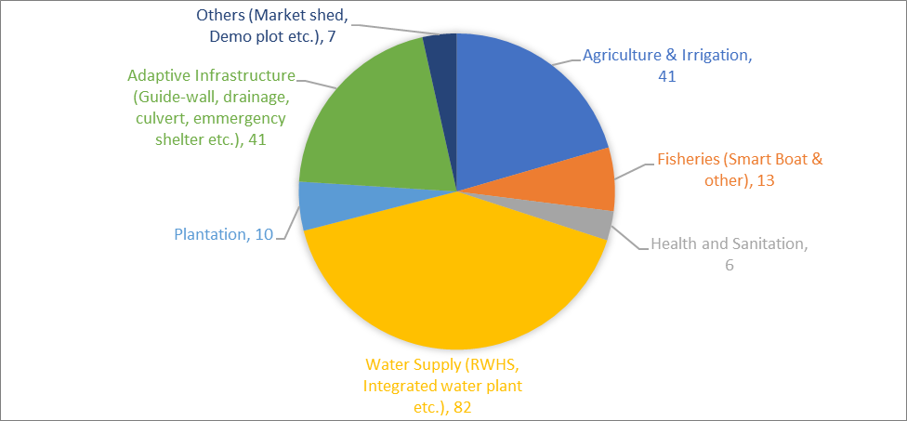

This year, LoGIC has focused on developing and expanding the knowledge and capacity of local governments and households to implement nature-based solutions which have the potential to simultaneously address societal challenges, including climate change mitigation and adaptation, natural disasters, human health, food and water security, as well as biodiversity loss. To design and implement PBCRG schemes that provide nature-based solutions, LoGIC has entered a partnership with the Bangladesh University of Engineering Technology (BUET) and the Center for Natural Resources Studies (CNRS).
To support vulnerable households in adapting to climate change, LoGIC has, since its inception, disbursed a total of US$ 9.72 million to 35,000 selected beneficiaries through its CRF grants. In 2021, LoGIC, through its grievance redress mechanism, selected 18,000 new beneficiaries, all of which are women-led households. The CRF enables them to implement CALOs and gain financial security despite increasingly frequent climate change-induced hazards. 74% of 17,000 beneficiary households (selected in 2019 and 2020) have gained economic benefit from the implementation of CALOs.
Addressing the barriers to women’s financial inclusion is vital for closing the gender gap, empowering women both socially and financially, and in turn increasing their overall resilience. In 2021, LoGIC partnered with the NGO PCC & MEC to facilitate the inclusion of beneficiaries into the formal banking system, their access to Mobile Financial Services (MFS), as well as strengthen beneficiaries’ capacity and understanding of access to financial resources, services, and markets through training. Furthermore, PCC & MEC will initiate value chain development and facilitate market linkages. With the inclusion of key financing partners such as banks and insurance companies in its model, LoGIC aims to create a conducive market-based ecosystem for sustainable livelihoods by fulfilling their low-cost financing requirements. Keeping in mind the challenge of creditworthiness of the borrower/beneficiaries in the area of access to land and business viability, LoGIC is acting as the mediator in charge of facilitating financing for adaptive/resilient livelihood initiatives by connecting the credit/loan seekers to credible financial institutions. This innovative financing model also incorporates insurance facilities so that beneficiaries can avail enhanced access to climate-adaptive insurance upon climate-resilient livelihood products, thus securing entrepreneurial sustainability. In 2021, the firm facilitated the opening of 18,000 individual bank accounts for climate-vulnerable households. Notably, all beneficiaries – women who traditionally do not have access to formal bank accounts – have since the start of the project opened individual or group bank accounts, and all have made at least one bank transaction this year.
Many beneficiaries living in remote areas cannot access physical branches of banks, therefore financially excluding them. To this end, LoGIC has taken up initiatives to introduce beneficiaries to mobile wallets which enable them to carry out their banking activities digitally. However, many households do not have access to technology, such as smartphones. To counter this challenge, LoGIC has approached the private sector to procure smartphones for beneficiaries, as well as banks to provide small loans to support beneficiaries in obtaining such phones.
The saving practices of beneficiaries are a major indicator of their economic empowerment.
Compared to the baseline year, the savings of LoGIC households have increased from 14% to 82%, a significant achievement toward increased living standards and climate resilience. LoGIC is in the process of fostering community development through the establishment of cooperatives with legal organizational structures through which beneficiaries will deposit a certain amount of periodic savings and ensure the sustainability of their investments. Through the cooperatives, they will be able to access financial institutions such as banks and the capital market more easily, as well as run business with trade licenses, export and import with joint stock licenses, and be listed in the Bangladesh Securities and Exchange Commission by obtaining a company license.

Evidence based Policy Advocacy
Over the past four years, LoGIC has gathered extensive evidence through the monitoring and review of the efficacy and sustainability of its climate adaptation activities. This forms the basis for targeted, evidence-based policy advocacy to mainstream the project’s good practices into government planning and strategic decision-making processes and ensures their continuation and expansion beyond the scope of the project. As LoGIC is entering its final year, the project is also utilizing this evidence to scale up good practices, optimize its core processes, and further strengthen its climate change narrative.
In 2021, LoGIC started the development of a ‘Climate Vulnerability Index’ (CVI) which will strengthen local Government’s capacities for accountable planning and financing of CCA and risk reduction measures and provide detailed evidence to inform advocacy on mechanisms for financing local resilience. The CVI maps the exposure (whether a district is prone to extreme weather events), sensitivity (the likelihood of an impact on the district by the weather event), and adaptive capacity (what the response or coping mechanism of the district is) of the various areas in Bangladesh down to the local government level. This helps identify vulnerabilities and plan strategies to enhance resilience and adaptive capacities by climate proofing communities, economies, and infrastructure. With the help of the CVI, union-level administrations will be able to formulate the budgetary provision for annual development taking into account climate disaster vulnerability. On a national level, high vulnerability areas can be identified based on extensive data and evidence and be prioritized for infrastructural development, adaptation, or maintenance. Moreover, the CVI will inform policy makers and development partners and therefore contribute to the overall achievement of Agenda 2030.

To formulate the Index, LoGIC has established an inter-ministerial committee to assess the field’s requirements and reform the existing financing and allocation policy to be need-based. Based on the project’s experience, LoGIC has developed a Local Climate Financing Framework (LCFF) model. LoGIC has shared the framework with the Local Government Division (LGD) and has advocated for its inclusion in the revised National Climate Financing Framework (CFF). At a national level roundtable discussion in October 2021, LoGIC presented its youth participatory advocacy initiative. The project highlighted the impacts of climate change faced by climate vulnerable youths in Bangladesh and advocated for a more climate-vulnerable youthfriendly policy framework.
As the Government of Bangladesh is increasingly focusing on developing its tourism sector, LoGIC has been advocating for eco-tourism, which will not only sustain the environment and heritage of natural sites, but also include the diverse local climate-vulnerable communities in the sector who can benefit economically. LoGIC has created an inception report in which it has identified four districts (Khulna, Bagerhat, Sunamganj, and Kurigram) for which it is assessing potential business opportunities for eco-tourism through a community-based approach. Following this assessment, LoGIC will create business plans for the respective districts based on gathered data and stakeholder consultations.
In 2021, LoGIC also advocated with banks and other financial institutes for the financial inclusion of climate-vulnerable women. In the coming year, LoGIC will lead discussions with the Financial Institution Division (FID) to explore options for an innovative financial mechanism that will allow CRF beneficiaries to access formal bank financing after their graduation. Two other policy issues identified by LoGIC that require further attention are the implementation of
- Parametric cyclone and risk insurance for the assets of Local Government Institutions; and
- Risk transfer mechanism for embankments.

Youth as Change Makers
LoGIC believes Bangladesh’s youth to be important agents of change that need to be empowered to ensure intergenerational change towards a climate-resilient future. Building the capacities of rural climate-vulnerable youths not only increases climate resilience within their communities, but will also enable youths to become active change-makers to help tackle long-term climate change challenges. As a result, LoGIC has developed a Youth Engagement Strategy that will supplement LoGIC’s current strategy for enhancing community climate resilience by including young people as key drivers for climate action. The project will integrate youths into LoGIC supported local adaptation planning, climate risk assessments, CCA tracking and monitoring processes and therefore build their climate resilience and adaptation capabilities.
LoGIC will provide the necessary guidance and assistance for youth to increase their adaptive capabilities and climate resilience, as well as to engage in local decision-making processes and develop innovative solutions toward making real changes at the grassroot level. The project will nurture their capacities, skills, knowledge, enthusiasm and capabilities and channel them towards enhanced leadership in adaptation and mitigation challenges under the existing framework and objective of the LoGIC project. The project envisions to equip the youth with the requisite skills to deal effectively with complexities like climate change, of which they are direct victims. Overall, LoGIC will raise awareness of climate change and environmental issues among Bangladesh’s youth and create a space and platform for them to advocate and widen their networks, locally and nationally.
Thus far, LoGIC has identified 8,872 youth from vulnerable communities and project beneficiaries’ families who will be part of a LoGIC Youth Network across the project’s working area. In this year alone, 219 youth groups have been launched across seven districts. The interconnected LoGIC youth network will build a platform for a national youth movement in Bangladesh, starting at the grassroot level. To date, a total of 132 youth from six LoGIC districts have been provided training on climate change, LoGIC interventions, as well as sheep insurance in order to engage and develop them as local insurance agents and create market linkages.

- Key challenges and mitigation measures:
  - The livelihood initiatives of CRF beneficiaries were affected differently by both climatic hazards and non-climatic hazards, such as Amphan and COVID-19. As a result, 21% of beneficiaries were unable to start the next cycle of their CALO, and 21% started livelihood activities that they had to stop. This experience has made beneficiaries more cautious about updating existing business plans. LoGIC has developed a calendar for climate-adaptive livelihoods divided by districts to inform CRF recipients about which CALO is secure to take up in each season.
  - There is an occasional lack of understanding among stakeholders of the benefits of LoGIC’s long-term approach when compared to traditional relief programs. Additionally, most poor beneficiaries express more interest in implementing traditional livelihood options that are not climate-adaptive but offer short-term economic returns. There has been a gradual decrease in this initial apprehensiveness since the project’s inception due to LoGIC’s awareness-raising initiatives and the implementation of its evidence-based risk atlas in the localities.
  - Beneficiaries occasionally show an unwillingness to establish or remain in saving groups with other CRF recipients due to conflict or a preference for grouping with relatives or friends. To prevent this, LoGIC is highlighting the advantages of saving in groups, such as increased opportunities for CALO scale-up and enhanced group engagement.
  - Despite beneficiaries benefitting from PBCRG schemes, such as pure drinking waterrelated schemes, some beneficiaries are unwilling or unmotivated to pay a minimum fee for products or services which are necessary to maintain the facility in the long term. There is often no viable and sustainable alternative that does not require long term maintenance.
  - The sustainability of certain adaptation interventions requires continued efforts from the project which may entail some post-implementation expenditure. Post-adaptive infrastructures, for example, require operational management and maintenance work, the cost for which the communities need to bear after project completion.
  - As per administrative rules, PBCRG schemes must be completed by a certain month of the fiscal year which often does not align with the seasonal nature of the implementation and functioning of certain schemes. The Block Grants Coordination Committee (BGCC) at the Upazila level provided approval of those schemes with an adjusted timeframe.
  - The results and impacts of LoGIC depend largely on the utilization of PBCRGs by UPs and CRFs by the beneficiary households. While many of the schemes and livelihood options taken up by the local governments and households respectively are aligned with CCA, their quality and performance of them in this regard pose both risks and challenges. To this end, LoGIC has recruited an engineer to monitor the design phase of PBCRGs and ensure their efficacy and sustainability. Community Mobilization Facilitators (CMFs) are now dedicating 100% of their time to monitoring the implementation of CRFs. On top of the existing District Climate Change Coordinators (for CRFs) and the District Grants Monitors and Facilitators (for PBCRGs), LoGIC has recruited 19 additional facilitators for close monitoring at the Upazila level.
  - The influence and pressure of UP members and local elites caused limited interruptions to the beneficiary selection process. To counter this, LoGIC shared its beneficiary selection process at different levels (e.g. UPs, Upazila administration, district and community meetings) to showcase its transparency and lack of bias.

- Lessons Learned:
  - Cultivating sunflower, maize, watermelon, and bangi (i.e., non-traditional livelihoods for communities) would be suitable options for CALOs if freshwater is managed for irrigation.
  - Risk management plans need to be developed and additional measures are required to boost or sustain livelihood activities that have been stopped or damaged due to COVID19 related lockdowns.
  - A more in-depth understanding of livelihoods of beneficiaries will be useful for the project to support them in their immediate, intermediate, and long-term strategy for achieving climate-resilient livelihood pathways.
  - The project needs to develop effective ways to remove the practical and strategic barriers to the take up of CALOs, such as the risk of beneficiaries repurposing the CRF to respond to other challenges such as the COVID-19 pandemic, cyclone, flood, or other emergency responses. This would take away the purpose of the climate change project. Safeguarding CALOs and ensuring close monitoring may minimize the risks.
  - LoGIC needs to identify alternative ways to ensure funding necessary for the maintenance of PBCRG community schemes, such as the collection of fees once every year or season, or the linkage of the schemes with ongoing efforts of other governmental and non-governmental organizations.
  - The level of awareness of UPs on local level climate risks plays an important role in the prioritization of adaptation measures. Utilizing recently developed climate risk atlases during meetings with UP representatives has been found to help their understanding of what types of schemes are more relevant for CCA and which are purely developmental in nature. This underscores the importance of awareness raising for formulating effective climate risk reduction action plans.
  - Planning, designing, budgeting, and implementation are important determinants of the effectiveness of adaptation measures. To this end, the project has hired project engineers for infrastructural interventions related to adaptation. However, certain interventions require very specific types of technical capacities which may not be available in the project. Therefore, the project may have to enter into further partnerships and outsource technical knowledge.

d) Way Forward

As LoGIC is concluding its fifth year and entering its final year, the project is scaling up its best practices and optimizing its core processes to further strengthen its local financing model and deliver climate finance to the most vulnerable people with lower transaction costs and higher adaptation benefits. The following areas of focus will inform the final project year in 2022:

Capacity Building
In 2022, LoGIC will train 45,000 CRF recipients on CALOs and ensure the financial inclusion of all beneficiaries. By building cooperatives with legal organizational structures, conducting workshops, and establishing market linkages, LoGIC will enable beneficiaries to make period group savings and create group businesses. LoGIC’s youth strategy will ensure that youth are included in climate adaptation strategies and therefore achieve lasting change for intergenerational climate resilience.

Climate Finance
Ensuring access to climate finance is a key component of the LoGIC model. In 2021, LoGIC partnered with PCC & MEC to facilitate the financial inclusion of its beneficiaries. In 2022, LoGIC, through PCC & MEC, will facilitate the opening of 1,990 group bank accounts, as well as provide training to all 35,000 LoGIC beneficiaries on financial literacy. Moreover, LoGIC will establish market linkages and facilitate contract farming for the 1,990 beneficiary groups to ensure the sustainability of their CALOs.

Policy Advocacy
Achieving policy-level change is crucial for long-term change. Consequently, strengthening policy advocacy is a key priority for LoGIC as it is entering its final year. LoGIC will continue to implement a top-down approach in order to sensitize local government officials on the necessity for climate change adaptation. To this end, the project will chair various meetings and round table discussions on climate change adaptation and climate financing with the Government, civil society organizations, and other relevant stakeholders. When relevant, LoGIC will use its available budget to hire consultants for specific policy advocacy issues.
As LoGIC is entering its final year, the project has started the development of an exit strategy and sustainability plan. Thus far, LoGIC has initiated 24 consultations with CRF partners, youths, local governments, media, and Community Mobilization Facilitators (CMF) across five districts.

CRF beneficiaries who have completed at least three cycles/types of climate adaptive livelihood options (CALO) will be graduated from LoGIC support. According to the project’s database, there are currently 7,870 CRF beneficiaries who have completed at least three cycles/types of CALO. LoGIC has defined five indicators to assess the capacity of beneficiaries to graduate in the first quarter of next year:
- Social Indicator: Completed at least three cycles/type of CALO and can manage their livelihood and bank operation without supports from LoGIC.
- Economic indicator: Gained positive return (1:<1) from investment in CALOs.
- Environmental Indicator: Implementing diversified climate resilient actions which are not environmentally harmful.
- Financial Indicator: Has knowledge of and ability to access financial market.
- Institutional/Transformation Indicator: Has gained awareness of climate change adaptation and is working as a change agent in the community.

To sustain the results of PBCRG investment as well as the adaptation planning and financing practices mainstreamed into local government processes, the LoGIC project has adopted the following exit strategies:
- Update the Union level RRAPs for the next couple of years with the participation of Ups and raise their awareness on adherence to the RRAPs during five-yearly and annual planning.
- Form management committees with the participation of UP representatives, members of beneficiary communities, and other local-level stakeholders to ensure postimplementation management of PBCRG schemes.
- Equip management committee members or other stakeholders with the capacity and skills necessary for post-implementation.
- Establish a ‘user fee’ mechanism to raise funds for post-implementation operations and maintenance work.
- Sign agreement document among the concerned parties to ensure post-implementation management.
- Link PBCRG schemes with relevant ongoing efforts of other governmental and nongovernmental organizations and agencies.

The finalized exit strategy and sustainability plan will inform the remaining project period. To ensure the sustainability of LoGIC’s adaptation strategy, the Government, UNDP, and UNCDF will work together and explore ways to arrange funding for a broader scale-up of LoGIC from the Government of Bangladesh.

Roadmap for LoGIC Scale-up
Phase 1: April 2022-February 2023
In this scale-up phase, LoGIC will be working in six newly selected climate-vulnerable districts
(in addition to the existing seven districts): Sandip, Cox’s Bazar, Noakhali, Satkhira, Gaibandha, and Chapainawabganj, as well as three climate-vulnerable districts of the Chittagong Hill Tracts. All districts have been identified based on the Bangladesh Climate and Disaster Risk Atlas: Exposures, Vulnerabilities, and Risks report published by the Asian Development Bank. Specific local government units will be identified by LoGIC’s ongoing nationwide CVI. Overall, LoGIC will scale up its model in the 16 most climate-vulnerable districts including three districts from the Chittagong Hill Tracts.

EU | UNDP-UNCDF | LGD | Embassy of Sweden | Timeline
Developing action fiche | Developing project document | Developing DPP | Developing concept note | April-May 2022
EU signing Financing Agreement with ERD | Placing to ERD | Placing to  Planning  Commission | Sharing with  MPTF | June-Dec 2022
EU signing Contribution Agreements with UNDP and UNCDF | Signing with ERD | Placing to  ERD | Signing MPTF agreement | Jan-Feb 2023
LoGIC II is proposed to start on 1 March 2023 with support from the Local Government Division, EU, the Embassy of Sweden, UNDP and UNCDF.

Phase 2: Nationwide Scale-up of LoGIC Model
LoGIC has been included in the GCF’s Country Programme for Bangladesh as agreed with the Government of Bangladesh and has been recognized as a sustainable adaptation model to support local government institutions to deliver CCA actions effectively and efficiently at different levels. Country Programmes are the cornerstone of each country’s pipeline development with GCF and are the first stage of the updated GCF project and programme cycle, forming the basis for prioritizing the further development of funding proposals for projects and programmes submitted by Accredited Entities on behalf of countries for funding.
Potential GCF financing would entail a primary co-financing commitment of the Local Government Division of $75 million with GCF’s expected contribution totalling around $100 million ($25 million as a grant, $25 million as guarantees, and $50 million as a reimbursable grant). UNDP is notably eligible to act as an accredited entity to GCF for using grants, guarantees, and reimbursable grants. However, the process from proposal submission to signing agreements is time consuming and complicated. Following is a roadmap for GCF proposal submission. Each activity mentioned in the table has a number of sub-activities. Timelines are very tentative as those are subjective to GCF’s consideration. A conservative estimate suggests that it will take at least 15-16 months to complete the process from beginning to end.

Activity | Actors | Timeline
Concept note submission | UNDP, LGD, ERD | December 2022
Feedback and recommendations and finalization of the concept note | UNDP, ERD, GCF  Secretariat | February 2023
- Project Document (GCF’s Funding Proposal) preparation Feasibility Study  - Stakeholders’ Consultation  - Validation  - Finalization | UNDP, ERD | Mar– Aug 2023
Funding Proposal submitted to NDA Bangladesh | ERD | September 2023
Stakeholders’ Consultation - Second |  | September 2023
Obtaining No Objection Letter from NDA |  | September 2023
Funding proposal submission to the Secretariat | UNDP, GCF Secretariat | September 2023
Analysis and Feedback and Assessment recommendation to the Board | GCF Secretariat | Oct – Dec 2023
Independent Assessment (done by Independent Technical Assessment Panel) | GCF’s Technical Advisory Panel, | January 2024
Submission of documentation to the Board | GCF Secretariat | Feb 2024
Board decision | Board | Feb/Mar 2024
Post approval follow-up | GCF Secretariat | Feb/Mar 2024
Implementation of Board conditions | GCF Secretariat | Feb/Mar 2024
Funded activity agreement | GCF Secretariat, UNDP | March 2024
Letter of commitment | Interim Trustee | March 2024
Funding proposal conditions | GCF Secretariat, UNDP, Board | March 2024

e) Risk and Issue Management:
Sl. | Project Risk  This is mandatory. Please add project risks which your project has identified during the reporting period. | Likelihood  (High/  Moderate/Low) | Mitigation Measure  Each mitigation measure should respond to the project risk in the left column.
1 | Fiduciary risks of re-purposing the CRF by the project beneficiaries to meet COVID-19, cyclone, and other emergency responses. | High | Safeguarding climate adaptive livelihood options were implemented through close monitoring.
2 | Risk of non-transformative resilience of CRF beneficiaries due to the fact that a year-round calendar for seasonal and continuous adaptation of their livelihoods is available. | Moderate | A yearlong district wise climate adaptive livelihood seasonal calendar was developed and skill transfer to the CRF beneficiaries was ensured.
3 | Risk of continuation and M&E of project interventions under the current COVID-19 situation. | Moderate | The project ensured project preparedness and modelling of interventions considering the pandemic situation. Alternative ways of data collection to assess the project's progress are being sought.
4 | Risk of further project delay due to slow administrative processes in approval of revised DPP and other related documents | Moderate | The project discussed the issue with the PIC and DPs to expedite the administrative process.
 | Risk of continuity and assessing of project interventions under the current Covid-19 situation. | Moderate | Ensure project preparedness and modelling of interventions considering the pandemic situation. Find alternative ways of data collection to assess the project's progress.
 | Risk of hampering the ward census  in Covid-19 pandemic and monsoon rain | Moderate | Ensure alternative plan according to available workforce and consider the situation to meet the deadline.
 | Risk of corona virus infection of | High | Continue the census data collection
 | Community Mobilization Facilitators (CMF). |  | in a limited manner or stop collection observing the Covid-19 pandemic situation.
 | Risk of slow progress of project activities due to Union Parishad election. | Moderate | Maintain careful relationship with UPs and involve DDLG and UNOs  in decision making and implementation.

f) Partnership
Establishing partnerships is an important way to enhance the effectiveness of resilience-building efforts as it offers the opportunity of complementing existing knowledge, skills, capacities, and resources.

Partnership with BRAC
To ensure capacity building on climate-resilient means of livelihoods for CRF beneficiaries and create linkages with private sector actors for scalable business opportunities, a partnership between LoGIC and BRAC has been established. This is a 12-month partnership to provide training on the most feasible adaptive and economically feasible livelihood options to 63,000 CRF beneficiaries. BRAC has developed 17 training modules on CALOs, which support scalable business opportunities.

Partnership with BUET and CNRS
LoGIC entered into partnerships with the Bangladesh University of Engineering Technology (BUET) and the Center for Natural Resources Studies (CNRS) to design and implement PBCRG schemes that provide nature-based solutions to climate change-induced hazards. The project has partnered up with BUET to transfer its technology of reducing soil erosion using vetiver grass to the Local Government. Professor Dr. Mohammad Shariful Islam, Department of Civil Engineering, BUET is providing necessary technical support to LoGIC to demonstrate vetiver based slope protection in Pankhali Union, Thanahat Union, and Rajibpur Union. On the other hand, CNRS is working closely with the UPs of Koyra Sadar, Moharajpur and Dakkhin Bedkashi for mangrove plantation and with the UPs of Uttar Sreepur and Dakkhin Sreepur for swamp afforestation. Mangroves act as natural barriers to prevent the damage of cyclones and tidal surges, and swamp forest protects human settlements from erosion following floods and flash floods. These partnerships will act as key driving forces for the successful implementation of the aforementioned nature-based solutions.

Partnership with Population Crisis Control & Mass Education Committee (PCC & MEC)
Financial inclusion of the most climate-vulnerable people, especially women, is one of the key priorities of the new strategy for low-carbon, climate-resilient, and pro-vulnerable development. LoGIC has established a partnership with the Population Crisis Control and Mass Education Committee (PCC & MEC) to develop market linkages and financial inclusion for the most climate-vulnerable households of CRF beneficiaries. The organization is providing support to facilitate the opening of individual and group bank accounts of the newly selected 18,000 CRF beneficiaries and strengthening the 35,000 beneficiaries’ capacity and understanding of, as well as access to, financial resources, services, and markets. Furthermore, the partnership is establishing market linkages and value chains for LoGIC’s 1990 beneficiary groups to support their climate-adaptive businesses.

Monitoring & Evaluation
The LoGIC M&E system plays an essential function in project implementation and programmatic improvement, providing valuable information on program targets and periodic progress, contributing to the overall achievement of the project’s goals. The main objective of LoGIC’s M&E system is to facilitate the project management staff to o Ensure operational activities are planned and implemented on time and aligned with the project’s overall objective. o Establish a learning environment, identify potential shortfalls in the expected performance, and share successes.
o Develop appropriate remedial actions.

Monitoring
In light of COVID-19 induced lockdowns wherein all physical movements of project staff had to be halted, the project initiated alternative ways to continue its monitoring activities:
- In August 2021, LoGIC conducted its fourth round of “Kemon Achen” (How Are You?), a light touch survey on the adaptation status of climate-vulnerable communities in the context of the COVID-19 pandemic. LoGIC is a pioneer in UNDP to conduct such a survey of beneficiaries within the context of COVID-19. The project staff conducted telephonic interviews with 426 beneficiaries of LoGIC to understand the immediate impacts of the pandemic on the physical and mental health, livelihoods, and education of the project beneficiaries. The information collected from the interview was documented online using a data screen and aided project monitoring and follow-up.
- Field staff were guided over the phone, texts, and online meetings to better understand data collection. LoGIC provided front-line staff with tablet phones for data collection, including photographs. These helped the project to continue its monitoring of regular project activities during the COVID-19 pandemic.
- LoGIC used a virtual monitoring system i.e., video calling, to monitor community level activities. The gathered information was shared in virtual meetings attended by project stakeholders such as DDLG, UNO, Chairman, UP Secretary and LoGIC-PMU.
- LoGIC had planned an EU mission to project sites in Khulna in January 2022 which had to be cancelled due to concerns related to COVID-19. The project has created and maintained its Management Information System (MIS) and monitoring databases to capture and track beneficiary, household, Union Parishad and intervention level data necessary to calculate values for all indicators tracked quarterly and annually. The data captured in the databases was used to analyse project outputs and outcomes across geographic locations and findings were shared with project management on a quarterly basis.
- The Adaptation Tracking and Measuring (ATM) system is used to measure and monitor the climate adaptation and resilience progress of households and communities receiving support from the project. On a monthly basis, the ATM collects data from project supported households against the set adaptation indicators. The data is used to prepare quarterly adaptation monitoring reports.
- The project management has agreed on set standards for all project interventions. The LoGIC M&E system has prepared five process monitoring tools based on these set standards and conducted regular monitoring of sample interventions using the tools. The project monitoring team prepared quarterly monitoring reports which were shared with management.

Evaluation
- Mid-term Evaluation (MTE): The Mid-Term Evaluation (MTE) aims to assess the relevance of the project objectives, as well as the efficiency, effectiveness, and sustainability of the project. The Evaluation is undertaken in accordance with guidance from United Nations Evaluation
Group (UNEG). The international research firm “IPA Global” has been hired to conduct the MTE of LoGIC. However, the start of the MTE was delayed due to COVID-19 related travel restrictions, which hindered the international evaluator from entering the country. The MTE has since commenced and the collection of field-level data has been completed. Due to COVID-19, the deadlines for the deliverables have been rescheduled and the final MTE report will be available by March 2022.
- Annual Progress Review (APR): To assess LoGIC‘s progress and capture its challenges and lessons learned, an Annual Progress Review (APR) has been conducted by the renowned national-level research organization ‘Unnayan Shamannay’. The APR will complement the final project evaluation and will inform the project management and project steering committee.

Reporting
To document the project’s progress and challenges, as well as showcase LoGIC’s achievements, the following reporting documents were drafted in 2021:
- Quarterly Progress Reports
- Quarterly MIS Reports
- Quarterly Monitoring Reports
- MPTF Report (for SIDA)
- Six-Monthly report (for Local Government Division, GOB)
- Annual Progress Report 2021 (for EU)

g) Cross-cutting issues Social and environmental safeguard
Social and environmental safeguard policies are essential mechanisms for LoGIC to prevent and mitigate undue harm to the environment and its inhabitants as a result of project activities. During project implementation, safeguards help define measures and processes to effectively manage risks and enhance the project’s positive impacts. LoGIC ensures that all PBCRG schemes undergo rigorous checking using a standardized template in order to check if the proposed intervention is compliant with the social and environmental safeguards. The indicators of this checklist include, among others, compliance with human rights of the marginalized groups, gender equality, environmental sustainability, risks and threats to biological diversity, community health, security, working environment, cultural heritage, displacement and resettlement and environmental pollution.

Gender
Climate change is not a gender-neutral issue. Women commonly face higher risks and greater burdens from the impacts of climate change in situations of poverty and 70% of the world’s poor are women. Women’s unequal participation in decision-making processes and labor markets compound existing inequalities and often prevent women from fully contributing to climaterelated planning, policymaking, and implementation. LoGIC’s gender strategy is based on the following premises:
- Vulnerability to climate change is gendered. Women are disproportionately vulnerable to natural hazards due to pervasive social norms. These norms reinforce socially acceptable gender inequality and reproductive responsibilities, which in turn, constrain women’s mobility and survival options.
- Adaptive capacity is gendered. Women have less control over capital, limited economic opportunities, and a lack of voice in decision-making. These factors reduce women’s capacity to adapt and overcome hazards.
- Vulnerabilities are intergenerational and youth are key human capital to transform for building resilience. Investing in youth is most transformational and investing in vulnerable youth, especially girls, can be extremely useful, beneficial and transformative.
- Access to institutions that can help increase adaptive capacity is also gendered. Findings from studies reveal that very few women have access to public institutions. This constrains their access to adaptation information and support. The findings also reveal that by practicing gender inclusion, institutions can promote transformation of women as change agents with higher adaptive capacity.

Recognizing women’s important contributions as decision-makers, stakeholders, educators, carers, and experts across sectors and at all levels is crucial for achieving equitable and sustainable solutions to climate change. LoGIC recognizes the important intersection of climate change and gender. Therefore, gender has been made a cross-cutting priority in the project with relevant issues mainstreamed into the regular development planning and budgeting and by building awareness on the effect of climate change on vulnerable groups.
LoGIC’s commitment to gender equality is reflected in its beneficiaries: 99% of CRF recipients are climate-vulnerable women who, through the support of the project, can take on CALOs, increasing their social and financial security, as well as their independence and agency within their communities. Moreover, 82% of PBCRG schemes implemented in 2021 were gender responsive. Through the project, women gain access to formal financial institutions and undertake climate-adaptive livelihoods. The inclusion of women in decision-making at the local government level ensures that their voices are heard and gender concerns are considered in policies and adaptation strategies. LoGIC has a gender-sensitive M&E framework that ensures sex-disaggregated data collection.

Marginalized Communities & Persons with Disabilities (PWD)
LoGIC takes an equitable and inclusive approach to climate finance and adaptation by reaching out to the most vulnerable and hardest to reach communities, so nobody gets left behind. In 2021, LoGIC modified its beneficiary selection process to include the hardest-to-reach communities in the project’s working areas, prioritizing women, girls, ethnic minorities, marginalized and persons with disabilities (PWDs). By adopting a human rights-based approach, LoGIC can ensure that vulnerable and marginalized people get the choice, entitlement, and participation in the entire process of building local resilience. The following graph depicts the beneficiary distribution of the newly selected 18,000 CRF beneficiaries:
(100% women, 6% representative of marginal occupational group, 4% Persons with Disability-PWD representatives, 1% indigenous people, 4% fisherfolk, 49% day labor, 9% women headed, 77% landless (Agricultural) and 43% living on or outside embankment.

h) Qualitative assessment
During the reporting period, the UNDP & UNCDF country office, Project Management Unit (PMU) and District level staffs visited UPs and community to check progress and quality of the project interventions. PMU also supported to strengthen the coordination with stakeholders at local and national level.
Project developed activity-wise monitoring checklists to assess the progress and the quality of the implementation of PBCRG schemes and the capacity development of livelihood options for the CRF beneficiaries.
LoGIC has made partnerships with some organizations/institutions to ensure timely delivery of project interventions and quality achievements of the project results.

i) LoGIC Exposure in Media
This year, LoGIC launched the Extension Phase of the Project via ZOOM, in the presence of Honourable Minister, Md. Tazul Islam, Ms. Rensje Teerink, Former Ambassador and Head of Delegation of the European Union to Bangladesh, Ms. Christine Johansson, Deputy Head of
Mission, Embassy of Sweden to Bangladesh, Mr. Helal Uddin Ahmed, Senior Secretary, Local Government Division, Ms. Saila Farzana, Joint Secretary, LGD & National Project Director, LoGIC Project, Ms. Van Nguyen, Deputy Resident Representative, UNDP Bangladesh and many other national and local level dignitaries. Mr. Tazul Islam remarked, “The LoGIC project has proven to be a good system to deliver climate finance through local government institutions, directly reaching climate vulnerable people to invest in local adaptation.” Alongside the Government, he also thanked the project’s development partners for supporting the most climatevulnerable people of Bangladesh. Former Ambassador Rensje Teerink highlighted the EU’s decade long support to Bangladesh in combating climate change.
In March 2021, Mr Per Olsson-Fridh, Sweden‘s Minister for International Development
Cooperation visited LoGIC’s project sites in the coastal belt of Bangladesh, accompanied by Her Excellency Alexandra Berg von Linde, Swedish Ambassador to Bangladesh, Sudipto Mukerjee, Resident Representative of UNDP Bangladesh, Joint Secretary of Local Government Division, Saila Farzana, and Jesmul Hasan, Country Focal Point of UNCDF along with many other delegates. The Minister expressed his satisfaction after seeing how Sweden’s support is being used for climate change adaptation in Bangladesh. Mr Espen Rikter-Svendsen, the Ambassador of Norway to Bangladesh. He also visited the LoGIC projects in Dacope, Khulna, which he described as eye-opening in terms of the volume of activities and complexities associated with climate change adaptation efforts in Bangladesh. He also emphasized the improvements in the livelihoods of the people in the most climate-vulnerable regions and appreciated the understanding amongst the local Government and all other relevant stakeholders.
Throughout 2021, LoGIC established widespread communication and visibility of the project and its development partners and all relevant stakeholders at the district and national level.
LoGIC organized 16 episodes of broadcasting to raise awareness of climate change and climateadaptive livelihoods through community radio programs across four districts. Local celebrities, the Deputy Director of the Local Government, Upazila line department officials, journalists, CRF Partners, and youth representatives attended the on-aired programs. Each radio station produced and broadcasted four episodes weekly, which were also re-broadcasted. The discussions highlighted the success stories of beneficiaries and successes of beneficiaries in local-led climate-adaptive livelihoods, bank transfers, and developing unified business plans for building climate resilience. The discussions also profiled climate change issues in the area and disseminated information on the climate change context of each region. Profiling LoGIC’s activities and the issue of climate change through community radio facilitated the climate change discourse in the area and increased the visibility and interest of other stakeholders in discussions of advocacy and planning for climate change.
In the context of COVID-19, the project raised awareness of social distancing and hygiene measures among all beneficiaries, project staff and relevant stakeholders of the local government institutions.
During the climate hazards of Cyclone Yaas and floods in the project areas, LoGIC ensured strong messaging on resilience building and climate change adaptation to its project communities and households.
LoGIC distributed branded vests to all 18,000 newly selected CRF beneficiaries and project staff were provided with branded umbrellas and caps during the monsoon season.
In 2021, LoGIC continued to regularly update its social media platforms to communicate the activities and results of the project to its followers. On Bangladesh’s most popular social media platform, Facebook, LoGIC’s page reached 315,956 audience members and engaged them in discussions on climate change. LoGIC has also established a strong presence on Twitter, with daily updates on climate change issues, project outcomes, and the project’s approach to working towards sustainable solutions through innovative techniques. LoGIC’s website (https:// logicbd.org) is regularly updated and is a knowledge hub for national and international climate action. To ensure widespread visibility of project activities, key events, and successes at the district and national level, LoGIC has been featured in local and national media, including TV news, radio channels, and other offline and online media.
Quarterly newsletters/E-bulletins have been disseminated to all stakeholders at district and national levels, providing information on the project’s significant highlights, events, achievements, learnings, media visibility, visits from local government representatives, and inaugurations of schemes. Additionally, blogs, human interest stories, and write-ups have contributed to highlighting the project‘s progress and achievements.

III) Indicator Based Performance Assessment
 | Achieved Indicator Targets | Reasons for  Variance with  Planned Target | Source of Verification
Outcome 1  Indicator: % of 72 UPs that have incorporated climate change adaptation actions into their development plans (LDP).  Baseline: 13.9% (Jan, 2018)  Planned Annual Target: 100% | • 100% UPs have incorporated climate change adaptation into their annual and five-year’s development plans through developing Risk Reduction Action Plan (RRAP).  In 2021, Climate Change Adaptation (CCA) actions are integrated and streamlined through UP schemes. This year, 72 UPs planned 863 CCA linked schemes which is 3 percent more than last year, Nature based CCA solutions and safe water supply was given focus this year. | NA | Annual  Progress  Report 2021
Indicator: % of 72 UP plans that have addressed the adaptation needs and priorities of vulnerable women and girls.  Baseline: 6.9% (Jan, 2018)  Planned Annual Target: 50% | • 100% of UPs have prioritized adaptation needs and priorities of vulnerable women and girls.  In 2021, 47% of the UP CCA linked schemes supported the most climate vulnerable poor, 32% schemes for marginalized groups, 35% for climate change adaptation needs of vulnerable women and girls and 1 percent for climate change adaptation needs of climate refugee households. | NA | Annual  Progress  Report 2021
Indicator: % of UP that have established and are implementing the Climate Resilience Financing system.  Baseline: 0% (Jan, 2018)  Planned Annual Target: 80% | • 99% of the UP established and implemented the PBCRG with their own financing and accounting system and supported CRF interventions with their administrative system (understand the CRF mechanism, fully engaged in the process, redress the grievances mechanisms and aware of the types of work CRF beneficiaries are undertaking in curving down their climate change vulnerabilities).  Integration of CCA in UP planning has significantly increased compared to the previous year, which is a significant progress to achieve the LoGIC objective- to establish a financial mechanism for climate resilient action at local level. | NA | Annual  Progress  Report 2021

Indicator: % of 27 UPs that are allocating other resources to implementing CCA linked schemes.  Baseline: 31.9% (Jan, 2018)  Planned Annual Target: 70% | • 71% of target UPs mobilized additional resources from different sources for climate resilience schemes.  In 2020, the progress indicated 7% increase from 2019. This also indicates the UPs are more aware and educated about the climate change issues. | NA | Annual  Progress  Report 2021
Output 1  Indicator (1): % of women, poor and marginalized people that participate in the formulation of climate risk integrated LDPs  Baseline: 1.3%  (Reference: LoGIC Baseline Study 2018) Annual Target: 52% | 100% of the newly selected 18,000 CRF beneficiaries (100% women, 6% representative of marginal occupational group, 4% Persons with Disability-PWD representatives and 1% indigenous people, 24% farmer, 4% fisherfolk, 49% day labor, 9% women headed, 77% landless (Agricultural), 43% living on or outside embankment) participated in the household risk reduction action plan (HH-RRAP) developing process. | NA | Annual  Progress  Report 2021
Indicator (2): % of target UPs that integrate CCA solutions into LDPs to support the most vulnerable households.  Baseline: 31.9% (Reference: LoGIC  Baseline Study 2018)  Annual Target: 100% | • 100% of the targeted 72 UPs integrated climate change adaptation (CCA) solutions into the local development plans (LDP).  The strategic poverty and political economy analysis of PBCRG schemes are under progress, it will help to better understand how PBCRG are benefitting the most vulnerable. | NA | Annual  Progress  Report 2021
Output 2  Indicator (1): % of 17,000 vulnerable households (women, poor and marginalized) who benefit from CCA finance.  Baseline: 10% (National)  Annual Target: 60% | 59% of people (78% are female) in the working areas are benefitted from LoGIC interventions. | NA | Annual  Progress  Report 2021
Indicator (2): % of 72 UPs that secure funding to support CCA linked schemes based on their performance.  Baseline: 0% (Reference: LoGIC | • 100% of 72 UPs have secured PBCRG funding to support CCA linked schemes based on their performance.  In 2021, allocation was given to 72 UPs for selected 200 schemes. 72 UPs prepared 200 CCA linked schemes based | NA | Annual  Progress  Report 2021
Baseline Study 2018)  Annual Target: 100% | on that allocation and received the PBCRG money. UP performance in CCA linked scheme implementation was considered to define the UP-wise PBCRG allocation.
Indicator (3): % of Open Budget sessions in 72 UPs that discussed CCA linked expenditure.  Baseline: 6.9% (Reference: LoGIC  Baseline Survey 2018)  Annual Target: 100% | • 100% of Open Budget sessions in 72 UPs discussed CCA linked expenditure.  In 2021, all the UPs organized open budget meeting, although the participation of the concerned officials and UP body was not satisfactory. 23% of the participants were female. | NA | Annual  Progress  Report 2021
Output 3  Indicator (1): The extent to which National Adaptation Plan (NAP) and 7th Five Year Plan (7FYP) integrate financing for local adaptation.  Baseline: 0 (No) (Reference: LoGIC  Baseline Study 2018)  Annual Target: Yes (Scale⁸ 1-4) | • NAP preparation is under progress by MOEFCC and NDA to GCF for Bangladesh. General Economics  Division (GED) is formulating the 8th FYP.  In the mid-term evaluation (Report will be available in Jan 2022) the progress will be assessed. | NA | Annual  Progress  Report 2021
Indicator (2): The extent to which local climate financing framework is integrated into the national Climate Financing Framework.  Baseline: 0 (No) (Reference: LoGIC  Baseline Study 2018)  Annual Target: Yes (Scale 1-4) | • Local Climate Financing Framework (LCFF) model is developed based on LoGIC experience. LoGIC shared the LCFF with Local Government Division (LGD) to ensure a policy provision for LCFF in the revised Climate Financing Framework (CFF).  Once the LCFF model is recognized National Climate Financing Framework and tested, LGD with enhanced capacity will be able to scale up it to all vulnerable UPs. | NA | Annual  Progress  Report 2021

⁸ ⁸ Scale:
1.Specific commitment to finance local adaptation mentioned
2.Allocations made to finance local adaptation mentioned
3.Specific commitment to finance local adaptation mentioned
4.Allocations made to finance local adaptation mentioned

Success stories:

FOSTERING GRAIN RESILIENCE IN BAGERHAT
In the Bagerhat district of south-western Bangladesh, communities are already facing the harsh realities of climate change. In the last two decades, farmers in this region have noticed a significant rise in heat waves during the summertime, increased desertification, a lack of rainfall, and severe salinity intrusion in water. This has resulted in immense socioeconomic downfalls for the farmers who can now only cultivate one type of crop per year, instead of the usual three or four. For the rest of the year, the land remains unfertile and dry, leaving farmers with minimal to no income.
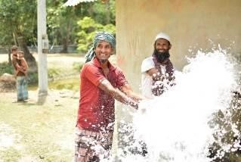
“Even a few years ago I was able to cultivate three types of rice per year. I could do other seasonal vegetable cultivation as well,” says Hares Akon, a farmer in the Rayenda Union. “But now we struggle to make ends meet as crop production is very little and so is our income,” shares Hares – a similar situation for all the other farmers residing in this area. Hares and his family dreamed of building a strong brick house that would weather the harsh windstorms and rainfalls during natural hazards, which have been occurring increasingly often in this area. However, their unfavorable economic situation meant that the family had to continue to live in their small house made from mud and bamboo with a roof made from fragile tin, prone to destruction due to the frequent harsh weather events in Bagerhat.
“When a storm blew away our tin roof the last time, we had nowhere to go. Every time when there is a storm, I worry about whether we will survive it,” says Hares’ wife Minara who used to help her husband with crop cultivation and storage. She used to keep some of the produce for home and sold the rest in the market at a profitable rate.
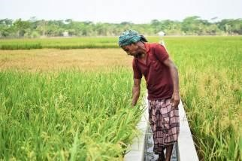
However, now there is very little crop to sell, let alone to keep at home. When farmers like Hares raised this issue at Union Parishad meetings, LoGIC, through its PBCRG scheme, facilitated the implementation of a solar-based agricultural irrigation plant that redirects water from nearby natural canals. This water irrigation system has solar-based pumps that bring water to the surface and disperse it through valves that are distributed across the 2000-acre agricultural land. While frequent climate hazards often disrupt the electric supply in the area, the solar panels provide more consistent power for better crop cultivation. This irrigation plant offers a nature-based solution that uses clean energy and surface water and thus avoids the harmful environmental impacts of groundwater extraction.
Farmers are now able to harvest not only one but three types of crops throughout the year on this 2000-acre land. This has had tremendous socio-economic impacts on the farmers through an increase in crop diversification and higher production yields of vegetables and rice.
“Previously we could only produce around 500 kgs of rice from one cultivation per year, but now we are able to produce 1600kgs of rice from just one cultivation, while the other two cultivations give us additional crops around the year,” explains Hares, one of the 600 farmers cultivating in this plot of land.
A PBCRG of USD$21,000 was provided to the local government for the implementation of the solar-based agricultural plant. Farmers and other local governance support projects contributed around USD $11,600 through a co-financing mechanism, creating strong local ownership and ensuring long-term sustainability of the irrigation plant. LoGIC also played a catalytic role in developing a committee for the maintenance, as well as the monitoring of the optimal utilization of water from the plant. Committee members include local government representatives, community farmers, and community mobilization facilitators who meet once a month to discuss, plan, and share ideas and opportunities around the irrigation system.
“Since the installation of the solar-based agricultural water irrigation system, our economic returns have more than doubled. Like me, all the farmers have diversified their production, selling their yields in the market, and reaping profits,” says Hares. He and his wife Minara have started to keep aside some of their savings every month to build a brick house to protect them from future climate hazards. Hares’ family is one of many to gain climate resilience with the support of LoGIC.

SOWING THE SEEDS OF RESILIENCE IN KHULNA
Dacope, Khulna is one of Bangladesh’s most climate vulnerable regions, frequently experiencing cyclones, thunderstorms, and flooding which are destroying infrastructure and agriculture. With the majority of coastal people largely depending on natural resources for economic survival, the frequent destruction caused by climate disasters is depleting resources and livelihoods, pushing many households into even deeper poverty.
Rikta Roy, living in Dacope, had long been struggling to find a stable source of income. “Storms, cyclones and salinity levels in water have increased over the years. This has disrupted my livelihood immensely,” said Rikta. She started rearing chickens and ducks with high hopes of selling the poultry eggs for a profit. But the cyclone Amphan in May 2020 destroyed these hopes as it swept away from her small poultry farm, Rikta’s only source of income. She could not even catch fish as the ponds were too saline. Rikta and her fellow coastal women are particularly vulnerable to the adverse impacts of climate change. The women are typically in charge of collecting water and ensuring nutrition for their families, but freshwater sources are dwindling due to increased salinity. Meanwhile, the salinity of the soil makes it difficult for them to rear animals and grow crops and vegetables. Men in the area frequently migrate away from the coastal areas, leaving women with the extra burden of sustaining their families and generating an income.
Moreover, women are often left behind in capacity-building and education activities, leaving them ill-equipped to ensure their safety during natural disasters. They are the hardest-hit demographic during cyclones and storms, falling into a vicious cycle of poverty and vulnerability aggravated by climate change. A survey undertaken by LoGIC profiled the most climatevulnerable women in Dacope Upazila, where Rikta and other members got enlisted. The women were divided into smaller groups where each member received a CRF of USD 340 (approximately BDT 29,000) as direct support to undertake climate adaptative livelihoods with immediate benefits for their income. LoGIC established a co-financing mechanism where these women contributed USD 58 (approx. BDT 5,000) from their personal funding to ensure strong ownership of the community and beneficiaries for sustainability. Working with local government authorities, agricultural officers, and community mobilisation facilitators, LoGIC supported these groups through every step of the implementation process -- planning, financing, climate-adaptive business model formulation, and land leasing for cultivation. The project also provided training on watermelon cultivation, created access to financial institutions, and established market linkages for these women. “I spent my days ploughing land, watering seeds, using fertilisers and pesticides when necessary. The cultivation period lasted around three months. Finally, when the watermelons were ready, the project helped us connect with retailers for sale,” said Rikta.
Between March to May 2021, LoGIC has supported over 200 women in watermelon cultivation in Dacope. The women invested $46,000 in production and gained a total profit of $90,000. This is just one of the many schemes of the LoGIC project. “We sold watermelon at a double profit, and with these savings, we will do cultivation in the upcoming season,” said Rikita.
LoGIC is supporting over 7,000 beneficiaries in Khulna to take their first step towards sustainable livelihoods. Coastal women are looking forward to the upcoming season to cultivate pumpkin, cucumber, corn, and sunflowers. These vegetables will not only earn them a profit but also provide nutrition for their families. With the support of LoGIC, these women are sowing the seeds for long-term climate resilience.

Annex-1: Debrief on Mid-Term Evaluation of LoGIC project

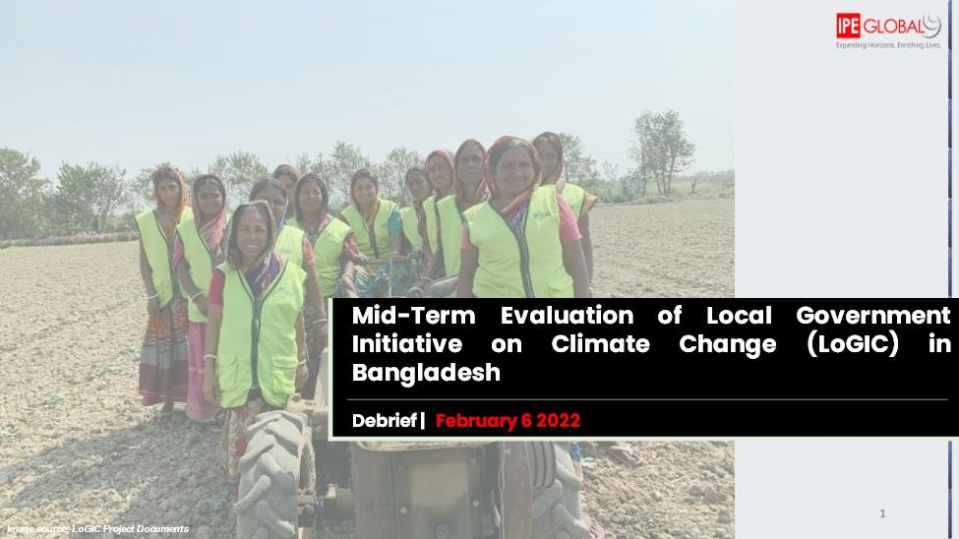

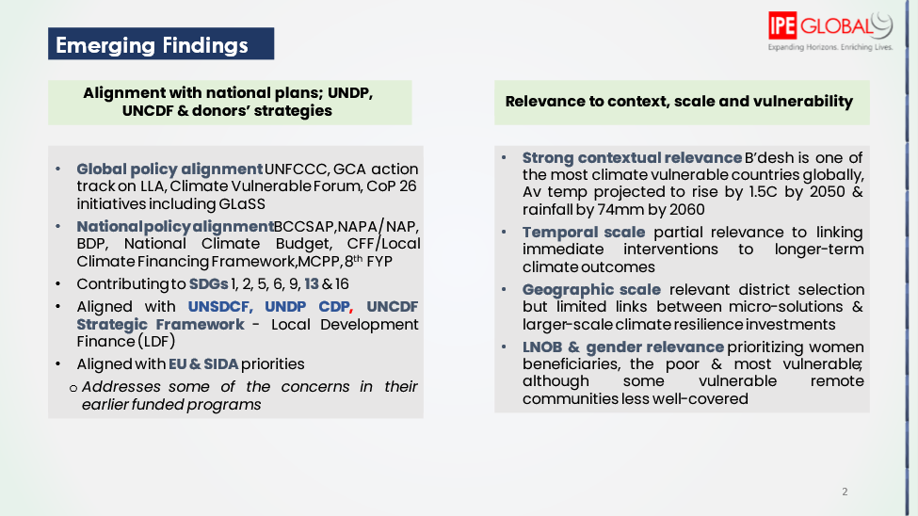

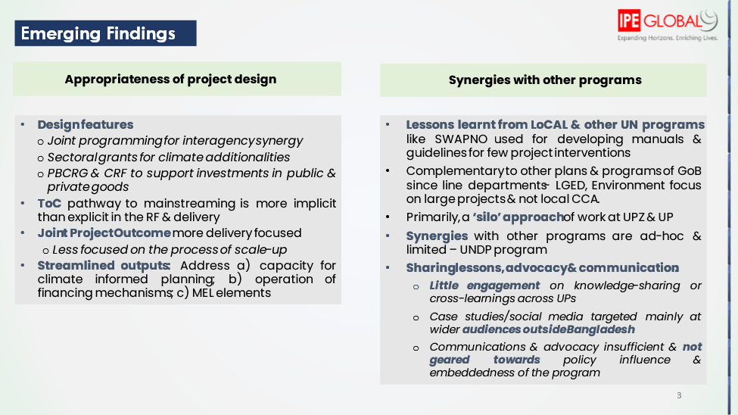

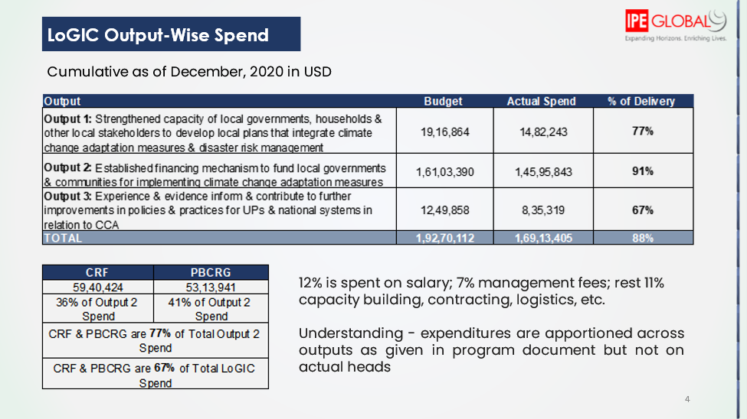

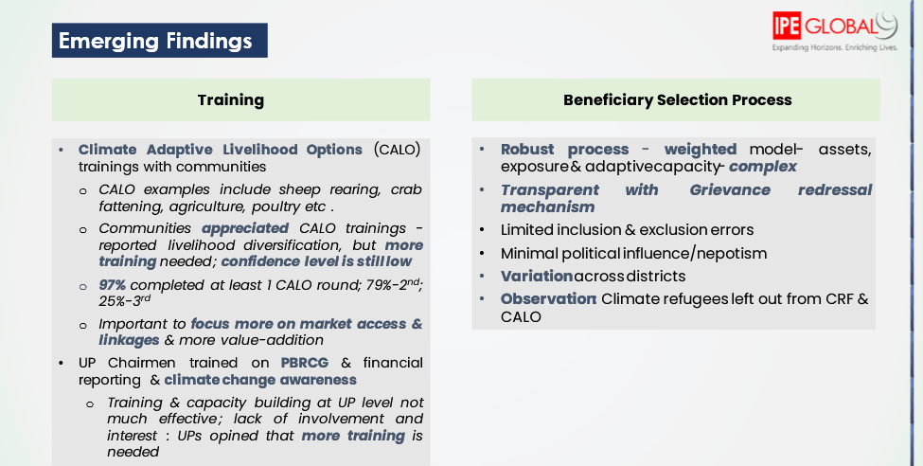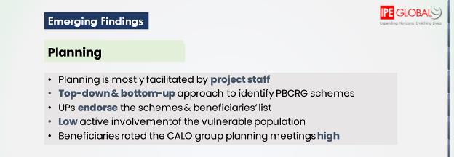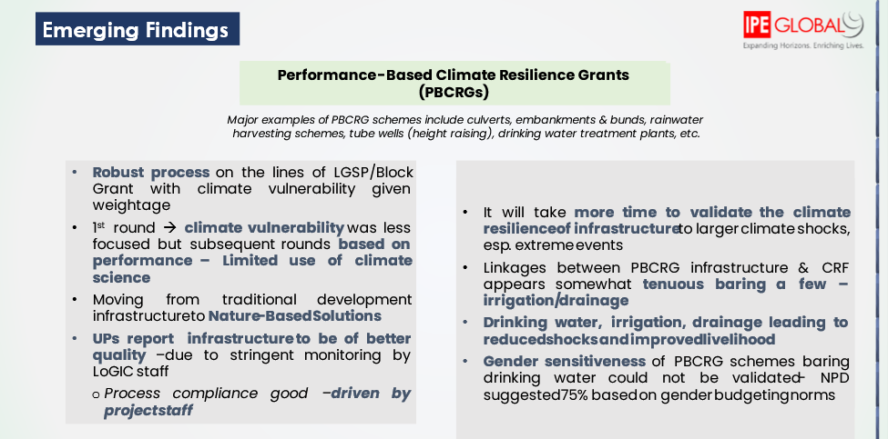

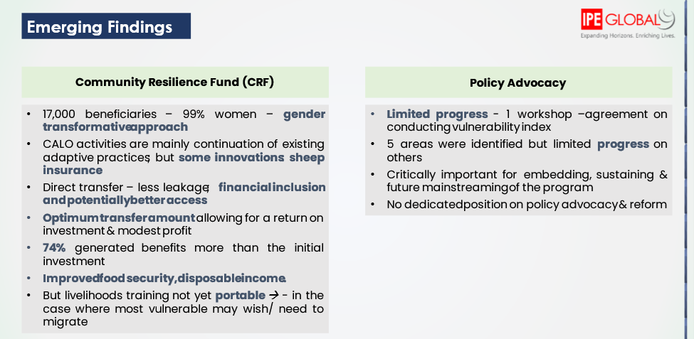

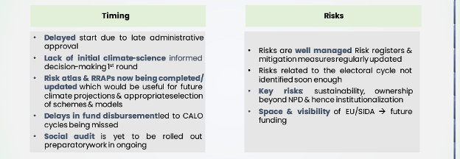

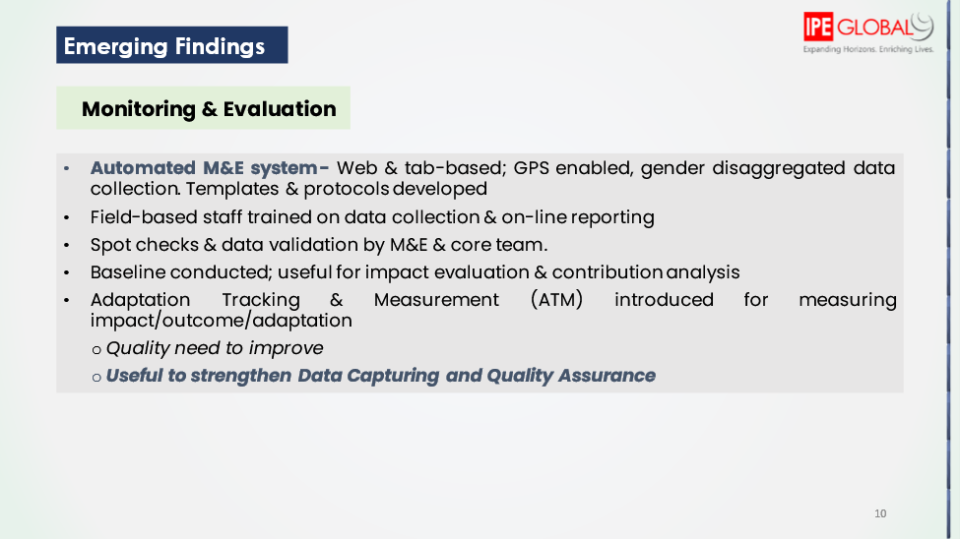

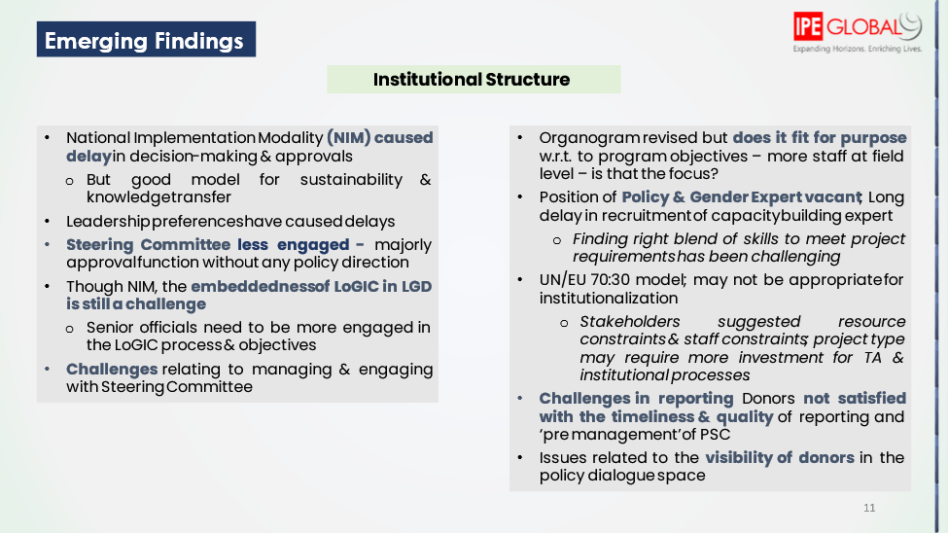

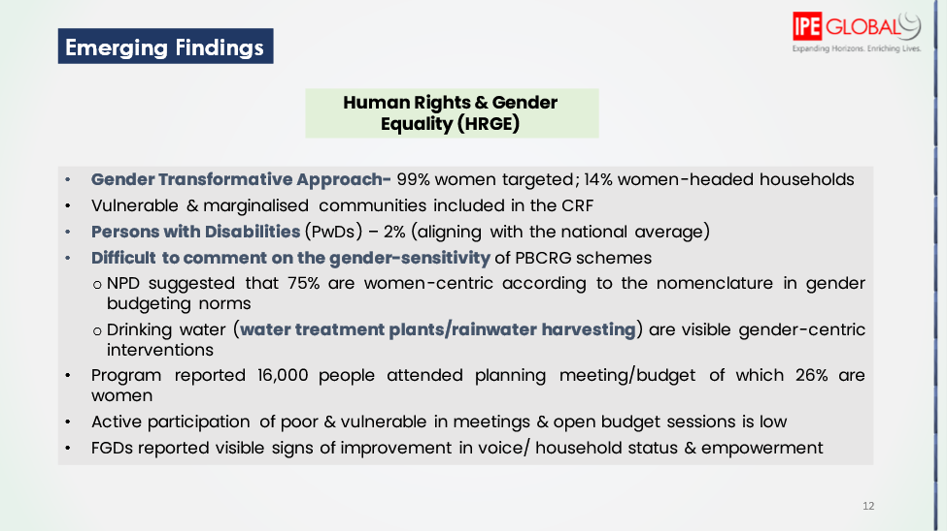

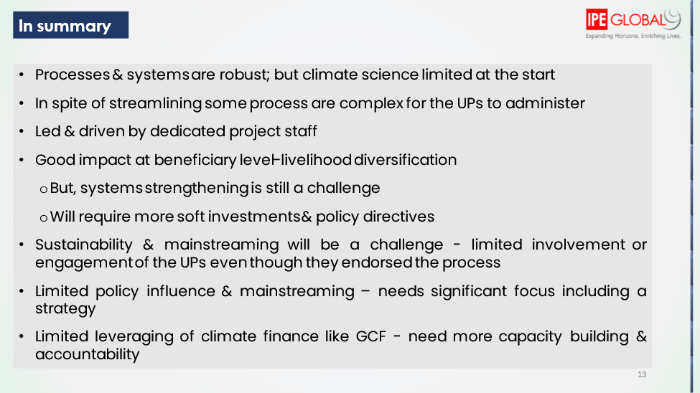

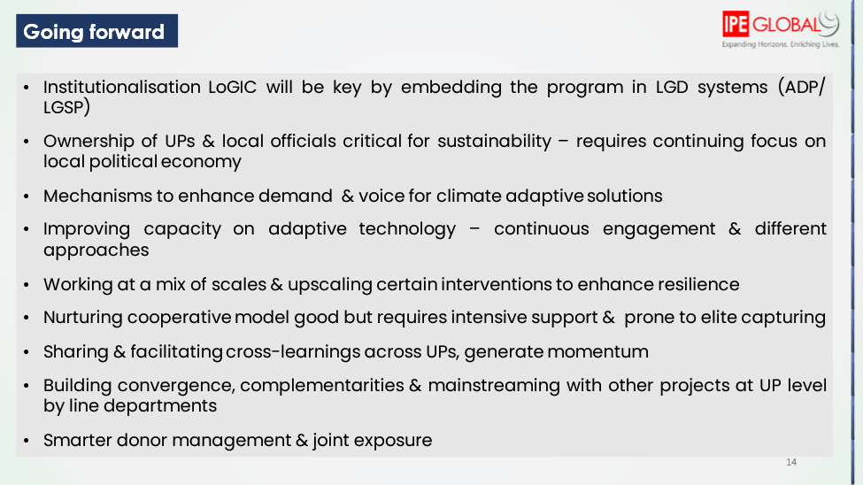

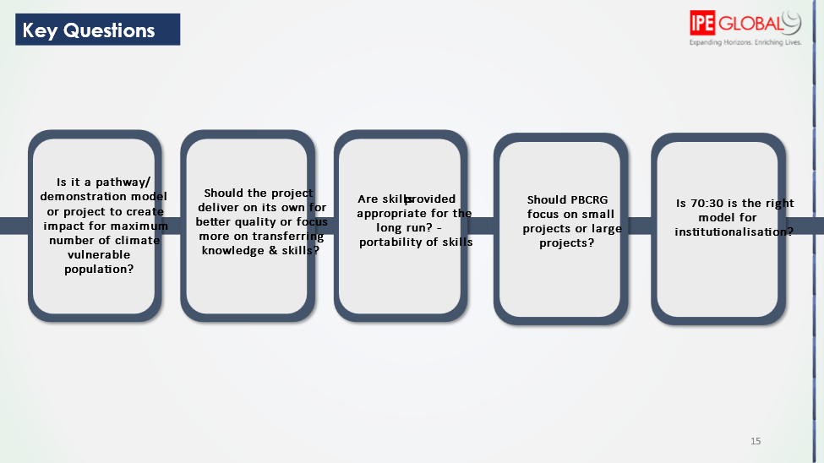

Annex-2 : Report on Annual Progress Review 2021

LOCAL GOVERNMENT INITIATIVE ON CLIMATE CHANGE (LoGIC)

ANNUAL PROGRESS REVIEW 2021

Prepared by
Table of Contents
List of Tables 38
List of Figures 38
Chapter 1 Background and Objectives of the Annual Progress Review (APR) 39
Background 39
Objective of the review 40
Chapter 2 : APR Implementation Strategy and Framework 40
Data Collection Tools 41
Survey Locations 41
Sample Size and Distribution 42
Chapter 3 : Vulnerability to Resilient Regime for CRF Beneficiaries 44
Resilience in standard of livings 44
Strengthening financial capacity 49
Enhancing climate adaptive livelihoods 55
Adaptive capacity 59
Chapter 4 : Resilience of UP Functions 63
UPs functionality performing mandate 63
Capacity of UPs to assess climate risk 64
Budgetary response of UPs to address climate change risks 66
Climate change adaptation in UP plan and budget 67
Translating RRAP into tangible CCA actions 68
Inclusivity in LGIs decision making process 71
Chapter 5 : Summary and Way Forwards 72
Summary 72
Way Forward 73
Annex-I: Survey Questionnaire of CRF Beneficiaries Error! Bookmark not defined.
Annex-II: Checklist for interviews with UP Officials Error! Bookmark not defined.
Annex-III: Case studies Error! Bookmark not defined.

List of Tables
Table 3.1: Changes in the households’ assets and utilities | 48
Table 3.2: Completion of CALO | 56
Table 3.3: Salinity problem in primary source of drinking water | 59
Table 3.4: Status of primary drinking water | 59
Table 3.5: Migration due to climate change | 60
Table 3.6: Main Reasons of Migrations | 61
Table 3.7: Climate Migration tendency | 61
Table 3.8: Major climatic factors that lead to migration  List of Figures  Figure 2.1: Data collection tools used for the review 41 | 61
Figure 3.1: Construction Material of the Houses (%) | 45
Figure 3.2: Percentage of having meals per day | 46
Figure 3.3: Status of households’ chronic diseases | 46
Figure 3.4: Changes in the drinking water sourcing | 47
Figure 3.5: Change in income earning compared to baseline situation | 50
Figure 3.6: Changes in Sources of income for beneficiaries compared to baseline | 51
Figure 3.7: Having any savings in their households | 52
Figure 3.8: Sustainability of beneficiaries with savings | 52
Figure 3.9: Sources of house improvement or repairing | 53
Figure 3.10: Reasons for households’ capability to manage health expenses | 54
Figure 3.11: Cumulative number of CALO being initiated by CRF beneficiaries | 55
Figure 3.12: % number of CALOs initiated and % of completed at least 1 cycle for each CALOs | 56
Figure 3.13: Reinvesting the CALO benefits | 57
Figure 3.14: Perceived usefulness of CALO trainings | 58
Figure 3.15: Top three types of treatment practices before and now | 60
Figure 4.1: Climate change related issues discussed in Ward Shabha in 2020-21 | 64
Figure 4.2: Climate change related issues discussed in Open Budget Meetings | 65
Figure 4.3: Share of total CCA project budget in UP Budget 2020/21 | 66
Figure 4.4: Share of total CCA project budget in UP Budget 2017/18 | 66
Figure 4.5: Share of number of CCA projects in terms of total number of UP projects 2020/21 | 66
Figure 4.6: Share of number of CCA projects in terms of total number of UP projects 2017/18 | 66
Figure 4.7: Funding of UP Projects by source in terms of total budget | 68
Figure 4.8: Major (top 2-3) climate risks identified in RRAP | 69
Figure 4.9: CCA projects undertaken by Union Parishad | 70

Background and Objectives of the Review

Background
LoGIC project is designed streamlining the strategy of climate change adaptation (CCA) into the local development plan along with internalizing the climatic threat on the mostly vulnerable people. That adaption capacities of the vulnerable sections of the society can be improved once their participation in the local planning, development meeting and open forum can be ensured along with providing capital for making them more resilient. In those particular areas, LoGIC is such a holistic program that tried to capacitate supply side and demand side players to make them resilient as a whole of the society towards climate change adaptation.
Since 2017, LoGIC has been successfully transferred climate resilient grants to 72 UPs and 35,000 vulnerable households, through the Performance Based Climate Resilience Grants (PBCRG) and Community Resilience Fund (CRF). This diverse stakeholder community includes ethnic minority groups, fisherfolks, persons with disability, marginal occupational groups etc.
LoGIC provided Performance Based Climate Resilient Grants (PBCRG) to 72 Union Parishads to implement 653 community-based adaptation schemes and Community Resilience Fund (CRF) to 35,000 vulnerable households to implement 23 types of Climate Adaptive Livelihood Options (CALO).
LoGIC is providing 13 million USD as Community Resilience Fund (CRF) and 9 million USD as Performance Based Climate Resilient Grant (PBCRG). 1.5 million USD is used for value chain and critical resilient asset support to vulnerable people and 2.5 million USD is used for skill development of 35,000 vulnerable households and 2,000 Local Government Institution (LGI) representatives and local stakeholders.
In the implementation context, earlier it was expected that it will be completed by 2021. However, due to outbroke of COVID-19 pandemic, the overall implementation process of the LoGIC project within the timeline was delayed and overall project activities are targeted to be completed by Dec 2022. As a result, the annual progress review 2019 and annual progress review 2020 was shifted to 2021 and 2022 respectively. It is found that the budget expenditure under the LoGIC project was not enough in between 2020 and 2021. As the project got momentum for disbursing fund and it is expected that the project can burn the amount within the newly set timeline.
Unnayan Shamannay as per their partnership with LoGIC project through UNDP have conducted the annual progress review 2021 of the LoGIC projects. The overarching objective of this review is to compare the progress achieved in the project areas to the baseline situation. Through the baseline survey in 2018, data were collected and compiled against a comprehensive set of indicators. This APR 2021 collected data (through a quantitative survey) against the same set of indicators and review them. Additionally, the review team collected additional qualitative information from the field levels and review reports produced by LoGIC implementing personnel over the course of the project so far.

Objective of the review
The specific objectives of this proposed APR of LoGIC project are as given below:
Assessing impact of LoGIC in terms of enhancing household level 01) climate change resilience (with focus on the CRF component).
Measuring progress towards improving community engagement in 02) climate change adaptation (with focus on PBCRG component).
Documenting the lessons learnt from implementing LoGIC so far (review 03) of monitoring data and developing case studies).

As pointed out already, this review has mainly compare the current situation with the baseline one (using the preset indicator framwork and collecting additional qualitative and secondary source information).

Framework of Review and APR Implementation Strategy

APR implementation strategy
This review study followed to both quantitative and qualitative approaches. The expected outcome of LoGIC project is to improve local level inclusive planning and strengthen financing mechanism for community-based climate change adaptation solutions engaging local government. As part of the project, the Community Resilience Fund (CRF) is distributed among the selected households (i.e., 35,000 HHs up to now) to enhance climate resilience of their respective livelihoods; and performance-based community resilience grants are allocated among the selected union parishads (UP) to promote the climate change adaptation techniques by utilizing community participation in designing and implementing different climate adaptive schemes in their respective UP (PBCRG component of the project).
To assess achievements of the CRF, the review mainly used a quantitative approach. And to measure progress made by PBCRG receiving UPs a more qualitative approach was used with some quantitative analysis for comparison. The study also includes review of ATM and MIS data regularly collected by the LoGIC project for monitoring purposes. It also reviewed the documents produced over the course of the project to report progress/changes. To track changes in project implementation strategy due to the COVID-19 pandemic, the review team will develop certain case studies (to propagate lessons learnt).
Data Collection Tools
The review used a) questionnaire survey; b) in-depth interviews (KIIs), c) content analysis, and d) case studies. The purpose of each of these tools are shown below:
Figure 0.1: Data collection tools used for the review
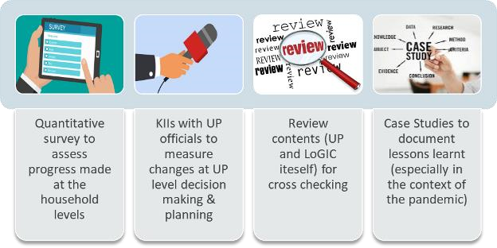
Survey Locations
LoGIC has been implemented in climate change vulnerable areas of Bangladesh, and the project has divided its working areas in to four climate vulnerable zones, namely- (i) flash flood prone haor areas (Sunamganj); (ii) flood prone char areas (Kurigram); (iii) southwest coastal areas (Khulna and Bagerhat); and (iv) south-central coastal areas (Barguna, Patuakhali and Bhola).
Considering the time and resource constraint, the APR 2021 covered four districts (one from each of the said zones). From each of the selected district, two UPs were covered by this survey. As per the LoGIC monitoring documents, some UPs have been found performing comparatively better (in terms of attaining project objectives) than others. From each of the selected district one such ‘better performing UP’ and another ‘regular UP’ has been chosen upon consultation with LoGIC officials. The survey sample (both qualitative and quantitative were evenly distributed across these eight UPs (two from each district).
The districts chosen by the review team are- a) Sunamganj (from flash flood prone haor areas); b) Kurigram (from flood prone char areas); c) Bagerhat (from Southwest coastal areas); and d) Barguna (South-central areas). Communicating with LoGIC officials and field level facilitators, UnSy has chosen the sample CRF beneficiaries based on the criteria mentioned already.
Sample Size and Distribution
UnSy administered a small-scale survey with the two types of the beneficiaries-(i) households that have received CRF and (ii) UPs receiving PBCRG allocations. To perform the survey as mentioned, UnSy followed mix-method approaches. To identify the extent of working success and progress of the Local Climate Finance model, quantitative survey with household was carried out. The target population for household survey was 17,000 recipient households (those who got amount from CRF). Based on the sampling technique of Cochran, W.G. (1963), the representative sample size with precision is about 309 . To evenly distribute the sample size (no. of households to be surveyed) among eight UPs across the four selected districts the sample size is taken 320. Within the UPs the CRF receiving households were selected on a random basis. From each of the UPs (both ‘better performing’ and ‘regular’ ones) at least one official was engaged through KIIs for qualitative survey for understanding the social and economic situation as a whole. For gathering knowledge about the current progress and output of the projects under the PBCRF funds, the reviews targeted the UP Chairman and UP Secretary for understanding about the participation, contribution and implementation of the PBCRG projects as well as other CCA linked projects. To collect the detail inside about the progress of the LoGIC project, we have focused on the two types of case study-one from CRF beneficiaries and another from PBCRG based CCA linked projects of the UPs. Total four case studies for CRF beneficiaries and four for PBCRG based CCA linked projects were conducted The following table details out the sample size and distribution.
Zone | District | Union | Households (for questionnaire survey) | KIIs with UP officials | Case Studies
Flash flood prone haor | Sunamganj | Better Performing Union (1) | 40 | 1 to 2 | 1 to 2
 |  | Regular Performing Union (1) | 40 | 1 to 2
Flood prone char | Kurigram | Better Performing Union (1) | 40 | 1 to 2 | 1 to 2
 |  | Regular Performing Union (1) | 40 | 1 to 2
South-west coastal | Bagerhat | Better Performing Union (1) | 40 | 1 to 2 | 1 to 2
 |  | Regular Performing Union (1) | 40 | 1 to 2
Southcentral | Barguna | Better Performing Union (1) | 40 | 1 to 2 | 1 to 2
 |  | Regular Performing Union (1) | 40 | 1 to 2
 |  | Total | 320 | 8 to 16 | 4 to 8
The geographic location of the surveyed CRF beneficiaries is shown in the following map.

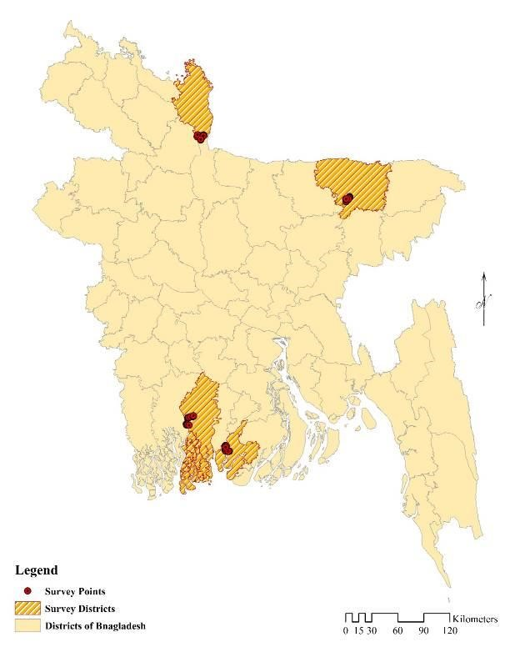

Vulnerability to Resilient Regime for CRF Beneficiaries
Building resilience for the climate vulnerable communities is one of the foremost objectives of the LoGIC intervention. CRF supports for the climate vulnerable communities basically works as a must needed one for the betterment of the targeted population. The present study tries to review the progress of the intervention. While assessment of the living standard of beneficiaries, financial capacity improvement, implementation of climate adaptive livelihoods options, confidence in facing disasters and knowledge and participation in LGIs decision making process were the key determinants to track their progress due to the intervention. Resilience of the communities towards climate vulnerabilities was assessed observing the socio-economic status and their present confidence and preparedness for fighting against the natural calamities to protect their living and livelihoods. Disaster risks reduction for the target population can be possible only if the vulnerable communities are protected by increasing confidence and capacity with proper support as per their level of capacity to implement in time. LoGIC project engaged poor and climate vulnerable people through CRF supports to give them trainings with their level of adaptation capacity and provide micro-capital to implement the self-employment utilizing their earned knowledge from project. That process has attributed some benefits in their current living standard, self-employment, in financial capacity building and overall confidence building to reduce the natural disaster induced risks. In the current chapter, resilience of the beneficiaries towards climate vulnerability are discussed in terms of socio-economic, living status and financial strengthening aspects.

Resilience in standard of livings

Housing quality
The degree of comfort that CRF beneficiaries are enjoying in the living is very important element for understanding their situation. The comparison with the baseline situation can give us the ideas about their improvement at the border aspects. Housing quality is one of the most influential indicators of the assessment of living standard and provides important insight into climate change induced disaster resilience of households. In terms of housing structure as a measure for housing quality, significant improvement has been reported by CRF beneficiaries.
As traditional housing structures which are generally constructed with naturally available structural materials are considered more vulnerable to climate change induced disasters compared to Improved housing structures made from industrialized construction materials namely brick, cement and CI roofing sheet. As reported by CRF beneficiaries, use of traditional housing structure came down to 40.3 percent from 46.3 percent found in the baseline. Moreover, the most vulnerable of the traditional housing structures, Wood planks and Bamboo housing structure, decreased from 6.2 percent in the baseline to a negligible 0.9 percent during the time of APR survey. Respondents also reported that use of the Bamboo and mud housing structure came down from 12.2 percent in the baseline to a paltry 3.8 percent in 2021.
Figure 0.2: Construction Material of the Houses (%)
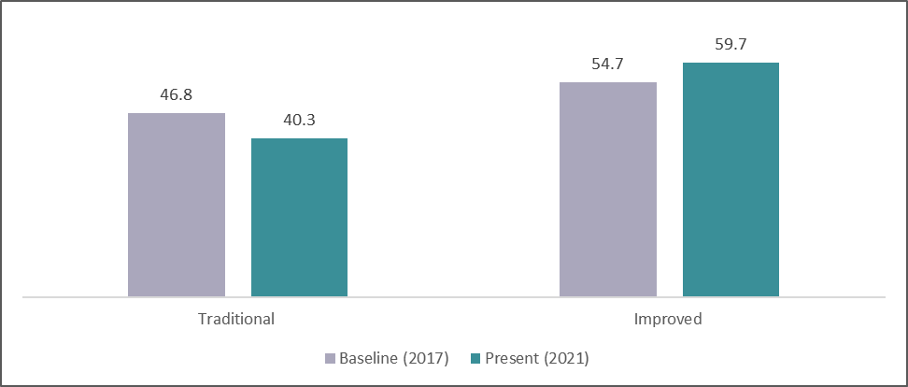
The adoption and utilization of improved housing structures also increased from 54.7 percent of among the surveyed CRF beneficiaries in 2017 to 59.7 percent in 2021. The biggest increase was reported in CI Sheet housing structures (from 41.2 percent in Baseline to 54.1 percent during APR 2021). The increased adoption of CI Sheet housing structure can be attributed to the status of CI Sheet housing as a transitionary housing structure in their process of availing higher quality housing namely (Brick and CI Sheet or Brick/Cement Housing structure).
The improved housing quality of CRF beneficiaries can also be inferred from the percentage of CRF households who had incurred expenses during the last 2 years (LoGIC Project implementation years). About 51 percent of CRF beneficiaries reported that they had to allocate monetary resources to improve and repair their house while 49 percent reported in the negative. Housing repair and improvement expenditures indicates the household’s increased capacity to elevate their housing status as well as their climate change induced natural disaster resilience in respect to housing as the money was spent to repair resulting from natural disasters (Flood, Flash Flood, Sea rise and salinity and cyclone) and maintain their state of housing quality.

Health and Nutrition
In sustainable livelihood framework, health and nutritional state are considered as important elements of human capital. Food intake and incidence of diseases are indicators of health vulnerability. CRF beneficiaries reported significant improvement in their nutrition state an absolute majority (97.5 percent) of the respondents reported that their food intake is now optimal (three meals a day) from the 77.4 percent reported in baseline. In alignment with the aforementioned finding, the number of respondents who consumed two meals a day also decreased significantly from 22.7 percent to 97.5 percent in 2021.
Figure 0.3: Percentage of having meals per day
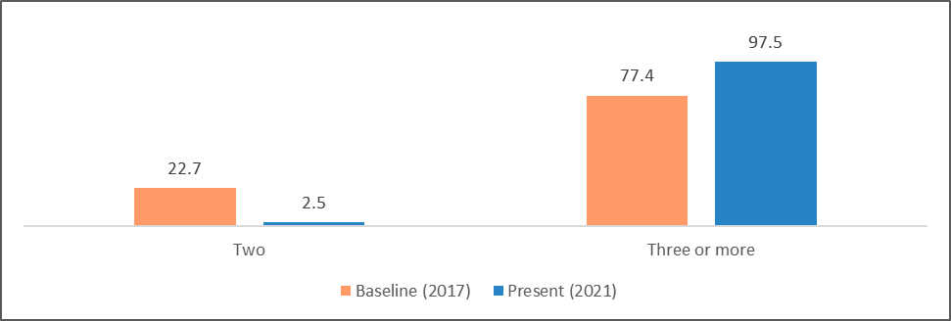
But another important indicator of health capital, the incidence of chronic disease, has remained unchanged from the baseline. No significant changes observed in the percentage of CRF beneficiaries suffering from Hypertension, Heart disease, Diabetics, Skin Disease and Dysentery. A slight increase observed in the percentage of households reporting no chronic disease with 58.44 percent in 2021 from 56.3 percent in baseline.
Figure 0.4: Status of households’ chronic diseases
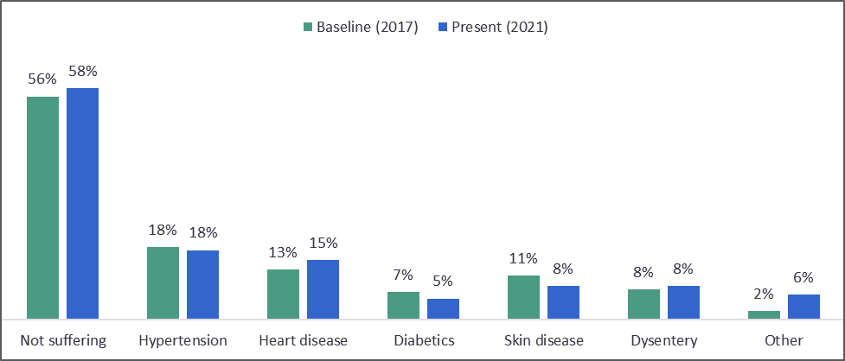
There are several chronic diseases namely Hypertension, Heart disease, Diabetics, Skin disease etc. that have serious effect on people’s lifespan. Comparing to the baseline data with the current state of a particular chronic disease (APR survey), overall state of chronic disease will be determined.
As reported by CRF beneficiaries, not suffering from chronic disease increased to 58.44 percent from 56.3 percent in the baseline. Moreover, the most common and crucial of the chronic diseases, hypertension remains almost consistent, only decreased from 18.2 percent in the baseline to meagerly 17.5 percent. Another common and disastrous chronic disease diabetes remain almost the same, a slight decrease happened from 6.9 percent in the baseline to 5.31 percent in 2021 APR survey. Heart disease increased from 12.6 percent in the baseline to 15 percent during APR. Also, dysentery increased from 2.1 percent to 6.25 percent.

Source of Drinking water
Source of drinking water for the climate vulnerable areas is the major issues for reviewing their resilience in terms of improvement of living standard. It is found that tube well remains the consistent primary source of drinking water that meagerly decreased from 74.4 percent in the baseline to 73.8 percent during APR survey. Besides, rainwater becoming an important primary source of drinking water, increased from 4.3 percent in the baseline to 12.5 percent. As a primary source of drinking water, the use of desalinization plant also increased from 0.1 percent to 0.3 percent. The use of pond water decreases from 16.5 percent in the baseline to 11.6 percent. There is a possibility that awareness from the different programs and even LoGIC trainings can be
Figure 0.5: Changes in the drinking water sourcing
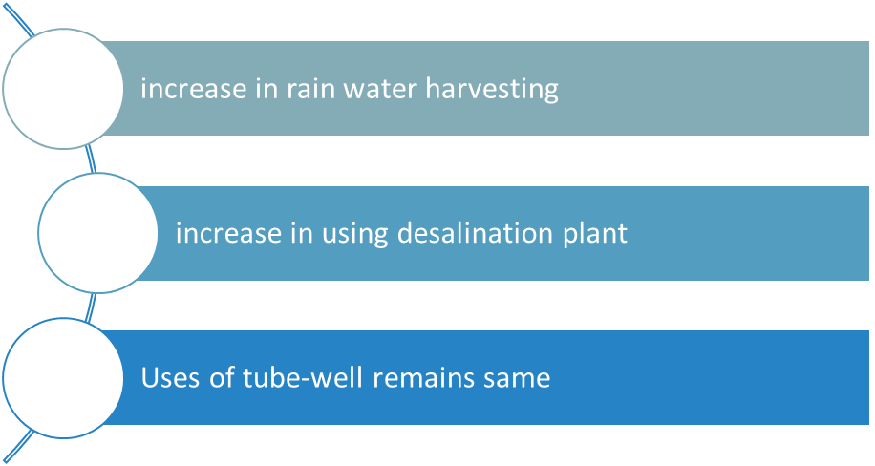
191
%

210
%
%

Same

attributed for utilizing the improved sources for drinking water.
At earlier, about 27.3 percent respondents reported that they have no secondary source for drinking water while in the current review, this percentage has been decreased to 21 percent. That means there is some improvement being found. It can logically be said that the availability of secondary sources for the beneficiaries are increased in the possibility of UP intervention or the other inventions from development partners.
Difficulties in collecting lifesaving drinking water from sources are the major challenges in
Bangladesh. That issues became prominent in the climate vulnerable areas and for the poor households. It is found that majority of the CRF households (53%) are not currently facing the difficulties for managing their primary sources of drinkable water. In the different climate vulnerable regions, the level of difficulties is different across the seasons. While People of Southwest coastal (Saline and sea rise affected) region have 100 percent difficulties during dry seasons, 56.3 percent respondents in South-central coastal (cyclone events) have reported difficulty in dry season. In flood and flashflood affected regions, 60.0 and 73.8 percent people suffers to collect drinking water in dry season. Overall, 72.5 percent of the people face difficulties to collect drinking water during season, while it has become difficult for 27.5 percent to collect drinking water in rainy season.

Household Asset and Utility

A family’s journey toward economic solvency becomes apparent when the number of assets it possesses starts to increase. Financial as well as food security are the main reasons of families spending money on buying things that make their lives easier or have an economic prospect. The CRF beneficiaries have seen a great increase in the number of household assets since the intervention after 2017. As it is reported earlier that 51 percent invested for their housing quality improvement or repairing. It can be attributed that increase investment opportunities for housing quality have revealed the scope of expenditure for other households’ assets makings. That can be regarded from the below outlined table.
Table 0.1: Reported changes in the households’ assets and utilities
Utilities and assets Baseline (2017) Present (2021)
Utility
Electricity connection | 34.80 | 83.44
Physical asset
Television | 9.10 | 15.00
Mobile phone | 86.20 | 98.13
Refrigerator | 2.20 | 5.63
Water pump | 1.00 | 3.75
Computer/laptop | 0.20 | 0.31
Bicycle | 10.60 | 15.00
Motorcycle | 2.40 | 2.50
Rickshaw/van | 0.00 | 5.31
Economic asset
Boat | 4.60 | 12.19
Livestock | 29.70 | 81.82

The use of electricity has increased to 83.44 percent (by 140% compared to baseline) and the CRF beneficiaries reported that more than 98 percent of the households have mobile phones now. As mobile phone provide access to information and MFS, this perhaps is the most important indicator of the improved living standard of the beneficiaries. Other physical assets such as the television, refrigerator and motorcycles etc. have also increased in number within this period. The percentage of CRF beneficiaries possessing Rickshaw/van which provides opportunities to earn both directly and indirectly (by renting out the vehicle) has also increased. This indicates that the beneficiaries are thinking about the future by investing into long term income generating options.

The most noticeable output of the intervention is the number of livestock the CRF beneficiaries possessed in 2021. The number has increased by 52 percent, which is the greatest increase among all criteria since the base year. This reflects the success of the trainings (CALO) and the program. It was also reported that the possession of boats by the CRF beneficiaries has increased to 12 percent from less than 5 percent.

Changes in the usage of utility, physical and economic assets are vital in evaluating the impact of an intervention on the lives and livelihood of the beneficiaries. It exhibits their economic resilience as well as their coping capacity to adversities.

The LoGIC project has affected the lives of the CRF beneficiaries differently. Though, the impact of the project was not same to everyone, about 94 percent of them reported medium to high impact of the project on their lives and livelihood. More than half of the beneficiaries have reported medium impact and about 6 percent have reported a low impact. Assessing the indicators of housing quality, investment in housing, health and nutrition, sources of drinking water and household assets, it can be reasonably inferred that CRF beneficiary households now enjoy improved living standards. Improvements in most of the indicators can be attributed to LoGIC interventions as was reaffirmed with perceived impact of LoGIC project on overall living standard and livelihood with 94 percent of respondents affirming medium to high impact of the project on their living standard.

Strengthening financial capacity
Financial capacity for reducing the disasters risks is the key to understand the resilience of the beneficiaries. The CRF beneficiaries have been trained to cope with new type of livelihoods trainings for making their livelihoods options in their current geographical situation. That knowledge helps to engage themselves in the number of livelihoods options.

Improvement of monthly income and changes in primary sources
In comparison to baseline situation, it is found that average households monthly income of CRF beneficiaries has been increased to BDT 10,194. While it was about BDT 8,964. That means, in general, reported income increased by about 14 percent compared to baseline situation. However, the beneficiaries were asked about their own opinion on the increase of income. About 85 percent of the beneficiaries perceived that their overall households as well as their own income has been increased compared to the last three years before. Though, reported income has been given us a picture that their household monthly average income earning is increased, however, the perceived increased income is very high. That means, income earning increased significantly as we found in the reported income as their perception.
Figure 0.6: Change in income earning compared to baseline situation
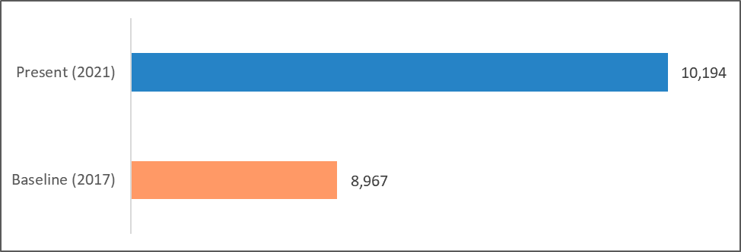

Increase in income can be attributed as an important determinant to find the positive changes in the financial capacity. While significant changes in the primary sources of income can be another determinant to measure their changes in improving with resilience. In the baseline, about 11 percent reported that they had no income sources while in the annual progress review 2021, only 2.2 percent have reported they have no primary sources of income. In case of, share of primary sources of income from agriculture, as day labourers, semi-skilled labour, and unskilled labourer remains same as the baseline situation. There are no significant changes in those category of income sources.
It is very interesting to reveal that the primary income sources have been changed for some of the beneficiaries. Poultry/livestock rearing as primary income sources for only 0.6 percent in baseline period while it stands at about 6 percent during the annual progress reviews of the beneficiaries. While source of income from fishing/shrimp farming more than doubled and from involvement as a transport workers or driver has been increased by 68% compared to the baseline situation. In the previous section, we found that the economic assets, on an average, including the rickshaw/van, boats and motorcycle have been increased, so it can be attributed that the income opportunities for some the beneficiaries from the last mentioned sources have been resulted.

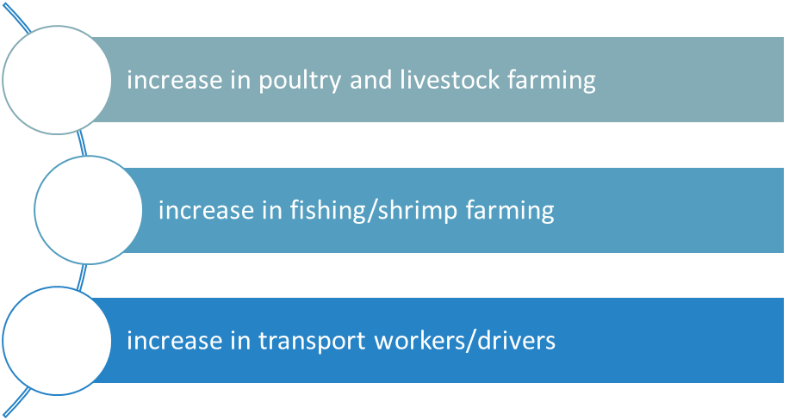
838
%

108
%

68
%

Figure 0.7: Changes in Sources of income for beneficiaries compared to baseline

The share of primary income sources of small business has been decreased to 5.31 percent from 8.6 percent in baseline. That means, the share of small business for CRF beneficiaries has been decreased because shock of COVID-19. Other reasons may be that their involvement with LoGIC project made alternative income options for better financial capacity development. At earlier, about 68 percent CRF beneficiaries reported that they had no secondary sources of income. In the current reviews, we found that only 17 percent reported about not having secondary sources of income. That means, LoGIC intervention made the situation better for the generating income sources for the beneficiaries and, in return, the financial capacity of the beneficiaries can said be improved at some extent.

Savings for sustainability
Savings practices of the CRF beneficiaries are the major measurable indictors to look into it. In comparing to the baseline year (2017), we see that savings of household have increased to 82 percent from 14 percent. It is a strong indicator of achieving resilience in climate-vulnerable communities and resilience in the standard of living of these communities.
Figure 0.8: Having any savings in their households
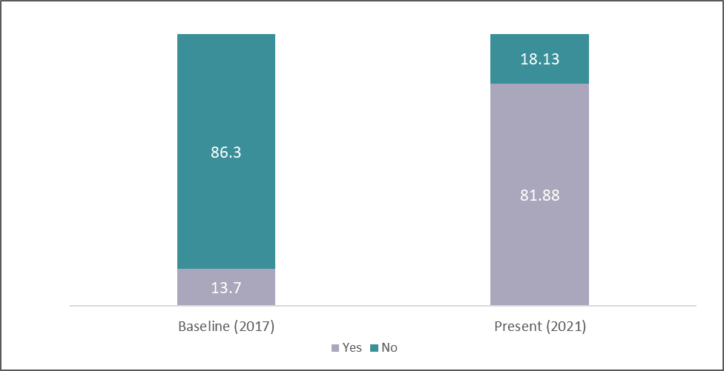
Among the respondents who have savings, we see that 37.19 percent have savings amounts ranging from BDT 1,000 to BDT 5,000. Around 17.19 percent and 13.13 percent can save ranging from BDT 5000 to 10,000, and BDT 10,000 to 20,000 respectively. 10.63 percent responded that they can save above BDT 20,000 while 21.87 percent still have below BDT 1,000 savings. In short, not only the savings capacity of CRF beneficiaries has been increased but also the amount of savings has been increasing to a satisfactory level.
Figure 0.9: Sustainability of beneficiaries with savings
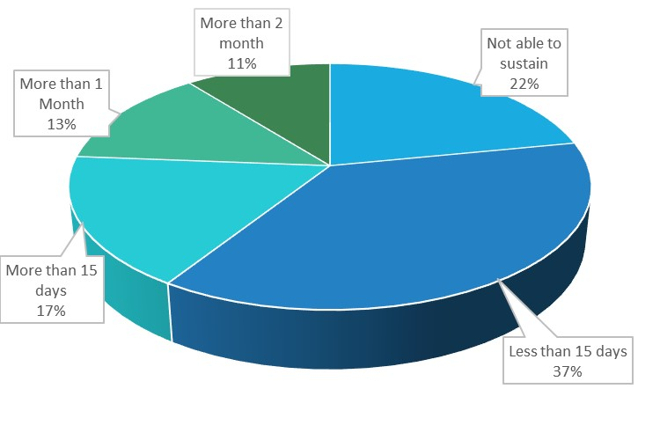
Suppose, there is no income opportunities for the beneficiaries what will be the situation considering the savings and average income of the beneficiaries. It is found that about 11 percent can sustain more than 2 months with the savings amount. While 13 percent beneficiaries can live more than 1 month and 17 percent for more than 15 days. At least 15 days can be survived by the 37 percent respondents and 22 percent cannot be able to sustain with the current state of savings. That means savings practices of the beneficiaries will be the most important factors for the beneficiaries for financial capacity to be more resilient. In that particular discussion, it can be attributed that LoGIC CRF support made the beneficiaries stronger in facing the income vulnerability for the certain time of necessity as a whole.

Capacity to housing situation improvement
Capacity to invest in the house improvement is another dimension to see the financial capacity of the CRF supported households. As it is shown earlier that the housing situation of the households has been shifted from traditional structure to improved structure and now it is revealed that those (who repaired or improved their house structure) households have been capacitated to source from their savings and other resources availability.
Figure 0.10: Sources of house improvement or repairing
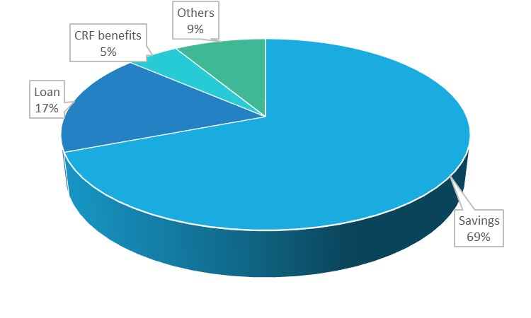
The money used for house repairs or improvement mostly comes from savings sources. We see from the chart (Figure 3.9) that 69.1 percent of respondents have savings to use for house repairing or improvement purposes. The dependency on other sources like loans, LoGIC funding, NGOs, aid, etc. has been reduced to a significant level. This proves the improved resilience of the climatevulnerable communities in overcoming the damage done by natural disasters and shown strong evidence for improving their financial capacities. It is also regarded that the those who took loan where 84 percent perceived that their loan repay capacity has been improved considering the previous situation.

Capacity improvement for health expenditure
Figure 0.11: Reasons for households’ capability to manage health expenses
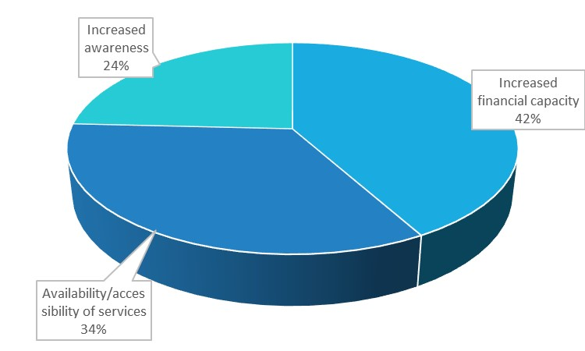
In managing the health expenses, 85 percent of respondents agree that their capability of managing the health expenses has been increased. Among them, 41.9 percent think that their financial capacity has been increased which in turn helps in managing health expenses. However, 33.9 percent and 24.2 percent find availability/accessibility of services and increased awareness are responsible for increasing the capability of managing the health expenses. This data shows both the improvement in resilience as well as the effectiveness of CRF benefits.
The respondents feel that LoGIC has a medium to high impact on their financial status. 50.94 percent of respondents think that LoGIC has a medium impact while 42.81 percent think that it has a high impact on their financial status. Overall, we see that the LoGIC project has the greatest (more than 90 percent in number) impact on CRF beneficiaries' financial status. Therefore, the result shows a satisfactory resilience in the standard of living has been achieved among CRF beneficiaries. On the other hand, there are some gender dimensions of the overall improvement. It is found that the level of involvement of husbands in spending money from the CRF beneficiary account which is ranging from no involvement to moderate involvement and very little high involvement. Collectively, a good number of respondents say that their husbands have no or low interference in spending money from CRF beneficiary account (combinedly 44.6%). This proves that more financial independence i.e., empowerment has been established among women. That means the way of financial support being provided by the women has been revealed and their family level overall financial capacity improvement has been exposed as a whole.

Enhancing resilience in applying climate adaptive livelihoods options (CALO)
LoGIC CRF supports have been provided to the 35,000 vulnerable households. Then, the targeted people got trainings on the different type of income generating climate adaptive livelihood activities. In case of LoGIC project, they identified about 23 types of IGAs which is familiar as climate adaptive livelihood options (CALO). CALO trainings improved their skills for prepared as an entrepreneur for self-employment. After the trainings, the beneficiaries started to get the CRF supports for initiating the provided knowledge into actions with their own plans. The project tries to engage beneficiaries with multiple CALO trainings for ensuring more income generating (not only on the single livelihoods option). The more livelihoods options at hand mean more resilient income opportunities considering the vulnerability for frequent occurrence of climatic events.
Reviewing the Annual Progress Report 2021 of LoGIC project, we found that up to now total 35,000 beneficiaries got the trainings on the CALOs and already started their venture or farming. And, all of them have received the grant from CRF for starting their livelihoods. As per the report, 46 percent initiated 3 types of CALO among the 17,000 CRF beneficiaries while 80 percent initiated 2 types of CALO and 100% initiated 1 type of CALO. Our results are mostly similar with their findings. We found that more than 2 percent have initiated 4 types of CALO while 43 percent initiated 3 types of CALO, followed by 78 percent initiated 2 types of CALO and 100 percent initiated 1 type of CALO.
Figure 0.12: Cumulative number of CALO being initiated by CRF beneficiaries
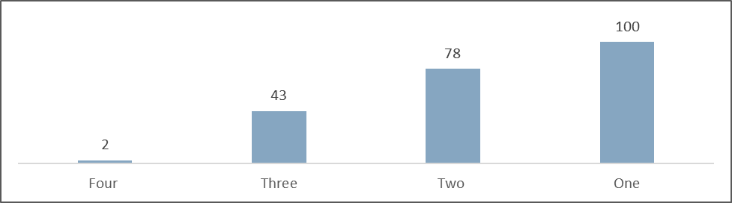
The most interesting things have been found in the cycle completion of the initiated CALOs. About 3% of the respondents have not completed any cycle at all (regardless of the number of CALOs they have initiated). If we look into the heatmap generated from the cycle completion perspective, it is found that 40.6 percent completed the one cycle of their 1st CALO while 15.3 percent have completed three cycle of the 1st CALO. Interestingly, only about 3% have completed three cycles of 3rd CALO. On the other hand, if we look into the 2nd CALO with two cycles completion, it is good revealed that about 29 percent done that task. That can be attributed as the significant evidence

that completion of more cycles with more CALOs is better for building resilience against the climate induced income shocks. The higher the cycle completion with higher number of CALOs, the resilience towards fighting with climate shocks will be stronger. The optimal level in our case is 29 percent. That means 2nd CALO with two cycles completion will be the better in the short-run. If it can be reached to 3rd CALO with 3rd cycles completion by the project ends, then the resilience of the beneficiaries can be easily attributed. Therefore, the cycles completion rates with increased number of CALO is important for building capacity of the beneficiaries.
Table 0.2: Number of cycles completion with the numbers of CALO initiated
Number of cycle completed | 1st CALO | 2nd CALO | 3rd CALO | 4th CALO
One cycle completed | 40.6 | 37.2 | 25.6 | 1.6
Two cycles completed | 40.3 | 29.1 | 7.8 | 0.3
Three cycles completed | 15.3 | 3.1 | 2.5 | 0.0
Four cycles completed | 0.3 | 0.0 | 0.0 | 0.0

Figure 0.13: % number of CALOs initiated and % of completed at least 1 cycle for each CALOs
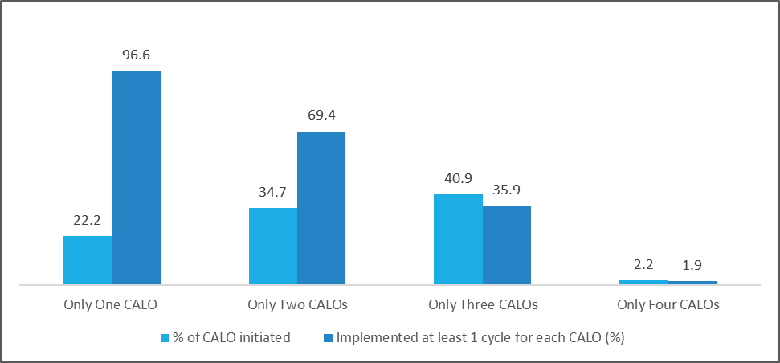
It is also important to review the numbers of CALO initiated and successfully completed at least 1 cycle for the better discussion. It is found that 22 percent have initiated only one number of CALO while 97 percent of them have completed at least 1 cycle. In case of only 2nd number of CALO, at least 1 cycle have been completed by about 69 percent. In case of only 3rd number of CALO, out of 41 percent 36 percent have completed at least 1 cycle. For the new beneficiaries, the cycle completion rate will be logically low as per the hypothesis. Then, it is interesting to note that around 25 percent have successfully finished 2nd initiated CALO with at least 1 cycle.
About benefits of the CALO in their livelihoods, 3 percent reported that they did not get any benefits yet from the initiated CALO. Those who reported no benefits of CALO, they are basically started their initiatives not more than 2 months. Hence, we got the results. About 97% gained positive return from the CALO implementation. That results can be casted as the success of LoGIC for generating livelihood options with confidence for the most vulnerable communities.
Figure 0.14: Reinvesting the CALO benefits
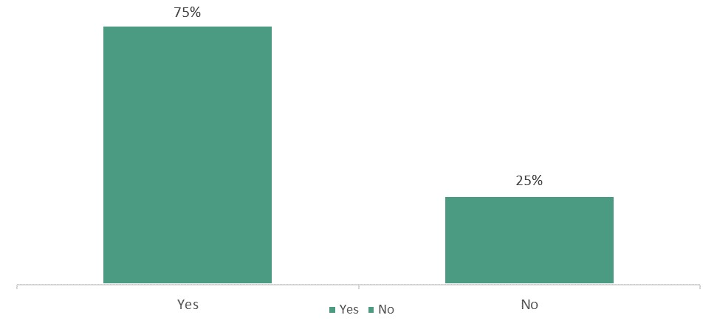
From the survey, it is also reported that they have started reinvesting the return from cycle completion of CALO. About 75 percent shared that they reinvest CALO benefits for the expansion of CALO by increasing the numbers of livestock, poultry, cultivating paddy or homestead vegetable.
About 22.5 percent report that they have taken loan for the expansion of climate adaptive livelihoods options. That means that their financial capacity has been increased. It is also found that 15.3 percent gave emphasis on the taking loan in future. The indicator clearly shows the financial capacity as well as the CALO expansion capacity of the beneficiaries. About 90 percent of the loan recipients took loan from MFIs and 6 percent took from Bank. If there is a scope for MFIs linkage program for the beneficiaries, then they can avail more opportunities for the expansion of CALOs. Interesting thing is that 93 percent claimed that they are confident enough to continue their CALOs without the support of LoGIC project in future. At earlier, it is mentioned that they took loan for CALO expansion. So, there is some loan requirement for the beneficiaries. Already, the bank and mobile financial services (MFSs) started giving nano-credit for the account holders¹³. As we mentioned earlier that more than 93 percent have mobile phone which can be the added benefits for opening the MFS accounts. Through their account the MFS nano-loan can be made available for them.

At mentioned earlier that LoGIC project arranged trainings 23 types of CALO for the beneficiaries. Besides that, building linkage with private sector actors for scalable business opportunities a partnership between LoGIC and BRAC has been built. LoGIC has developed trainings modules and provided trainings to the CRF beneficiaries. That means the CALOs trainings are designed as per the context, skill and knowledge level of the beneficiaries considering their education attainment. The output of the provided trainings have been well articulated from the given figure.
Figure 0.15: Perceived usefulness of CALO trainings
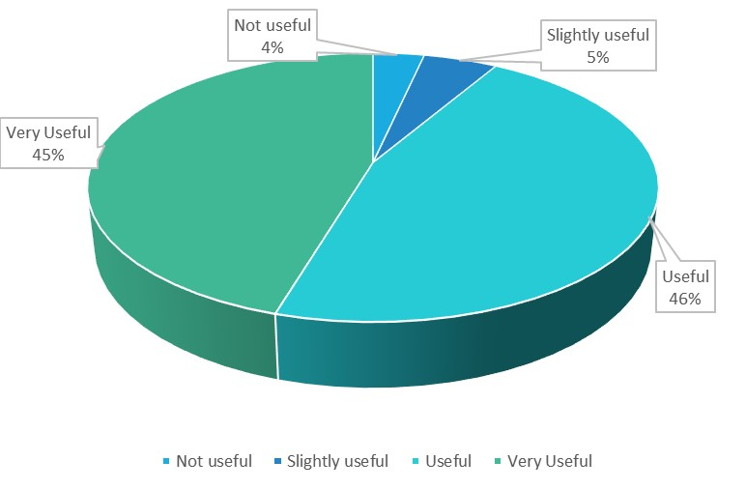
About 45 percent perceived trainings as very useful for making their better livelihoods options while about 46 percent thought that trainings were useful. Only 9 percent have rated as slightly useful or not at all. That means most of them perceived that CALO trainings were useful indeed. While 84.2 percent reported that the CALO driven income generating activities can likely be their primary source of income for their households.
Perceived impact of the CALO trainings on the overall capacity building including the confidence of the beneficiaries are revealed when they were asked about the facts. About 91 percent perceived that their CALO trainings and making livelihoods options for better earning opportunities are resulted due to their intervention. Only 9 percent flagged the fact as low to no impact for their alternative livelihood engagement related capacity building. That can be attributed as the stronger evidence for understanding the situation of the CRF beneficiaries regarding livelihoods generating capacity enhancement dimensions.

Climate change adaptation capacity enhancement
Climate change adaptation capacity building in a short interval is not much easier as we claimed in theory in general. the process is more difficult for the climate vulnerable communities in particular. In addition, the indicators for measuring the adaptation are not very easy task as well. For the sake of the current review, we tried to focus on most common issues of climate change events happening and how they cope with the situation.
Table 0.3: Having salinity problem in primary source of drinking water (%)
 | Baseline (2017) | Present (2021)
Yes | 20.4 | 17.2
No | 79.6 | 82.8

In comparison to the baseline year (2017), we can say that the awareness level among the people has risen. The salinity problem in the primary source of drinking water is in low percentage. Since, we saw earlier that the rain water harvesting and desalination plant were major changes in their drinking water, it has been possible to be attributed that they are using the relatively less different sources of drinking water which are not saline to report them.
Table 0.4: Treating status of primary drinking water sources (%)
 | Baseline (2017) | Present (2021)
Treated | 17.1 | 42.81
Not treated | 82.9 | 57.19
Figure 0.16: Top three types of treatment practices
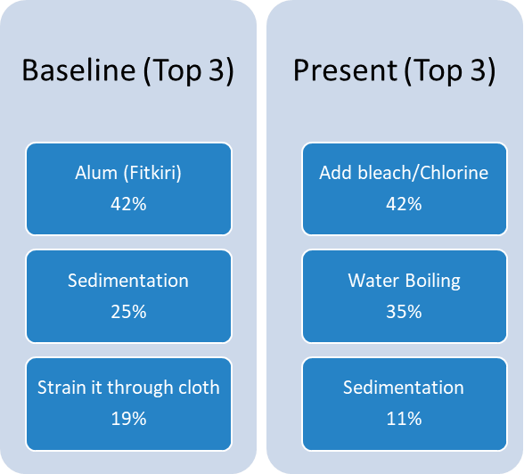

As we have said that awareness about the use of pure water has increased among the people (CRF households), here, the data exactly shows the similar trends. Previously, households were mostly accustomed to using Alum (Fitkiri), cloth as strainer and sedimentation. Now, households are more aware of taking a scientific approach to purifying water. According to respondents, 42.3 percent use bleach/chlorine, 35 percent prefer to boil water, and only 10.9 percent still use sedimentation approach. Therefore, we see the overall result that the number of percentages has increased in terms of people using treated water (42.81 percent) compared to baseline year (17.1 percent).
The tendency of migration of household members still shows a positive trend. The survey data shows that from 2021 the rate of permanent relocation of any adult household members now 11.56 percent, which was only 3.2 percent in 2017. That means, there are still some extents of relocation or migration among the family members.

Table 0.5: Anyone migrated from the respondents’ household
Anyone migrated | Baseline (2017) | Present (2021)
Yes | 3.2 | 11.56
No | 96.8 | 88.44

Moreover, while identifying the reasons behind the migration, 51.35 percent of respondents say that the effect of Climate Change is responsible for the permanent relocation. However, climate change has an impact on reduction of income as well, and at that point 21.62 percent of respondents think that both climate change and financial reasons are responsible for the increasing trend of migration. It can be assumed that the migration rate or relocation of the household members can be increased if the scope of livelihoods became more contracted.

Table 0.6: Main Reasons of Migrations
 | Percentage
Economic/Financial/Employment | 21.62
Effect of Climate Change | 51.35
Both (1) and (2) | 21.62
Other (social/political) | 5.41

Considering the family migration as a whole, we see that the overall climate migration tendency is low. But, if we break it down into areas, we see that flood-affected areas have a medium to high tendency of migration. Also, in south-central coastal, south-west coastal and flash-flood areas have some medium rate of tendency of climate migration. Therefore, we can say that while CALO is beneficial for people in these regions, it is not enough to stop migration.

Table 0.7: Climate Migration tendency of the other households in their UPs (family as a whole)
Regions | Low (%) | Medium (%) | High (%)
South-west coastal | 87.5 | 11.2 | 1.25
South-central coastal | 80.0 | 20.0 | 0.0
Flood | 53.7 | 26.2 | 20
Flash-flood | 86.2 | 12.5 | 1.25
Overall | 76.8 | 17.5 | 5.63

Considering the major climate factors in migration, it is seen that things are pretty much the same, only the frequency of happening has increased in the current year. Therefore, we see factors like storm surge, floods, river erosion, and flash floods mostly leading households to migration.

Table 0.8: Major climatic factors that lead to migration
Factors | Baseline (2017) | Present (2021)
Storm surge (big wave)/cyclones | 18.2 | 33.44
More saltwater in surface/ground water | 18.2 | 5.31
Floods (extreme rain events)/water logging | 18.2 | 42.19
Riverbank / Coastal erosion | 18.2 | 38.75
Flash flood | 9.1 | 32.81
Change in environment was no reason to leave | 18.2 | 11.56

To perceive the migration tendency among CRF households, we see that they have a low level of migration tendency. Among respondents, 86.25 percent have not thought about migration at all. To talk about achieving resilience in disaster preparedness, we have seen that the awareness of using scientific methods in purifying water has risen. Households are gaining more stability in generating income. Also, the tendency for possible future migration among CRF beneficiaries is expected to be low. Therefore, we can say that the CRF beneficiaries have achieved resilience in disaster preparedness. Here, 55.94 percent of respondents say that LoGIC has a medium impact in overall disaster preparedness and 30.31 percent of respondents think that LoGIC has a high impact in this respect.

Resilience of UP Functions
LoGIC project is designed to empower both the climate vulnerable communities and LGIs in order to increase their capacity to adapt to climate change risk and manage climate change induced disasters. This process has had significant impact on both the supply side (LGI) and the demand side (climate vulnerable communities) of climate change resilience and adaptation services. While the demand side received intervention in the form of CRF, the supply side received Performance-Based Climate Resilience Grants (PBCRG). PBCRG has incorporated the concept of a formula-based performance rating mechanism in overall UP budgetary allocation. Thus, along with providing the impetus for taking projects to increase climate change resiliency, it has also provided for the incorporation of a framework better monitoring and knowledge management resulting in increased overall operational efficiency of LGIs (Union Parishad).
During LoGIC APR 2021 survey, the overall climate sensitivity of LGIs development plans along with local development planning process was found to be on a positive trend due to significant PBCRG intervention. This chapter assesses the LoGIC project’s PBCRG interventions efficacy by connecting the indicators concerned LGI’s Climate Change Adaptation (CCA) plans and access to CCA services for women, poor and marginal communities.

UPs functionality performing mandate
LoGIC in its aim to strengthen capacity of LGIs to develop local plans that integrate CCA measures has been working to increase the capacity of LGI through actively PBCRG funding for projects related to local CCA measures.
In order to encapsulate the true impact of LoGIC project among the intervention population, LoGIC intervention receiving LGI’s operational efficiency has emerged as an important indicator. From the APR survey 2021, it has been found that 75 percent of the UPs have conducted 2 Ward Shabhas in 2021 while the rest of the UPs have organized 1 Ward Shabha in 2021. UPs have the responsibility of conducting 2 Ward Shabhas every year, thus it can be concluded that PBCRG intervention receiving UPs are slowly but steadily reaching their mandated responsibility of conducting 2 Ward Shabhas every year. Moreover, all the UPs have conducted Open Budget Meeting while Annual Development Planning Meeting in 2021. Thus, considering the regularity of conducting Ward Shabhas, Open Budget Meeting and Annual Development Planning Meeting, it can be inferred that LoGIC intervention receiving UPs have shown expected operational efficiency.

Climate Change Induced Risk Awareness and Adaptation of UPs
In alignment with the achievement of expected operational efficiency of UPs, these institutions have shown awareness about climate change, CCA measures as well as climate change induced disaster risk management. All 8 UPs surveyed during APR 2021 reported to have discussed climate change related problems or projects in ward shabhas. Additionally, 100 percent of the UPs expressed the perception that climate change issues have increasingly become the more important issue since the implementation of LoGIC project due to increased climate change awareness as well as the increased capacity to address climate risks through PBCRG funded schemes.
LoGIC project intervention receiving population of UP validated the stated figures of increased addressing of climate change issues in Ward Shabhas. Corresponding to the reportage of 100 percent UPs addressing climate change issues in Ward Shabhas, nearly 98 percent of the respondent of demand side (LoGIC intervention receiving population) affirmed that climate change issue addressing in ward shabhas has become more prevalent (either Occasional or Regular) since the implementation of LoGIC project.
Figure 0.17: Climate change related issues discussed in Ward Shabha in 2020-21

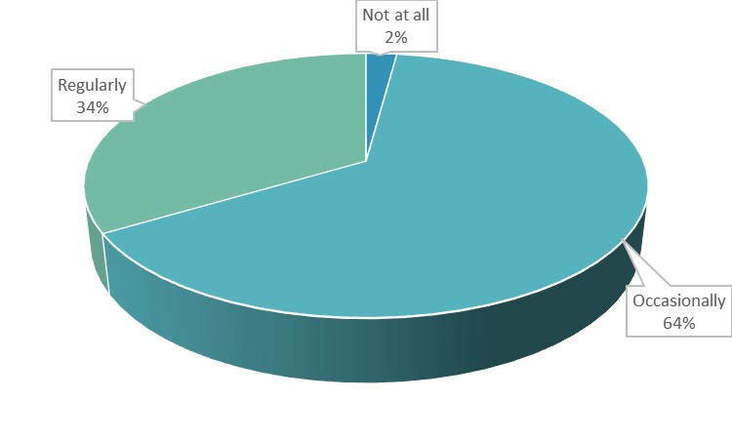

Role of UPs to assess climate risk
Climate change induced vulnerabilities and risk identification have been standardized through Community Risk Assessment (CRA) process at Ups. CRA essentially provides a framework of identification of climate risks. The climate risks and vulnerabilities are identified by the LGIs through grassroots level opinion collection mechanism. CRA findings are then incorporated into Risk Reduction Action Plan (RRAP) which is unique for every UP. The RRAP which contains the local demand for CCA measure, has been incorporated into the Annual Development Plan as well as the Five-Year Plan of the UPs. With the incorporation of the CCA actions into the local government planning document, the CCA proposals transform into agendas of Open Budget Meetings and are allocated funds to combat the climate change risk as well as fund the adaptation mechanisms.
During the LoGIC APR survey of 2021, it was found that all 8 UPs surveyed, have conduction CRA meetings and workshops to identify the climate risks and the challenges posed by vulnerabilities caused by climate change. Moreover, 100 percent of the surveyed UPs reported that the climate change induced risks identified in their CRA meetings were also discussed during the ward shabhas ensuring the establishment of a process of climate change risk and vulnerabilities redressing
Figure 0.18: Climate change related issues discussed in Open Budget Meetings
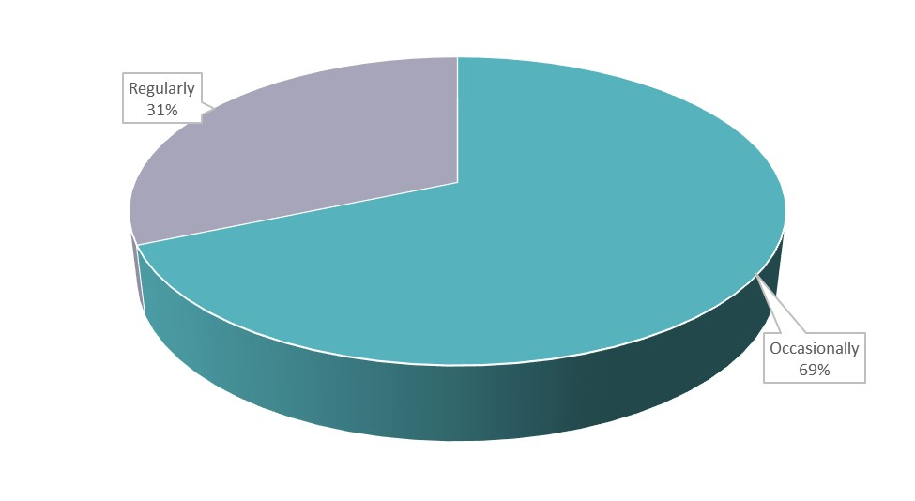
mechanism in LGIs.
Meanwhile, 100 percent of the UPs have considered the climate change issues identified in the CRA while preparing the Annual Development Budget and thereby creating a provision for climate change adaptation actions mentioned in RRAP to be implemented. This process has established a formal channel of redressal mechanism of climate change risks and climate disaster management on a local level.
UP reportage of adoption climate change risks as specific planning issue and increased awareness of the impact of climate change which might have been earlier been attributed as the continuation of the history of natural disaster, has been validated by the LoGIC project intervention receiving population with 100 percent of the respondents confirming that climate change issues are now being discussed in Open Budget Meetings. The insight essentially implies that as climate change risks are now being addressed in open budget meetings and PBCRG funded projects are being implemented, climate change adaptation planning in local level starting from CRA and ending with implementation are now being followed.

Budgetary response of UPs to address climate change risks
Budget allocations (implementation) for CCA linked schemes in UP budgets are one of the strongest indicators of climate change awareness of UPs. It also shows the mainstreaing and integration of the local level planning process for CCA.

Figure 0.19: Share of total CCA project budget in  UP Budget Fy 2020-21  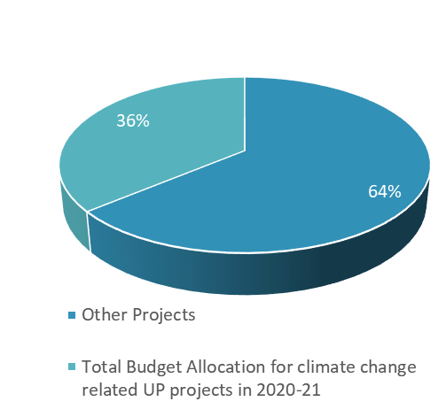 | Figure 0.20: Share of total CCA project budget in UP Budget  FY 2017-18  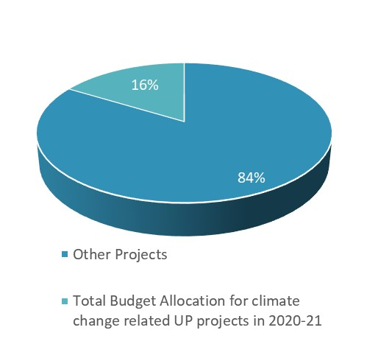
Figure 0.21: Share of number of CCA projects in terms of total number of UP projects FY2020/21  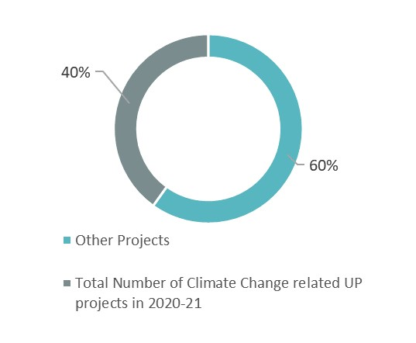 | Figure 0.22: Share of number of CCA projects in terms of total number of UP projects FY2017/18  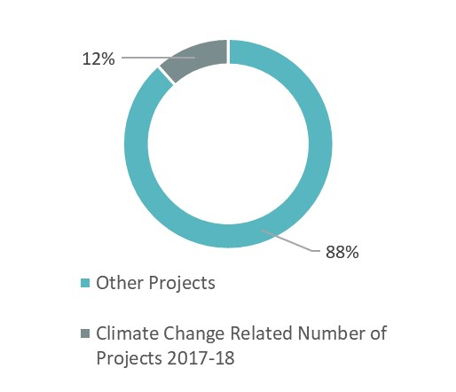

The Ups in LoGIC area have shown significant increase in budget allocations made for CCA projects as well as in terms of number of CCA projects implemented.
In 2017-18, about 16 percent of the total UP budgets were allocated for CCA linked projects and schemes. CCA allocation has increased to 36 percent of the total UP budget in 2021. This shows an important improvement in terms of climate change risk awareness and plans to mitigate the climate risks. Similar improvements have been observed in the percentage of CCA linked schemes implemented by UPs. Earlier in 2017, around 12 percent of the schemes undertaken by the UPs were linked to CCA but in 2021, 40 percent of all UP schemes have been found linked to CCA. It can be definitively stated that PBCRG grants provided by LoGIC Project has acted as a catalyst behind this improvement in number of CCA schemes being approved. The reportage of both UPs and LoGIC beneficiaries that the climate change issues are being more frequently addressed in Ward Shabhas and included in the UP planning documents, can be provided with evidence of implementation through the increased budgetary allocation for CCA.

Climate change adaptation in UP budget
During APR 2021 survey, it was observed that 36 percent of the total budget of UPs were allocated for CCA linked schemes. LoGIC project’s PBCRG grants for UP schemes accounted for 16 percent of the total UP budget while 19 percent of the total budget were funded by other sources which are also CCA linked.
Figure 0.23: Funding of UP schemes by source in terms of total budget
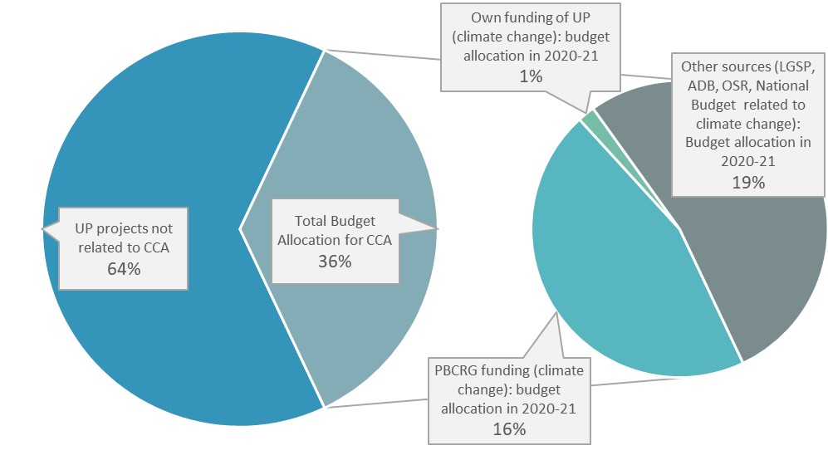

But more importantly, UPs are now implementing CCA linked schemes utilizing their own funds (OSR e.g. holding tax on property transfer) as 1 percent of the total budget of UPs are allocated for climate adaptive projects and schemes which is sourced from their own funds.
This development signals an important milestone for LoGIC project as it marks the beginning of climate actions of LGIs utilizing their own funds. Utilization of own funds for CCA linked schemes imply that UPs have started to put enough emphasis on climate change risks.

Translating RRAP into tangible CCA actions
It is imperative to evaluate the effectiveness of the process of CCA incorporation in LGI planning process. The process commences with organizing CRA meetings, and the identification of climate risks identified and ends with the implementation of CCA actions by the UPs. Thus, the CRA findings are incorporated into RRAP should be effectively translated into tangible action as CCA linked schemes by UP.
In case of Flood Zone, the top three most important issues identified in CRA was flood, drought and sanitation which accounted for 75 percent of all the CCA issues raised. Other issues which emerged in CRA of flood zone are river erosion and scarcity of drinking water. While analyzing the type of CCA schemes undertaken by the UPs in 2021, it was found that health and sanitation related CCA schemes were the biggest portion of the allocation (50%). 25% of the issues raised in CRA was water supply linked CCA schemes e.g. flood resistant tubewell accounted for 38 percent of the allocation.
During the analysis of climate risks identified in CRA of Flash Flood prone zone, it was observed that scarcity of drinking water, river erosion and awareness about the effects of climate change were biggest concerns of the population. The three issues combined, accounted for a total of 86% percent. Another issue which emerged was the hampering of the agricultural activities due to less rainfall.
In order to address these climate risks, UPs have allocated 29 percent of its CCA-linked budget for water supply projects and an equal percentage of budget for adaptive infrastructure to combat the river erosion risks identified in the CRA. UPs in flash flood zone also undertook CCA linked health and sanitation schemes allocating 29% of their total CCA budget. 14% of their CCA budget was allocated for plantation related schemes.
Figure 0.24: Major (top 2-3) climate risks identified in RRAP
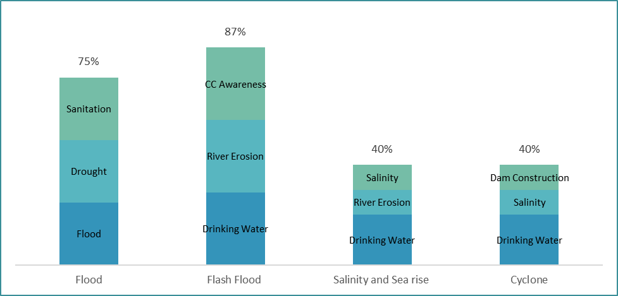
Figure 0.25: CCA projects undertaken by Union Parishad
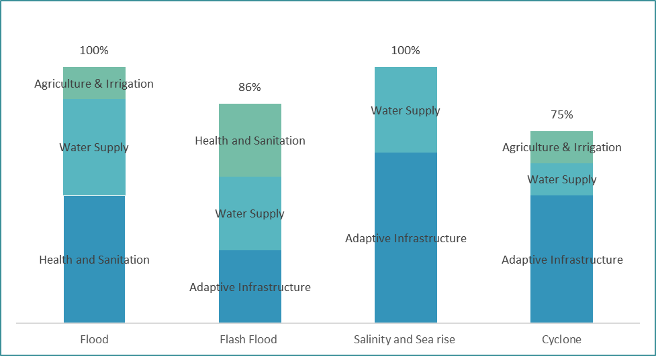
While studying the LoGIC UPs situated in salinity and sea rise zone, it was found that 40 percent of the issues identified in the CRA was related to scarcity of drinking water, salinity, and river erosion. These were the top three climate risks identified in CRA. Other climate risks pinpointed at CRA were extremity of floods, stronger tidal surges, health risks of women and children during disasters, need of constructing dams, construction of roads, bridges and, culverts and requirement of training on income generating activities.
In the salinity and sea rise zone LoGIC UPs were found directing 67 percent of their total budget for CCA linked schemes and to adaptive infrastructure. This expenditure has emerged as an attempt to address CCA risks identified in CRAs namely river erosion, floods, tidal surges, need for dams, need for roads, bridges, and culverts. The rest, 33% of funds were allocated for water supply related projects which was a major issue raised in CRA considering the chronic scarcity of drinking water in these areas due to high levels of salinity in both surface and groundwater.
In Cyclone prone zones of the south, the climate concerns which has aggravated over the years are scarcity of drinking water, salinity and need for dams to protect the locality. These three major issues comprised a total of 40% of risks incorporated in RRAPs. Other risk issues which were raised in CRAs were hampering of agriculture due to less rainfall, unnaturally high temperature, decreasing groundwater level, increased natural disaster, need for training on income generating activities and lack of employment opportunities for women.
In Cyclone zone, adaptive Infrastructure accounted for 50% of the total CCA linked schemes taken by UPs which addressed the need for dams and increased natural disaster. Water supply ensuring schemes comprise 13 percent of total CCA budget allocation of UPs of the region and these schemes are aimed at addressing the issues of salinity and scarcity of drinking water which together account for 30 percent of CCA linked project budgets. Other CCA-linked projects implemented by UPs are plantation, smart boat, and women friendly sales centre and solar powered irrigation system. Thus, here also we can observe that climate issues raised in CRA are now being implemented through CCA-linked schemes by UPs.
Thus, the process of CCA incorporation in LGI’s planning and implementation process is found to be quite efficient and LoGIC project’s PBCRG funding has surely played an instrumental role in improving the CCA planning and capacity of LGIs. It has been found that local climate risks identified in CRA have been at the heart of CCA schemes implemented by UPs signifying a holistic representation.

Inclusivity in LGIs decision making process
Awareness and participation in local development planning process of LGIs has emerged as key indicators of progress of LoGIC Project. It has been found that LoGIC CRF beneficiaries’ awareness has been leading to participation in local development planning.
CRF beneficiaries’ 49.06 percent have knowledge about Ward Shabha and 82.84 percent of them have participated in Ward Shabha proving the efficacy of awareness as a catalyst for increasing participation. About 9.06 percent of beneficiaries’ have knowledge about UP’s Annual Development Plan and CRF beneficiaries’ participation in Annual development plan is 14.79 percent. Of all the CRF beneficiaries, 7.19 percent have knowledge about Five-Year Plan with 5.92 percent participation rate. Furthermore, 9.38 percent of CRF beneficiaries’ have information on CRA and the rate of participation for CRA stands at 11.83 percent. Only 8.88 percent do not participate in any kind of meeting. Having knowledge about UP functions of CRF beneficiaries has contributed their participation in different meetings.
In alignment with the insight gathered in the above section about the positive correlation between awareness and participation, it is found that women’s participation in Annual Development Planning is 21.9 percent while in Open Budget meeting their participation is 21.4 percent. Furthermore, Women’s participation in Ward Shabha is 23.9 percent. For such kind of participation, the percentage of occasionally discussed women related project or issues in Ward Shabha is 72.9 and the percentage of discussing these women related issues regularly is 24.3. The percentage of women related project not discussed at all is merely 2.9. Therefore, it can be concluded that women’s participation in functions of UP have had an effect in the increase in number of occasions when women related project or issues are discussed in Ward Shabha.
The participation of poor in Annual Development Planning, Open Budget Meeting and Ward Shabha were approximately 33, 35 and 37 percent respectively. As more than one third of the participants in ward shabha were from the poor community, the issues affecting them have been discussed regularly almost 34 percent of the time. Additionally, around 64 percent of time, these issues have been discussed in ward shabhas on an occasional basis. The increase in participation of the poor in different types of meetings have facilitated raising the issues experienced by the poor in the ward shabhas.
The participation of the people of the marginal community in all the meetings (Annual Development Planning, Open budget Meeting and Ward Shabha) ranged from 2.3 -3.3 percent. Their participation in the Ward Shabha has ensured the discussion of issues affecting them. 15 percent of the times in the Ward Shabhas, discussion of these types of issues took place on a regular basis while 69 percent of the time the discussion was occasional. As the participation of the poor increased the instances in which the issues affecting them have been discussed in Ward Shabhas, the participation of the marginal community in meetings generated the same results.
The participation of women, poor households, and marginal communities in Ward Shabhas, Open Budget Meetings, Fiver-Year Plan meeting has led to a positive gain in the representation of issues which affect them. This representation of issues in LGI planning events and documents have been translated into affirmative action as 100% of the UPs have implemented schemes related to climate risks faced by women, poor households, and marginal communities.

LoGIC project has been found to have been empowering LGIS to increase their capacity to adapt to climate change risk and manage climate change induced disasters. The PBCRG support has provided the much-needed impetus for taking schemes to increase climate change resiliency of locality. All the surveyed Ups during LoGIC APR 2021 reported to have discussed climate change related problems or projects in their ward shabhas. Additionally, 100 percent of the UPs expressed the perception that climate change issues have increasingly become the more important issue since the implementation of LoGIC project. It was also found that all UPs have conducted CRA to identify the climate risks and the challenges posed by vulnerabilities and a qualitative analysis of the issues identified in CRA have been at the heart of CCA linked schemes implemented by UPs. Awareness of women, poor and marginal communities regarding the functional structure has also led to their participation in the local level planning meetings (Ward Shabha, Open Budget Meeting and FiveYear Plan Meeting and CRA). Therefore, LoGIC Project has increased the LGI’s capacity to deal with climate change risks along with providing a participatory environment for climate vulnerable communities to engage in the process of implementing CCA action.

Summary and Way Forwards

Summary
Climate vulnerability has emerged as one of the most important issues threatening to impact the development gains made by Bangladesh. In such a context, LoGIC project provided a unique, modular and localized solution for CCA actions aimed at both LGIs and climate vulnerable households. CRF (meant for climate vulnerable household) and PBCRG (meant for climate vulnerable LGIs) have cumulatively addressed both the demand and supply side CCA actions.

The project had intra-variations in terms of impact in living standard of the CRF beneficiaries, about 94 percent of them reported medium to high impact of the project on their lives and livelihood. More than half of the beneficiaries have reported medium impact and about 6 percent have reported a low impact. Assessing the indicators of housing quality, investment in housing, health and nutrition, sources of drinking water and household assets, it can be reasonably inferred that CRF beneficiary households now enjoy improved living standards. Improvements in most of the indicators can be attributed to LoGIC interventions as was reaffirmed with perceived impact of LoGIC project on overall living standard and livelihood with 94 percent of respondents affirming medium to high impact of the project on their living standard.

LoGIC has had a consequential impact on the financial status of CRF beneficiaries. 50.94 percent of respondents think that LoGIC has a medium impact while 42.81 percent think that it has a high impact on their financial status. Overall, we see that the LoGIC project has the greatest (more than 90 percent in number) impact on CRF beneficiaries' financial status. Therefore, the result shows a satisfactory resilience in the standard of living has been achieved among CRF beneficiaries. On the other hand, there are some gender dimensions of the overall improvement. It is found that the level of involvement of husbands in spending money from the CRF beneficiary account which is ranging from no involvement to moderate involvement and very little involvement. Collectively, a good number of respondents say that their husbands have no or low interference in spending money from CRF beneficiary account (combinedly 44.6%). This proves that more financial independence i.e., empowerment has been established among women. That means the way of financial support being provided by the women has been revealed and their family level overall financial capacity improvement has been exposed as a whole.
Perceived impact of the CALO trainings on the overall capacity building including the confidence of the beneficiaries are revealed when they were asked about the facts. About 91 percent perceived that their CALO trainings and making livelihoods options for better earning opportunities are resulted due to their intervention. Only 9 percent flagged the fact as low to no impact for their alternative livelihood engagement related capacity building. That can be attributed as the stronger evidence for understanding the situation of the CRF beneficiaries regarding livelihoods generating capacity enhancement dimensions.

Way Forward
LoGIC project with its CRF and PBCRG interventions, have started to affect the CCA capacity of both LGIs and climate vulnerable communities since its inception. Though the milestones achieved by the projects till date is quite substantial on its own right, there are significant sectors of improvement for the implementation agencies in terms of intervention delivery.
The design of CALO has emerged as a methodical and process of empowering CRF beneficiaries. It has been observed during the LoGIC APR survey that a sizeable portion of CRF beneficiaries have completed multiple cycles of multiple CALOs thereby increasing their climate resilience. Majority of the respondents expressed firm belief in the sustainability of their respective CALO stating that they will be able to continue their CALO now even without any further support from CRF. It is certainly heart-warming insight but considering their high climate vulnerability, it would be a pragmatic option to create a provision of continuing CRF funding for the most climate vulnerable CALO practicing CRF beneficiaries.
Moreover, LoGIC project can work more in the sector of financial inclusion of the CALO practicing CRF beneficiaries. LoGIC project can initiate a programme to facilitate the inclusion of their CRF beneficiaries to Moblie Financial Services (MFS) services. CRF beneficiaries’ inclusion into the formal financial sector through MFS will lead to better market accessibility for products produced through their CALOs but more importantly they should be provided with the option of gaining access to funds which some MFS have already started providing.
Climate change vulnerable areas have historically had high rates of migration due to adverse natural environment of the locale. Though there is no concrete way of completely put a definitive end to climate induced migration but identification of household with very high climate vulnerabilities rate can help in reducing the rate of climate change induced migration. These highly climate vulnerable households should be brought under CRF funding framework and providing special attention and assistance to them to ensure that their climate risks decrease. This measure can be expected to reduce the rate of climate change induced migration.
In APR 2021, it was found that beneficiary selection process of LoGIC CRF intervention appeared remarkably precise in comparison to other projects. But while sanctioning PBCRG schemes, there is scope for inspecting the details of the schemes as to how the benefit of the project will be transferred to ultimate intended beneficiaries which is the local population. As the eventual beneficiaries are receiving the project intervention via LGI, a specific subset of inquiry can be made to the LGIs regarding how their proposed CCA scheme beneficiaries will be selected. This extra cautionary measure will allow better monitoring of the PBCRG funded CCA schemes.
Another issue which can be considered to better the implementation process of LoGIC Project is through evaluating the sustainability of PBCRG projects in terms of maintenance. A case in point is the Integrated Rainwater Harvesting Plants of Mongla, where the desalinization module of the plant, which is a maintenance requiring component with costly consumables, is due for a maintenance and the maintenance cost is to be set by open tender. LoGIC District Climate Finance Coordinator (DCFC) should be more proactive regarding the maintenance costs while evaluating any PBCRG.
Apart from the analytical process of proposing the way forward for LoGIC Project, grassroot level opinion regarding how to better implement the project bears special significance. Among the issues which arose from APR 2021 survey are holistic development of the locality, broaden the range and capacity of the project, CRF schemes should be introduced in every ward, CRF beneficiaries who have failed to gather return should be provided further investment capacity, providing support and maintenance through LoGIC and increase the number of trainings.
Other quantitative suggestions made by LoGIC project beneficiaries are need to engaging people with relevant climate adaptive IGA and providing them with training, capacity enhancement, ensure more participation of local influential people in project affairs and women’s participation should be increased.

Note: Outcomes, outputs, indicators and targets should be as outlined in the Project Document so that you report on your actual achievements against planned targets. Add rows as required for Outcome 2, 3 etc.
Sample size for finite population correction: SS_{f} = , where In our cases, the sample population is 17,000. Putting it into the formula will give us the sample size close to 309 (with 95% confidence level and 1.1% of margin of error)
Mill/factory/garments worker, tailor, electrician, plumber, sanitary worker, mechanic, carpenter, mason, blacksmith, potter, cobbler and barber.
Rickshaw/van puller, trolley puller, stone worker and crab/shrimp fingerling collector.
List of CALO: Crab fattening, Carp fish polyculture, Sheep rearing, Pig rearing, Integrated Agriculture and Poultry, Native chicken Rearing, Duck and Fish farming, Green Job (Bamboo-based Handicraft), Duck rearing, Maize Cultivation, integrated vegetable cultivation, Vermicompost, watermelon cultivation, saline water fisheries, nursery development.

